The below shows cases how the user can import data into students and teacher tables, via attached flat file. The application looks to the SampleData folder and then chooses the csv file dependent upon the name of the file. Press the import button to populate the MSSQL tables.

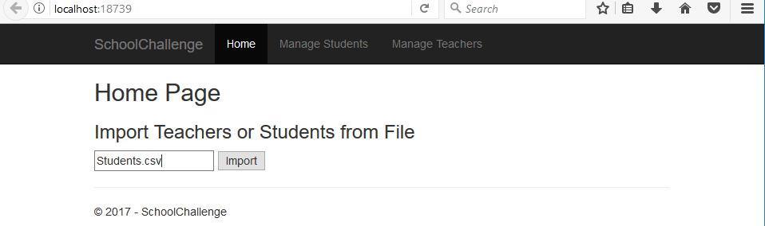

Not only does this add new records, but it also prevents duplication and updates existing records. This is because of a Stored Procedure written that uses a MERGE.

If you click on the Manage Students tab this brings the user to see a list of students that are currently existing in the Students table. Here the user can edit, delete, and review details of each student record. The student list shows the ‘Student Number’, ‘First Name’, ‘Last Name’, and ‘Has Scholarship’, but not the ‘Student ID’ as this is a autoincremented unique key.

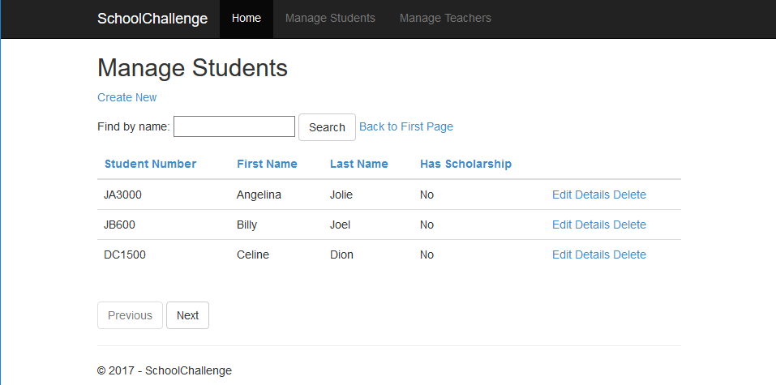

By clicking on the ‘Create New’ link it will take the user to a page to create a new student record. As you can see in the image below you can specify each field to populate in the Student table. Click the ‘Create’ button to add a record or click the ‘Back to List’ link to return to the previous page.

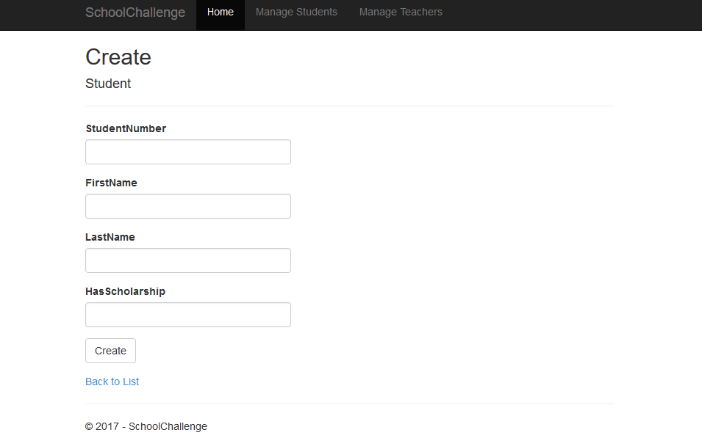

By populating the ‘Find by name:’ field we can do a search of every student by first name or last name as seen below. The user can hit the ‘Back to First Page’ link to restore the full view again. To sort each field is a link that when clicked will sort in descending and click again back to ascending order.

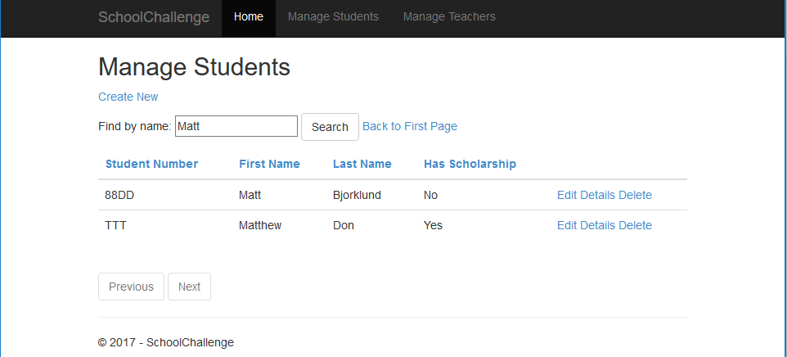

If there are too many records to be displayed on the screen there are multiple pages the user can use to view groups of Student records. By click Next and Previous buttons the user can review every Student record. The buttons become disabled when you can’t move to the Next or Previous page.

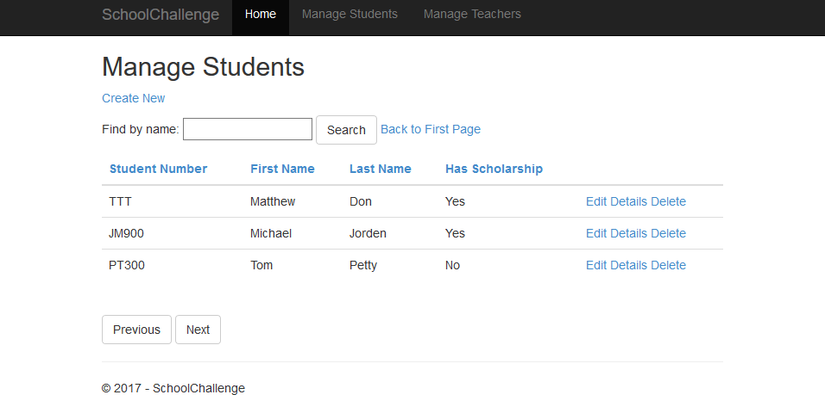

Every step above can be recreated for the Teacher table as well. Instead of navigating to the ‘Manage Students’ tab the user would click the ‘Manage Teachers’ tab. The screenshots below show the exact uniform functionality as the Students just with different field names.

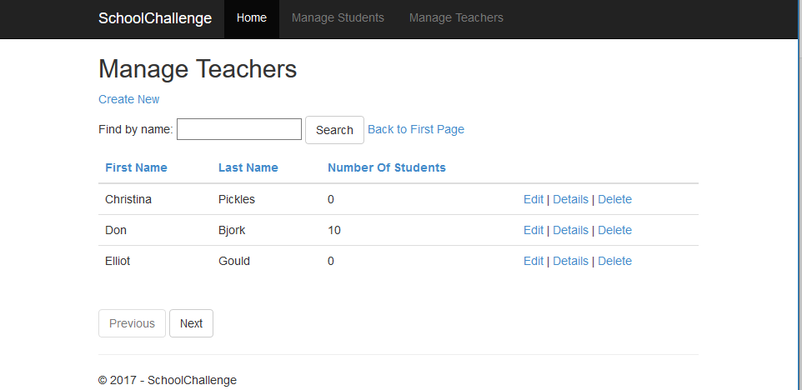

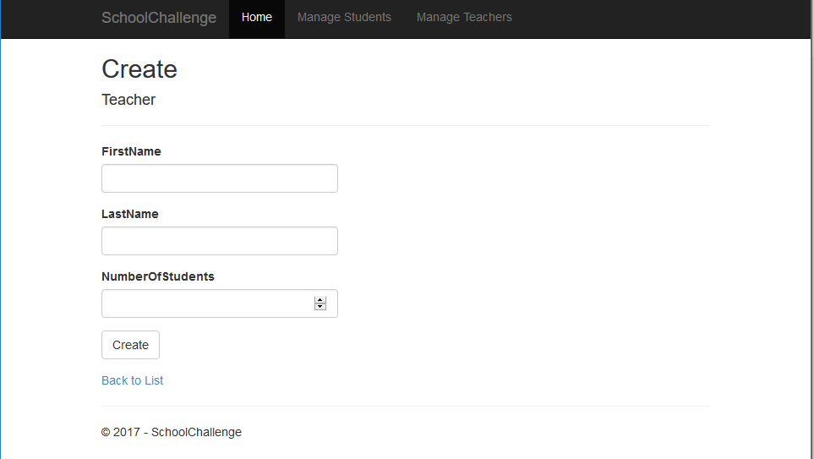

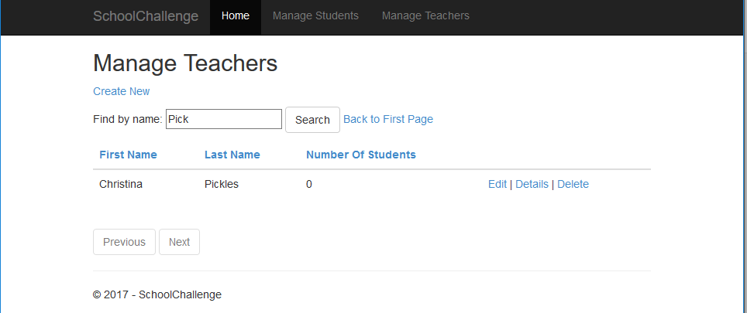

Every field for Students and Teachers have validation during data entry. The user must enter all values and it must correspond to the data type when editing or adding.

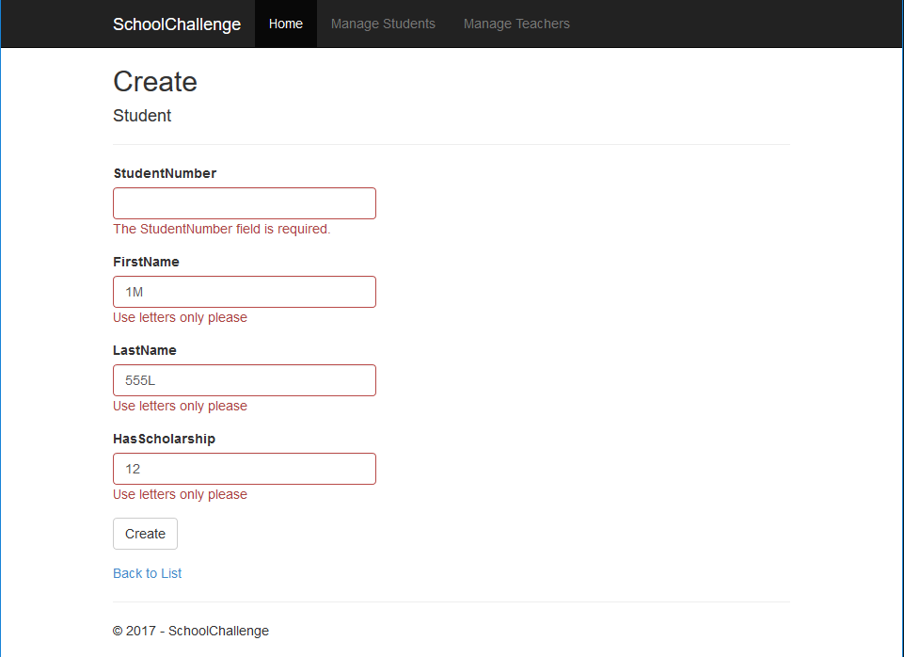

The below are the tables that were created.

