Matt Boler

Digital Image Processing, Project 2

Because pixels are aligned in an ortholinear grid, rotating an image with straight lines in it results in a sort of staircase pattern. Applying an interpolation function will include a form of antialiasing, in which gray pixels are added to the edge of the staircase to make it appear smoother. This effect can be seen in the first image below. This rotation introduces some interesting alterations to the Fourier transform of the image, also shown below. The Fourier transform of a horizontal line is simply a vertical line; this is because the transform is a combination of the transform of vertical impulse sequences, whose transform is a constant, and horizontal constants, whose transform is an impulse. These combine to give a vertical line of each horizontal impulse, which line up because vertical sections must be constant. Alternatively, the transform of the rotated line is the rotated transform of the original line.

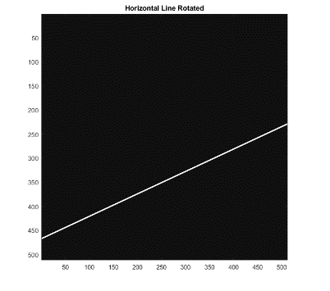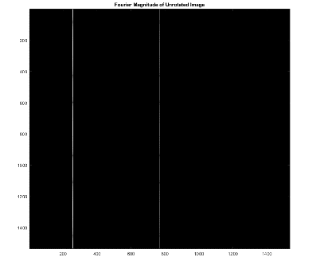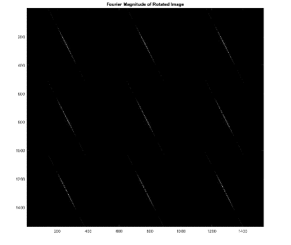

Subsampling the rotated line by selecting alternating pixels produces a half-size image in which no interpolation or anti-aliasing is performed. Because of this, the new image is more jagged than the original. This shows in the transform of the image having stronger high-frequency content. Alternatively, by downsampling via averaging a pixel neighborhood, edges are smoother by gray patches, resulting in less high-frequency noise in the transform. The function used for this downsampling is attached at the end. The mentioned images are shown below.

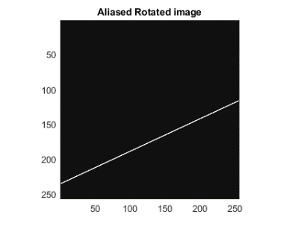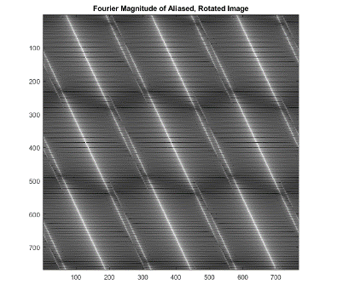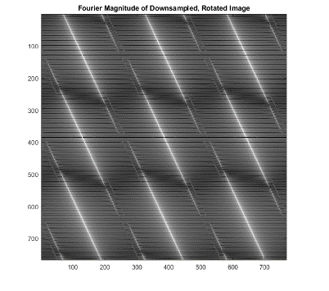

When sampling a sinusoid as opposed to a line, subsampling has an interesting effect on both the image and its transform. The subsampled image clearly displays aliasing, as the original pattern appears broken and has a changed dominant direction. Additionally, the transform of the image initially appears to be flipped about the y axis. In actuality, we are witnessing aliasing in the vertical direction as periodic copies infringe on the plot of the transform. The original’s transform has a peak at w_m = 0.65*pi and w_n = 0.2 * pi. Because we increase our sampling delta from 1 to 2, we expect these to show as w_m = 1.30*pi and w_n = 0.4*pi in the subsampled image. However, aliasing shows peaks at 2*pi/delta – w_m = 0.69*pi. w_n is not affected as the aliasing is not strong enough for horizontal overlap. These images are shown below.

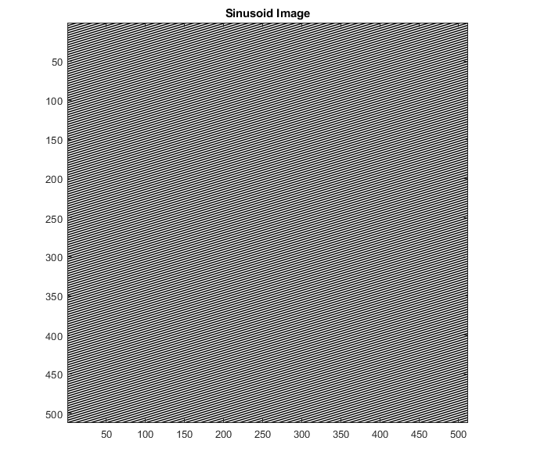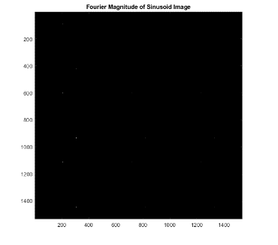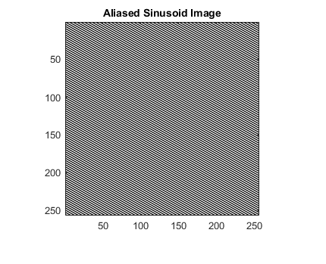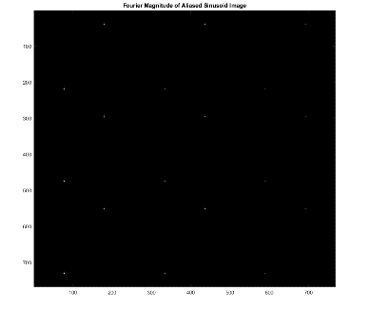

function [downsampled] = downsample_boler(image)

% My plan: 4 separate halved images, add and average

[height, width] = size(image);

u_idx = 1:2:width;

v_idx = 1:2:height;

img_topleft = image(u_idx, v_idx);

img_topright = image(u_idx+1, v_idx);

img_botleft = image(u_idx, v_idx+1);

img_botright = image(u_idx+1, v_idx+1);

downsampled = (img_topleft + img_topright + img_botleft + img_botright) ./ 4;

end