|  |
| --- |
| Hochschule Esslingen |
| Laborbericht Computerarchitektur |
| Labor 3 |

|  |
| --- |
| Brandel Matthias, Julian Ruess  05.01.2018 |

Inhalt

Abbildungsverzeichnis 1

A.1 Functional Requirements 2

A.2 User Interface of the Program 2

A.3 Module overview 3

A.4 Data Dictionary 4

A.4.1 List of all global Variables 4

A.4.2 Hardware Resources 4

A.5 Flowcharts for all Modules 5

A.5.1 Main Program 5

A.5.2 Ticker 6

A.5.3 Clock 6

A.5.4 Clock US 7

A.5.5 decToASCII 7

A.5.6 AD 8

A.5.7 Thermometer 8

A.5.8 Entpreller 9

A.5.9 LED 9

A.6 Interface Documentation for all Subroutines 10

# Abbildungsverzeichnis

Abbildung 1: Module Overview 4

Abbildung 2: Main Program 6

Abbildung 3: Ticker 7

Abbildung 4: Clock 7

Abbildung 5: Clock US 8

Abbildung 6: decToASCII 8

Abbildung 7: AD 9

Abbildung 8: Thermometer 9

Abbildung 9: Entpreller 10

Abbildung 10: LED 10

# A.1 Functional Requirements

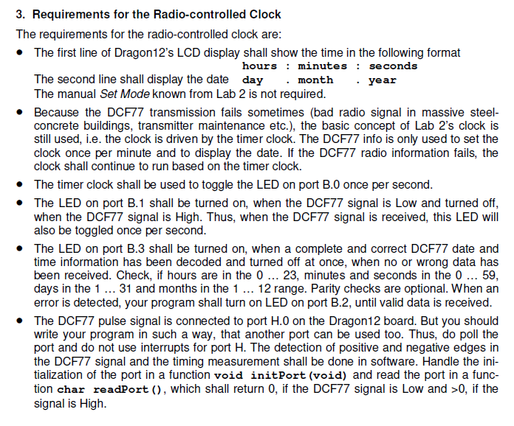

# A.2 User Interface of the Program

LCD display

* First line : Current Time in HH:MM:SS Format and Temperature
  + Normal mode example (HH:MM:SS 20oC)
  + US mode example (HH:MM:SS(AM/PM) 20oC)
* Second line : Current Weekday and Date
  + Example (FRI 05.01.2018)

LED display

* LED0: toggles once per second
* LED1: ON, if DCF77 signal is low and OFF, if DCF77 signal is high
* LED2: ON, if a receiving error is detected until valid data is received
* LED3: ON, if a complete and correct DCF77 date and time information has been decoded until no or wrong data has been received.

Operating Buttons

* SW2: If pressed for more then one second, it toggles between US and normal mode

# A.3 Module overview

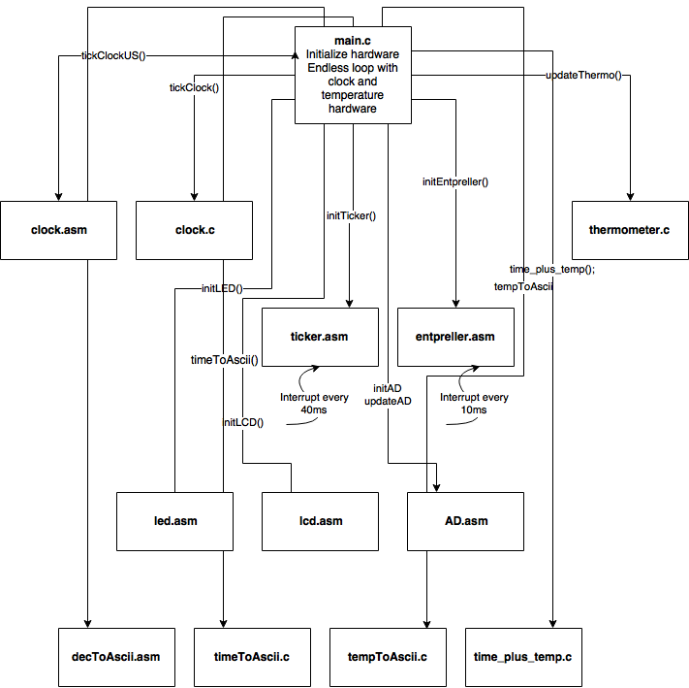

Abbildung 1: Module Overview

# A.4 Data Dictionary

## A.4.1 List of all global Variables

Tabelle 1: global Variables



## A.4.2 Hardware Resources

Tabelle 2: Hardware Resources



# A.5 Flowcharts for all Modules

## A.5.1 Main Program

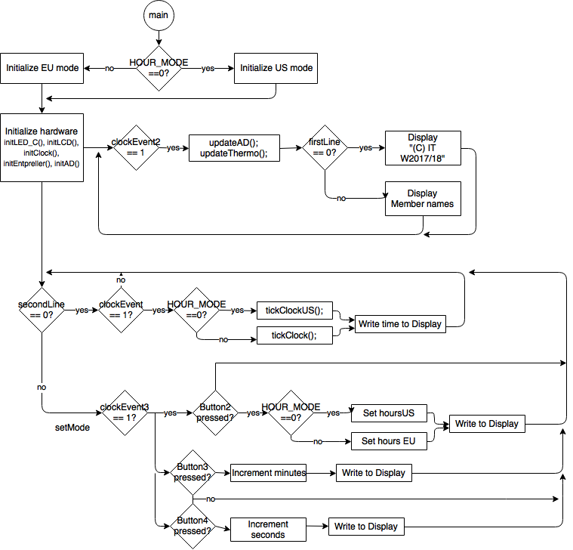

Abbildung 2: Main Program

## A.5.2 Ticker

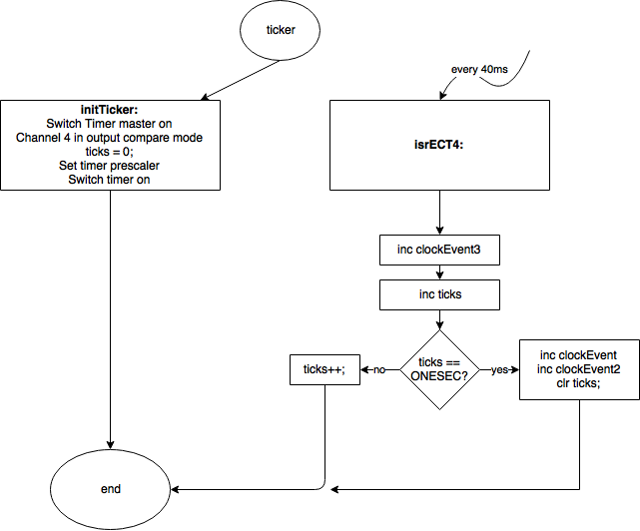

Abbildung 3: Ticker

## A.5.3 Clock

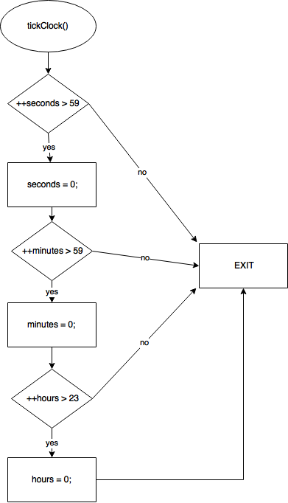

Abbildung 4: Clock

## A.5.4 Clock US

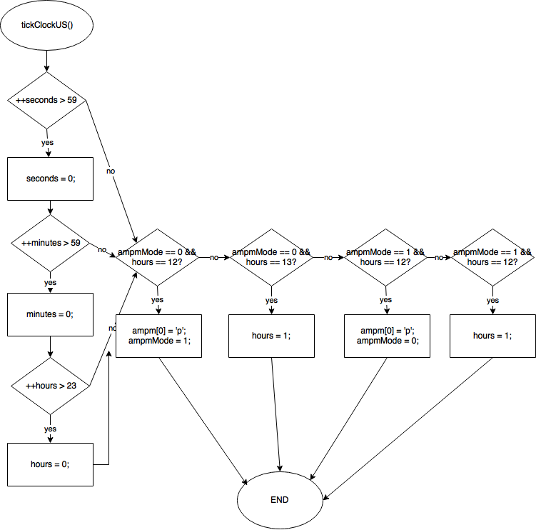

Abbildung 5: Clock US

## A.5.5 decToASCII

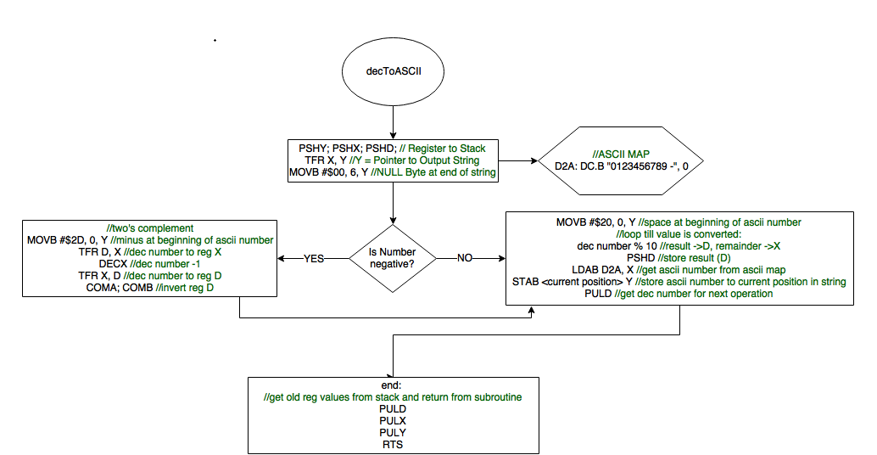

Abbildung 6: decToASCII

## A.5.6 AD

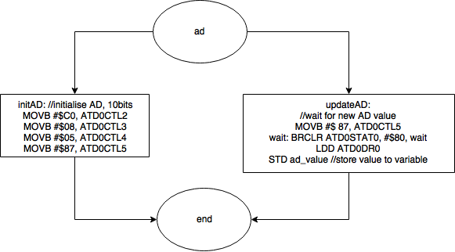

Abbildung 7: AD

## A.5.7 Thermometer

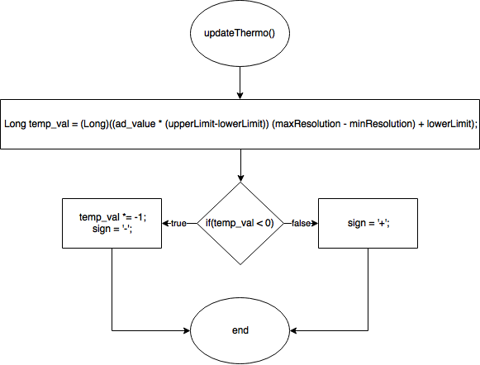

Abbildung 8: Thermometer

## A.5.8 Entpreller

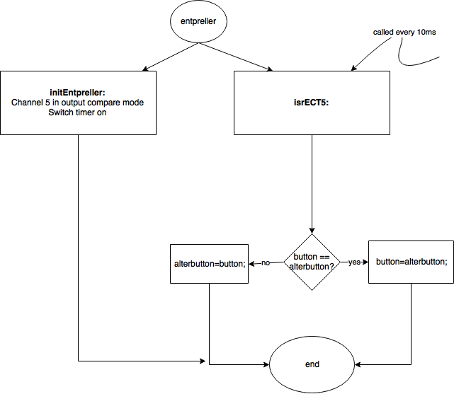

Abbildung 9: Entpreller

## A.5.9 LED

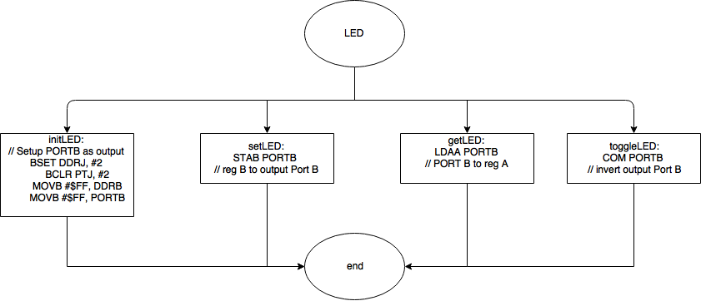

Abbildung 10: LED

# A.6 Interface Documentation for all Subroutines

**Public interface function: initLCD … Initialize LCD (called once before using the LCD)**

Parameter:

Return:

Registers: Unchanged

**Public interface function: writeLine … writes string to LCD-Display**

Parameter: X --> pointer to zero-terminated ASCII string, B --> row number (0 or 1)

Return:

Registers: Unchanged

**Public interface function: delay_10ms … wait until 10ms elapsed**

Parameter:

Return:

Registers: Unchanged

**Public interface function: initLED … Initialize LEDs (called once before using the LEDs)**

Parameter:

Return:

Registers: Unchanged

**Public interface function: toggleLED … toggles the LED output port**

Parameter: B --> Bitmask with information which LEDs should be toggled

Return:

Registers: Unchanged

**Public interface function: setLED … set the LED output port**

Parameter: B --> Bitmask with information which LEDs should be set

Return:

Registers: Unchanged

**Public interface function: clrLED … clear the LED output port**

Parameter: B --> Bitmask with information which LEDs should be cleared

Return:

Registers: Unchanged

**Public interface function: initTicker … initializes Ticker function**

Parameter:

Return:

Registers: Unchanged

**Public interface function: tickClock … Clock function**

Parameter:

Return:

Registers: Unchanged

**Public interface function: initAD … initializes AD function**

Parameter:

Return:

Registers: Unchanged

**Public interface function: updateAD … reads AD value**

Parameter:

Return: D --> ad value as integer

Registers: Unchanged