InvenTracker App

Matthias Bradshaw

CS 360

01/22/26

Week 3 Project option: 1
Goals
The main purpose of the InvenTracker application is to allow authorized users to access inventory data in a user-friendly manner that allows them to quickly and efficiently update warehouse inventory for a retail store. There will be two main databases that allow the app to function, one for user log in credentials and one that contains all the item information within the warehouse. The app will start at a login screen so only authorized users can access the data, once logged in the app will show the inventory in a scrollable format on the screen. To make it easy, users will have functional buttons to add or remove items from the inventory as well as being able to see the current quantity of an item and update that with a simple plus or minus button on either side of the quantity as items flow in or out of the warehouse. There will also be an invisible banner at the top that appears when an items stock reaches zero to quickly notify a user of that situation.
The InvenTracker application is designed with several core goals in mind. These goals include improving inventory accuracy through real-time updates, increasing efficiency by allowing users to manage inventory from a mobile device, and supporting informed decision-making by providing immediate visibility into current stock levels. Additionally, the application aims to reduce downtime caused by out-of-stock items by notifying users when inventory quantities reach zero.
Users
The main users of the InvenTracker App would be warehousing staff, marketing employees, and employees in charge of placing orders such as managers. While all users rely on accurate and up-to-date inventory information, their needs differ based on their roles. Warehouse staff prioritize speed and ease of updating quantities during daily operations, marketing staff focus on visibility into inventory trends to support planning decisions, and managers require alerts and summaries to prevent stock shortages and support ordering decisions.
Warehouse staff would use the app to quickly update the inventory as things come and go through the warehouse whether that’s receiving new items or shipping items to customers or a retail store front. A potential implementation would be to have data for each item’s location in the warehouse that may speed up the process of the warehouse staff gathering or placing items in their specified locations, which would speed up the process in a large warehouse. For this they would need a good organizational layout, naming shelves in the warehouse that coordinates with the data of each item and to maintain those standards as new items come into the warehouse and database.
A marketing director may use the app to track what items are in abundance or are hot ticket items. Being able to see the items and their quantities without direct presence in warehouse means they can get the info without being in the way and from any remote location. This should minimize hinderance on the warehouse staff’s activities, increasing productivity. A potential implementation to add would be to track when items were last moved in the warehouse or sort items by their quantities, which may speed things up for someone planning marketing related aspects for the company. The goal for their situation may be to maximize profits for the company by matching the supply and demand of items via discounted sales or raising prices on various items. If the warehouse is getting full and a certain item has a large stock that hasn’t moved or a newer version of the product is coming in, they may be able to free up space by putting the older model on sale where people will find value in purchasing it there by freeing up space in the warehouse.
Managers or employees charged with placing orders for items benefit from this app if it is successfully implemented. Having digital records updated quickly on the exact items and quantities in the warehouse lets them see the overall picture and the finer details in real time. In a warehouse that may have thousands of items with varying quantities, an item reaching low or zero stock may go un-noticed, the banner at the top of the app will alert managers of items that reach zero stock. By doing so they can be sure to place new orders to minimize the time in which an item is out of stock. The back end of the app could also be changed to set alerts at different quantities, so an item alert is displayed when 5 or any other amount remains. This would make them more efficient at their job rather than having to roam the warehouse, they would always have the information on hand providing that the app is successfully implemented at all levels of the company.
UI Design
The User Interface of the app needs to be simple yet effective. As of now there are two main screens which the user will interact with, the first being the login screen and the second being the main screen that is used for tracking inventory. Android provides certain guidelines to follow when building an app which we should take note of in our design and layout. Specifically maintaining device safe areas like the system bars and navigation region are essential as well as developing with display cutouts in mind like the front camera on various devices. Another consideration is using scalable layouts and units when designing the app, not all devices have the same size screen so by using dp (density independent pixels) and sp (scalable pixel) units ensures that the app will maintain a similar look and feel regardless of the device it runs on. Below is a Visio sketch of how I envision the layout of the app:
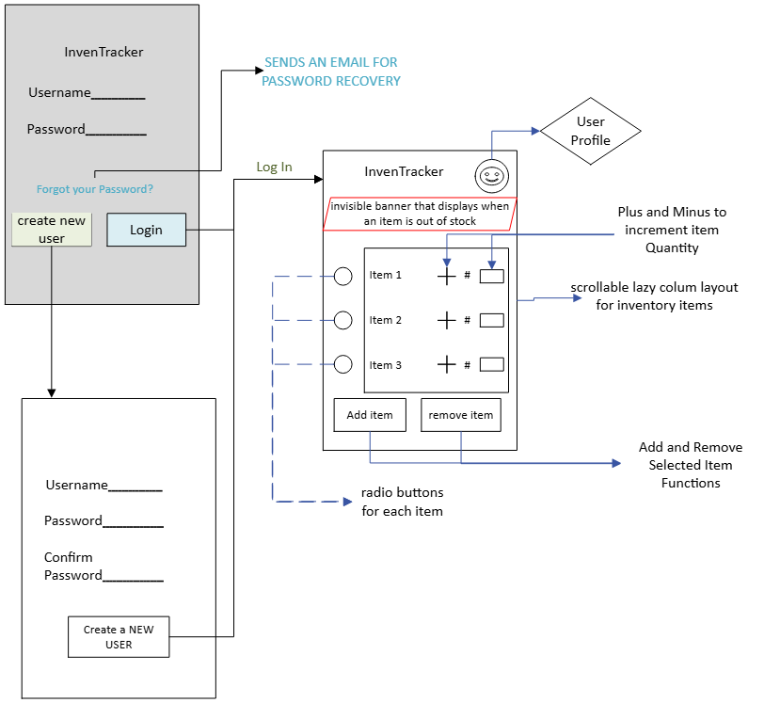
This sketch highlights the main features of the login page which will change when the user clicks on “create new account” to unhide an additional password confirmation text field. The password text fields should hide user inputs with dots to provide an extra level of security. Theres an option to recover lost passwords if needed and the log in button for a user to securely log in with their credentials.
After logging into the app, the main screen will display with the InvenTracker name at the top just below the status icon bar and any notches for sensors. There will be a profile icon in the top right which will provide user capabilities like changing passwords or logging out. The heart of the app will be the scrollable inventory grid in which each item will feature a radio button for selection, its name, quantity and a plus or minus button to update quantities. The invisible banner will appear above the grid only when an item reaches 0 for its quantity value. The buttons for adding an item and removing an item will be constrained to the bottom area of the screen and will be outside of the scrollable grid area so that the user has access to them no matter how large the inventory grid is. The remove item button will work based on the selected item’s radio button and it should ask for verification before removal. Adding an item with the button should allow the user to input item information and a base quantity to start from.
Functional Requirements
As described in the UI section, the application includes several interface components that are directly connected to application logic and database operations, including radio buttons, quantity adjustment buttons, item management buttons, login input fields, alert banners, and a scrollable inventory list. When the login button is selected, the application logic validates the entered username and password against credentials stored in the user database to ensure that only authorized users can access inventory data. If the credentials are valid, the application transitions to the inventory screen, where inventory data is requested from the database and displayed to the user.
The lazy column layout will allow us to display all the items from the database on the app and will pull the items quantity which can be updated via the + and – buttons to increment or decrement the stored quantity value in the database. The remove item button will interact with the item database based on the radio buttons for the selected item to remove that item from the database. The add item button will allow users to make a new entry into the item database. All these buttons will work with OnClick function calls to implement the function that they should provide like removing, adding items, updating quantities, or selecting an item by its radio button which changes its setChecked state to true. The lazy column will be a scrollable layout within the main page of the app which allows the main buttons to stay in focus for quick access in the app. The invisible banner will appear for any item whose quantity reaches zero to quickly alert a user.
Data Flow within the app
As the app is based solely on two databases the flow of data is directly related to how the user interacts with the app. The login page requests user input for a username and password whether it’s for creating a new account or using an existing one. If it’s an existing account the credentials are checked against the user database to allow login, if it’s a new user it will add the credentials to the user database which after approval allows access to the secondary database. The login button when clicked and credentials verified, bring in the activity screen that will request and display data from the second database of inventory items into the lazy column layout. The user can then interact with the plus or minus button from each item to change the quantity in the database which will reload the items in the lazy column with updated values. The radio button will allow the user to select an item which can be removed from the database via the remove item button which will call a function to remove the item from the database and then reload the lazy column with an updated list from the database. The add item button will allow users to create a new entry in the database and then will also reload the lazy column layout to display the updated data from the database.

