CS4222 Homework 4 Report

Valérian Rey A0175705B
Matthieu Buot de l'Epine A0175473X

How to run our code:

Algorithm explanation:

- Walking/Idle detection:
We used an algorithm very similar to the first step counting algorithm that we studied in class. First, we retrieve the data from all the accelerometers and compute the corresponding magnitude for each sample. Then we compute the left moving variance of this magnitude (where we used the complete moving variance for step counting) because we don’t want to wait for the future data, it improves the latency. According to the algorithm seen in the lecture, we finally compute square root of that variance before applying two thresholds that bound the obtained standard deviation. We chose these thresholds so that they correspond to a normal walking rhythm.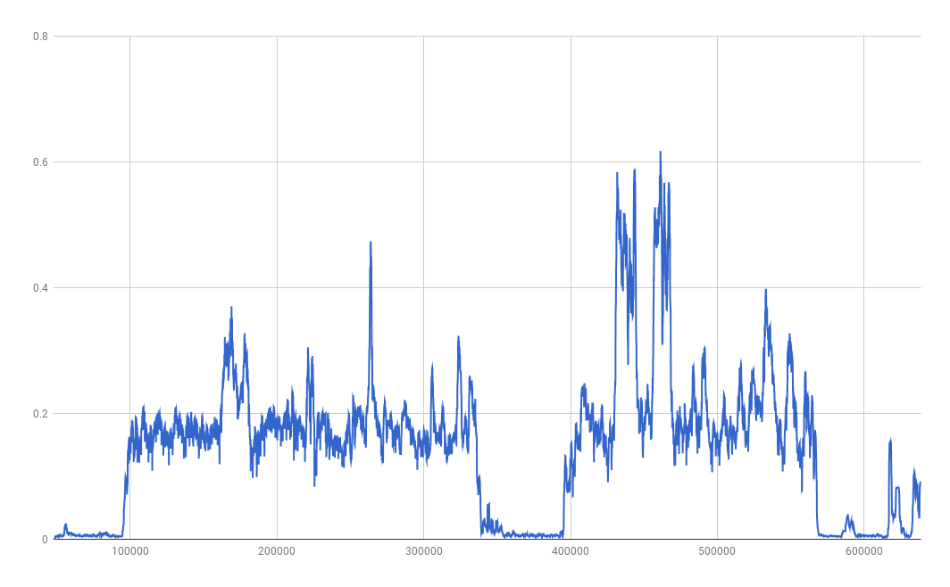
Figure 1: Our obtained moving standard deviation (window size: 25, threshold: 0.065)

- Floor change detection:
For this algorithm we only used the barometer sensor because it’s able to detect changes in altitude of more than one meter. Our program first tries to smoothen the signal by applying three consecutive moving average filters. Then we compute the slope at each point of the smoothen signal, then we apply one more moving average filter and finally we keep the absolute value of our data. We again use thresholds in time and amplitude to only keep the largest areas above zero which corresponds to the floor changes. For the second data set, we had to deal with a significant noise which we couldn’t determine the origin. We tried to cope with it with many different arrangements but we always had either too many or not enough floor changes based on the ground truth. So, we decided to keep a version where we are able to clearly identity three of the floor changes and also where we don’t include wrong outputs.
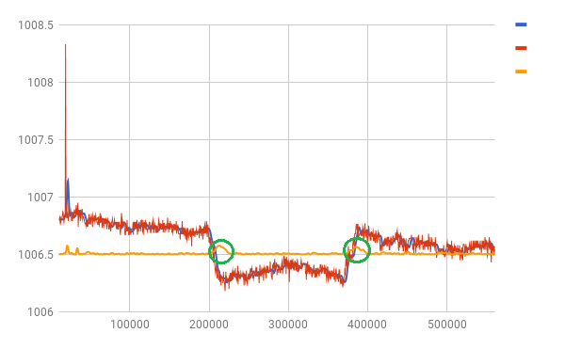
Figure 2: Our floor detection signal for the first dataset and the detected floor changes

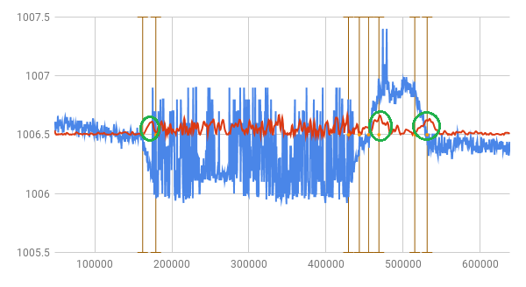
Figure 3: Our floor detection signal for the second dataset and the detected floor changes (in green)

d. Accuracy based on ground truth:

