Jarrod Bailey && Mathew Camp

Final Project Proposal

Overview:

Our project is a GUI that will allow clinical personnel to store, retrieve, and edit a list of patients and the information about their individual visits to the clinic.

Advanced Features:

Our project will utilize a JDBC SQLite database to store related information. Clients will interact with the software through the use of a GUI built using Java FXML. Threads will be used to query lists of data from the database for better efficiency. A generic controller will be used as a parent class for all controllers.

GUI Scenes:

1. Patient Summary
2. Visit List
3. Visit information
4. Medication information
5. Allergy information

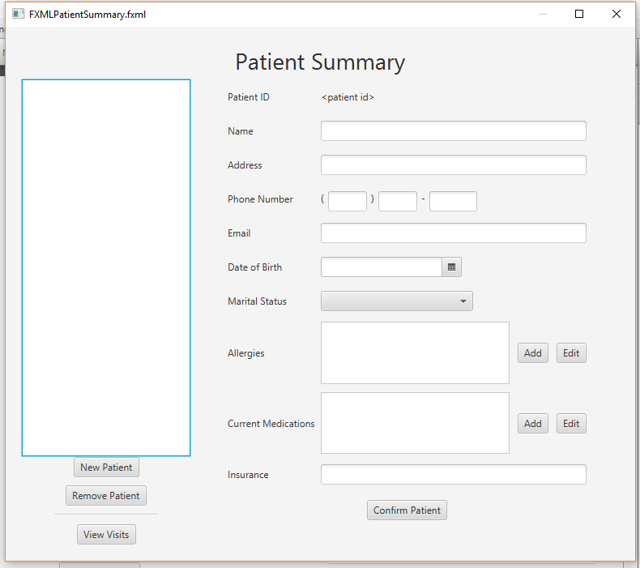

1. Patient Summary

This scene will display a list of all the patients in the database. Users will be able to view the information about each individual patient, edit that information, and add new patients to the database. From this scene, users will also be able to open another scene that contains a selected patients clinical visits. Scenes can also be accessed that allow aditional medications and allergies to be added to patients. Every change to the database shall refresh the list views.

Buttons:

List View - When selecting a patient, all fields shall be filled with the patients information.

New Patient - Clears the text fields and sets patient id to -1 so that new patients may be added.

Remove Patient - Removes the select patient from the database.

View Visits - Creates a new stage with the visit list scene, passing on the selected patient.

Allergies/Medication Add/Edit - Creates a new stage with the allergy/medication information scene, passing on the selected patient. When that scene is closed, the new allergy/medication is added/Updated to the patient in the database.

Comfirm Patient - Inserts a new patient into database if new patient was selected, otherwise updates the currently selected patient.

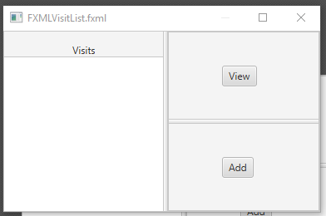

2. Visit List

This scene will display a list of the visits for the selected patient. Users will be able to view a previous visit but will not be allowed to edit it. Users will also be able to add new visits to a patient. Upon adding a new visit, the list view will be refreshed.

Buttons:

List View - N/A

View - When pressed, the Visit Info scene will be launched, passing on the selected View.

Add - When pressed, a blank Visit Info scene will be launched, allowing the user to add a visit to the patients view list.

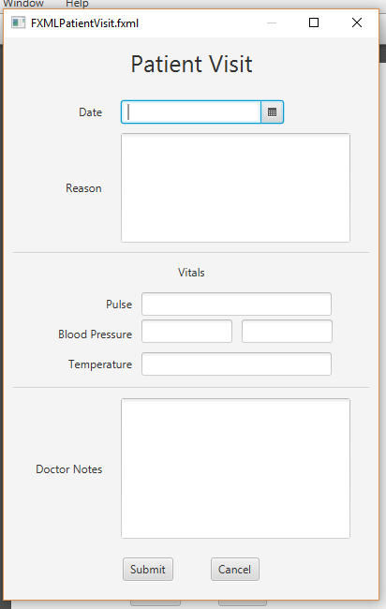

3. Visit Information

This scene will allow the user to view a specific patient visits’ information and to add new visits to that patient.

Buttons:

Submit - Closes the scene if viewing. If adding a new visit, the database is updated with the new visit.

Cancel - Closes the stage with no additonal action.

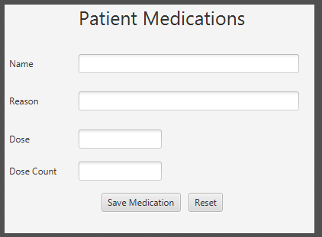

4. Medication Information

This scene allows the users to edit or add a new medication to a specific patient.

Buttons:

Save Medication - When pressed this will add or update the medication into the database.

Reset - Clears the fields.

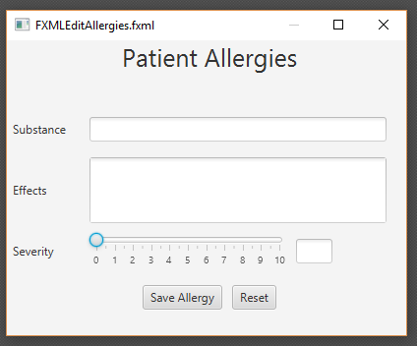

5. Allergy Information

This scene allows the user to edit or add new allergies to a patient.

Buttons:

Save Allergies - When pressed this will add or update the allergy into the database.

Reset - Clears the fields.