Matthew Boyle
Object-Oriented Programming: 04:547:202:07
Professor Schmeding

Purpose: The purpose/ goal of the project was to create a weather app that would function similarly to popular weather widgets such as Apple’s built-in weather app. This would have the ability to add and update different aspects of the weather such as temperature and skies. The major libraries that were used in the project were requests, JSON, os, and kivy. Requests were used to be able to pull information from Open Weather's API using a specific link. OS was used to open and read JSON files to use the data stored and JSON was used to create and store these files in my “databank” weather_data. I wanted to do it like this to simulate the idea of storing the information on a server to be able to create an online forum in the future. I decided to Kivy because it seemed pretty beginner-friendly and simple to use to create a GUI for my weather app. The backend coding wasn’t that difficult and building the app wasn’t too bad either. What I struggled with and was extremely time-consuming was figuring out how to get the positioning of my labels and widgets. There wasn’t a lot of information I could find online that was easy to understand and more beginner tools focused on following the layout of the box format than allowing for custom formatting. I also really struggled with making the objects dynamic so that they would grow and shrink/reformat with the screen. In the end, I was able to get all of that to work and was happy with the results. Although I’m sad I ran out of time because the app is rather barebones and missing some important functionality. 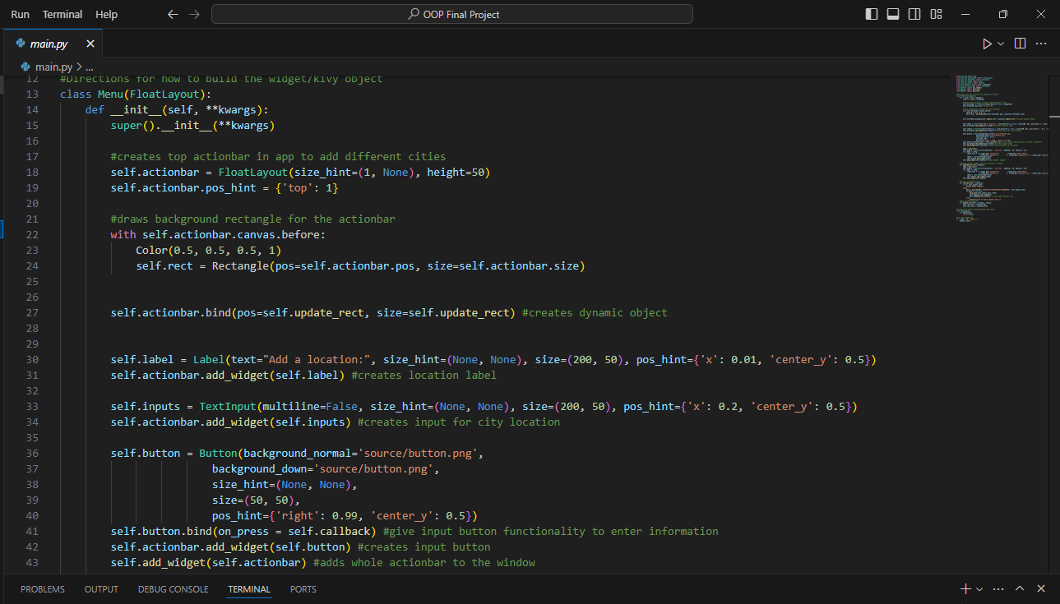
Here I basically call def init and super because this is the child to the parent Menu. Menu is called to actually build the website but I use the child as the “directions”. This allows me to do stuff like call self because creation variables and adding them to the widget often works in funky ways and gets really confusing. Here I basically build all of my actionbar pieces the input, the box background, and the enter plus icon into the actionbar object. I do this because It makes it so i can use post_hint to fit everything in relation to my gray box. This way I don’t have to move everything around to arbitrary x and y positions and have to rely on guess-and-check for where those positions are. Background normal sets the what button I want the picture to be, and I have folder with images called source to easily pull from. Background down is what the picture will be set to while the button is pressed, however I don’t need that as the reload function gives enough indication to the user that something has happened. The bind function allows me to call a function to make something happen on a press. And then it’s just a simple case of adding all the widgets to the screen with the add_widget function.
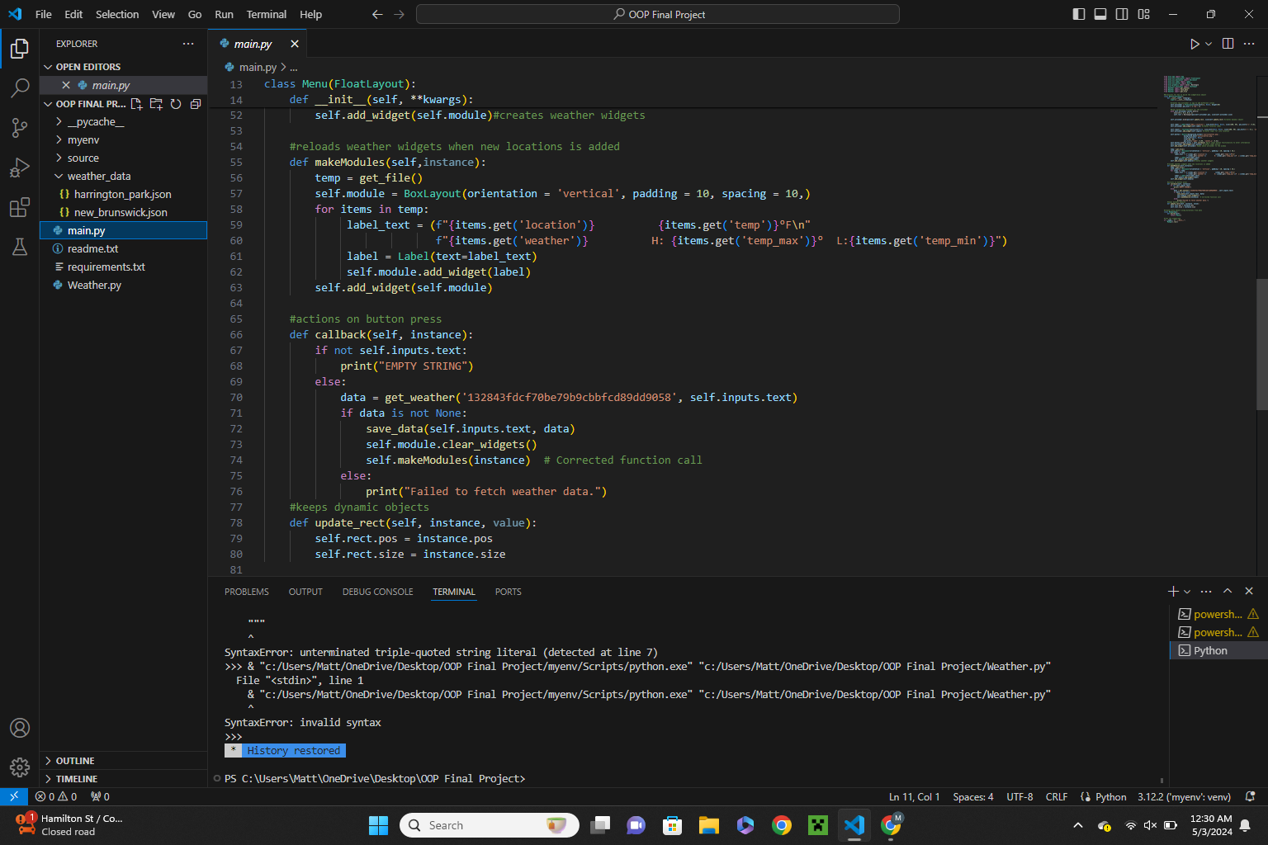
FloatLayout is a type of layout in Kivy that allows me to place my widgets in any spot I want. The way Kivy works is you have to create a class and object that functions as the app or web application. Inside of this class, I have the function makeModules which allows me to call it to rebuild the weather widgets/icons of different locations. Being able to call this allows me to delete and rebuild as a refresh function rather than to add the new location and weather information. This is because I’d have to figure out how to locate its specific file but what’s way more difficult would be having to resize all the other icons to fit them all on the page. The update rectangle updates the position of my action bar on the top so that it will adjust if the window size changes.

Follow up: For a follow-up i would really work on the design and over feel of the web application. I would want to create a box to hold all the weather information and a more colorful background. Maybe one that even changes based on the weather being displayed (rain gets a rainy background). I would also want to add some more functionality such as a delete button to delete locations you don’t want anymore as you currently have to go in and manually delete the json files. I would also want to create a login system so that each widget is unique to the user. Maybe even let users customize their backgrounds.

