Alphasense fan experiment
MJC
Contents
26-July-2017 - Sunon Fan test 1 1
Notes 1
Test 1 2
Test 2 2
Test 3 3

26-July-2017 - Sunon Fan test 1

Notes
- Testing Sunon 60 mm fan
- Set two Alphasenses side by side one with Kyles external fan attached, Alphasense fan still attached and running on both.

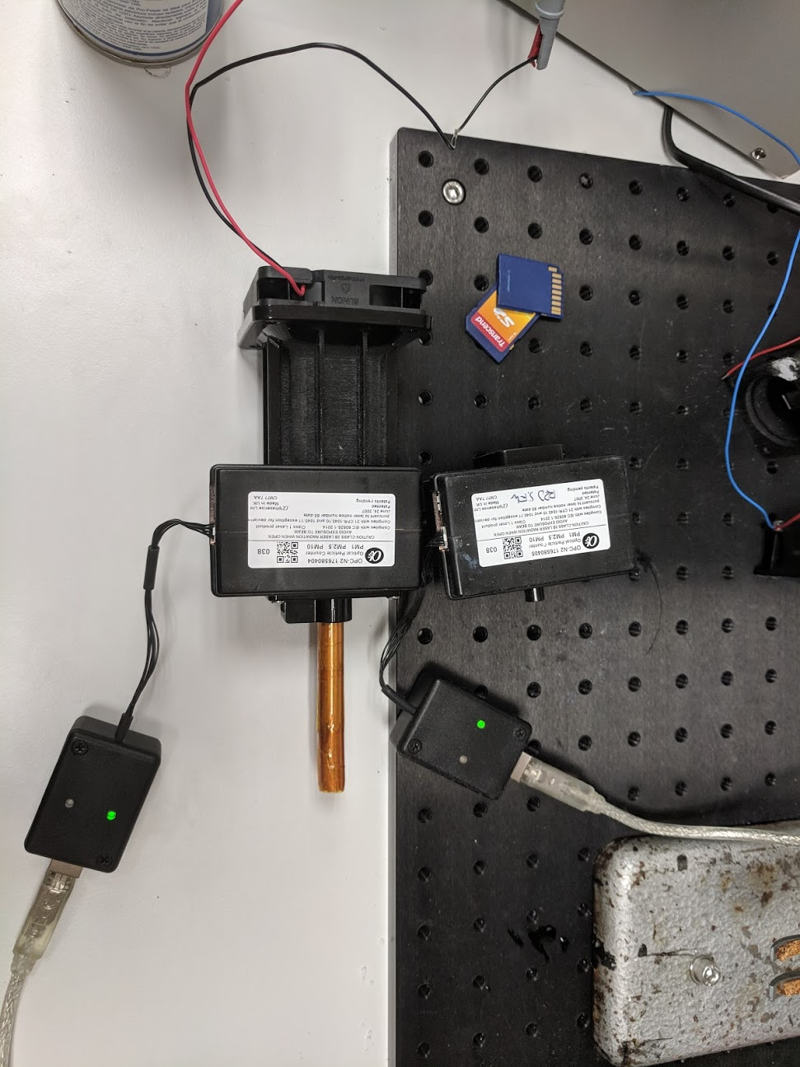

Test 1
- Both Alphasense units powered up
- Increasing fan voltage in increments of 0.25 V every 10 loops
- Holding voltage at max (10 V) once its reached
- Filename AlphasenseData_26072018_1.csv
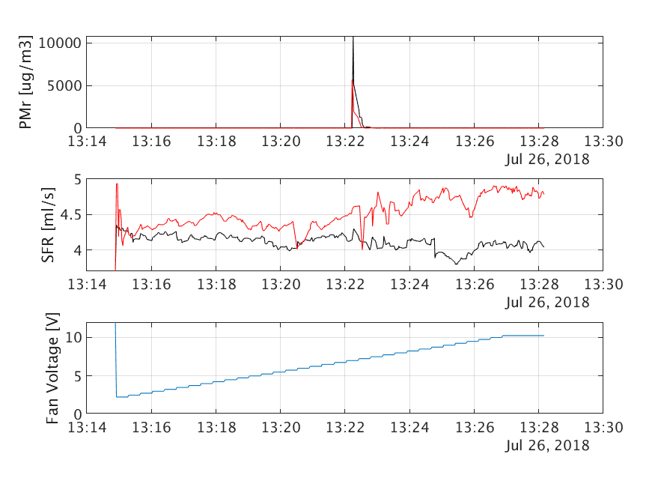
- Rolling average with 20 point window

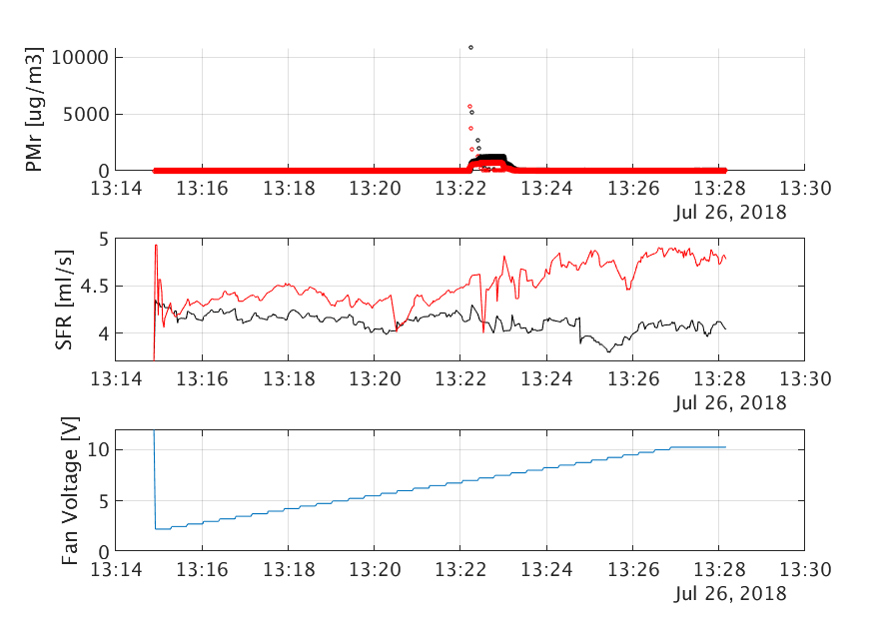
Test 2
- Made the unit so that the fan resets back to zero and ramps again
- Filename AlphasenseData_26072018_2.csv
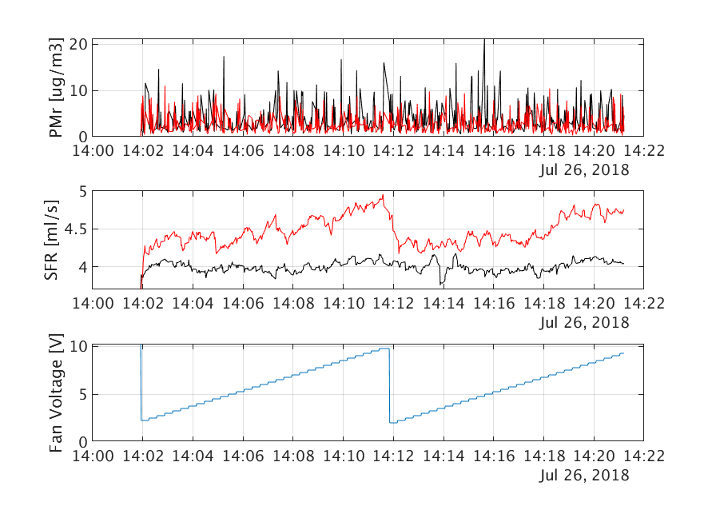
  - Added a rolling average over the Pmr window is 20 points

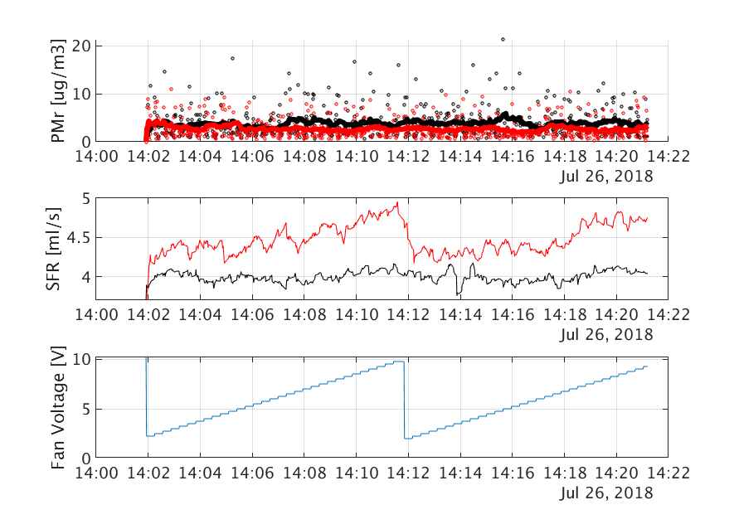

Test 3
- Decided to increase the wait time at each voltage step.
- Test crashed

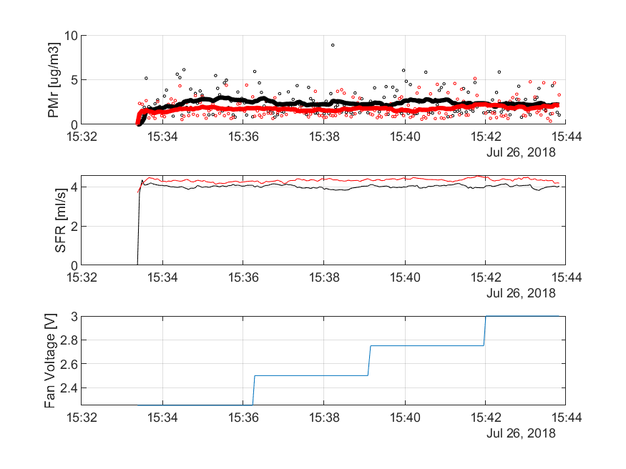

30-July-2017 - Sunon Fan test 1

Test 4

