**Installation Instructions:**

1. Download the archived project (file should be named “Team-A1-SER-225-Game.zip”). Unzip the archive folder and extract the contents to wherever you plan to store the game files.
   1. Make sure that extracting the files gives a folder called “Team-A1-SER-225-Game” and does not put all the contents of the project in the folder you extracted to. If this happens, create a new folder called “Team-A1-SER-225-Game” and place all the newly extracted files into this folder.
2. Launch Eclipse and select a workspace to add this project into.
   1. If you do not wish to add this to a previous workspace, you can create a new one to store the project.
3. With your new workspace, select “File” from the top ribbon, then select “Import”.

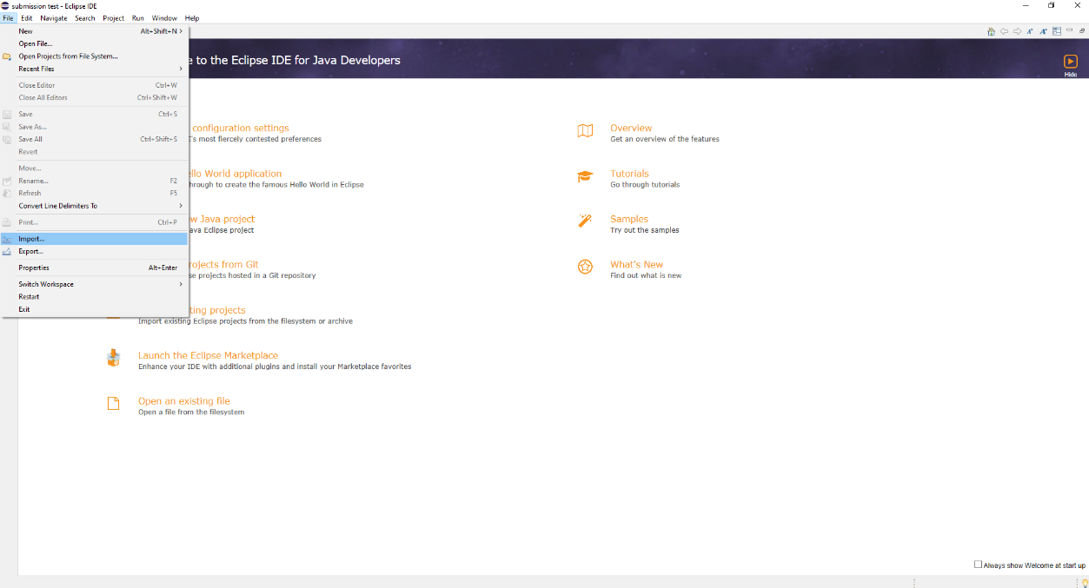

1. In the Import window, expand the option “General” and select “Projects from Folder or Archive”.

1. Select “Directory…” and then choose the new folder you created called “Team-A1-SER-225-Game”.

1. Press “Finish” and the project should appear in the Package Explorer. To test the game, navigate to the Game.java class in the src folder under the Game package. Running this class should launch the game.