Path of Ambition
Webapp Data Architecture & Content Mapping

Developer handoff document for site structure, dataset relationships, and content ownership.

8 JSON files  Core content sets | 9 in rules_sections  Top rule sections | 13 origins · 12 professions · 175 spells  Primary entities

Document intent
- Provide a build-ready map of how each JSON dataset relates to the site information architecture.
- Clarify where content belongs in the UI so a developer can implement pages, routes, search, and cross-linking without reinterpreting the booklet.
- Define which datasets are canonical and where duplicated or embedded content should be treated as grants, previews, or cross-references rather than source-of-truth records.

1. Product Goal and Site Information Architecture
The site should function as a hybrid between a dense tabletop rules compendium and a modern fantasy web experience. The home page acts as a table-of-contents gateway, while deeper pages behave like searchable tools and reference pages.
Primary top-level site sections
Site Area | Primary Data Owner | Purpose
Home | Landing page / table of contents | Route cards into Rules, Adventurer, Feats, Spells, and Items.
Rules Overview | rules_sections.json | Booklet-derived reference content, system overview, combat rules, actions, equipment systems, and keeper guidance.
Adventurer | origin_data.json + profession_data.json | Detailed character-creation and starting feature content for Origins, Vocations, and Professions.
Feats | origin_feats.json + profession_feats.json | All progression feats gained after character creation, grouped by source owner and tier.
Spells | spell_data.json | Global spell compendium with filtering by tier, school, source, range, duration, and tags.
Items | equipment_data.json | Weapons, armor, shields, kits, masterwork rules, augments, and recovery/inventory subsystems.

Navigation rule for Actions
- Actions should live under Rules rather than as a primary top-level content family.
- Add a persistent quick-access navigation entry in the main nav or omni-menu that jumps directly to action groups and/or the Rules → Actions anchor.
- Recommended quick-access groups: Offensive, Maneuver, Utility Actions, General Actions, Narrative Actions, Passive, Triggers.

Technical Foundation
The project will be built using Next.js to handle routing and server-side rendering for the rules compendium. The developer will handle all data ingestion and placement into the UI; no automated content pipeline is assumed for initial launch.
User Persistence
For the initial launch, user data and favorites should be cached locally on the browser using LocalStorage. A full user login or authentication system is not required at this stage. LocalStorage should store user preferences, bookmarked entities, and any other lightweight personalization data. This approach keeps the architecture simple while still delivering a personalized browsing experience without server-side accounts.

2. Dataset Inventory and Ownership
The build should treat each JSON file as a domain dataset. The table below identifies its canonical purpose, the entity types it owns, and where it should be surfaced in the site.
Dataset | Approx. Size | Canonical Domain | Primary Site Area | Notes
rules_sections.json | 9 top-level sections | Narrative/manual content | Rules Overview | Anchorable reading experience; not the primary source for spells, feats, or items.
actions_data.json | 7 groups / 35 actions | Combat and utility actions | Rules Overview + quick nav | Action groups, AP cost, requirements, outcomes.
origin_data.json | 13 origins / 39 vocations | Character creation: Origins | Adventurer | Owns origin packs, vocation attribute bonuses, and starting origin features.
origin_feats.json | 49 feats | Origin progression feats | Feats | Tiered feats keyed by origin owner; includes a Universal bucket.
profession_data.json | 12 professions / 39 base features | Character creation: Professions | Adventurer | Owns starting features, path options, packs, proficiencies, and some embedded spellcasting/cantrip grants.
profession_feats.json | 213 feats | Profession/path progression feats | Feats | Tiered feats keyed by profession owner; tags usually indicate class-wide or path-specific feat families.
spell_data.json | 175 spell rows | Spell compendium | Spells | Primary spell records by tier; also contains cantrips and some reference-only rows.
equipment_data.json | 31 weapons / 22 kits | Items and equipment systems | Items + Rules | Owns both item entities and rules subsystems such as recovery, inventory, augments, ammunition, and quality.

3. Cross-Dataset Relationship Map
The site should use a content graph rather than isolated pages. The goal is that rules, entities, and progression content can all resolve to each other through stable IDs/slugs and named references.
Recommended relationship model
- rules_sections → references actions, items, origins, professions, feats, and spells through links and summary cards.
- origin_data → owns Origins; each Origin owns multiple Vocations; each Vocation may own one or more starting features.
- origin_feats → extends origin_data; each feat belongs to one Origin owner (or Universal) and one Tier bucket.
- profession_data → owns Professions; each Profession owns starting features, packs, proficiencies, and two named path options.
- profession_feats → extends profession_data; each feat belongs to one Profession owner, one Tier bucket, and often one path tag such as Alchemist, Infiltrator, Herald, or Vanguard.
- spell_data → is the canonical spell catalog; profession/origin records may grant spells or cantrips, but those grants should point back to spell records whenever possible.
- equipment_data → owns both entity lists (weapons, kits, shields, armor types) and rules systems used by other entities such as Catalyst, Brace, Light, Heavy, Reload, and augment behavior.
- actions_data → is a shared rules utility dataset used by Rules pages and by any feat, equipment, or spell page that references an action by name.
Recommended entity registry
Entity Type | Suggested Route Pattern | Notes
rule_section | rules/{section_slug} | Top-level or child narrative pages from rules_sections.
action_group | rules/actions#{group_slug} | Anchored quick links for grouped action references.
action | rules/actions/{action_slug} | Optional dedicated action detail pages.
origin | adventurer/origins/{origin_slug} | Origin landing page with vocation cards and linked feat progression.
vocation | adventurer/origins/{origin_slug}/{vocation_slug} | Optional deep page; can also render in-page tabs.
origin_feat | feats/origins/{origin_slug}/{feat_slug} | Progression feat record.
profession | adventurer/professions/{profession_slug} | Profession landing page with starting kit, features, and path overview.
profession_feat | feats/professions/{profession_slug}/{feat_slug} | Progression feat record, optionally filtered by path tag.
spell | spells/{spell_slug} | Canonical spell detail page.
item | items/{item_slug} | Canonical item detail page for weapon / kit / shield / armor / trait or rule article.

4. Page-by-Page Data Mapping
Home / Table of Contents
- Uses rules_sections.json for the core high-level chapter list and summaries.
- Uses site metadata plus curated feature panels to lead users into Rules Overview, Adventurer, Feats, Spells, and Items.
- Should visually lean cinematic and atmospheric, not encyclopedic.
Rules Overview
- Primary source: rules_sections.json.
- Embed or cross-link action_groups from actions_data.json for Combat and Actions topics.
- Cross-link equipment subsystems from equipment_data.json for inventory, recovery, armor, shields, augments, and item traits.
- Cross-link into spells and class pages when the rule text references them.
Adventurer
- Primary sources: origin_data.json and profession_data.json.
- Origins page should support an Origin → Vocation drill-down, because vocation attribute bonuses and starting features are nested beneath the origin.
- Professions page should surface class fantasy, base stats, proficiencies, path options, starting packs, and starting features.
- Character-creation pages should cross-link directly to follow-on progression content in the Feats section.
Feats
- Primary sources: origin_feats.json and profession_feats.json.
- The UI should merge both datasets into a unified feat browser with filters for owner type, owner name, tier, path tag, trait type, AP cost, and prerequisites.
- Every feat page should link back to its parent Origin or Profession page.
- Origin and Profession pages should show feat preview cards filtered from these datasets.
Spells
- Primary source: spell_data.json.
- Global spell browser should filter by tier, school, source, range, duration, area, and cantrip status.
- Profession and origin pages should display spell grants as linked references into this compendium rather than duplicate full spell definitions whenever a canonical spell record exists.
Items
- Primary source: equipment_data.json.
- Implement both entity pages (weapons, kits, armor, shields, traits) and article-style rules sections (recovery, ammunition, augments, masterwork, inventory).
- Profession and feat pages can link into item traits, kits, shields, armor categories, and weapon groups.
Site ownership matrix
Page | Owned Data | High-value Cross-links
Rules Overview | rules_sections, actions, equipment rules | Actions, item traits, spellcasting overview, progression overviews
Adventurer | origins, professions | Origin feats, profession feats, granted spells/cantrips, starting packs
Feats | origin_feats, profession_feats | Origins, professions, actions, spells, items
Spells | spell_data | Profession/origin grants, rules spellcasting pages
Items | equipment_data | Profession packs, feats that modify kits, armor, augments, or weapon behavior

5. Object-Level Mapping Rules
The following implementation rules prevent the same concept from being stored or rendered as multiple conflicting records.
Concept | Canonical Ownership Rule
Origin vs Origin Feat | origin_data owns creation-time content. origin_feats owns progression-time content after character creation.
Profession vs Profession Feat | profession_data owns base class package content. profession_feats owns post-creation progression feats and path investment.
Embedded spell grants | If a profession or vocation feature grants a spell/cantrip, store the grant on that feature but resolve display to spell_data when a matching spell slug exists.
Actions | Do not duplicate action definitions inside feats. Instead, feats should reference an action name or action slug when they alter an existing action.
Equipment systems | Recovery, inventory, masterwork, ammunition, and augment rules belong to equipment_data but should render in both Items and relevant Rules pages.
rules_sections | Use rules_sections for reading flow, summaries, and chapter structure. Avoid re-entering entity-level data here if it already lives in a dedicated dataset.

Recommended foreign-key / slug strategy
- Every renderable record should get a stable slug: origin_slug, vocation_slug, profession_slug, feat_slug, spell_slug, action_slug, item_slug.
- Feat rows should include owner_type + owner_slug + tier + feat_slug.
- Vocations should include origin_slug so they are addressable as nested content.
- Spell grants inside professions/origins/feats should store spell_ref = spell_slug where possible, and fall back to inline-grant rendering only when no canonical spell row exists.
- Action alterations should use action_ref = action_slug whenever a feat explicitly modifies Weapon Strike, Dash, Hide, Dodge, Cast a Spell, and so on.
- In the Next.js build, all slugs must be resolvable at build time using the JSON datasets as the canonical source of truth. Unresolved slug references will cause broken links or 404 pages during static generation. All cross-dataset relationships — including spell grants from professions/origins and action alterations from feats — must be validated against the slug registry before the build completes.
6. Known Data Caveats to Handle in the Build
Issue | Observed Pattern | Build Rule
Origins mismatch | origin_data includes Nomad, while the booklet wording includes Hunter; origin_feats lacks Apprentice and includes Universal. | Developer should treat the uploaded JSON as the canonical source of truth for the Next.js application schema. Preserve a data-quality checklist for reconciliation, and ensure any unresolved origin or feat references are flagged before static build generation to prevent broken links.
Spell source field naming | In spell_data, the field named 'spheres' is functioning as the source list for many rows (e.g., Anima, Mana, Primeval, Soul). | Normalize to 'sources' in the application schema and reserve 'school' for Aberration / Augmentation / etc.
Reference-only cantrip rows | spell_data contains malformed or reference-only cantrip records used as embedded grants. | Flag these as non-canonical or hide them from public spell listings unless resolved.
Embedded cantrip definitions | profession_data and some origin/profession features embed cantrip text directly. | Treat these as grants or local overrides, not the first-choice spell source of truth.
Trait/cost formatting variance | Feat records mix passive/offensive/narrative/maneuver values and cost formatting in raw_markdown-derived fields. | Normalize activation, cost, and trait arrays during ingestion.

Current mismatch checklist
- Origins without a matching feat bucket: Apprentice.
- Feat owners without a matching origin record: Universal.
- Origins present in JSON but not in booklet wording: Nomad.
- Origins present in booklet wording but not in JSON: Hunter.

7. Search, Linking, and UI Behavior
Recommended user experience model
- Global omni-search across all entities and rules chapters, similar to tool-first reference sites.
- Persistent left-side content explorer on interior pages for dense navigation, with a cleaner cinematic landing page on Home.
- Sticky page-local filters on Feats, Spells, and Items pages.
- Backlinks on entity pages: 'Referenced in Rules', 'Granted by', 'Modified by', or 'Related Actions'.
Suggested quick-access menus
- Actions quick menu: anchor links to Offensive, Maneuver, Utility, General, Narrative, Passive, and Triggers.
- Adventurer quick menu: Origins, Vocations, Professions, Paths, Starting Packs.
- Spell quick filters: Tier, School, Source, Cantrip, Range, Duration.
- Items quick filters: Weapon Group, Damage Type, Range Band, Trait, Armor Type, Kit Category.
Search Error Handling
The global omni-search must implement a defined fallback state for zero-result queries. If a search query or applied filter combination returns no matching results, the UI must display the base fallback message: “search option not found.” This message should appear in place of the results list and must be consistent across all search surfaces — global omni-search, page-local filters on Feats, Spells, and Items — to prevent empty or broken-looking UI states.
Mobile and Responsive Behavior (Phase 5)
The advanced mobile/responsive behavior introduced in Phase 5 should specifically utilize card-based layouts throughout the compendium pages. Card-based layouts ensure that dense data — such as feat tables, spell listings, and item inventories — remains readable and navigable on smaller screens. Each entity (feat, spell, action, item) should collapse into a self-contained card with key attributes visible at a glance, replacing table rows where tables would overflow on narrow viewports.
8. Visual Design Direction
The site aesthetic should merge the dense, tool-like usability of 5e.tools / pf2e-style references with the cinematic, atmospheric framing shown in the fantasy landing-page references you supplied.
Design Axis | Direction
Density model | Tool-first interiors with searchable tables, filters, sticky navigation, and compact cards.
Atmosphere model | Hero sections, dark textured backgrounds, muted gold highlights, deep green/teal surfaces, and restrained fantasy ornament.
Theme support | Dual Dark Mode and Light Mode required. Both themes must be fully specified via design tokens. Dark Mode uses deep green/charcoal surfaces with muted gold accents. Light Mode uses warm off-white/parchment surfaces with the same muted gold accent family. All color values must be defined for both themes.
Iconography | Use Game-icons.net assets, provided as ZIP files containing icon versions for both Dark Mode and Light Mode. The developer should load the appropriate icon set based on the active theme. Do not substitute other icon libraries for the core compendium iconography.
Typography | Serif display face for hero headers and chapter titles (cinematic atmosphere); modern sans-serif for body text and all functional UI components (scannability). This split is mandatory: serif for impact, sans-serif for usability.
Layout split | Home page can be more cinematic; interior compendium pages should prioritize speed, scannability, and information density.
UI character | Modern/fantasy, not medieval pastiche. Clean surfaces, thin borders, glowing accents, subtle map/topography motifs, and elegant iconography.

Design token suggestion
- Dark Mode tokens: Background: deep green (#17352E) / charcoal. Primary accent: muted gold (#C9A84C). Secondary accent: cool teal / slate. Surface: dark charcoal with subtle texture.
- Light Mode tokens: Background: warm off-white / parchment. Primary accent: muted gold (same family, slightly deeper for contrast on light surfaces). Secondary accent: muted teal / sage. Surface: light stone or linen tones.
- Muted gold accent is shared across both themes and must remain consistent as the primary brand accent in all interactive elements, highlights, and headings.
- Use thin border lines and icon cards to echo tool-site layouts.
- Use fantasy motifs as texture and framing, not as heavy decorative clutter.

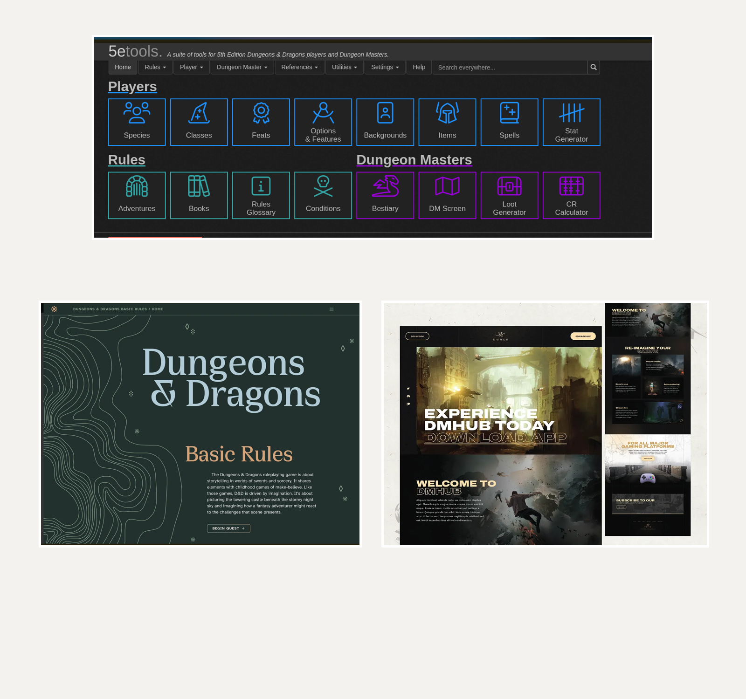
Reference board — utility-density, atmospheric fantasy framing, and cinematic promotional composition.
- Reference A informs interior navigation density and card-based tool layout.
- Reference B informs hero typography, map-line motifs, and mood.
- Reference C informs cinematic art treatment and modern section composition.
9. Recommended Implementation Order
Phase | Priority | Outcome
Phase 1 | Content ingestion + normalized schema layer | Create the canonical app schema, slug generation, link resolution, and search index.
Phase 2 | Rules + Adventurer pages | Implement Rules Overview, Origins, Vocations, and Professions with cross-links and starting feature rendering.
Phase 3 | Feats browser | Merge origin and profession feats into one filtered browser with owner grouping and path filtering.
Phase 4 | Spells + Items compendiums | Ship the global spell browser and items browser with quick filters and deep links.
Phase 5 | Polish | Add cinematic home page, richer search, backlinks, and advanced mobile/responsive behavior.

The critical architectural decision is to separate narrative chapter content from entity compendium content. That keeps the site maintainable, searchable, and easy to extend later into builders, printable sheets, or encounter tools.

