Docker Compose Images:

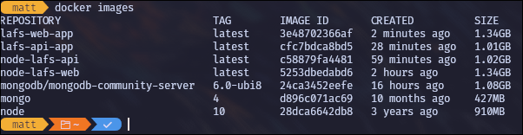

LoopBack Explorer adding new question:

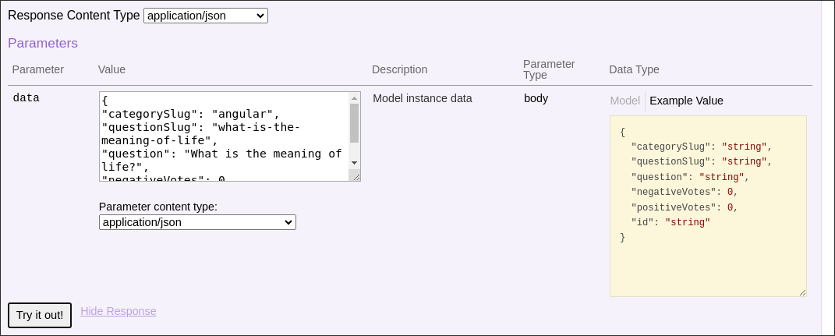

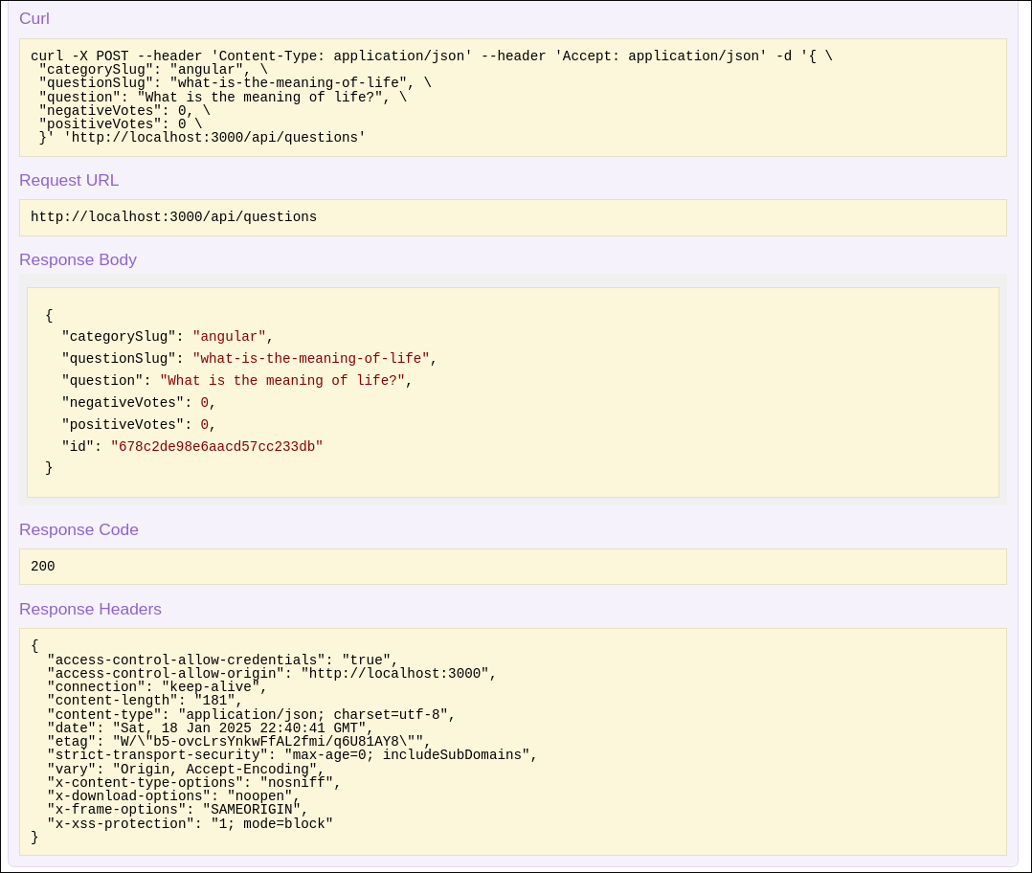

Angular frontend view of new question:  
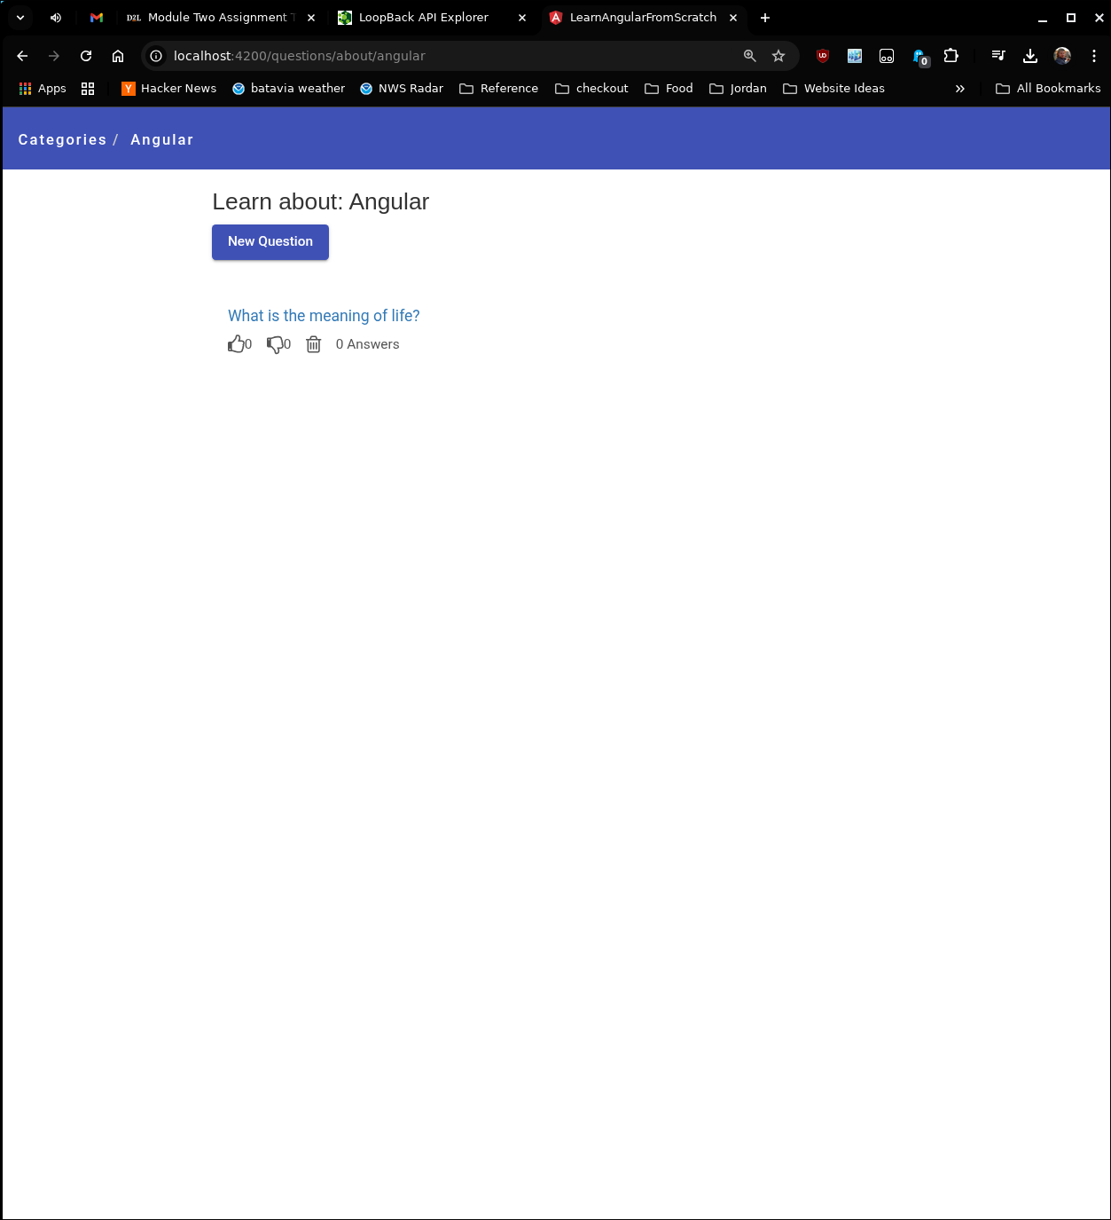

MongoDB showing question collection:



Docker ps -a:

