First serverless compute function

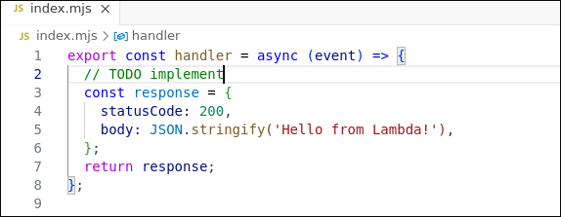

Execution results

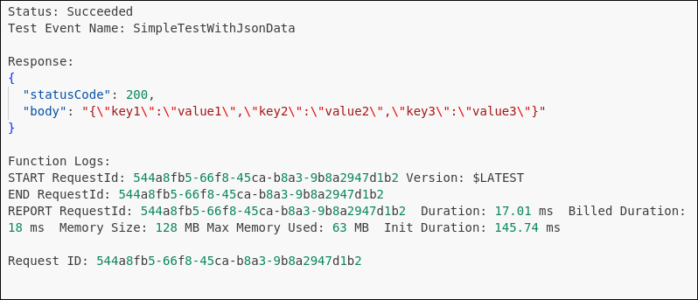

EchoWithQuery execution results

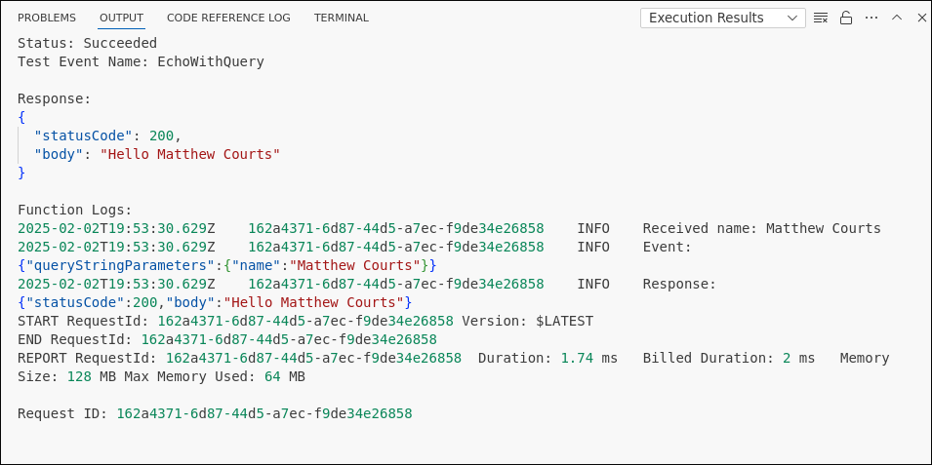

Screenshot or JSON for the created test event “EchoWithQuery”.

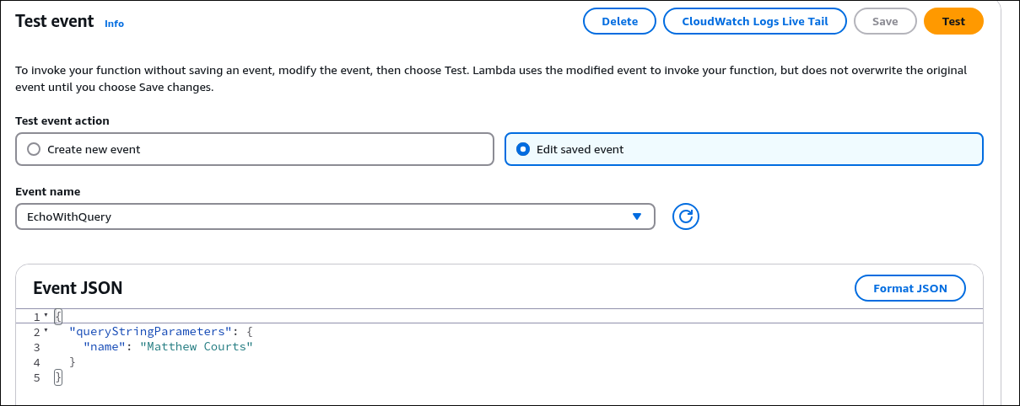

Source code or screenshot for index.js (about 22 lines of code), Also attached

