Screenshot of the GET method execution page

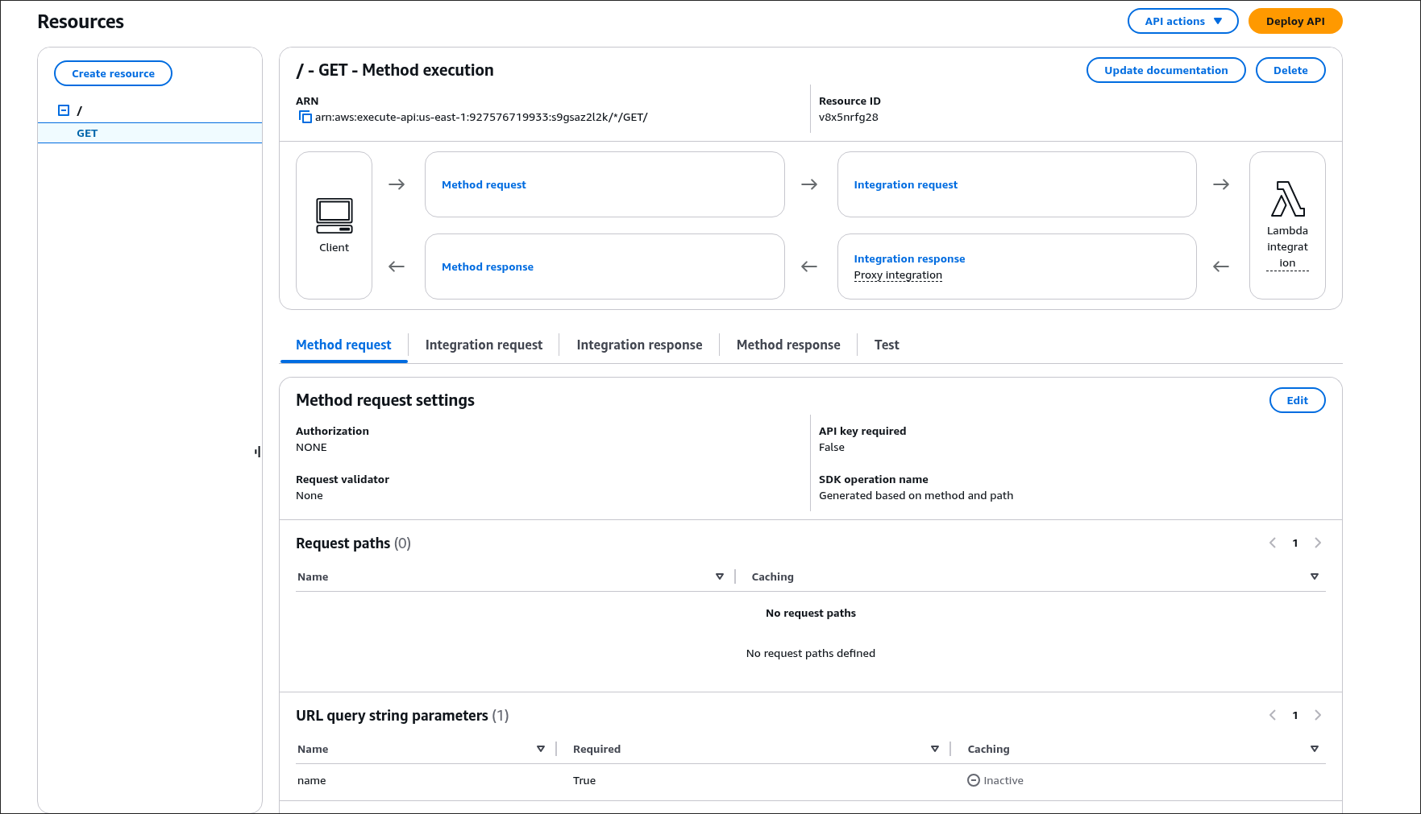

Screenshot of the GET test page

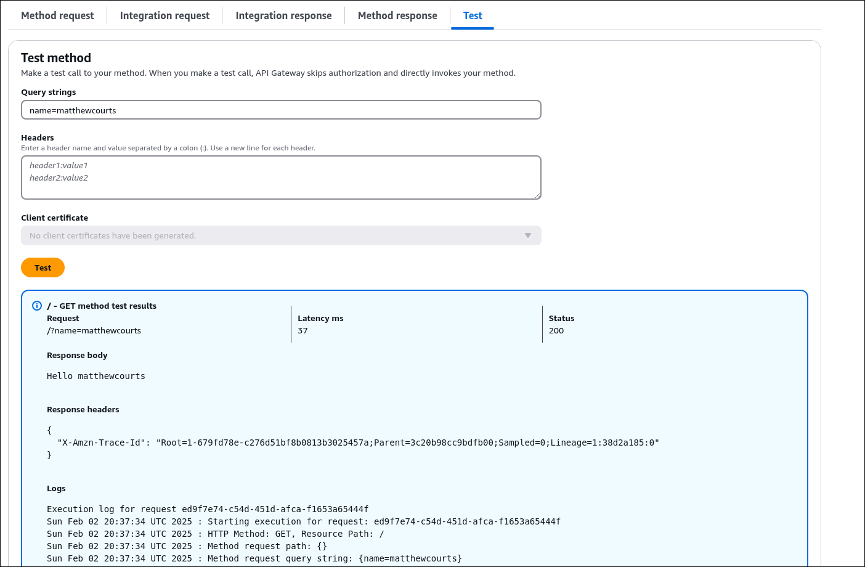

Screenshot of the browser running the URL

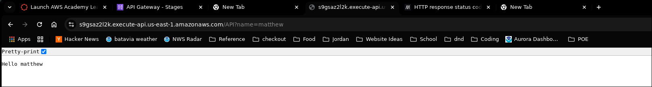

The invoke URL from your deployment

