1. Open MySQLWorkbench
2. Edit -> Preferences
   1. Open Modeling if it’s not expanded, choose MySQL
   2. If Default Target MySQL Version: is not set to 5.6, do so now. The reason this is necessary is that the Workbench version is higher and has functions built into it that will not work on the server we are accessing. Will cause errors when writing scripts.

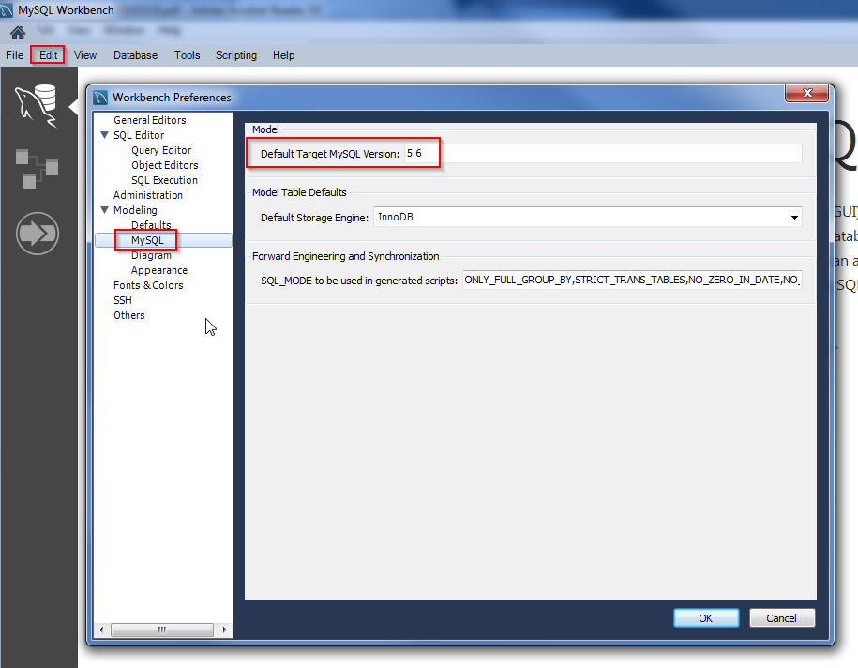

1. On the home screen, hit the plus next to MySQL Connections. This will allow us to connect the Workbench to the MySQL Server that houses all of the databases. These are hosted on the SC&I servers.  
   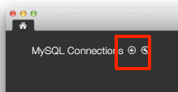 or 
2. Fill in the proper information on the form:

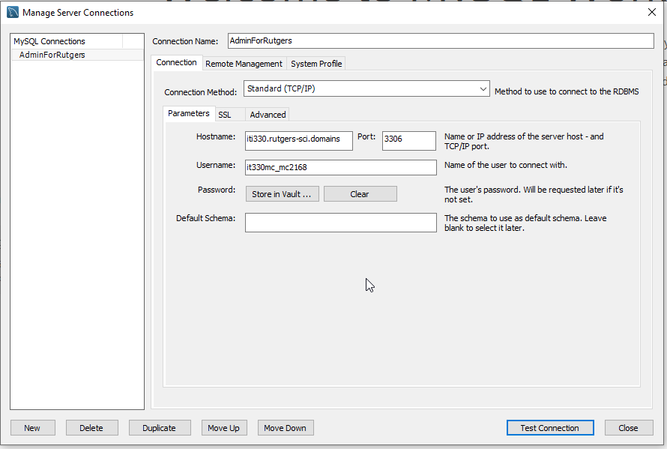

* 1. Connection Name: give it a name that tells where it’s connecting to. Helps when you have multiple connections to multiple servers. **Cannot have spaces in the name.** Use camelCase or underscores_to_name_it.
  2. Hostname: the address of the servers. **iti330.rutgers-sci.domains**
  3. Username: how you’ll identify yourself:
     1. it330mc + NetID
     2. **Ex: it330mc_FA20_abc1234** *(the underscores are important)*
     3. It is **it** 330, not **iti** 330

1. Hit the Test Connection button
2. You may see this when you connect, hit Connect Anyway:

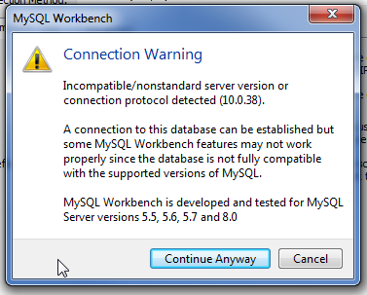

1. Enter your password: (your password is your **RUID** numeric an underscore and your **NetID**)  
   ex: **123456789_abc1234**  
   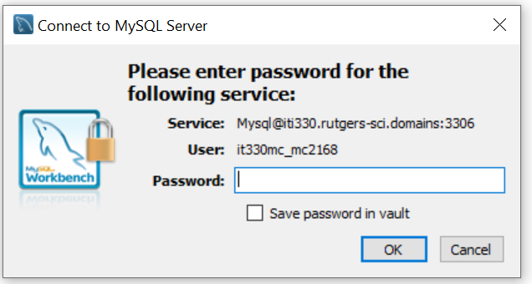
2. If this is your laptop, click Save password in vault and hit OK. Otherwise just hit OK.
3. You should see a Success message:  
   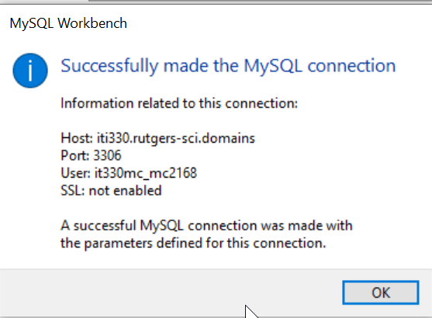
4. A new connection will appear on the Workbench main page:

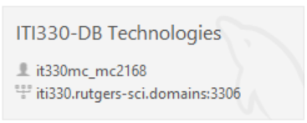

1. Click to establish connection to the database.