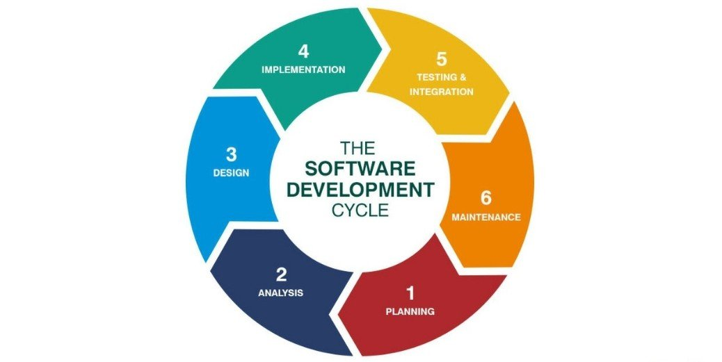

Steps

1.) Planning

2.) Analysis

3.) Design

4.) Implementation

5.) Testing & Integration

6.) Maintenance

Benefits

The life cycle is an iterative process which means each stage will be carried out multiple times and with each iteration the software is able to become even more developed. This gives the opportunity for customer testing during the development process and changes can be made easier. The product has the opportunity to be adjusted and made better after each iteration as ‘the model produces ongoing releases, each with small, incremental changes’ (Morris, 2018). If a client is not happy with a part of the project, this methodology does give them the chance to change their system requirements at a variety of different stages within the project.

Limitations

This methodology can take longer than the others due to testing and possibly changing the project at each iteration. This also creates a greater workload for developers, and you need to ensure you have good communication with your clients for this methodology to be successful. The documentation for a project created using the agile methodology can often be less detailed since it is likely that the project may change during the process of developing it so not everything can be documented straight away.

Suitability

This will be beneficial for our project as we meet with the client regularly so they can see each update, test it themselves and decide whether they are happy or would like something different.