Node-Red Flow – Remote Site

Figure – The whole Node-Red flow

Figure 1 shows the whole Node red flow. It mostly contains UI elements with followed by a function node to set a global variable to the user’s input. All the elements on the left side of the image are connected to one function node which is used to calculate the power and update the UI elements that the user can see. Lastly, there is a button labelled ‘Send immediate reading’ which will trigger the ‘Create JSON’ function node which will send a JSON object in an MQTT message. Otherwise, the ‘Create JSON’ function is triggered every minute.

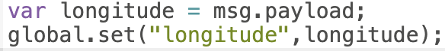

Figure – Function following a UI element

This is one of the functions that follows a UI input. It takes in the message payload and saves it to a global variable so it can be accessed later.

Figure – Central calculation node

This function is connected to each of the UI inputs and UI display elements. This function takes all of the necessary global variables to calculate the power output of the transmitter. This is done by calculating the temperature in and the temperature out then calculating the difference between the temperatures. Using the temperature difference multiply it by the flow rate and then multiply it by 0.007. Message values are then set to send out to the UI elements for the data to be displayed.

Figure – UI outputs

These UI elements reads the values of the message sent in figure 3 and displays them to the user.

Figure – Create JSON function node

This function node takes all the global variables and creates a JSON message using those variables. In addition, it takes a timestamp using DateTime. The message topic is then set to the site name and transmitter name and the message payload is assigned the JSON object.