Grafana set-up guide

# Adding a data source

1. Navigate to the data sources page and select the “Add data sources” button

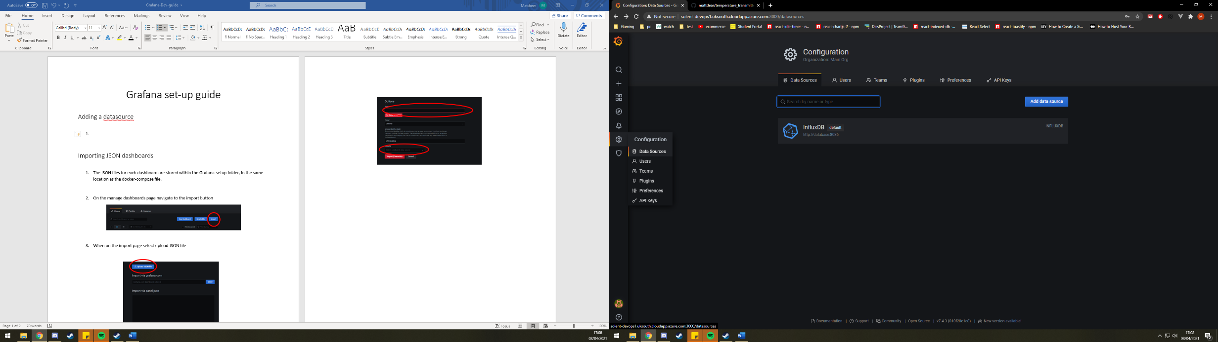

1. 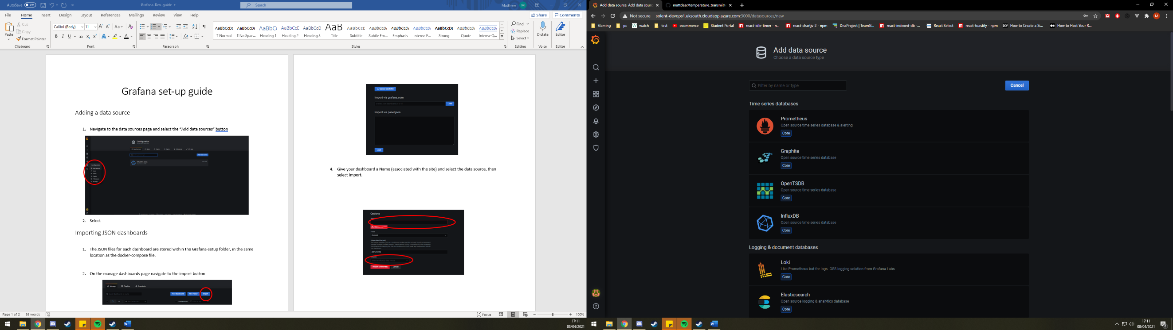Select influxDB
2. Fill in the InfluxDB Details to match the below screenshots.

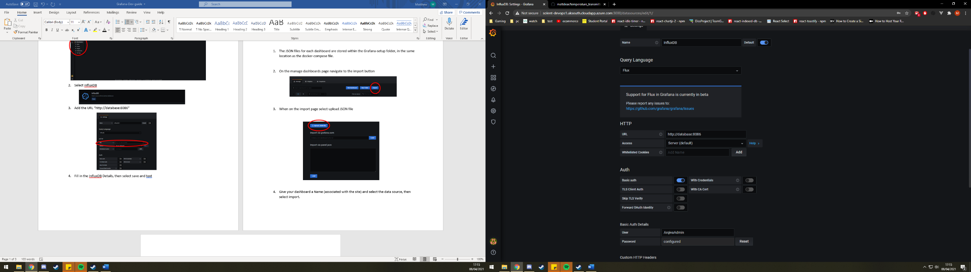

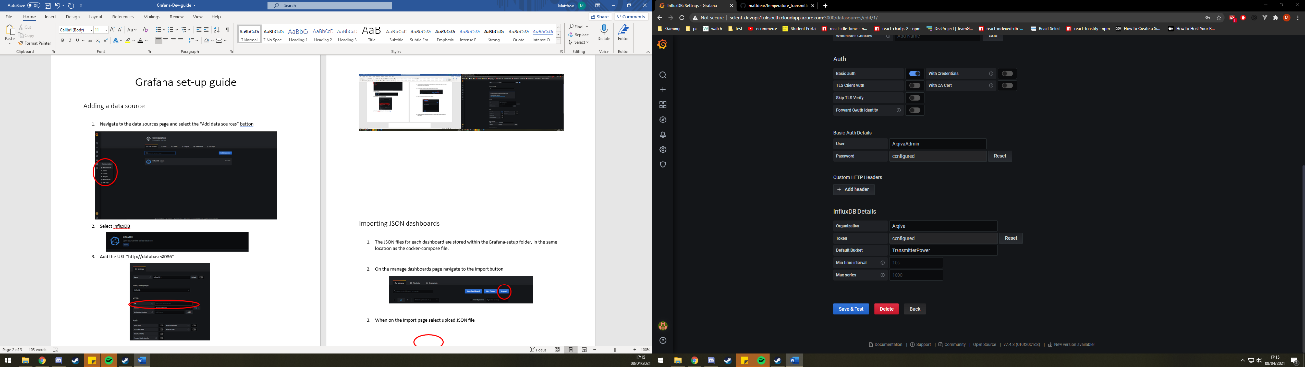

# Importing JSON dashboards

1. The JSON files for each dashboard are stored within the Grafana-setup folder, in the same location as the docker-compose file.
2. On the manage dashboards page navigate to the import button

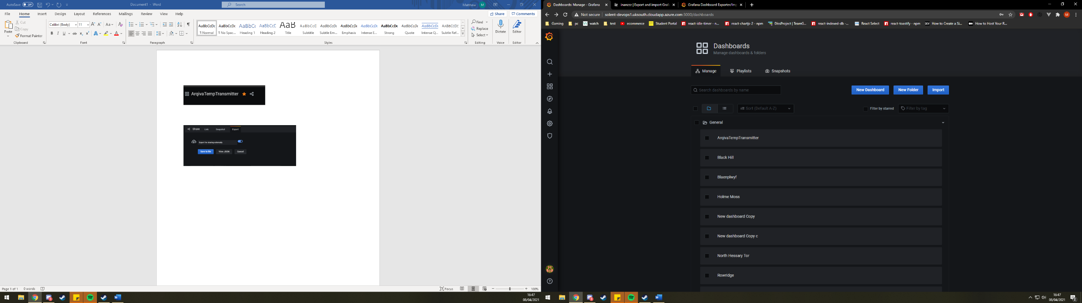

1. When on the import page select upload JSON file

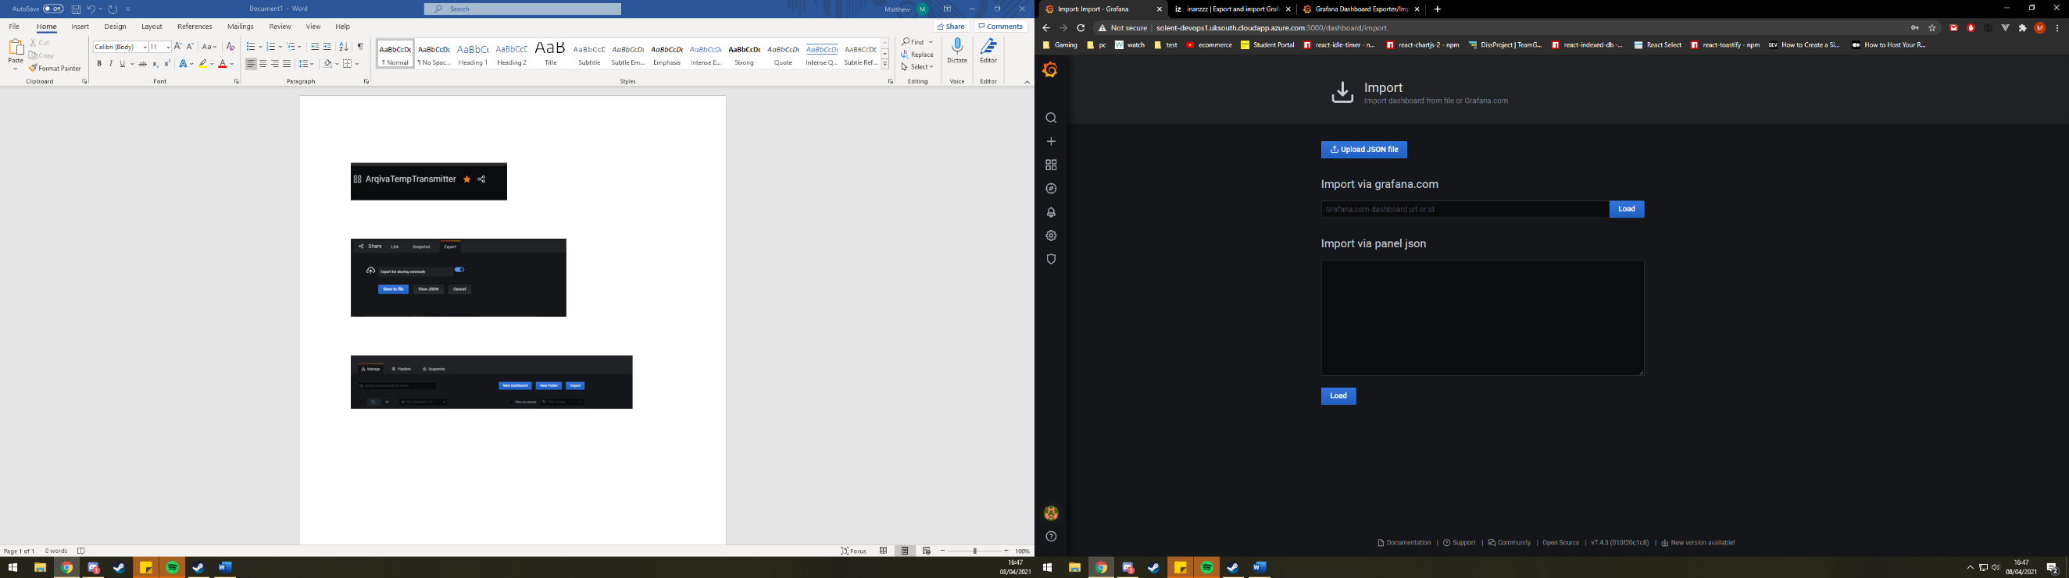

1. Give your dashboard a Name (associated with the site) and select the data source, then select import.

