RASP_Report_Prototype

Army Research Institute and Northrop Grumman

3/23/2020

## Individual Report for: A1000

### Personality

##### Personality: This graph displays results from the JPI-R Personality Test in **green bars**.

###### The **RED dots** represent the average of all Ranger Candidates.

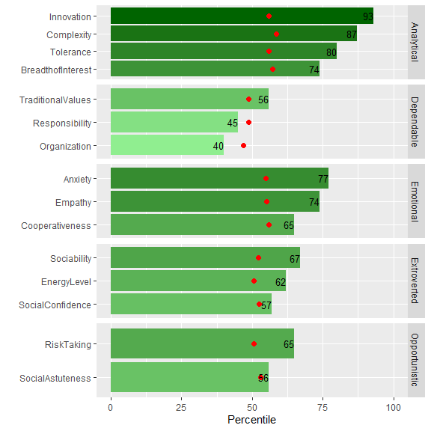

### Cognitive

##### Cognitive: This graph displays results from the MAB II Cognitive Test in **green bars**.

###### The **RED dots** represent the average of all Ranger Candidates.

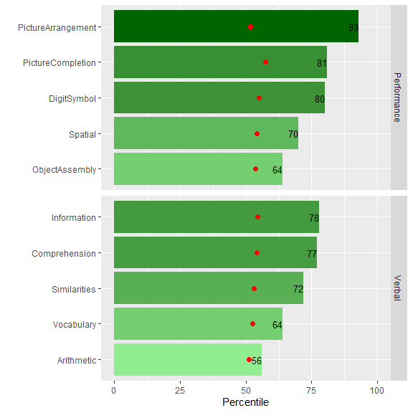

## Results from the Ranger Fit model for A1000.

###### Ranger Fit Scores are weighted scores based on multiple measures within each category (personality and cognitive). The objective score is 1.0. The dashed blue line represents a threshold Ranger fit score, above which suggests a good fit.

###### The **GREEN dots** represents the Ranger Fit Scores for **A1000** in each Category. The total RASP candidate distribution is displayed by the boxplot. This individual’s Ranger Fit Score ranks **10** of **100** in the RASP data repository.



 

