ICS 141 Programming with Objects
Program #6, 35 points
Due date: 4/28/2013
Name:

Goals: Understand how to do input and output using graphical user interfaces and Java applets.

Problem Description:
Create a store applet program with a graphical user interface that looks similar to this:

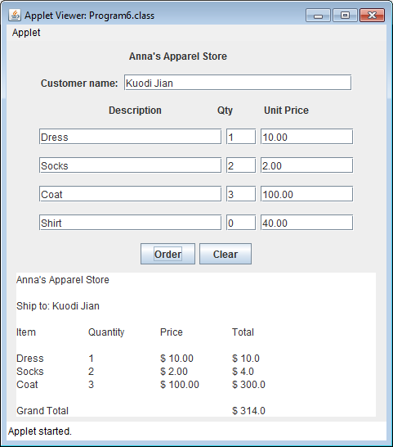

Your store must have a different name and sells four different items other than the sample items in the above diagram. The item names in the description column are fixed and users are not allowed to make changes (set the editable to false). Initially the quantity for each item should be set to 0. The user should be allowed to change the quantity of each item that they wish to purchase. The values in the Unit Price column are also fixed and users cannot change it. For each item, the unit price is determined by you for any reasonable value. The Order button should have the following behavior: once the user clicks the order button, your program should display the order line by line in the output text area. Along with the item description, quantity and unit price, display the line item total. Do not display information for any item the user has not ordered (where quantity is 0). At the end, display the grand total of all items purchased; the Clear button should have the following behavior: when the user clicks the clear button, customer name field should be cleared, all the quantity fields should be set to zeros, and the output text area should be cleared.

Design:
Start by drawing a picture of the screen with all its widgets and labels. Include the layout of the order that will be displayed in the text area at the bottom of the screen.

Implementation:
The beginning of a sample program is given below. You may use this working program as the basis for your own solution or you may take a different approach if you prefer.
The html file is also given to you. You may need it for testing the applet using web browser or using Applet viewer through TextPad. For Eclipse, it will run without the html file. In the following, we give you the contents of two files: The html file and the Program6 class file. These files are intended to help you get a quick start and you are free to make changes. In this initial working code, the layout needs improvement and some functionality is missing. Your tasks are to supply your Java code throughout this initial program to make the layout as shown above and to have functionality (including additional requirements) as specified in this documentation.

Html file:

<HTML>
<TITLE>
ICS 141 Assignment 6
</TITLE>
<BODY>
This web page has one java applet in it.
<br>
My name is: your name
<p>
<applet code = Program6.class width = 500 height = 500></applet>
<p>
copyright © 2009, metrostate university
</BODY>
</HTML>

The following is the initial partial Java program:

/* Partial solution to program #6
This program displays a menu of choices. User enters quantity and program reports total order.
*/

import java.applet.*;
import javax.swing.*;
import java.awt.event.*;
import java.awt.*;

public class Program6 extends JApplet implements ActionListener {
// Declare widgets, you need add/(delete) more widgets.
JLabel companyNameLabel;
JLabel customerNameLabel;
JLabel itemLabel;

JTextField itemField1;
JTextField qtyTextField1;
JTextField priceField1;
JButton orderButton;
JTextArea displayOrder;

JPanel compLabelPanel;
JPanel custNamePanel;
JPanel itemsLabelsPanel;
JPanel itemsPanel1;
JPanel itemsPanel2;
JPanel itemsPanel3;
JPanel itemsPanel4;
JPanel buttonPanel;

public void init() {

getContentPane().setLayout(new FlowLayout());

// Instantiate widgets and add them to the display window
itemField1 = new JTextField ("Dress", 20);
qtyTextField1 = new JTextField (3);
priceField1 = new JTextField ( "10.00", 10 );
getContentPane().add ( itemField1 );
getContentPane().add (qtyTextField1 );
getContentPane().add (priceField1);

orderButton = new JButton ( "Order" );
getContentPane().add ( orderButton );

displayOrder = new JTextArea ( 10, 40 );
getContentPane().add ( displayOrder );

// Listen for the button click
orderButton.addActionListener(this);
}

public void start() {
qtyTextField1.setText("0");
displayOrder.setText ("");
}

public void actionPerformed(ActionEvent event) {

Object sourceObject = event.getSource();
int qty;
double price;
double totalCost = 0;

// Did user click Order Button?
if (sourceObject == orderButton) {
String result = "";

// Retrieve quantity and price from input text fields
qty = Integer.parseInt (qtyTextField1.getText());
price = Double.parseDouble ( priceField1.getText());

// Create a string with the line item information
if (qty != 0)
result += itemField1.getText() + "\t" +
qtyTextField1.getText() +
"\t$ " + priceField1.getText() + "\t$ " +
qty * price + "\n";

// Display the string containing the line item info
displayOrder.setText ( result );
}
}
}

Additional Requirements:
To get full credits, you must satisfy all the following requirements besides the ones specified in the Problem Description.

1. Personalize your store. For this part, you need to satisfy the following two requirements:

1) put a company logo (must be constructed from an image file) on the upper left corner of your applet (you can use the Paint application that comes with the Window operating system to paint a logo and save it as either a gif or Jpeg file. You also need to find information in textbook or Internet on how to produce an image icon). The logo must be integrated into Java code (cannot be implemented with html code) and inserted at the upper left corner of the applet;
2) set the background color of the applet to a color that you like (the color cannot be gray).

2. The applet is laid out nicely and attractive.

Feel free to make the user interface as attractive and interesting as possible while retaining the functionality described above.

Score your points by finishing the following:

1. (6 pts) Paste your source code in the space below, your source code’s format and indentation will be checked.

package org.ics141.program6;

import java.awt.BorderLayout;
import java.awt.Color;
import java.awt.Container;
import java.awt.Dimension;
import java.awt.FlowLayout;
import java.awt.Font;
import java.awt.GridBagConstraints;
import java.awt.GridBagLayout;
import java.awt.event.ActionEvent;
import java.awt.event.ActionListener;

import javax.swing.BorderFactory;
import javax.swing.BoxLayout;
import javax.swing.ImageIcon;
import javax.swing.JApplet;
import javax.swing.JButton;
import javax.swing.JLabel;
import javax.swing.JPanel;
import javax.swing.JTextArea;
import javax.swing.JTextField;
import javax.swing.SwingConstants;

/**
* Your store must have
*
* a different name and sells four different items other than the sample items
* in the above diagram.
*
* The item names in the description column are fixed and users are not allowed
* to make changes (set the editable to false).
*
* Initially the quantity for each item should be set to 0. The user should be
* allowed to change the quantity of each item that they wish to purchase.
*
* The values in the Unit Price column are also fixed and users cannot change
* it.
*
* For each item, the unit price is determined by you for any reasonable value.
*
* The Order button should have the following behavior:
*
* once the user clicks the order button, your program should display the order
* line by line in the output text area. Along with the item description,
* quantity and unit price, display the line item total. Do not display
* information for any item the user has not ordered (where quantity is 0). At
* the end, display the grand total of all items purchased;
*
* the Clear button should have the following behavior:
*
* when the user clicks the clear button, customer name field should be cleared,
* all the quantity fields should be set to zeros, and the output text area
* should be cleared.
*
* @author mjdowell
*
*/
public class Program6 extends JApplet implements ActionListener {

// Company name and logo
JLabel companyNameLabel;
ImageIcon logo;

// Customer Name info
JLabel customerNameLabel;
JTextField customerNameField;

// Top level labels
JLabel descriptionLabel;
JLabel qtyLabel;
JLabel unitPrice;

// Product #1
JTextField itemField1;
JTextField qtyTextField1;
JTextField priceField1;

// Product #2
JTextField itemField2;
JTextField qtyTextField2;
JTextField priceField2;

// Product #3
JTextField itemField3;
JTextField qtyTextField3;
JTextField priceField3;

// Product #4
JTextField itemField4;
JTextField qtyTextField4;
JTextField priceField4;

// Buttons
JButton orderButton;
JButton clearButton;

// Order display
JTextArea displayOrder;

// Panels
JPanel mainPanel;
JPanel headerPanel;
JPanel itemLabelsPanel;
JPanel itemsPanel1;
JPanel itemsPanel2;
JPanel itemsPanel3;
JPanel itemsPanel4;
JPanel allItemsPanel;
JPanel buttonPanel;
JPanel summaryPanel;

/**
* 1) put a company logo (must be constructed from an image file) on the
* upper left corner of your applet (you can use the Paint application that
* comes with the Window operating system to paint a logo and save it as
* either a gif or Jpeg file. You also need to find information in textbook
* or Internet on how to produce an image icon). The logo must be integrated
* into Java code (cannot be implemented with html code) and inserted at the
* upper left corner of the applet;
*
* 2) set the background color of the applet to a color that you like (the
* color cannot be gray).
*/
public void init() {
getContentPane().setLayout(new FlowLayout());

initWidgets();
buildMainPanel(getContentPane());

getContentPane().add(mainPanel);

// Listen for the button click
orderButton.addActionListener(this);
clearButton.addActionListener(this);
}

/**
* This method init's the widgets. If we were building this for real, this
* information would be stored externally in a language specific Resource
* file.
*/
private void initWidgets() {

// First init the widgets
Font f = new Font("serif", Font.PLAIN, 32);
companyNameLabel = new JLabel("Matt's Merchandise");
companyNameLabel.setFont(f);
java.net.URL urlsmile = this.getClass().getResource("logo.png");
logo = new ImageIcon(urlsmile);

customerNameLabel = new JLabel("Customer name:");
customerNameLabel.setHorizontalAlignment(SwingConstants.RIGHT);
customerNameField = new JTextField("Matt Dowell", 20);
customerNameField.setPreferredSize(new Dimension(150, 25));

descriptionLabel = new JLabel(" Description");
descriptionLabel.setPreferredSize(new Dimension(220, 25));
qtyLabel = new JLabel("Qty");
unitPrice = new JLabel("Unit Price");
descriptionLabel.setHorizontalAlignment(SwingConstants.LEFT);
qtyLabel.setHorizontalAlignment(SwingConstants.CENTER);
unitPrice.setHorizontalAlignment(SwingConstants.RIGHT);

itemField1 = new JTextField("Sword", 28);
itemField1.setEditable(false);
qtyTextField1 = new JTextField("0", 3);
priceField1 = new JTextField("100.00", 10);
priceField1.setEditable(false);
priceField1.setHorizontalAlignment(SwingConstants.RIGHT);

itemField2 = new JTextField("Jayne Hat", 28);
itemField2.setEditable(false);
qtyTextField2 = new JTextField("0", 3);
priceField2 = new JTextField("6.00", 10);
priceField2.setEditable(false);
priceField2.setHorizontalAlignment(SwingConstants.RIGHT);

itemField3 = new JTextField("Serenity", 28);
itemField3.setEditable(false);
qtyTextField3 = new JTextField("0", 3);
priceField3 = new JTextField("850.00", 10);
priceField3.setEditable(false);
priceField3.setHorizontalAlignment(SwingConstants.RIGHT);

itemField4 = new JTextField("Firefly Poster", 28);
itemField4.setEditable(false);
qtyTextField4 = new JTextField("0", 3);
priceField4 = new JTextField("7.99", 10);
priceField4.setEditable(false);
priceField4.setHorizontalAlignment(SwingConstants.RIGHT);

orderButton = new JButton("Order");
clearButton = new JButton("Clear");

displayOrder = new JTextArea(10, 43);
}

/**
* Builds the main UI panel.
*/
private void buildMainPanel(Container pane) {

GridBagConstraints c = new GridBagConstraints();
mainPanel = new JPanel();
mainPanel.setLayout(new BorderLayout());

headerPanel = new JPanel();
headerPanel.setLayout(new BoxLayout(headerPanel, BoxLayout.Y_AXIS));

itemLabelsPanel = new JPanel();
itemLabelsPanel.setLayout(new BorderLayout());

itemsPanel1 = new JPanel();
itemsPanel2 = new JPanel();
itemsPanel3 = new JPanel();
itemsPanel4 = new JPanel();
allItemsPanel = new JPanel();
allItemsPanel.setLayout(new BoxLayout(allItemsPanel, BoxLayout.Y_AXIS));

buttonPanel = new JPanel();
summaryPanel = new JPanel();

mainPanel.setBackground(Color.WHITE);
headerPanel.setBackground(Color.WHITE);
allItemsPanel.setBackground(Color.WHITE);
buttonPanel.setBackground(Color.WHITE);
summaryPanel.setBackground(Color.WHITE);
itemsPanel1.setBackground(Color.WHITE);
itemsPanel2.setBackground(Color.WHITE);
itemsPanel3.setBackground(Color.WHITE);
itemsPanel4.setBackground(Color.WHITE);
itemLabelsPanel.setBackground(Color.WHITE);
JPanel compInfoPanel = new JPanel(new BorderLayout());
JPanel custNamePanel = new JPanel();
compInfoPanel.setBackground(Color.WHITE);
custNamePanel.setBackground(Color.WHITE);

// Build the company logo / name row
JLabel picLabel = new JLabel(logo);
picLabel.setPreferredSize(new Dimension(170, 95));
compInfoPanel.add(picLabel, BorderLayout.WEST);
compInfoPanel.add(companyNameLabel, BorderLayout.CENTER);
headerPanel.add(compInfoPanel);

// Build the customer name row
custNamePanel.add(customerNameLabel);
custNamePanel.add(customerNameField);

headerPanel.add(custNamePanel);
// headerPanel.setPreferredSize(new Dimension(400, 80));
mainPanel.add(headerPanel, BorderLayout.NORTH);

// The item labels and items should be in a panel by themselves
itemLabelsPanel.setLayout(new GridBagLayout());

c.fill = GridBagConstraints.HORIZONTAL;
c.weightx = 0.5;
c.gridx = 1;
c.gridy = 0;
itemLabelsPanel.add(descriptionLabel, c);

c.fill = GridBagConstraints.HORIZONTAL;
c.weightx = .5;
c.gridx = 2;
c.gridy = 0;
itemLabelsPanel.add(qtyLabel, c);

c.fill = GridBagConstraints.HORIZONTAL;
c.weightx = 0.5;
c.gridx = 3;
c.gridy = 0;
itemLabelsPanel.add(unitPrice, c);
// itemLabelsPanel.setBorder(BorderFactory.createLineBorder(Color.black));

itemsPanel1.add(itemField1);
itemsPanel1.add(qtyTextField1);
itemsPanel1.add(priceField1);

itemsPanel2.add(itemField2);
itemsPanel2.add(qtyTextField2);
itemsPanel2.add(priceField2);

itemsPanel3.add(itemField3);
itemsPanel3.add(qtyTextField3);
itemsPanel3.add(priceField3);

itemsPanel4.add(itemField4);
itemsPanel4.add(qtyTextField4);
itemsPanel4.add(priceField4);

buttonPanel.add(orderButton);
buttonPanel.add(clearButton);

allItemsPanel.add(itemLabelsPanel);
allItemsPanel.add(itemsPanel1);
allItemsPanel.add(itemsPanel2);
allItemsPanel.add(itemsPanel3);
allItemsPanel.add(itemsPanel4);
allItemsPanel.add(buttonPanel);
mainPanel.add(allItemsPanel, BorderLayout.CENTER);

summaryPanel.add(displayOrder);
summaryPanel.setBorder(BorderFactory.createLineBorder(Color.gray));
mainPanel.add(summaryPanel, BorderLayout.SOUTH);

mainPanel.setBackground(Color.WHITE);
}

public void start() {
}

/**
* once the user clicks the order button, your program should display the
* order line by line in the output text area. Along with the item
* description, quantity and unit price, display the line item total. Do not
* display information for any item the user has not ordered (where quantity
* is 0). At the end, display the grand total of all items purchased;
*
* when the user clicks the clear button, customer name field should be
* cleared, all the quantity fields should be set to zeros, and the output
* text area should be cleared.
*/
public void actionPerformed(ActionEvent event) {
Object sourceObject = event.getSource();
int qty;

// Did the user click Order Button?
if (sourceObject == orderButton) {
StringBuilder summaryText = new StringBuilder("Below is the order summary for customer: " + customerNameField.getText() + "\n\n");
summaryText.append("Item\tQty\tUnit Price\tItem Total\n\n");
double totalCost = 0;
qty = Integer.parseInt(qtyTextField1.getText());
if (qty > 0) {
summaryText.append(buildOrderSummary(itemField1, qtyTextField1, priceField1));
totalCost += getLineItemTotal(qtyTextField1, priceField1);
}
qty = Integer.parseInt(qtyTextField2.getText());
if (qty > 0) {
summaryText.append(buildOrderSummary(itemField2, qtyTextField2, priceField2));
totalCost += getLineItemTotal(qtyTextField2, priceField2);
}
qty = Integer.parseInt(qtyTextField3.getText());
if (qty > 0) {
summaryText.append(buildOrderSummary(itemField3, qtyTextField3, priceField3));
totalCost += getLineItemTotal(qtyTextField3, priceField3);
}
qty = Integer.parseInt(qtyTextField4.getText());
if (qty > 0) {
summaryText.append(buildOrderSummary(itemField4, qtyTextField4, priceField4));
totalCost += getLineItemTotal(qtyTextField4, priceField4);
}

summaryText.append("\n\nGrand Total:\t\t" + "$ "+totalCost);
displayOrder.setText(summaryText.toString());
} else {
// Assume it's clear
customerNameField.setText("");
qtyTextField1.setText("0");
qtyTextField2.setText("0");
qtyTextField3.setText("0");
qtyTextField4.setText("0");
displayOrder.setText("");
}
}

/**
* Builds an order summary for the given order line
*
* @param inItem
* @param inQty
* @param inPrice
* @return
*/
private String buildOrderSummary(JTextField inItem, JTextField inQty, JTextField inPrice) {
return inItem.getText() + "\t" + inQty.getText() + "\t$ " + inPrice.getText() + "\t$ " + getLineItemTotal(inQty, inPrice) + "\n";
}

/**
* Builds the line item total
*
* @param inQty
* @param inPrice
* @return
*/
private Double getLineItemTotal(JTextField inQty, JTextField inPrice) {
int qty = Integer.parseInt(inQty.getText());
double price = Double.parseDouble(inPrice.getText());
return qty * price;
}
}

2. (6 pts) Pick one feature or one segment of code that reflects your effort. Then write one paragraph on it in the space below:

The two private methods at the end of the program, buildOrderSummary() and getLineItemTotal() reflect the needs of this program to be able to support multiple order items without adding a significant amount of code. You could easily refactor this program to support an infinite number of line items.

3. (6 pts) Instructor’s view on how well the Requirement 1.1 is met?

4. (5 pts) Instructor’s view on how well the Requirement 1.2 is met?

5. (12 pts) Do screen captures of at least one of the program’s runs to show that the requirement 2 is met; have at least 4 items, and the grand total calculation is correct).

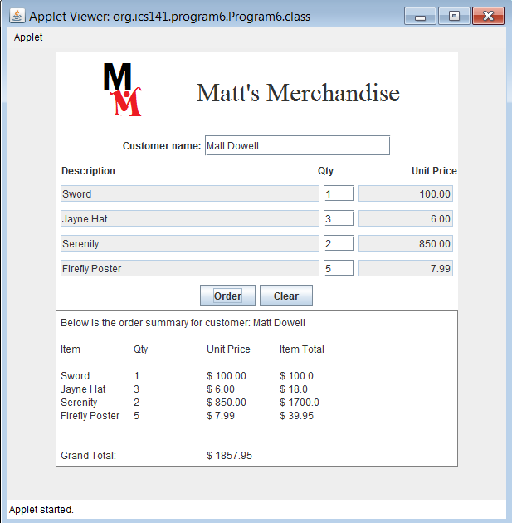

Note: this program is originally designed by Sue Fitzgerald.

Turn in through D2L:
This document with all the bold faced sections finished.

