02_Data_Visualization

Matt Dube

12/4/2018

Table of Contents

Load libraries and set theme

library(ggplot2)  
library(dplyr)  
library(ggthemes)  
library(here)  
library(readr)  
library(purrr)  
library(tidyr)  
library(vcd)  
library(corrplot)

theme_set(theme_light())

Load data

customer <- read_csv(here("00_Data/raw", "WA_Fn-UseC_-Telco-Customer-Churn.csv"))

Functions to assist with plotting

plotNumData <- function(varList, inputData, numCols=2) {  
 gather(data=inputData, varList, key = "var", value = "value") %>%  
 ggplot(aes(x=Churn, y=value, fill=Churn)) +  
 geom_boxplot() +  
 facet_wrap(~ var, scales = "free", ncol = numCols) +  
 scale_fill_brewer(palette = "Paired")  
}  
  
plotCharData <- function(varList, inputData, numCols=2) {  
 gather(data=inputData, varList, key = "var", value = "value") %>%  
 ggplot(aes(x=value, fill=Churn)) +  
 geom_bar() +  
 coord_flip() +  
 facet_wrap(~ var, scales="free", ncol = numCols) +  
 scale_fill_brewer(palette = "Paired")  
}  
  
plotHistograms <- function(varList, inputData, numCols=2) {  
 gather(data=inputData, varList, key = "var", value = "value") %>%  
 ggplot(aes(x=value, fill=Churn)) +  
 geom_histogram() +  
 facet_wrap(~ var, scales = "free", ncol = numCols) +  
 scale_fill_brewer(palette = "Paired")  
}

Boxplots of numeric features

numVarToPlot <- c("tenure", "MonthlyCharges", "TotalCharges")  
plotNumData(numVarToPlot, customer)

## Warning: Removed 11 rows containing non-finite values (stat_boxplot).

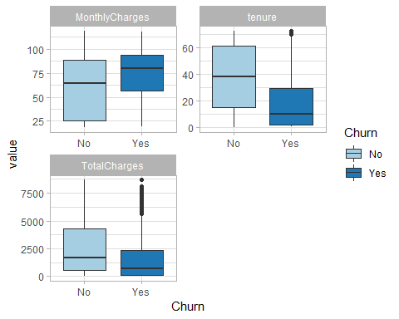 Histograms of numeric features

plotHistograms(numVarToPlot, customer)

## `stat_bin()` using `bins = 30`. Pick better value with `binwidth`.

## Warning: Removed 11 rows containing non-finite values (stat_bin).

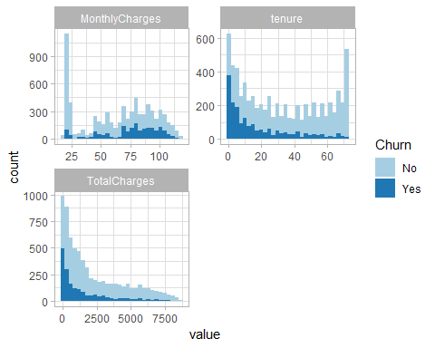

Notes on numeric features:

<<<<<<< HEAD * customers with smaller tenures and higher monthly charges are more likely to churn. * there are a few long tenured customers who have churned, and appear as outliers in the boxplot. * total charges has a few potential outliers as well that need to be examined.

Bar plots of character features

varToPlot <- c("gender", "Partner", "Dependents", "PhoneService")  
plotCharData(varToPlot, customer)

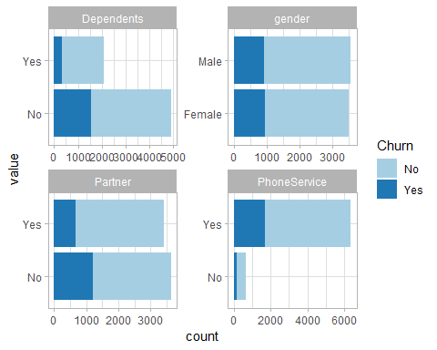

varToPlot <- c("MultipleLines", "InternetService", "OnlineSecurity", "OnlineBackup")  
plotCharData(varToPlot, customer)

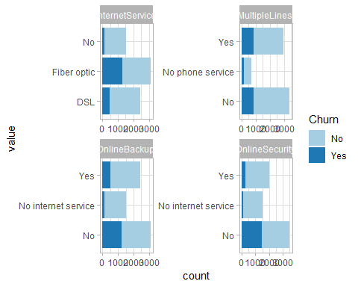

varToPlot <- c("DeviceProtection", "TechSupport", "StreamingTV", "StreamingMovies")  
plotCharData(varToPlot, customer)

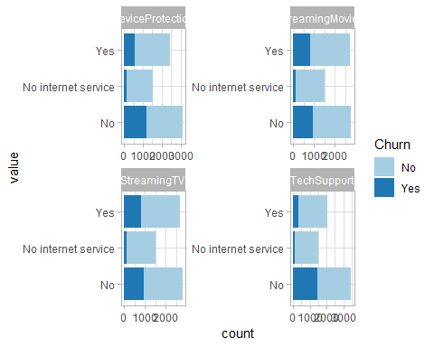

varToPlot <- c("Contract", "PaperlessBilling", "PaymentMethod")  
plotCharData(varToPlot, customer)

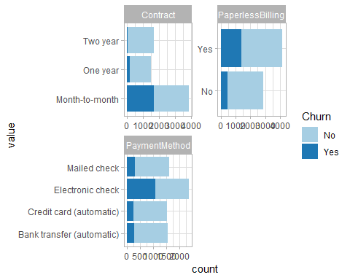

* customers will smaller tenures and higher monthly charges are more likely to churn.
* there are a few long tenured customers who have churned, and appear as outliers in the boxplot.
* total charges has a few potential outliers as well that need to be examined.

Review correlation between tenure, TotalCharges and MonthlyCharges.

cust_numeric <-   
 customer %>%  
 select(-SeniorCitizen) %>%  
 keep(is.numeric)

M <- cor(cust_numeric,use="complete.obs")

corrplot(M, method="number", type="lower")

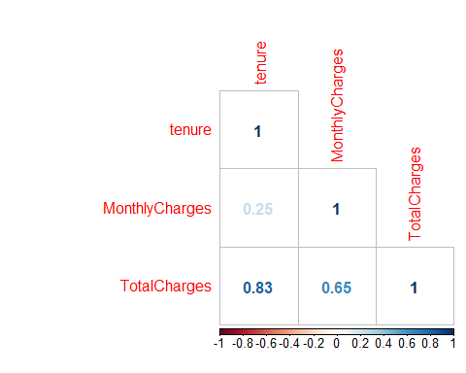

Tenure and TotalCharges have a strong correlation. MonthlyCharges and TotalCharges are also strongly correlated. When we get to data cleaning TotalCharges should be removed - or at the minimum not used as a predictor in our models.