Models

Matt Dube

December 15, 2018

library(readr)  
library(dplyr)  
library(here)  
library(caret)  
library(gbm)  
library(car)  
library(nnet)  
library(earth)  
library(pROC)  
library(vip)  
library(tibble)

Load data

customer_clean <- read_csv(here("00_Data/clean", "customer_clean.csv"))

split the data

set.seed(5432)  
index <- createDataPartition(customer_clean$Churn, p=.75, list = FALSE)  
trainData <- customer_clean[index,]  
testData <- customer_clean[-index,]

Load models

gbm.fit <- readRDS(here("03_Models","gbm_model.rda"))  
nnet.fit <- readRDS(here("03_Models","nnet_model.rda"))  
mars.fit <- readRDS(here("03_Models","mars_model.rda"))  
xgb.fit <- readRDS(here("03_Models","xgb_model.rda"))

vip(gbm.fit, fill = "#2b8cbe") + ggtitle("GBM")

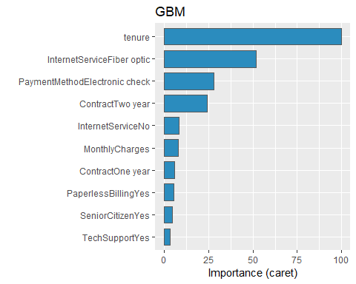

vip(nnet.fit, fill = "#2b8cbe") + ggtitle("nnet")

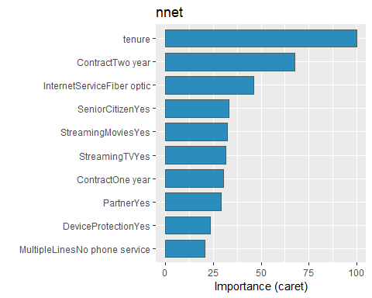

vip(mars.fit, fill = "#2b8cbe") + ggtitle("MARS")

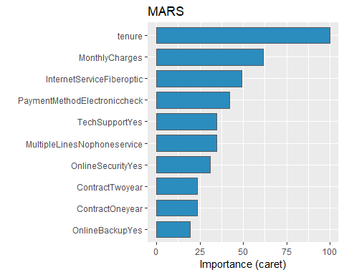

vip(xgb.fit, fill = "#2b8cbe") + ggtitle("xgBoost")

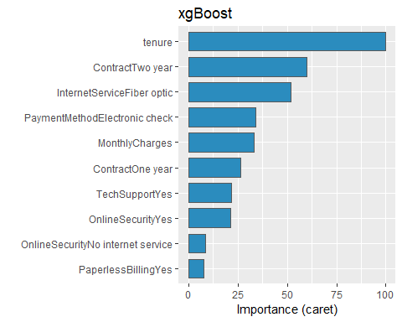

make predictions with each model

gbm.predict <- predict(gbm.fit, newdata = testData)  
nnet.predict <- predict(nnet.fit, newdata = testData)  
mars.predict <- predict(mars.fit, newdata = testData)  
xgb.predict <- predict(xgb.fit, newdata = testData)

varImp(mars.fit)

## earth variable importance  
##   
## only 20 most important variables shown (out of 27)  
##   
## Overall  
## tenure 100.000  
## MonthlyCharges 61.467  
## InternetServiceFiberoptic 49.090  
## PaymentMethodElectroniccheck 42.083  
## MultipleLinesNophoneservice 34.618  
## TechSupportYes 34.618  
## OnlineSecurityYes 30.976  
## ContractOneyear 23.546  
## ContractTwoyear 23.546  
## OnlineBackupYes 19.532  
## PaperlessBillingYes 17.495  
## SeniorCitizenYes 10.910  
## MultipleLinesYes 6.322  
## StreamingTVNointernetservice 0.000  
## PaymentMethodMailedcheck 0.000  
## OnlineSecurityNointernetservice 0.000  
## PaymentMethodCreditcard(automatic) 0.000  
## StreamingMoviesYes 0.000  
## PartnerYes 0.000  
## OnlineBackupNointernetservice 0.000

test_X <- testData %>% select(-Churn)

library(lime)

##   
## Attaching package: 'lime'

## The following object is masked from 'package:dplyr':  
##   
## explain

library(vip)  
  
set.seed(5431)  
local_obs_1 <- test_X[sample(1:nrow(test_X),4, replace = FALSE),]  
  
set.seed(6541)  
local_obs_2 <- test_X[sample(1:nrow(test_X),4, replace = FALSE),]  
  
  
explainer_mars <- lime(test_X, mars.fit, n_bins = 5)

explanation_mars <- explain(  
 x = local_obs_1,  
 explainer = explainer_mars,  
 n_permutations = 5000,  
 dist_fun = "manhattan",  
 kernel_width = .75,  
 n_features = 10,  
 feature_select = "auto",  
 labels = "Yes"  
)  
  
plot_features(explanation_mars)

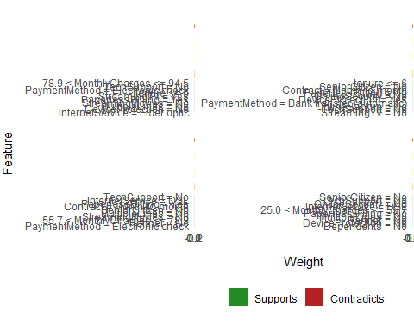

explanation_mars <- explain(  
 x = local_obs_2,  
 explainer = explainer_mars,  
 n_permutations = 5000,  
 dist_fun = "manhattan",  
 kernel_width = .75,  
 n_features = 10,  
 feature_select = "lasso_path",  
 labels = "Yes"  
)  
  
plot_features(explanation_mars)

