Squires App
Complete User Guide for A&V Squires Plant Co. Ltd. – December 2025
Digital Forms Management System

Table of Contents
- 1. Introduction
- 2. Getting Started
- 3. Dashboard and Navigation
- 4. Timesheets
- 5. Vehicle Inspections
- 6. RAMS Documents
- 7. Absence & Leave
- 8. Vehicle Maintenance & Service
- 9. User Management (Admin)
- 10. Reports and Exports
- 11. Messaging System
- 12. Common Scenarios
- 13. Troubleshooting

1. Introduction

What is the Squires App?
The Squires App is a comprehensive digital forms management system designed specifically for A&V Squires Plant Co. Ltd. It replaces paper-based processes with an easy-to-use web application that can be accessed from any device with an internet connection.

What Can You Do With This App?
- Submit Digital Timesheets: Record your working hours each week with automatic calculations
- Complete Vehicle Inspections: Perform daily safety checks on company vehicles
- Access RAMS Documents: View Risk Assessments and Method Statements for your jobs
- Request Annual Leave: Submit and track holiday requests
- Track Vehicle Maintenance: View and update vehicle service schedules
- Communicate with Colleagues: Send and receive messages within the system
- Generate Reports: Create PDF and Excel reports for various purposes

Who Is This Guide For?
This guide is primarily aimed at managers and administrators, but it covers all features available to different user roles including:
- Field Workers: Creating timesheets and inspections
- Office Staff: Processing forms and managing data
- Managers: Approving submissions and viewing reports
- Administrators: Managing users and system configuration
💡 Tip: This application works best on desktop browsers (Chrome, Edge, Firefox, or Safari). Whilst it works on mobile devices, some features are optimised for larger screens.

2. Getting Started

Accessing the Application
- Open your web browser (Chrome, Edge, Firefox, or Safari recommended)
- Navigate to: https://squiresapp.com
- Bookmark this page for easy access in future
Screenshot 1: Login page with email and password fields

Logging In
- Enter your email address (this will have been provided by your administrator)
- Enter your password
- Tick "Keep me signed in" if you're using a personal device
- Click the Sign In button
⚠️ Important: For security reasons, don't tick "Keep me signed in" if you're using a shared or public computer.

First Time Login
If this is your first time logging in, you will need to set a new password. Follow these steps:
- Enter your email address
- Check your email for a temporary password sent by the admin, and use it to log in
- Create a new, secure password when prompted

Understanding User Roles
Your account will have one of the following roles, which determines what features you can access:
Role | What You Can Do
Employee | Create timesheets and inspections for yourself
Manager | All employee functions, plus approve/reject submissions, create forms for others, and view reports
Admin | All manager functions, plus manage users, configure system settings, and access all data
💡 Tip: If you need access to additional features, speak to your administrator about changing your role.

3. Dashboard and Navigation

The Dashboard
When you log in, you'll see the main dashboard. This may look different, based on your Job Role. This is your central hub for accessing all features.
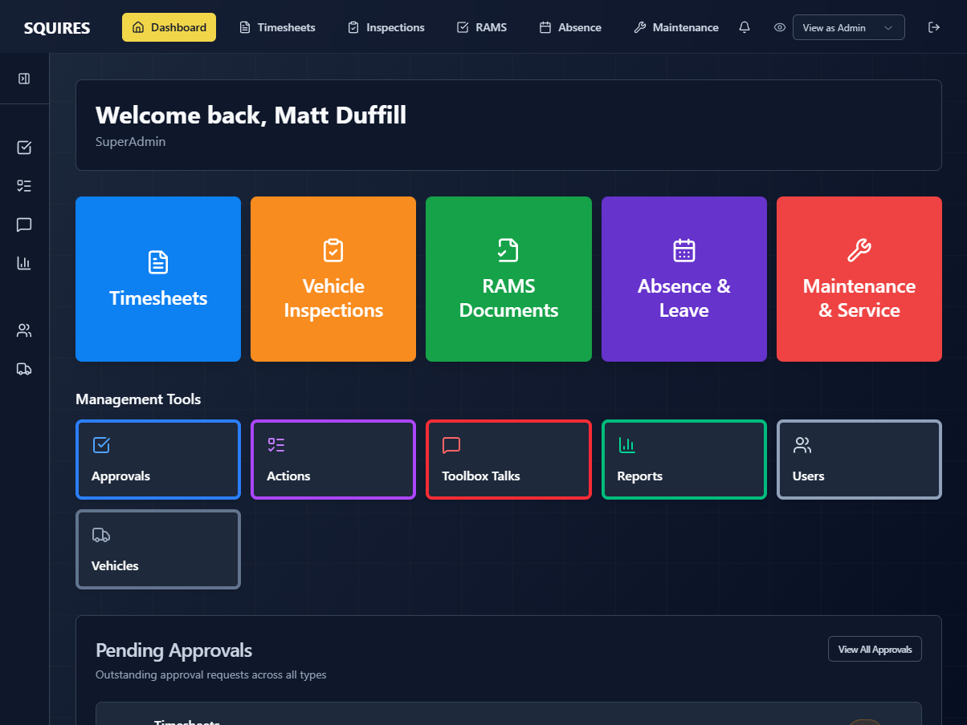
Screenshot 2: Main dashboard with all feature tiles

Dashboard Tiles
The dashboard displays tiles for each major feature. Click any tile to access that feature:
Tile | Icon | What It's For
Timesheets | 📄 (Yellow) | Record your weekly working hours
Vehicle Inspections | ✓ (Blue) | Complete daily vehicle safety checks
RAMS Documents | 📋 (Green) | View risk assessments for your work
Absence & Leave | 📅 (Purple) | Request and manage holidays
Maintenance & Service | 🔧 (Red) | Track vehicle maintenance schedules

Navigation Bar
At the top of every page, you'll see the navigation bar with quick links:

4. Timesheets

Overview
Timesheets are used to record your working hours for each week. The system automatically calculates total hours and can detect special conditions like bank holidays and night shifts.
Screenshot 4: Timesheets list with status badges and filter buttons

Viewing Your Timesheets
- Click the Timesheets tile on the dashboard
- You'll see a list of all your timesheets
- Each timesheet shows:
  - Week ending date
  - Total hours worked
  - Status (Draft, Pending, Approved, Rejected)
  - Who it was created for

Understanding Timesheet Status
Status | What It Means | What You Can Do
Draft | Not yet submitted | Edit and submit
Pending | Awaiting manager approval | View only
Approved | Approved by manager | View and download PDF
Rejected | Needs corrections | View comments, edit, and resubmit

Creating a New Timesheet
- Click New Timesheet button
- Select the week ending date (must be a Sunday)
- The system checks if you already have a timesheet for that week
- If no duplicate exists, the timesheet form will open

Filling In Your Timesheet
- Vehicle Registration: Enter the reg number of the vehicle you used
- For Each Day (Monday to Sunday):
  - Enter start and finish times
  - The system calculates hours automatically
  - Add job number if applicable
  - Add any remarks or notes

Special Features

Automatic Hour Calculation
When you enter start and finish times, the system automatically calculates:
- Daily hours (including lunch break deduction if applicable)
- Weekly total hours
- Number of days worked

Bank Holiday Detection
The system knows about UK bank holidays and will suggest ticking the Bank Holiday box on those dates.
💡 Tip: You can still enter Bank Holiday hours if worked, if needed.

Saving Your Work
You have two options when working on a timesheet:
- Save Draft: Saves your progress without submitting. You can come back and finish it later
- Submit for Approval: Completes the timesheet and sends it to your manager for review

Submitting Your Timesheet
- Click Submit for Approval
- A confirmation window appears showing a summary:
  - Total hours
  - Days worked
  - Vehicle registration
  - Day-by-day breakdown
- Review the summary carefully
- If everything is correct, click Confirm Submission
- If you spot an error, click Go Back to Edit
⚠️ Important: Once submitted, you cannot edit the timesheet unless your manager rejects it and asks for changes.

Editing a Rejected Timesheet
If your manager rejects your timesheet:
- Open the timesheet from your list
- Read the manager's comments carefully (shown at the top)
- Make the requested changes
- Click Submit for Approval again

For Managers: Approving Timesheets
If you're a manager, you can approve or reject timesheets:
- Go to Timesheets page
- Filter by "Pending" to see timesheets awaiting approval
- Click on a timesheet to open it
- Review all the details carefully
- Either:
  - Approve: Click the green Approve button
  - Reject: Click Reject, add comments explaining what needs to be fixed, then confirm
- There is also a further approval system in place where required. Approved timesheets can be marked as “Processed” or “Adjusted”.

Screenshot 8: Manager approvals page with pending timesheets

For Managers: Creating Timesheets for Others
Managers can create timesheets on behalf of employees:
- Click New Timesheet
- Select which employee you're creating it for from the dropdown
- Choose the week ending date
- Fill in the timesheet as normal
- Save as draft or submit for approval
💡 Tip: When a manager creates a timesheet for an employee, the employee can still edit it if it's in draft status.

Downloading Timesheet PDFs
Once a timesheet is approved, you can download a PDF copy:
- Open the approved timesheet
- Click the Download PDF button
- The PDF includes:
  - Employee details and signature
  - All hours worked
  - Job numbers and remarks
  - Approval status

5. Vehicle Inspections

Overview
Vehicle inspections are daily safety checks performed on company vehicles. The system currently uses a 14-point, or a 26-point checklist to ensure all vehicles are safe to operate.

Screenshot 9: Vehicle inspections list with registration numbers and status

Creating a New Inspection
- Click Vehicle Inspections on the dashboard
- Click New Inspection
- Select the vehicle you're inspecting from the dropdown
- Enter the current mileage
- Select the week you're inspecting for

Marking Items
For each checklist item, you have three options:
- ✓ (Tick): Item is satisfactory
- ✗ (Cross): Item has a defect that needs attention

Recording Defects
If you mark any item with a cross (✗), you must provide details:
- When you mark an item as defective, a text box appears
- Describe the defect clearly (e.g., "Nearside front tyre tread below legal limit")
- Optionally, add a photo of the defect (coming soon!)
- Indicate if the vehicle is still safe to use
💡 Tip: Clear photos of defects help the maintenance team understand and fix issues more quickly.

Adding Photos (coming soon!)
You can attach photos to your inspection:
- Click the camera icon or "Add Photo" button
- Either:
  - Take a photo using your device's camera, or
  - Upload a photo from your device
- Add a description of what the photo shows
- The photo will be included in the inspection report

Completing the Inspection
- Go through each day's checklist
- Mark all items appropriately
- Add defect details and photos where needed
- Review your entries
- Click Submit Inspection
- The inspection is sent to your manager for review
⚠️ Important: If a vehicle has serious defects that make it unsafe to operate, do not use the vehicle and inform your manager immediately.

For Managers: Reviewing Inspections
Managers should regularly review vehicle inspections:
- Go to Manager Actions
- Review the defects shown (marked with warning icon)
- Take appropriate action

6. RAMS Documents

Overview
RAMS (Risk Assessment & Method Statement) documents describe the safe way to carry out specific work tasks. All employees must read and understand the relevant RAMS before starting a job.

What is a RAMS Document?
- Risk Assessment: Identifies hazards and risks associated with the work
- Method Statement: Describes the safe procedure for carrying out the work
- Control Measures: Steps to reduce or eliminate risks
- Emergency Procedures: What to do if something goes wrong
Screenshot 12: RAMS documents page with search functionality

Accessing RAMS Documents
- Click RAMS Documents on the dashboard
- Browse the list of available documents
- Use the search box to find specific documents by name or job type
- Filter by category if available

Reading a RAMS Document
- Click on a RAMS document to open it
- You'll see three options:
  - Open: Read the document in your browser
  - Download: Save a PDF copy to your device
  - Email: Send a copy to your email address
- The system records which documents you've accessed

RAMS Document Sections
A typical RAMS document includes:
- Job Description: What work is being carried out
- Location: Where the work will take place
- Hazards Identified: What could cause harm
- Persons at Risk: Who might be affected
- Control Measures: How to stay safe
- PPE Required: What protective equipment to wear
- Emergency Procedures: What to do in an emergency
- Sign-off: Who has approved this document
⚠️ Important: Always read the relevant RAMS document before starting a new job. If you don't understand any part of it, ask your manager for clarification before proceeding.

For Managers: Uploading RAMS Documents
Managers and admins can upload new RAMS documents:
- Go to RAMS Documents
- Click Upload New RAMS
- Enter document details:
  - Document name
  - Category
  - Description
  - Related job numbers (if applicable)
- Upload the PDF file
- Click Save
- The document is now available to assign to users

For Managers: Tracking Document Access
Managers can see who has accessed each RAMS document:
- Open a RAMS document
- Click View Access History
- See a list showing who opened, downloaded, or emailed the document and when
- Export this data as a PDF if needed
💡 Tip: RAMS documents should be reviewed and updated regularly (at least annually) to ensure they remain accurate and relevant.

7. Absence & Leave

Overview
The Absence & Leave module allows you to request annual leave (holidays) and track your leave balance. Managers can approve or reject requests and see team availability.

Screenshot 14: Absence & Leave page with calendar and leave summary

Viewing Your Leave Balance
When you open the Absence & Leave page, you'll see:
- Annual Entitlement: Total days you're entitled to per year
- Days Taken: How many days you've used
- Days Approved: Leave that's been approved but not yet taken
- Days Available: How many days you have left to book

Requesting Annual Leave
- Click Absence & Leave on the dashboard
- Click Request Leave
- Select the start and end dates of your leave
- The system calculates the number of working days automatically
- Add a note if needed (e.g., "Family holiday abroad")
- Click Submit Request
- Your request is sent to your manager for approval
💡 Tip: The system automatically excludes weekends and bank holidays when calculating working days.

Request Status
Status | What It Means
Pending | Awaiting manager approval - you can cancel if needed
Approved | Manager has approved - your leave is confirmed
Rejected | Manager has declined - see their comments for the reason

Cancelling a Leave Request
If your plans change, you can cancel a pending or approved request:
- Go to your list of leave requests
- Find the request you want to cancel
- Click Cancel Request
- Confirm the cancellation
- The days are added back to your available balance
⚠️ Important: Give as much notice as possible when cancelling leave, especially if it's already been approved.

For Managers: Approving Leave Requests
When an employee submits a leave request, managers receive a notification:
- Go to Absence & Leave
- Click the Pending Requests tab
- Review each request considering:
  - Business needs and workload
  - Other staff already on leave
  - Adequate notice given
- Either:
  - Approve: Click Approve to confirm the leave
  - Reject: Click Reject and add a reason (e.g., "Sorry, we already have 2 people off that week")
- The employee is notified of your decision

For Managers: Team Calendar View
Managers can see a calendar view of all team absences:
- Switch to Calendar View
- See colour-coded leave for all team members
- Identify potential coverage issues
- Export to PDF or print for office display

For Admins: Managing Leave Entitlements
Administrators can adjust leave entitlements:
- Go to User Management
- Select an employee
- Click Edit Leave Entitlement
- Adjust their annual allowance
- Add any carry-over days from previous year
- Save changes

8. Vehicle Maintenance & Service

Overview
The Vehicle Maintenance & Service module helps you track and manage all vehicle maintenance activities including MOT, tax, servicing, and safety equipment checks. This replaces the old Excel spreadsheet system.
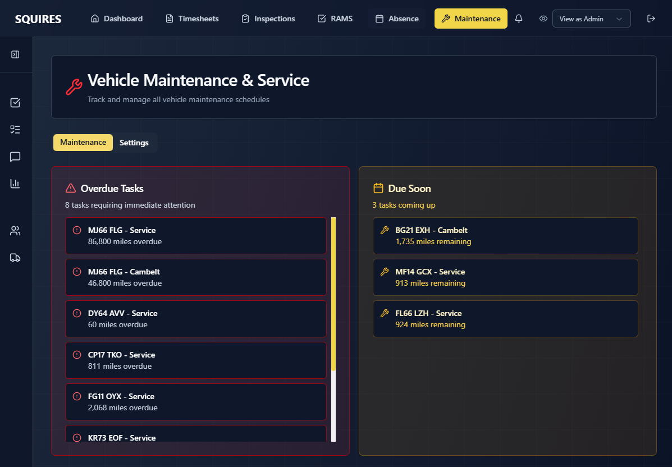
Screenshot 17: Maintenance dashboard showing vehicle list with colour-coded status indicators for MOT, Tax, Service due dates

What Does This Module Track?
For each vehicle, the system currently monitors:
- Tax Due Date: When vehicle road tax expires
- MOT Due Date: When the MOT test is due
- Service Due: Mileage-based service intervals
- Cambelt Replacement: When cambelt needs replacing
- First Aid Kit Expiry: When first aid kit needs renewing
- Current Mileage: Automatically updated from vehicle inspections

Understanding the Colour Coding
Colour | What It Means | Action Needed
Red | Overdue - past the due date or mileage | Urgent - schedule immediately
Amber | Due Soon - within the warning threshold | Plan maintenance soon
Green | OK - plenty of time remaining | No action needed
Grey | Not Set - no due date recorded | Add the date when known
💡 Tip: The warning thresholds are configurable. By default, date-based items warn 30 days in advance, and mileage-based items warn 1,000 miles in advance.

Viewing Vehicle Maintenance
- Click Maintenance & Service on the dashboard
- You'll see a list of all vehicles with their maintenance status
- Items needing attention are highlighted in red or amber
- Click on any vehicle to see full details

Alert Panels
At the top of the maintenance page, you'll see two alert panels:
- Overdue Tasks (Red): Items that are already overdue and need immediate attention
- Due Soon (Amber): Items that will be due within the warning threshold

Updating Maintenance Records
When maintenance is completed, update the system:
- Find the vehicle in the list
- Click Edit
- Update the relevant date or mileage:
  - Tax renewed? Update the Tax Due Date
  - MOT completed? Update the MOT Due Date
  - Service done? Update the Service Due Mileage
- Add a comment explaining what was done (minimum 10 characters required):
  - "MOT passed on [date], renewed for 12 months"
  - "Full service completed at 45,000 miles. Cost: £250. Next service due at 55,000 miles"
  - "Tax renewed online, expires Aug-26"
- Click Save Changes
⚠️ Important: You must add a comment every time you update a maintenance record. This creates an audit trail showing what was done and when.

Automatic Mileage Updates
The system automatically updates vehicle mileage:
- When a vehicle inspection is submitted, the current mileage is recorded
- This mileage is automatically copied to the maintenance system
- You don't need to manually enter mileage - it happens automatically
- The "Last Updated" timestamp shows when the mileage was last refreshed

Viewing Maintenance History
To see all changes made to a vehicle's maintenance records:
- Click History button next to the vehicle
- You'll see a chronological list of all updates showing:
  - What changed (old value → new value)
  - Who made the change
  - When it was changed
  - The comment explaining why

For Admins: Configuring Maintenance Categories
Administrators and managers can customise the maintenance system:
- Go to Maintenance & Service
- Click the Settings tab (gear icon)
- Here you can:
  - Add new maintenance categories (e.g., "Tyre Replacement")
  - Edit existing categories
  - Change warning thresholds (e.g., warn 60 days before MOT instead of 30)
  - Delete unused categories
💡 Tip: Changes to warning thresholds take effect immediately and apply to all vehicles.

Sorting and Searching
To find specific vehicles or sort the list:
- Search: Type a registration number in the search box
- Sort: Click any column header to sort by that column
- Filter: Click the overdue or due soon panels to filter the list

9. User Management (Admin)
⚠️ Admin Only: This section is only accessible to administrators. Regular users and managers cannot access user management features.

Overview
The User Management section allows administrators to control who has access to the system and what they can do.

Accessing User Management
- Click your profile menu in the top left
- Click Users
- Alternatively, click the Users tile in the Management Tools dashboard tiles

Creating a New User
- Click Add New User
- Fill in the user's details:
  - Full Name: Their complete name
  - Email Address: This will be their username
  - Employee ID: Company employee number (if applicable)
  - Role: Choose from your configured roles (e.g., Employee, Manager, Admin)
- Click Create User
- The user receives an email with their temporary password

Editing User Details
To update a user's information:
- Find the user in the list
- Click Edit
- Update any details as needed
- Click Save Changes

Changing User Roles
To change what a user can access:
- Edit the user
- Select a different role from the dropdown
- Save changes
- The user's permissions update immediately
💡 Tip: Changes to roles take effect the next time the user logs in or refreshes their browser.

Resetting User Passwords
If a user forgets their password:
- Find the user in the list
- Click Reset Password
- The user receives an email with a new temporary password
- They log on with the new temporary password, and then create a new password

Deactivating Users
When someone leaves the company:
- Find the user in the list
- Click Deactivate
- Confirm the action
- The user can no longer log in
- Their historical data (timesheets, inspections) is preserved
⚠️ Important: Deactivated users cannot be reactivated. If someone returns to the company, you'll need to create a new account for them.

Managing Roles and Permissions
Administrators can create and customise roles:
- Go to Admin → Roles
- You'll see a list of existing roles
- Click Add New Role to create a custom role
- Set permissions for each module:
  - Timesheets - can they create and view timesheets?
  - Inspections - can they access vehicle inspections?
  - RAMS - can they view RAMS documents?
  - Absence - can they request leave?
  - Maintenance - can they view maintenance schedules?
  - Reports - can they generate reports?
- Set timesheet type (if applicable) - which timesheet format should users with this role use?
- Save the role

Viewing User Activity
To see what a user has been doing:
- Open the user's profile
- Click the Activity tab
- View their recent actions including:
  - Timesheets submitted
  - Inspections completed
  - RAMS documents accessed
  - Leave requests made

Managing Vehicles
Administrators can add and manage vehicles:
- Go to Admin → Vehicles
- Click Add Vehicle
- Enter vehicle details:
  - Registration number
  - Make and model
  - Year
  - Category (van, truck, car, etc.)
  - Current mileage
- Click Save
- The vehicle is now available in inspections and maintenance

10. Reports and Exports

Overview
The Reports section allows managers and admins to generate various reports and export data to Excel or PDF format.

Accessing Reports
- Click your profile menu
- Click Reports
- Or from the dashboard, some modules have "View Reports" links

Available Reports

1. Timesheet Summary Report
Shows all timesheet data for a selected period:
- Select date range (from and to)
- Choose specific employees or "All Employees"
- Click Generate Report
- The report shows:
  - Total hours worked per employee
  - Hours broken down by week
  - Bank holiday hours
  - Night shift hours
  - Job numbers worked
- Export to Excel or PDF

2. Vehicle Inspection Report
Summarises vehicle inspection data:
- Inspections completed per vehicle
- Defects found and their status
- Vehicles with outstanding defects
- Compliance rate (% of inspections completed on time)

3. Absence Report
Shows leave taken and balances:
- Days taken per employee
- Days remaining
- Upcoming approved leave
- Leave patterns and trends

4. Maintenance Schedule Report
Lists all vehicle maintenance items:
- Upcoming MOTs and services
- Overdue maintenance
- Maintenance costs (if recorded)
- Vehicle utilisation based on mileage

Exporting to Excel
Excel exports are useful for further analysis or sending to external systems:
- Generate the report you need
- Click Export to Excel
- Choose what to include (summary only, or full details)
- The file downloads automatically
- Open in Microsoft Excel, Google Sheets, or similar
💡 Tip: Excel exports include formulas, so you can add your own calculations and pivot tables.

Exporting to PDF
PDF exports are ideal for printing or sharing officially:
- Generate the report
- Click Export to PDF
- The PDF is formatted for A4 paper
- Includes company branding and page numbers
- Print directly or save to your computer

11. Common Scenarios
Here are some typical situations and how to handle them using the system:

Scenario 1: Starting a New Week
Situation: It's Monday morning and you're starting a new working week.
What to do:
- Log in to the application
- Go to Vehicle Inspections
- Create a new inspection for your vehicle for this week
- Complete Monday's inspection checklist before starting work
- If any defects are found, photograph them and report immediately

Scenario 2: Submitting Your Weekly Timesheet
Situation: It's Sunday evening and you need to submit your timesheet for the week just ended.
What to do:
- Log in to the application
- Click Timesheets → New Timesheet
- Select the Sunday just passed as the week ending date
- Fill in your hours for each day, along with job numbers
- Add vehicle registration
- Review the summary carefully
- Click Submit for Approval
- Check the confirmation modal and submit
- Your manager will be notified and will approve it

Scenario 3: Booking a Week's Holiday
Situation: You want to book a week off in August for a family holiday.
What to do:
- Go to Absence & Leave
- Check your available days balance
- Click Request Leave
- Select your start date (first day off) and end date (last day off)
- The system calculates that it's 5 working days
- Add a note: "Family holiday"
- Submit your request
- Wait for your manager to approve
- You'll get a notification when it's approved or if there's an issue

Scenario 4: Finding a Tyre Defect During Inspection
Situation: During your daily vehicle inspection, you notice the front nearside tyre tread is very low.
What to do:
- In the vehicle inspection form, mark "Tyres - Tread Depth" with a cross (✗)
- In the defect description, write: "Front nearside tyre tread below 3mm, approaching legal limit"
- Take a photo of the tyre showing the tread
- Assess if the vehicle is safe to use for the day (if above legal limit, yes; if below, no)
- Submit the inspection
- Inform your manager immediately about the defect
- The manager will schedule tyre replacement

Scenario 5: Your Manager Rejects Your Timesheet
Situation: You submitted your timesheet but your manager has rejected it with comments asking for corrections.
What to do:
- Go to Timesheets
- Open the rejected timesheet (shown with red Rejected badge)
- Read the manager's comments carefully at the top
- Make the requested corrections
- For example, if they said "Please add job number for Thursday" - add the job number
- Once corrected, click Submit for Approval again
- Your manager will review the updated version

Scenario 6: Manager Approving Multiple Timesheets
Situation: You're a manager and it's Monday morning. You have 10 timesheets to review from last week.
What to do:
- Go to Timesheets
- Click the Pending filter to see only submissions awaiting approval
- Go through each timesheet one by one:
  - Check hours seem reasonable
  - Verify job numbers are correct
  - Look for any anomalies (very high hours, missing days, etc.)
- For timesheets that are correct: Click Approve
- For any with issues: Click Reject and add a clear comment explaining what needs fixing
- Process approved timesheets for payroll

Scenario 7: Admin Adding a New Employee
Situation: A new person has joined the company and needs access to the system.
What to do:
- Go to Admin → Users
- Click Add New User
- Enter their details:
  - Full name: "John Smith"
  - Email: their work email address
  - Employee ID: their HR system ID
  - Role: Select appropriate role (usually "Employee" to start)
- Tick "Send Welcome Email"
- Save
- The new user receives an email with instructions to set their password
- Confirm with them that they've received the email and can log in
- Show them this user guide

Scenario 8: Updating Vehicle MOT Date
Situation: A company van has just had its MOT and passed. You need to update the system.
What to do:
- Go to Maintenance & Service
- Find the vehicle in the list
- Click Edit
- Update the "MOT Due Date" to be 12 months from the test date
- In the comment box, write: "MOT completed at XYZ Garage on [date]. Passed with no advisories. Cost: £54. Next MOT due [date]"
- If you have the MOT certificate, you could also upload it as an attachment
- Save changes
- The vehicle's MOT status changes from red/amber to green

Scenario 9: Generating a Monthly Report
Situation: End of month and you need to generate a timesheet summary report for the office.
What to do:
- Go to Reports
- Select "Timesheet Summary Report"
- Set date range:
  - From: 1st of the month
  - To: Last day of the month
- Select "All Employees" or specific employees if needed
- Click Generate Report
- Review the report on screen
- Click Export to Excel
- Open the file and save it to the network drive or email it to payroll

Scenario 10: Vehicle Shows Red Alert for Overdue Service
Situation: You notice a vehicle in the maintenance list has a red alert showing the service is overdue.
What to do:
- Click on the vehicle to see details
- Check current mileage vs. service due mileage
- Contact the driver and ask them to book the vehicle in for service
- Once service is booked, make a note of the appointment
- After service is completed:
  - Update the "Next Service Due" mileage (current + 10,000 miles, or as recommended by garage)
  - Update the "Last Service" mileage to current
  - Add a detailed comment with date, garage name, work done, and cost
- Save changes
- The red alert disappears and changes to green

12. Troubleshooting

Common Issues and Solutions

I can't log in - "Invalid email or password" error
Solution:
- Check you're using the correct email address (the one provided by your administrator)
- Check caps lock isn't on when typing your password
- Try clicking "Forgot Password?" to reset your password
- If still having issues, contact your administrator

I can't see certain features that others can
Solution:
- Your user role might not have permissions for those features
- Check with your manager or administrator about your role
- They can update your permissions if needed

The page won't load or keeps spinning
Solution:
- Check your internet connection is working
- Try refreshing the page (F5 or Ctrl+R)
- Clear your browser cache and cookies
- Try a different browser
- If the problem persists, it might be a system issue - contact your administrator

My timesheet won't submit - validation errors
Solution:
- Read the error messages carefully - they tell you what's wrong
- Common issues:
  - Missing vehicle registration
  - Times not entered for all days
  - Finish time before start time (unless night shift)
  - Missing job numbers
- Correct the highlighted issues and try submitting again

I accidentally submitted the wrong timesheet
Solution:
- If it's still in "Pending" status, you cannot edit it
- Contact your manager immediately and ask them to reject it
- Explain what needs changing
- Once rejected, you can edit and resubmit

The vehicle I need isn't in the dropdown list
Solution:
- The vehicle might not have been added to the system yet
- Contact your administrator and ask them to add it
- They need to go to Admin → Vehicles → Add Vehicle

I can't remember which vehicle I used last week
Solution:
- Go to Vehicle Inspections and look at your previous inspections
- The vehicle registration is shown on each inspection
- Or check your previous timesheets

My leave request was rejected but I don't know why
Solution:
- Open the rejected leave request
- Your manager should have added comments explaining the reason
- If there are no comments, speak to your manager directly
- Once you understand the issue, you can submit a new request for different dates

I need to access the system on my phone but it's not working well
Solution:
- The system is designed primarily for desktop/laptop browsers
- It does work on mobile, but some features are better on a larger screen
- For best results:
  - Use landscape orientation on your phone
  - Use Chrome browser on Android or Safari on iPhone
  - For complex tasks like filling timesheets, try to use a computer if possible

Photos aren't uploading to my vehicle inspection
Solution:
- Check the photo file size - very large photos might fail
- Try taking a new photo at a lower resolution
- Make sure your internet connection is stable
- Ensure you've given the browser permission to access your camera

I'm getting a message saying the system can't find my profile
Solution:
- This usually means your account isn't fully set up
- Contact your administrator immediately
- They may need to recreate your account properly

Getting Help
If you can't resolve an issue using this guide:
- First: Try the solutions above for your specific issue
- If still stuck: Contact your system administrator with:
  - A description of the problem
  - What you were trying to do
  - Any error messages you saw
  - Screenshots if possible

Browser Compatibility
For best results, use one of these modern browsers:
Browser | Minimum Version | Recommended
Google Chrome | Version 90+ | ✓
Microsoft Edge | Version 90+ | ✓
Firefox | Version 88+ | ✓
Safari | Version 14+ | ✓
Internet Explorer | Not supported | ❌
⚠️ Important: Internet Explorer is not supported. If you're still using it, please switch to a modern browser.

Document Information
Application: Squires App - Digital Forms Management System
Company: A&V Squires Plant Co. Ltd.
Document Version: 1.0
Last Updated: December 2025
URL: https://squiresapp.com

This guide covers all major features of the Squires App. For technical support or questions,
please contact your system administrator.
© 2025 A&V Squires Plant Co. Ltd. All rights reserved.

