**Thermal Controller Help and Instructions:**

**To Create a new profile: Ctrl+N** or go to: **File>New.  
To Save: Ctrl+S** or go to **Fiile>SaveAs.  
To Begin Graphic Monitor:** Click on the ‘Monitor Temp’ box in the red control area.

**Editing a profile:** To begin editing, open a profile and double-click on one of the steps in the left hand display window.  
**Step Types:** Soak: dwell at the pre-set temperature, using time in minutes.  
 Ramprate: transition to a set-point, using degrees per minute.  
 Ramptime: transition to a set-point, using an ending time envelope.   
 (*Do not exceed 3 degrees Celsius per minute while testing a Pass Unit.)  
 Jump: enter a step number to jump into, and the number of times to repeat.

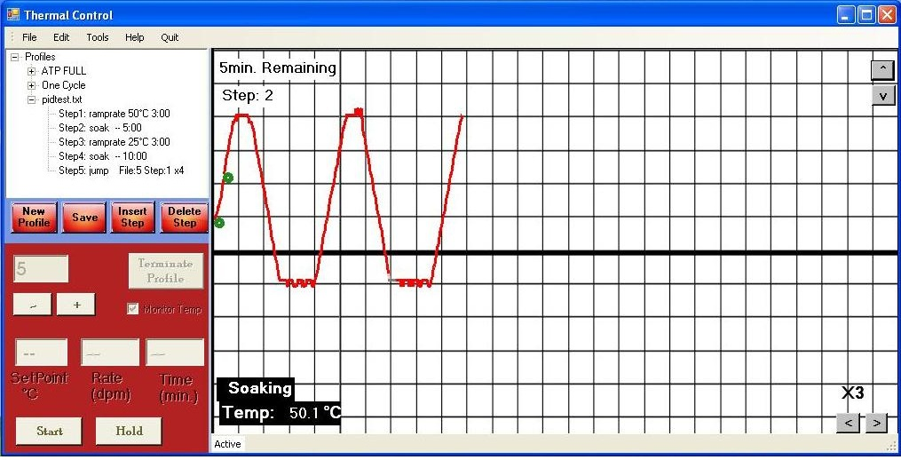

*note: the profile will overwrite file 5, named ‘PASSFILE in the F4 control memory.

**Starting a profile:** to monitor while starting, click on the ‘Monitor Temp’ box. This will open a serial connection with the thermal chamber, or produce an error window. When the chamber is not running a profile, the status check label will display “The chamber is idle”. If a profile is loaded in the left window, click on the ‘Start’ button. The profile will be uploaded to the chamber, and will begin running at step1. A green dot will appear on the GUI grid, and data will begin logging on the display. The grid can be cleared by right clicking and selecting ‘Clear’.

**TOOLS and FEATURES:**

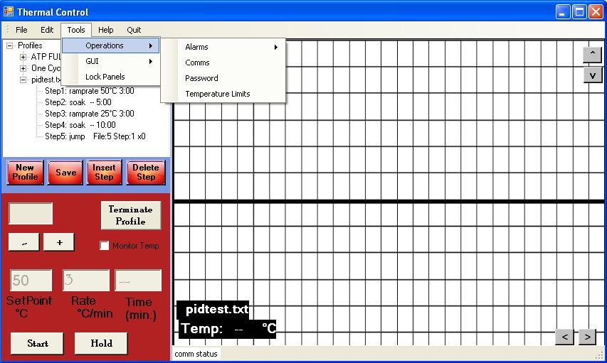

**Operations:**

If the thermal chamber is unable to heat or cool, and is displaying a correct temperature set-point, an alarm condition may have been triggered. This is due to the Temperature Limit points being exceeded. The alarm conditions can be displayed by clicking on **Tools>Operations>Alarms>Read.** As well as cleared by clicking on **Tools>Operations> Alarms>Clear.** It is a good idea to set the upper and lower limits at this point to the default values, or if during a Pass Unit test set to +60/-30°C.

**Troubleshooting:**  If the alarms remain active after a clear-command has been set, you must either change the upper/lower temperature limits, or wait for the chamber to return to an acceptable temperature, or both.

A manual for the WatlowF4 controller can be found at TestEquity.com, explaining all the registers within the controller memory. A feature has been added to this test software to allow a user to read and write controller registers. Click on: **Tools>Operations>Comms.** To set a password for controller access, click on: **Tools>Operations>Password.** Lastly, the panels can be locked, for security against losing GUI data during an ATP test.

Click on: **Tools>Operations>LockPanels.**

**Zooming: Ctrl+1 or 2, Ctrl+A or Z.**