Introduction
Seattle is famous for its rain, but is it actually wetter than other cities in the United States? To find out, this project compares precipitation between Seattle, WA and Burlington, VT with the ultimate goal of learning which city has more precipitation. More precipitation can either mean how often it rains or how much falls overall, so this project compares both.
Data
The data used in this project comes from the National Oceanic and Atmospheric Administration. It contains daily observations surrounding precipitation in Seattle, WA and Burlington, VT from 01-01-2018 to 12-31-2022.
To prepare the data for analysis, the Seattle and Burlington data was combined into one dataset tracking the date, city, and precipitation. Seattle was found to be missing 190 entries, which were dealt with by replacing the missing values with the mean value across years on that day. New columns for month, season, and any precipitation were then added so the cities could be compared in several ways.
Analysis
The comparisons focus on two questions. First, on average, does one city get more precipitation than the other? Second, does one city have a larger proportion of days with precipitation? Since daily weather varies a lot, a difference was only treated as meaningful if it was too large to be explained by normal daily chance. This was decided by statistical tests, specifically T and Z tests.
Results
Comparing the mean precipitation of all days showed no significant difference. Comparing the proportion of days with precipitation resulted in Seattle having more days with precipitation.
Comparing the mean precipitation by month showed significant differences in January, February, June, July, August, September, November, and December. Comparing the proportion of days with precipitation by month showed significant differences in January, February, April, July, October, November, and December.
Comparing the mean precipitation by season showed significant differences in Winter and Summer. Comparing the proportion of days with precipitation by season showed significant differences in all seasons.
Graphs are included comparing mean precipitation and proportion of days with precipitation by month and season. A star is plotted if there is a significant difference between the cities.

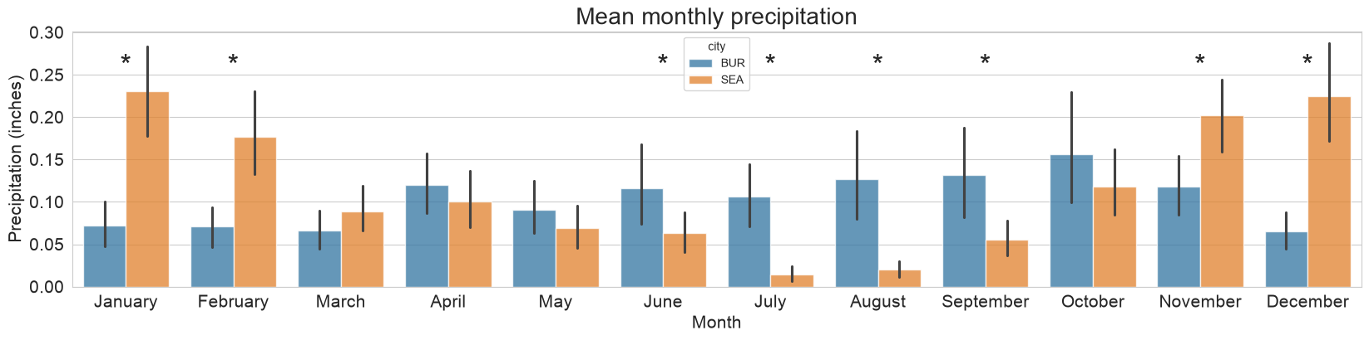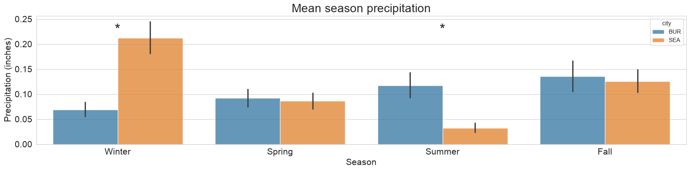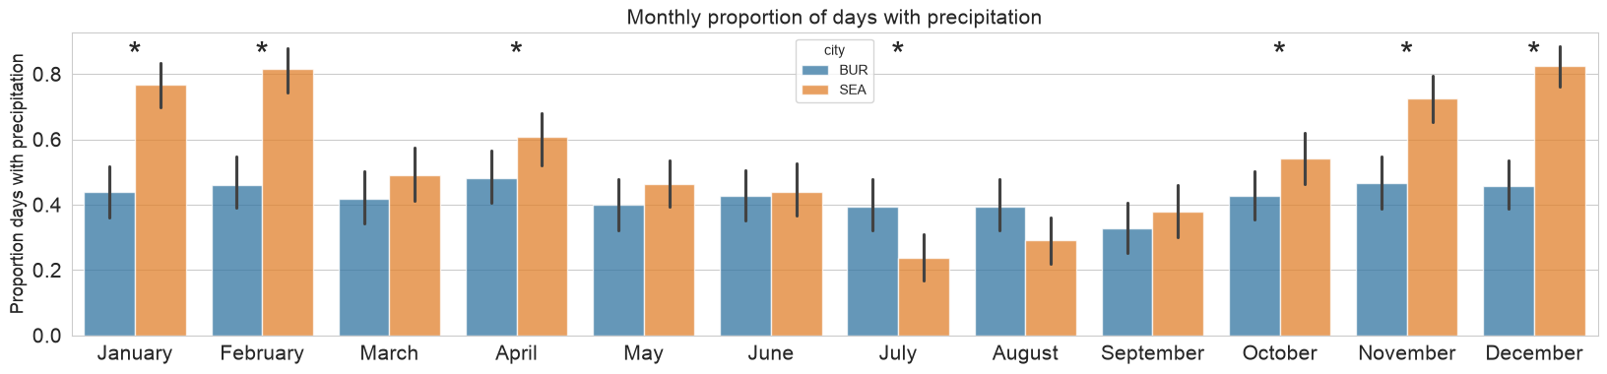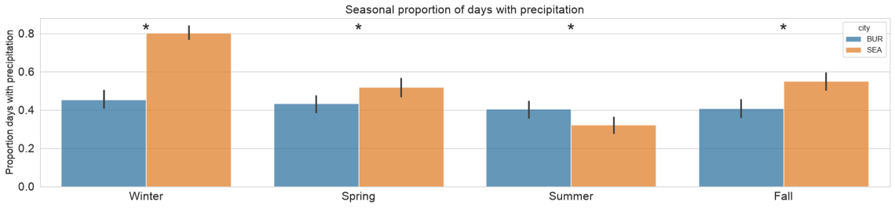

Conclusion
So, is Seattle really rainier than Burlington? It depends. Looking at how much precipitation falls, the cities are essentially the same. Over the five years, Seattle averaged 0.113 inches a day while Burlington averaged 0.104, a difference too small to be meaningful. In terms of how often there is precipitation, Seattle comes out ahead. Seattle’s rainy reputation holds up for frequency, but not for total amount.
The reason the amounts look so similar is that the cities’ rainy seasons are opposite. Seattle has more precipitation in winter, with significant differences in January, February, November, and December, while Burlington has more precipitation in the summer, from June through September. Seattle also had more days with precipitation in every season except Summer, when Burlington had more. Since the total average is roughly the same, this could mean it rains more when it does rain in Burlington than in Seattle. Seattle’s rainy winters and Burlington’s summers roughly balance each other out, making the yearly averages close together.

