Nuscan-SW-Architecture.docx

|  |  |  |
| --- | --- | --- |
| 05.2023 | Freiburg M., Schaffranek D. | Start document. |
| 06.2023 | Schaffranek D. | Add “3rd Party SW” chapter. Modify existing text. |
|  |  |  |
|  |  |  |
|  |  |  |

Table of Contents

1. Purpose 2

2. Glossary 3

3. Overview 4

4. Concepts 5

4.1. Nuscan (IDL) 5

Evaluation (options) 5

Acquisition 5

4.2. NuscanApp (C++) 7

NuscanApp 7

NGEFrame 7

TCPIPServer 7

NGEMonitor 7

NGEConfigurator 7

DataServerTf 7

DataServerAscan 7

StatusBScan 7

4.3. NCComNet 8

5. Data 9

6. Testing 10

7. Dependencies 11

8. 3rd Party SW 12

# Purpose

This document was created after the software was completed and may therefore not contain all information.

Nuscan with USIPxs is an ultrasonic testing system that checks certain components for material defects. The software of this system consists of the following components.

*Nuscan* is an application divided into two parts. One part defines the machine movements and the scan settings. The other part performs the scan.

*NuscanApp* is an application that performs the ultrasonic settings for the system. In addition, the application provides certain test functions and sets the system up for the upcoming ultrasound scan.

*NcComNet* is an application that communicates with the programmable logic controller (PLC).

# Glossary

Lists terms and abbreviations used in this documentation.

|  |  |
| --- | --- |
| Name | Description |
| Nuscan | Nutronic Scan |
|  |  |

# Overview

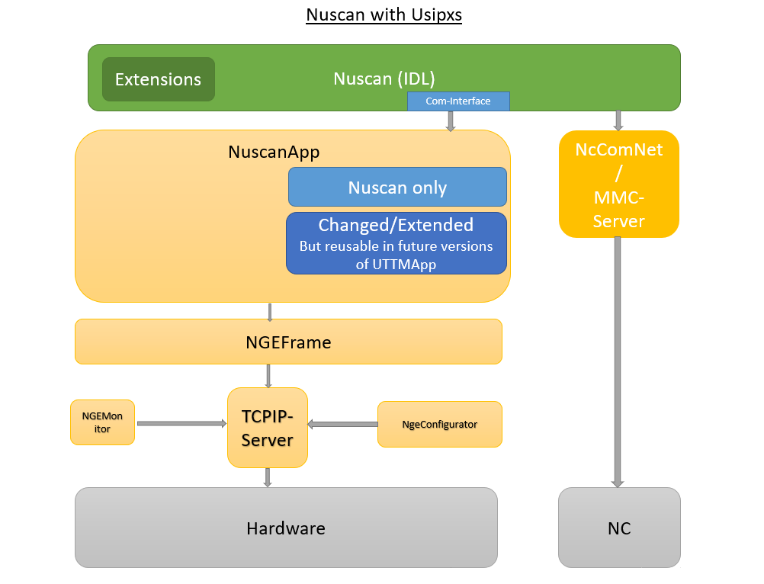

The Nuscan software consists of several individual software parts that communicate with each other. There is a software part written in IDL and a software part written in C++. These two parts communicate with each other via a COM interface. TCPIP is used to communicate with the ultrasonic electronics. Another software part is the NcComNet server, which communicates with the external PLC.

# Concepts

Describes the main concepts used within this module.

Show and describe the modules here.

The software is located on team foundation server:  
Nuscan (IDL)  
[http://alpvbhnptfsa01.ent.bhicorp.com:8080//tfs/Test%20Machines%20%E2%80%93%20Huerth/Sustaining/_git/NuScan](http://alpvbhnptfsa01.ent.bhicorp.com:8080/tfs/Test%20Machines%20%E2%80%93%20Huerth/Sustaining/_git/NuScan)  
NuscanApp (C++)  
[*http://alpvbhnptfsa01.ent.bhicorp.com:8080/tfs/Test%20Machines%20%E2%80%93%20Huerth/USIPxx%20Projects/NuScan_USIPxs/_versionControl?path=%24%2FUSIPxx%20Projects%2FNGE%2FNuscanApp&version=T&_a=contents*](http://alpvbhnptfsa01.ent.bhicorp.com:8080/tfs/Test%20Machines%20%E2%80%93%20Huerth/USIPxx%20Projects/NuScan_USIPxs/_versionControl?path=%24%2FUSIPxx%20Projects%2FNGE%2FNuscanApp&version=T&_a=contents)

## Nuscan (IDL)

Nuscan is programmed in Idl (Interactive Data Language).

The Nuscan software package consists of two main parts.

### Evaluation (options)

The evaluation part also consists of two main parts.

* Scan setup.
* Evaluation of the C-images generated during the scan.

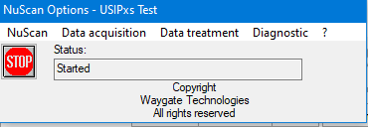

### Acquisition

This part of the program is responsible for:

* Translation of the part geometry to scan paths.
* Conversion of the scan paths into machine coordinates.
* Conversion of the machine coordinates into axis positions(translation) and angles(rotation) based on the definition of the mechanics.
* Communication with the machine control (NC,PLC, SPs) with help of NCComNet.
* Communication with the ultrasound device via COM interface.
* Creation of the scan files.

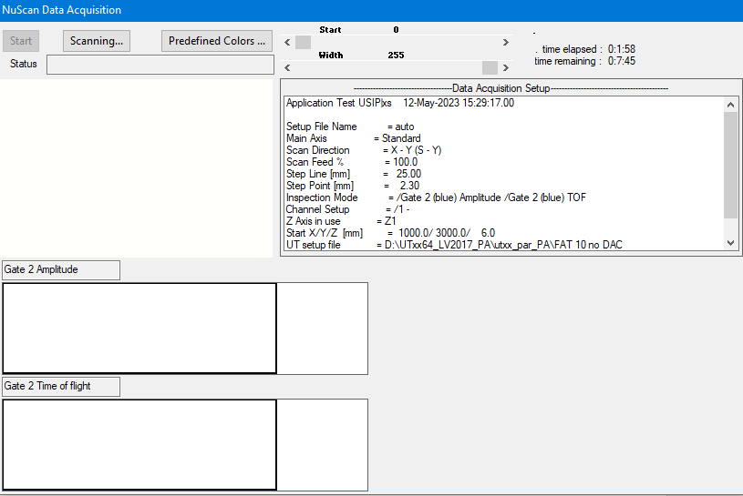

## NuscanApp (C++)

NuscanApp is written in C++. The main modules of the software are NuscanApp, NGEFrame, TCPIPServer, NGEMonitor and NGEConfigurator – other modules e.g., DataServerTf, DataServerAscan, StatusBScan.

### NuscanApp

The higher-level application for making the ultrasound settings.

### NGEFrame

The lower-level application for making the ultrasound settings.

### TCPIPServer

The TCPIPServer module is the interface between human interface software and the ultrasonic electronics.

### NGEMonitor

The NGEMonitor module is used to check, edit, or change the ultrasonic electronics.

### NGEConfigurator

The setup for the ultrasonic electronics can be edited with the NGEConfigurator module. In addition, settings for the ultrasound scan can be made.

### DataServerTf

The DateServerTf module controls the test functions data collection.

### DataServerAscan

The DateServerAscan module controls the data A-Scan data collection.

### StatusBScan

The StatusBScan module generates a B-Scan data structure and displays it on the surface.

## NCComNet

NcComNet is written in C#. It is used as a kind of “glue” between Nuscan(IDL) and the machine control.

With the use of AGLink it can handle div. types of control-system (Siemens) provided by L & R.

# Data

Describes major data structures. May reference to attached class names but does not contain a full class/member description.

# Testing

Each software release is tested and approved by a quality team. Errors are documented and fixed by means of these tests.  
Individually, unit test are implemented in the software.

# Dependencies

The Nuscan(IDL)-Part of the software uses some external Modules

|  |  |  |
| --- | --- | --- |
| Module | Type | Task |
| Adodb | Dll | Connect’s Nuscan to SQL-Server in addition to Dataminer (Part of IDL) |
| GEDateTime | Ocx | Input-Control for Date/Time |
| GEListAX | Ocx | Wrapper around Windows-List-Control |
| GEPassword | OCX | Password input |
| GETooltip | Ocx | Tooltip-control |
| ToolAPI | Dll | Wrapper around some Windows Api-Functions |
| UserApi | Dll | Dialog for assigning User-Permissions |
|  |  |  |

# 3rd Party SW

|  |  |  |
| --- | --- | --- |
| Component |  | License |
| XListCtrl GECommonCtrl/GEListAx/XListCtrl |  | CPOL-1.02 |
| Farpoint Spreadsheet Control  ToolImport/integration_huerth/FarPoint |  | Commercial |
| msinttypes  ToolImport/integration_huerth/rapidjson/include/msinttypes |  | BSD-3-Clause |
| Ogay/sha2  TMUtilities/integration_huerth/TMUtilities |  | BSD-3-Clause |
| rapidjson  ToolImport/integration_huerth/rapidjson |  | MIT |
| VisualStylesXP.cpp/h |  | Basic MIT-Style |
| FFTLib  NGEDataAScan/integration_huerth/NGEDataAscanFFT/FFTLib |  | ? |