Morph telco 2022-10-05, 13:00 CET

**Link:** [**https://meet.google.com/nsj-tbcy-yop**](https://meet.google.com/nsj-tbcy-yop) **[check here for link updates if it doesn’t work]**

**Latest Definitions:**  <https://github.com/ontolex/morph/blob/master/draft.md>

**Nexus:** https://nexuslinguarum.eu/the-action/join-us

**Participants [please add yourself]:**

Christian Chiarcos (CC)

Max Ionov (MI)

Katerina Gkirtzou (KG)

Fahad Khan (FK)

Khadija Ait ElFqih (KAE)

Matteo Pellegrini (MP)

Ciprian-Octavian Truică (CT) - excused

Penny Labropoulou (PL) - excused

Elena Simona Apostol (ESA)

Sina Ahmadi (SA)

Elena Benzoni (EB)

Petra Steiner (PS)

Theodorus Fransen (TF)

Thierry Declerck (DFKI)

# 0. Module draft

**Draft 4.16**

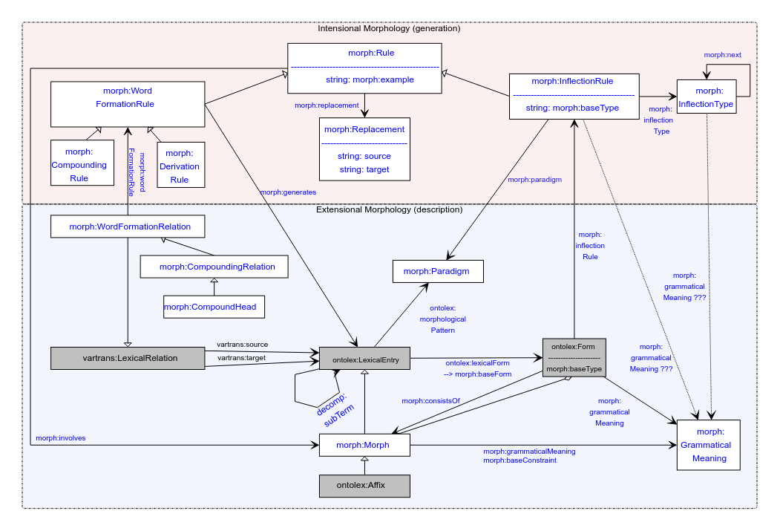

# 1. Publications

LLODream: Presented, an overview of the model. Not much feedback, but there was moderate interest

Publication: deadline 01.12, post-presentation publication

For Rasprave journal:

* Croatia’s linguistic journal
* All papers, including abstracts, summaries, notes and references should be not shorter than 24 000 and not longer than 30 000 characters with spaces.
* Manuscripts should be sent by e-mail to [rasprave@ihjj.hr](mailto:rasprave@ihjj.hr)
* Info from : <https://llodapproaches2022.mruni.eu/wp-content/uploads/2022/02/Rasprave_guidelines-for-authors_vilnius.pdf>

TODO@MI: ask CC if he wants to take charge on this

# 2. Handling of Semitic languages

TODO: figure out how to include missing categories to LexInfo (who?)

# 3. Definitions

See <https://github.com/ontolex/morph/blob/master/draft.md> and <https://github.com/ontolex/morph/issues> .

* PS: how to represent order of morphemes (more than one affix)
  + MI: inflectionType next (only for inflection)
  + CC: for derivation, we can decompose it into a tree structure by nesting lexical entries in derivation then order is indirectly encoded
  + CC: we also have an aggregate relation between form and morph, that can be an rdf:Seq [**TODO**: check that this is explicitly mentioned in draft]
    - Proposal@CC (after telco): that should be the preferred answer
* PS: how to represent derivation trees? ((A B) C)
  + CC: has been one of the original requirements (https://www.w3.org/community/ontolex/wiki/Morphology#Representation_needs, "N7: Multiple segmentation strategies")
  + Current solution: use decomp (note we have decomp:subterm already in diagram); if all intermediate steps are valid lexemes, this can also be done via multiple WordFormationRelations (Rules)
* Otherwise postponed, leaving more time for 3.
* CC (after telco): started to check and update requirements in wiki: <https://www.w3.org/community/ontolex/wiki/Morphology#Representation_needs>

# 4. Results of the STSM

# 5. AoB

Next call in 2 weeks