Morph telco 2022-03-09, 13:00 CET

**Link:** [**https://meet.google.com/nsj-tbcy-yop**](https://meet.google.com/nsj-tbcy-yop)

**Latest Definitions:**  <https://github.com/ontolex/morph/blob/master/draft.md>

[**https://meet.google.com/nsj-tbcy-yop**](https://meet.google.com/nsj-tbcy-yop)

**Participants [please add yourself]:**

Christian Chiarcos (CC) [christian.chiarcos@gmail.com](mailto:christian.chiarcos@gmail.com)

Matteo Pellegrini (MP)

Max Ionov (MI)

Katerina Gkirtzou (KG)

Penny Labropoulou (PL)

Fahad Khan (FK)

Agenda (please add, *but* do not edit table of contents directly, but add sections below and then update here):

**1. Module draft** **1**

**2 LDL submission ?** **2**

**3 Evaluation of inflectional data modeling** **3**

3.1 morph:stemType (Greek/Latin) 3

3.2 vartrans:orthVariant (Greek/Penny; Old English/Fahad) 3

3.3 POSTPONED: Other data 4

**4. Other todos** **5**

3.1 OntoLex TermElement vs. Morph subclasses 5

3.2 crafting/collecting definitions 5

# 1. Module draft

**draft 4.12**

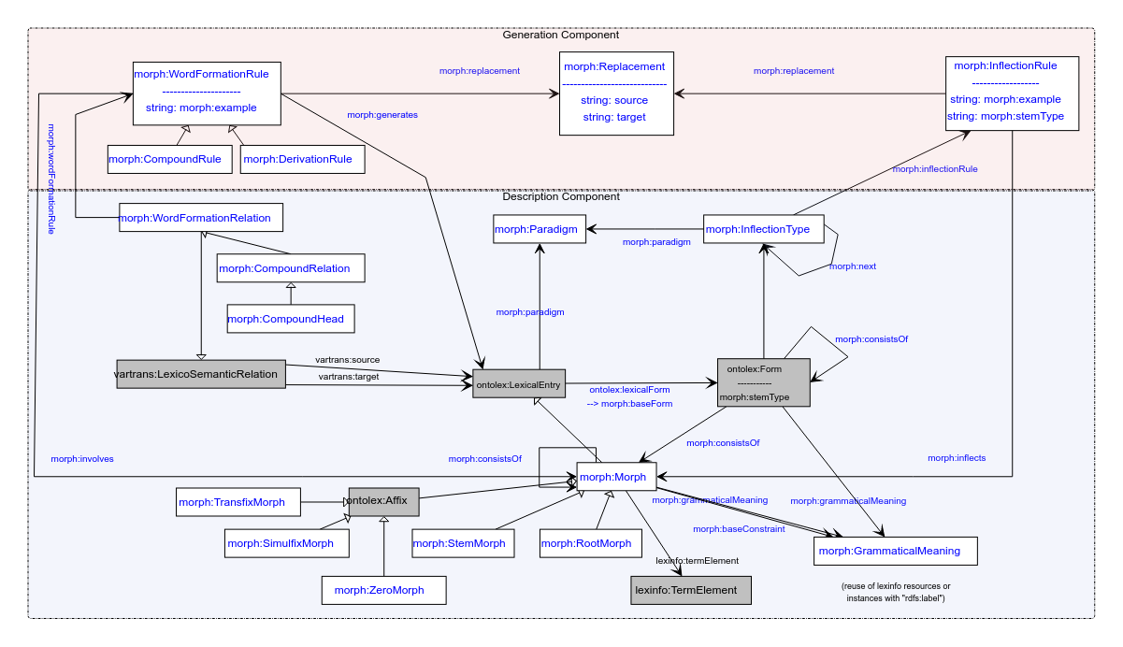

**Model draft 4.12 updates**

* morph:morphophonologicalRelation dropped
* grammaticalMeaning also pointing from ontolex:Form to GrammaticalMeaning (per request by Matteo and Penny) – mostly for filtering convenience
* stemType moving from LexicalEntry to ontolex:Form
* the arrow for involves *filled*

**Model draft 4.13 updates:**

* Rename morph:stemType property in the morph:Form (not in the InflectionRule). The

# 2 LDL submission ?

suggested last week, could document modelling progress

Deadline: April 8th

Willing to contribute:

* Christian
* Matteo
* Penny
* Max

TOOD@Max: send a Doodle poll to discuss the plan and responsibilities

# 3 Evaluation of inflectional data modeling

## 3.1 morph:stemType (Greek/Latin)

* different base forms for generation
  + stemType for “co-indexing” inflection rules and baseForms
  + Penny: my example is computational, not lexicographical, needed there

(from modern Greek inflection)

=> morph:stemType (identifier for different stems, also needed for Latin)

question: why at inflection rule and at ontolex:LexicalEntry ?

cf. Question (CC, 2022-02-23, offline): wouldn't it make more sense to model stemType at a (base) form rather than at the level of lexical entries?

tbc whether this works for Latin/Matteo

Added slides for tomorrow's discussion: <https://docs.google.com/presentation/d/1DI50ytMI1xcDjxpPQhAT1t6-jWbr5zCX/edit#slide=id.p1>

- Greek inflection: slides 1-3

- orthographic variants: slide 4

## 3.2 vartrans:orthVariant (Greek/Penny; Old English/Fahad)

OE sample data: …

New examples with vartrans:orthVariant as a vartrans:category (found it more interesting to instead of adding it just as a subproperty). What is still not clear though is how to define that the two (or more) orthographic variants share the same senses and syntactic behaviour.

lexis_data:augo_26232 a ontolex:LexicalEntry ;

rdfs:label "αυγό"@el ;

ontolex:canonicalForm lexis_data:augo_form

lexinfo:partOfSpeech lexinfo:commonNoun ;

morph:paradigm lexis_data:vouno ;

ontolex:sense lexis_data:augo_sense_USem1074 ;

synsem:synBehavior lexis_data:augo_SUNo25013 .

lexis_data:avgo_34067 a ontolex:LexicalEntry ;

rdfs:label "αβγό"@el ;

ontolex:canonicalForm lexis_data:avgo_form

lexinfo:partOfSpeech lexinfo:commonNoun ;

morph:paradigm lexis_data:vouno ;

~~ontolex:sense lexis_data:augo_sense_USem1074 ;~~

~~synsem:synBehavior lexis_data:augo_SUNo25013~~ .

lexis_data:avgo_form ontolex:writtenRep "αβγό"@el .

lexis_data:augo_form ontolex:writtenRep "αυγό"@el .

lexis_data:avgo_orthVariants a vartrans:LexicalRelation ;

vartrans:source lexis_data:avgo ;

vartrans:target lexis_data:augo ;

vartrans:category lexis:orthVariant .

Questions:

* morph namespace instead of lexis for orthVariant?
* any relation with `morph:baseForm` ?

Option with lexicog module works but multiplies the lexical entry data, e.g. senses have to be created for all lexicographic components.

* consensus

→ to be developed as part of the vartrans module but applied in order to connect two ontolex:LexicalEntry resources that only differ in their orthographic representation but share the same senses: a vartrans:orthVariant subproperty of vartrans:lexicalRel that entails that the same senses apply to both variants (restriction has to be formulated)

* possibilities (last time):

1. create separate entries and link them with a subproperty of vartrans:lexicalRel (your_namespace:orthVariant sub vartrans:lexicalRel) between two ontolex:LexicalEntries that are orthographic variants - the shared data of both would have to be repeated for both entries then or it has to be stated only on one lexical entry resource (duplicate all senses)
2. alternatively, leave senses of the variant empty, define in the semantics of orthVariant that this entails that the same senses apply to both variants)
3. use owl:sameAs and share senses (a bit messy, because semantically this means they are the same thing)

## 3.3 POSTPONED: Other data

define discussion order for

* FST grammars (German, Christian+Max, <https://github.com/acoli-repo/acoli-morph/tree/main/morphisto>)
* sample data on GDrive

# 4. Other todos

## 3.1 OntoLex TermElement vs. Morph subclasses

* <https://www.w3.org/community/ontolex/wiki/Morphology#Fixed_set_of_morph:Morph_classes:_Telco_12.05.2021>
* <https://github.com/ontolex/lexinfo/issues/21>
* question: extend lexinfo (and abandon morph subclasses) or morph subclasses (and replicate lexinfo) ?
  + the current modelling with some subtypes of morph(eme)s modelled as subclasses and others as TermElements is inconsistent

## 3.2 crafting/collecting definitions

* <https://github.com/ontolex/morph/blob/master/draft.md>
* you can contribute suggestions by creating issues (<https://github.com/ontolex/morph/issues>), via pull requests, or by direct editing (share your GitHub password)

## 