Morph telco 2022-12-21, 13:00 CET

**Link:** [**https://meet.google.com/nsj-tbcy-yop**](https://meet.google.com/nsj-tbcy-yop) **[check here for link updates if it doesn’t work]**

**Latest Definitions:** [**https://github.com/ontolex/morph/blob/master/draft.md**](https://github.com/ontolex/morph/blob/master/draft.md)

**Nexus:** [**https://nexuslinguarum.eu/the-action/join-us**](https://nexuslinguarum.eu/the-action/join-us)

**Participants [please add yourself]:**

Christian Chiarcos (CC, excused)

Max Ionov (MI)

Katerina Gkirtzou (KG)

Fahad Khan (FK)

Khadija Ait ElFqih (KAE)

Matteo Pellegrini (MP)

Ciprian-Octavian Truică (CT)

Penny Labropoulou (PL)

Elena Simona Apostol (ESA)

Sina Ahmadi (SA)

Elena Benzoni (EB)

Petra Steiner (PS)

Theodorus Fransen (TF)

Thierry Declerck (DFKI)

Ranka Stanković

Gilles Sérasset (GS)

Mike Rosner (MR)

https://meet.google.com/nsj-tbcy-yop

# 0. Module draft (4.17)

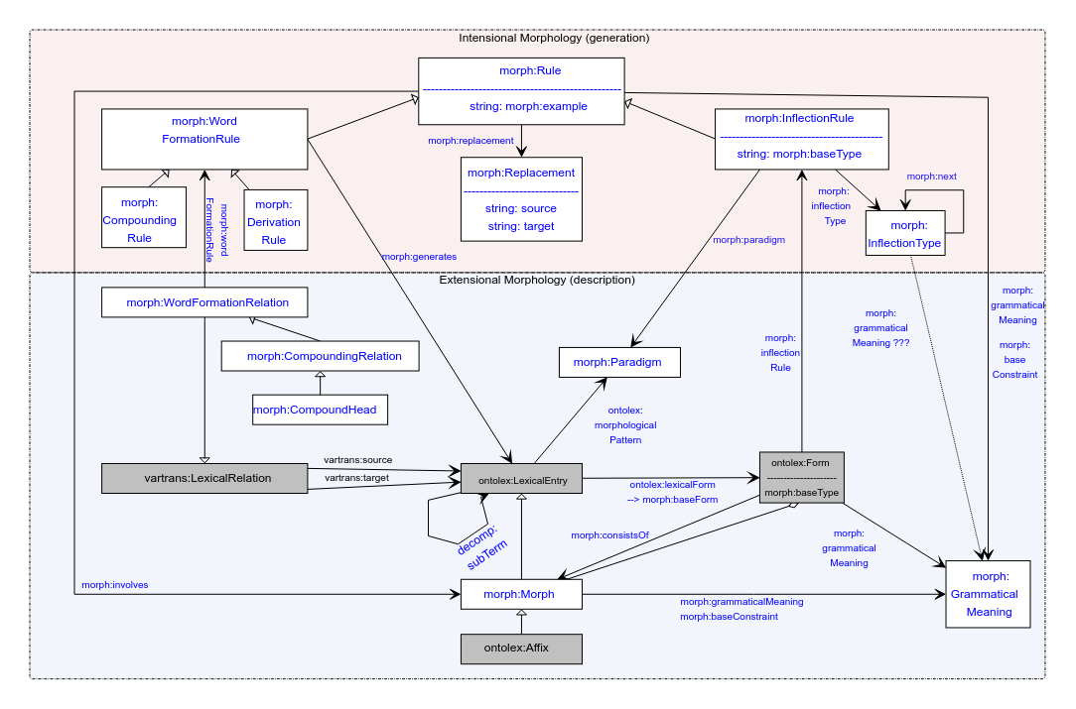

No changes

# Organizational

* Happy New Year. It’s 2023 already
* Morphology is great and vast, but **we really need to finish**. See below

# Publications

## eLex 2023

<https://elex.link/elex2023/>

**Submission deadline: 31.01.2023**

* Abstract only

Dates: 27.06-29.06

Topic:

* PL, KG: featured example for trad. Dict + computational resource, any updates?
  + Unable to get access to the digital dictionary with inflection that Penny suggested last time
* MR, ?: Semitic use-case?
* TF: Old Irish is possible, but not enough time

MI’s take:

* We need to go with a **simple use-case** to **demonstrate the full model**. This should become a reference publication (as it was with the previous eLex publication)
* Presenting at eLex gives us audience outside of LLOD but very relevant
* Focusing on complicated examples in a short presentation confuses people and makes them focus on said example, whereas we want to present our model
* Maybe show small examples of different types of morphology to show how we can handle it?
* Thoughts?
  + MP: Have a partial dataset with inflection, not full dataset
  + MI: I think it’s perfect
  + MP: Too many reference publications? There will also be *the* reference publication — the model description
  + FK: Maybe something directed at (e-)lexicographers. Something like a reverse to what was made for DH. Maybe morph+frac.
    - Take a more traditional electronic dictionary, maybe TEI, mention RDFa, show how it can be modeled in OntoLex. TEI conversion is secondary focus
    - Maybe take dictionaries from different types of languages
    - MR: is it a prerequisite that these entries are in machine-readable format?
    - FK: no, we can take entries from paper dictionaries
    - MR: then there is data

See [example](https://docs.google.com/document/d/1Z7z36kjzgTjLCB3YJswqzh1lLhN9GDKZ2ecACcXYeqI/edit?usp=sharinghttps://docs.google.com/document/d/1Z7z36kjzgTjLCB3YJswqzh1lLhN9GDKZ2ecACcXYeqI/edit?usp=sharing)

* + - Select entries to showcase specific phenomena in the corresponding languages
  + Topic: a showcase of representation of entries from different dictionaries with possibly different morphologies
  + Lead: **MI** + FK + MR
  + Authors: TF, CT, ESA, GS (depending on the content details)

## MWE Chapter

* Initiated in FrAC
* Initial abstract: <https://docs.google.com/document/d/1HLTsYScMiZE4Nb6b7mozN-SoKAIWtisdiKLa0OoXPuU/edit?usp=sharing>
* Draft for chapter: <https://www.overleaf.com/8285444258rpfnbwgwbrdp>
  + Template applied (<https://www.overleaf.com/latex/templates/langsci-skeleton-for-edited-volumes-2022-06/vvjbpxnrbnkk>)
  + Most content is there, very rough draft
* Slack channel: #frac-mwe-chapter
* authors: CC KG MI BK FK CT EA (TD can also contribute, we have been doing some work on MWE in Elexis)
  + Matteo: Latin not a great fit, possibly Elena Benzoni, tbc. yet (not sure)
    - Not by Jan 15
  + FK: maybe 1,5 weeks in January
* **Deadline will be extended, but only for 2 weeks**
  + (Sh|C)ould we ask for more?
    - FK: yes, definitely
    - TODO@MI: Ask CC to TODO@CC for another extension

# It is 2023, we need to finish the module

* MI: I think we achieved a level where we freeze everything and write it up
* Is there anything we are missing?
  + KG: LREC paper discusses the limitations of the module, we need to look at this, discuss the asap. **TODO@KG**: look into it and add this to the agenda or report it
  + MI: I think that we can still have limitations unsolved for the final module, we just need to explicitly decide
* Should we vote in Slack+mailing list since not everyone is in the call (*prediction*)
  + CC and MI should decide, then send to OntoLex chairs to approve
  + TODO@MI,CC: discuss
* Thoughts?
  + FK: maybe we still need more discussions, especially w.r.t. Semitic languages
  + FK: maybe we can take a couple of Wiktionary examples, model them (naively) and then show to experts (Mike, Khadija, Ilan)
  + FK: it is very important that we deal with non-European languages (non-Indo-European), so we need to make sure that we *can* model at least a good sample of languages of the world
  + MR are we going to try to handle Maltese data of [this kind](https://docs.google.com/document/d/1Z7z36kjzgTjLCB3YJswqzh1lLhN9GDKZ2ecACcXYeqI/edit?usp=sharing)? If so I would be glad to help.

# Handling of Semitic languages [maybe today]

**TO-BE-DONE**: figure out how to include missing categories to LexInfo

Khadija: data prepared for Arabic (cf. last time):

* [Morph Module semitic.odt](https://drive.google.com/file/d/1NST-qdkxAw7am6F3vGAap5o4eQv0ulV1/view?usp=sharing)

Necessary features:

* lexinfo:POS extensions (solved? See last call minutes for procedure)
* Modelling diacritics in Arabic (cf. call minutes last time)
  + Also cf. Umlaut in German and vowel harmony in Turkish for similar challenges
    - Recommendation (< GS): NFD normalization in morph:Replacement
    - **TBC:** are we ok with modelling roots as Morphs (i.e., LexicalEntries)?
  + If not modelled as morphs, then they could be modelled as rules (replacements)
    - **DONE@CC**: model updated
      * morph:grammaticalMeaning and morph:baseConstraint as properties of morph:Rule, the grammatical meaning is the change in meaning or morphology of the word (root)
    - **TO-BE-DONE@FK:** model a Hindi/Urdu example, e.g., <https://en.wiktionary.org/wiki/%E0%A4%96%E0%A5%81%E0%A4%B2%E0%A4%A8%E0%A4%BE#Hindi>
    - **TO-BE-DONE@Khadija:** Modelling examples for Arabic entries
* Not discussed yet: Circumfix
  + Morph:CircumfixParadigm
  + Prefix+suffix combination

## AoB ?

* We moved weeks, is that okay for everyone?
* Next call: 25.01.23