**Participants:**

Bettina Klimek (BK) [bettina.klimek@semalytix.com](mailto:bettina.klimek@semalytix.com)

Fahad Khan (FK)

Matteo Pellegrini (MP)

1. **Module draft 4.8**

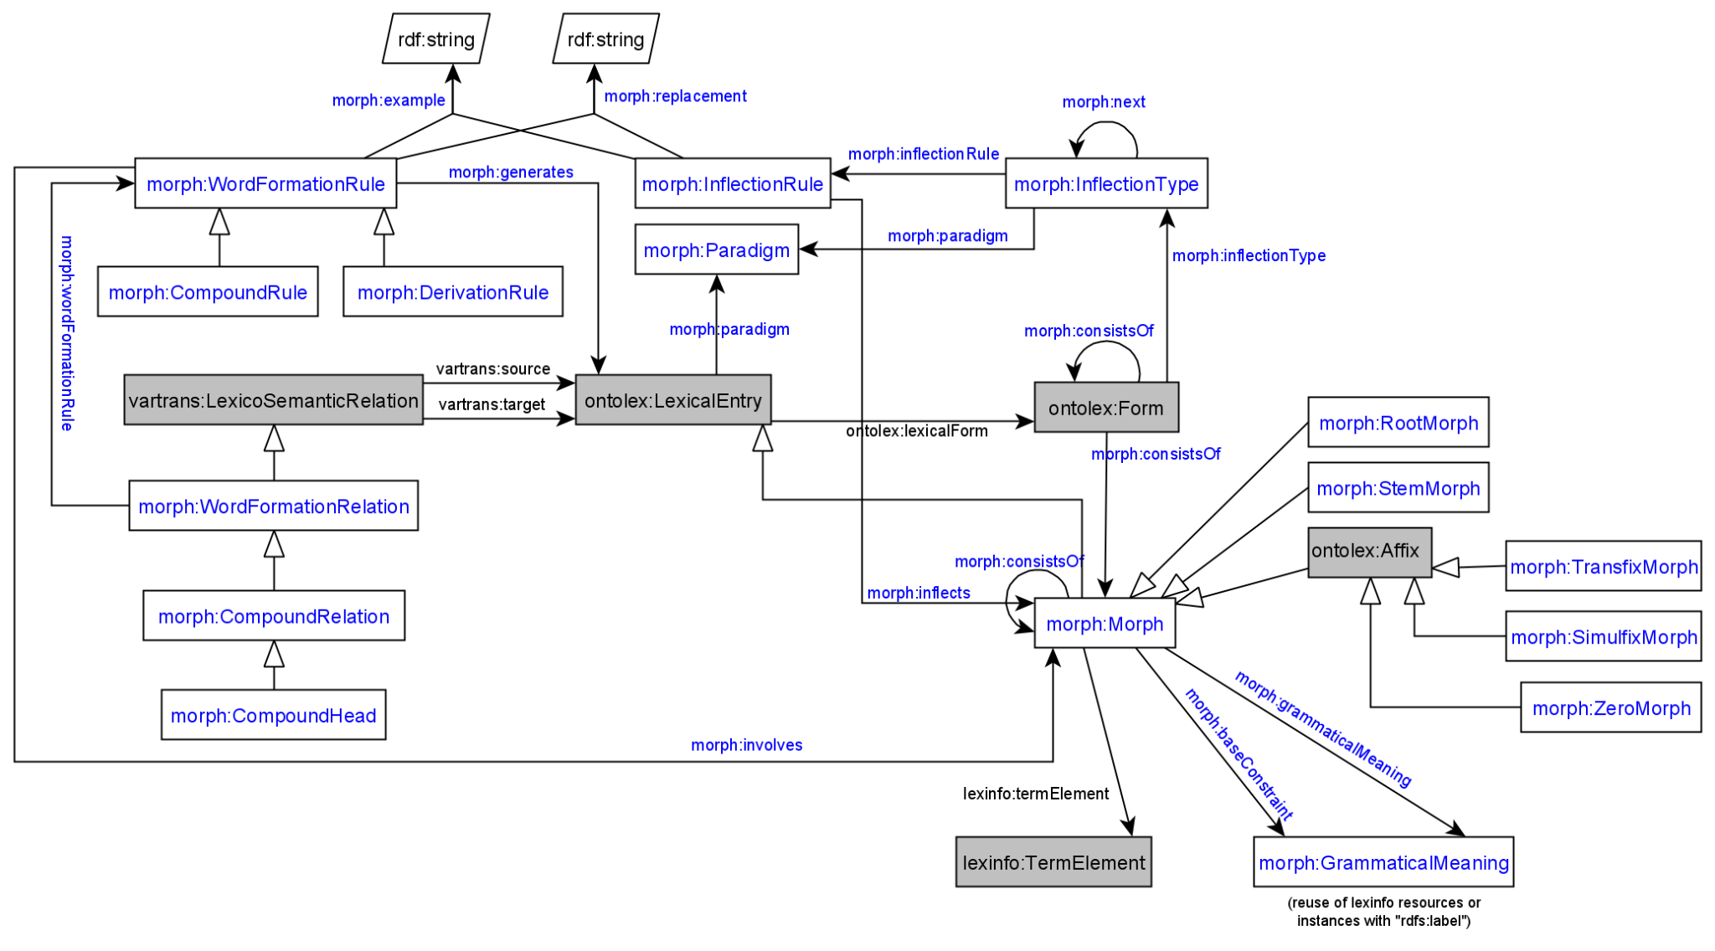

Adaptations included into module draft 4.8:

* morph:CompoundHead is subclass of morph:CompoundRelation
* object property: morph:baseConstraint with domain: morph:Morph and range: morph:GrammaticalMeaning
* replaced “external resource” as object of morph:grammaticalMeaning with class morph:GrammaticalMeaning
* one of the affix class merge options: removed morph:AffixMorph class, ontolex:Affix is a subclass of morph:Morph and the affix classes are subclasses of ontolex:Affix
* removed ontolex:Affix as subclass of ontolex:LexicalEntry

Adaptations to be included into module draft 4.9:

* datatype property morph:stemType with a literal and domain morph:InflectionRule
* add morph:baseForm as subproperty of ontolex:lexicalForm (in order to link a stem morph with a lexical entry)
* datatype property morph:morphophonologicalRelation on ontolex:LexicalEntry an ontolex:Form

**2. Greek inflectional data example by Penny**

Used [greek LEXIS lexicon data](https://drive.google.com/drive/folders/1ZYWx6KlOZ-T-fbb7fQkqNkByGTuE9Kwp?usp=sharing) (Greek extension of parole/simple)

What was aimed to be represented:

* morphological unit has grammatical category (part of speech) and canonical from, has an inflectional paradigm and is linked to the stems
* inflectional paradigm consists of constraints for part of speech and a set of grammatical features (number, case..) and a number reference to a stem and an ending (a suffix)
* representation of stress movement on syllables with morphophonological change
* representation of of link between morphological unit and graphic morphological unit

Questions:

1. How to link similar lemmas together with morphophonological relations to state which has been derived from the other?

datatype property morph:morphophonologicalRelation on ontolex:LexicalEntry and ontolex:Form

1. Orthographic variants of lemmas with similar inflectional paradigms should be linked.

E.g. different spellings in German words with “ph” and “f” which are both allowed (Foto vs. Photo)

Fahad: link both lexical entries with owl:seeAlso

CC: use lexicog vocabulary and treat both lexical entries under a single lexicon headword

→ Penny will look into lexicog module

3) How to represent the prototypical inflectional paradigm? Specifying the correct base form for a particular rule.

CC: proposes datatype property morph:stemType with a literal and domain morph:InflectionRule

**3. Representing the order of morphs**

General questions:

* granularity: ordering of morph:Morph resources in ontolex:LexicalEntry, ontolex:Form, morph:Morph?
* scope: unspecified ordering (linear enumeration) vs. relational ordering (before/after stem) - resurrecting morph:Prefix and morph:Suffix?
* representing non-linear morphs, i.e. transfixes and circumfixes in a generic way
* inclusion of decomp:Component resources?

Option 1: Reuse of ordered lists with RDF containers:

morph:Seq a rdf:Seq;

rdf:_1 :resource 1;

rdf:_2 :resource 2 .

Todo:

* Penny will update the Greek example data by using the lexicog module vocabulary
* all: look into Matteo’s presentation about Latin inflectional data: MATTEO ADD URL to presentation <https://drive.google.com/file/d/1v2M-LbCdrdaPl2LVuPKzOfU-fQjv_5_1/view?usp=sharing>

[MP: the part that I would like to discuss is the one on inflection, from slide 28]