Morph telco 2022-11-16, 13:00 CET

**Link:** [**https://meet.google.com/pvq-hxqi-arr**](https://meet.google.com/pvq-hxqi-arr) **[check here for link updates if it doesn’t work]**

**Latest Definitions:**  <https://github.com/ontolex/morph/blob/master/draft.md>

**Nexus:** https://nexuslinguarum.eu/the-action/join-us

[CC: apparently, Max needs to let us in

I created a new gmeet NOW]

**Participants [please add yourself]:**

Christian Chiarcos (CC)

Max Ionov (MI)

Katerina Gkirtzou (KG)

Fahad Khan (FK) (excused: 20 min late)

Khadija Ait ElFqih (KAE) – excused

Matteo Pellegrini (MP)

Ciprian-Octavian Truică (CT)

Penny Labropoulou (PL)

Elena Simona Apostol (ESA)

Sina Ahmadi (SA)

Elena Benzoni (EB)

Petra Steiner (PS)

Theodorus Fransen (TF)

Thierry Declerck (DFKI)

Ranka Stanković

Gilles Sérasset (GS)

# 0. Module draft (4.17)

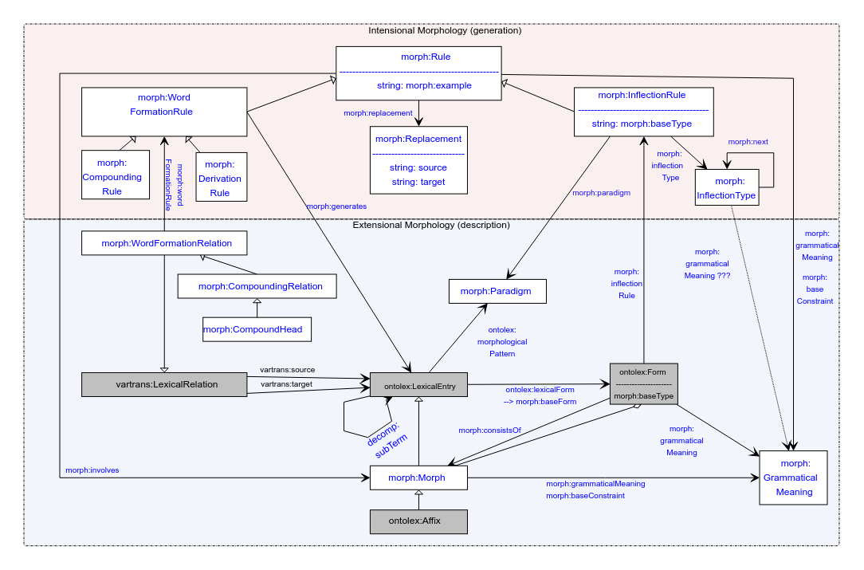

Updates:

* Domain of baseConstraint and grammaticalMeaning now includes morph:Rule
* New section: <https://github.com/ontolex/morph/blob/master/draft.md#overall-structure>

# 1. Publications

## LLODream postproceedings

deadline 01.12, post-presentation publication

Consensus: wait with an overview until model is stable

## MWE Chapter

* Initiated in FrAC
* Doodle poll: <https://doodle.com/meeting/participate/id/dyrZg8ze>
* Draft for chapter: <https://www.overleaf.com/8285444258rpfnbwgwbrdp>
* Template: <https://www.overleaf.com/latex/templates/langsci-skeleton-for-edited-volumes-2022-06/vvjbpxnrbnkk>, chapters/01.tex
* Initial abstract: <https://docs.google.com/document/d/1HLTsYScMiZE4Nb6b7mozN-SoKAIWtisdiKLa0OoXPuU/edit?usp=sharing>
* Slack channel: #frac-mwe-chapter
* authors: CC KG MI BK FK CT EA (TD can also contribute, we have been doing some work on MWE in Elexis)
* **TODO@CC**: Doodle poll for next call

## eLex 2023

<https://elex.link/elex2023/>

Submission deadline: 31.01.2023

Dates: 27.06-29.06

Topic tbd:

* Overview of the model
  + LREC was just dynamic part
  + Focus on changes since the last presentation
    - Inflection type, grammatical meaning changed
    - Descriptive part: morph
* Use case: Semitic? [if we have a consensus on that]
  + Probably too late
* Abstract only, paper later
* Topic to be decided at next call

# 2. Handling of Semitic languages [postponed]

Postponed, need Khadija to join (excused today)

## 3. Interlinking Latin Language Data in the Linguistic Linked Open Data

* Thierry STSM@CIRCSE/LiLa Sep-Oct 2022
* Focus on morphology, esp. with Marco Passarotti and Matteo
* *Issue*: linking with the corpus is problematic if corpus words are not disambiguated (semantically and grammatically)
  + Introduced underspecified forms (multiple lexinfo values for the same lexinfo property, e.g. lexinfo:case)
  + Suggestion: class morph:UnderspecifiedMorph as a subclass of ontolex:Form (?)
    - Matteo: yes, maybe better morph:UnderspecifiedForm?
* *Issue:* frequency counts for fully and partially disambiguated morphs
  + Suggestion: use morph:UnderspecifiedMorph, as well
  + Should be a FrAC Observable (“underspecified observable”)
* Tbc: do we need fully specified lexical entries in the model?
  + If not, this class would be nice to have
* Blog post
  + Draft restricted, so far, **TODO@TD**: provide a public link
* Gilles: rather classical problem, any examples with multiple underspecified dimensions
  + Same problem for Greek, Serbian, German (also Latin), e.g., number+case combinations
    - Post-call: Russian *кушанье* “food”, gen.sg.=nom.pl=acc.pl *кушанья* (gen.pl *кушаний*, nom.sg.=akk.sg. *кушанье*)
      * Serbian:   
        1) *predikcija* “prediction”; *predikcija* (gen.pl.=nom.sg.), *predikcije* (nom.pl.=acc.pl.=voc.pl.=gen.sg.)  
        2) *doteran* “polished”, adjective; form *doterana (nom.sg.fem.=voc.sg.fem.= gen.pauk.masc.=acc.pauk.masc.= nom.pl.neut.=voc.pl.neut.)* ;
  + Matteo: link forms to bundles of features (=> GrammaticalMeaning[s], optionally with lexinfo feats)
* Christian:
  + possibly forms can be underspecified in OntoLex (cf. one form for multiple lexical entries [not forbidden], forms in lexical resources that don’t disambiguate morphological features]); then, no new class needed
  + Possibly to be modelled with frac:Observable, cf. corpus queries (not fully discussed yet)
    - Gilles: not limited to FrAC use cases, but general feature of lexical resources; also not limited to morphology
    - Matteo: problem in the definition of ontolex:Form? [just string or string+features? Both definitions occur]
  + Question: do we need a specific class?
    - Thierry: was introduced for readability
    - Christian: We can infer underspecification from having multiple grammatical meanings
    - Matteo: in Lila helpful, but can be user class, useful feature is to state that something is unambiguous
    - Christian: model by property morph:soleGrammaticalMeaning (must be unique per form)
    - Matteo: or, specify at observable? Doesn’t necessarily require an extension of morph
  + Telco link: <https://meet.google.com/whn-efaq-cha>
  + **TODO@MP**: small data example

## 4. Definitions

See <https://github.com/ontolex/morph/blob/master/draft.md> and <https://github.com/ontolex/morph/issues> .

Postponed

## 5. AoB ?

Thierry: Cost Action UniDive on MWEs, Universal Dependencies etc.: <https://www.cost.eu/actions/CA21167/>

* Overlap: Thierry, Ranka, Christian
* Meetings yet to happen
* Thierry: reached out to establish ties between Nexus and UnIDive