Morph telco 2022-04-19, 13:00 CEST

**Link:** [**https://meet.google.com/nsj-tbcy-yop**](https://meet.google.com/nsj-tbcy-yop)

**Latest Definitions:** [**https://github.com/ontolex/morph/blob/master/draft.md**](https://github.com/ontolex/morph/blob/master/draft.md)

**Nexus:** [**https://nexuslinguarum.eu/the-action/join-us**](https://nexuslinguarum.eu/the-action/join-us)

**Participants [please add yourself]:**

Christian Chiarcos (CC) (20 min late)

Max Ionov (MI)

Katerina Gkirtzou (KG)

Besim Kabashi (BK)

Fahad Khan (FK)

Khadija Ait ElFqih (KAE)

Matteo Pellegrini (MP)

Ciprian-Octavian Truică (CT)

Penny Labropoulou (PL)

Elena Simona Apostol (ESA)

Sina Ahmadi (SA)

Elena Benzoni (EB)

Petra Steiner (PS)

Theodorus Fransen (TF)

Thierry Declerck (DFKI)

Ranka Stanković (RS)

Gilles Sérasset (GS)

Mike Rosner (MR)

Table of Contents

0. Module draft (4.17)

1. Semitic Roots

2. morph:baseConstraint

# 0. Module draft (4.17)

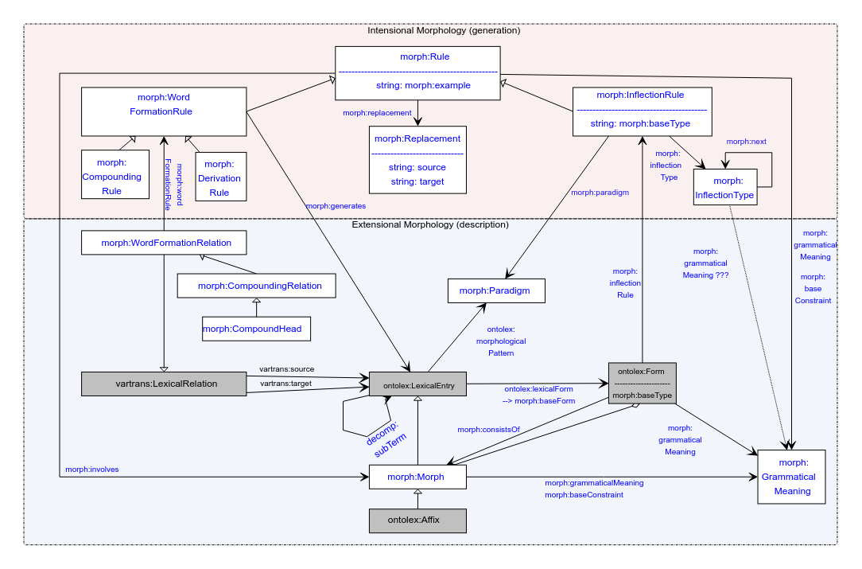

# 1. Semitic Roots

MI:

* Suggestion: Roots are morphs (lexinfo:RootMorph), canonical forms specified for a lexical entry consist of them.
* Approved by participants

Note by CC: lexinfo:RootMorph is suggested for addition to Lexinfo (<https://github.com/ontolex/lexinfo/issues/21>), then, it entails ontolex:LexicalEntry [that was also in one of our papers and the reason to abandon the morph taxonomy more than one year ago]

:k-t-b a lexinfo:RootMorph, ontolex:LexicalEntry ;

ontolex:evokes :k-t-b_meaning;

rdfs:label "k-t-b" .

# CC: clarification question: is the suggestion to not provide a lexical form?

# MI: for this particular lexical entry?

# CC: yes

:k-t-b_meaning a ontolex:LexicalConcept.

# not: LexicalSense

:kiteb a ontolex:Word ;

lexinfo:partOfSpeech lexinfo:verb ;

morph:morphologicalPattern <kiteb_paradigm> ;

ontolex:canonicalForm <kiteb_form> ;

morph:baseForm <kiteb_form> .

<kiteb_form> a ontolex:Form ;

morph:consistsOf roots:k-t-b ;

ontolex:writtenRep "kiteb"@mlt ;

ontolex:phoneticRep "/kɪtɛp/" .

NB: lexinfo:etymologicalRoot: lexical entry -> lexical entry; “Morpheme that has a particular status with regards to the word's etymology.”

# 2. Morph ordering

One of the requirements.

morph:consistsOf <morph1>, <morph2>

(this is RDF, unordered)

Diagram: diamond-symbol operator (that’s standing for rdfs:Seq)

:x morph:consistsOf :m1, :m2.

:x a rdfs:Seq; rdf:_1 :m1; rdf:_2 :m2.

We could debate whether to use Seq (= previously preferred) or List (= also discussed)

(for circumflexes, we either need to decompose or just to provide morph:consistsOf)

## 

# 3. AoB

We move the call by 15 minutes! Next call: 03.05.2023, **13:15 CEST**.

# 4. Chat (restructured, and filtered but not changed)

## 4.1 Arabic (RootMorph)

Fahad Khan

13:13

<https://en.wiktionary.org/wiki/%D9%83_%D8%AA_%D8%A8#Arabic>

Fahad Khan

13:30

I also don't think consonantal root should be a lexicalconcept, since it also plays a role in derivational morphology

Christian Chiarcos

13:31

what is the practice in dictionaries? organization by root or individual words? I guess in Malti, the latter. What about Arabic?

(@Gilles: yes, lexical entries in a dictionary can be used for a family of related words also in english)

Gilles Sérasset

13:32

@Christian, but ontolex:LexicalEntry has a more narrow sense. lexicog has the mean to represent this.

But sorry, I do have to leave now. Sorry sorry sorry, this discussion is very interesting.

Fahad Khan

13:33

arabic dictionaries are organised on the basis of roots:<https://lingualism.com/modern-standard-arabic/using-an-arabic-dictionary-tips-for-learners/>

Gilles Sérasset

13:34

@Fahad: yes they are ! and chinese ones on the basis of ideographic keys...

## 4.2 other vowel alterrnations (under the same entry or two allomorphs?)

Christian Chiarcos

13:26

as for vowelalternations without 1:1 correspondence to meaning/function, we actually have something similar in IE, too, ablaut. it also doesn't have a transparent function. English fly, flew, flown

= German fliegen - flog -geflogen

but it has other functions, e.g., abstractiuve: Berg (mount) - Gebirge (mountain)

Fahad Khan

13:27

but it isn't systematic enough that dictionaries that aren't etymological dictionaries are organised in terms as roots

in IE languages

Fahad Khan

13:28

*in terms of roots

Christian Chiarcos

13:28

@Fahad: ablaut: no, not in English, of course.

Christian Chiarcos

13:36

cf. gabaurths in<http://www.wulfila.be/lib/streitberg/1910/html/B041.html>, contains a MWE als sub-entry

Besim Kabashi

13:35

@Christian: German "fliegen - flog -geflogen" are forms from different "stem-allomorphs" …

Christian Chiarcos

13:36

@Besim: this is one way of describing them

Christian Chiarcos

13:49

allomorphs are variation (=> vartrans)

Christian Chiarcos

13:50

(differtent modelling strategies, because source documents are too heterogeneous wrt. allomorphs, som we must supoport both morph-level and morpheme-level organization; hence Morph instead of morpheme)

NB: RootMorph entails that :ktb is a lexical entry

Fahad Khan

13:50

yes we discussed this earlier

because Morph is a subclass of LexicalEntry

so every morph is a lexical entry by default

## 4.3 MI’s suggested RootMorph modelling

Fahad Khan

13:36

is rootmorph already in lexinfo?

Matteo Pellegrini

13:37

I don't think so

Christian Chiarcos

13:37

but it's suggested for addition

You

13:37

This is a lexical entry, so we can connect it to the lexical concept

Christian Chiarcos

13:38

modelling: +1

Fahad Khan

13:39

maybe LexicalConcept can be related to the root

Christian Chiarcos

13:39

lexical concept: +1

## 4.4 lexinfo;etymologicalRoot (suggested by Fahad)

Christian Chiarcos

13:42

etymological root is not morphological, I think. can be multi-morpheme

moment

Fahad Khan

13:43

i assume etymological root is a kind of root so it should be a morpheme

etymon is more general

Christian Chiarcos

13:45

lexinfo:etymology (=> skos:definition)

etymnologivcalroot: in lexinfo 3.0, it is indeed a morpheme!

Christian Chiarcos

13:46

with lexinfo:etymologicalRoot, we can connect root and derived words as lexical entries

Fahad Khan

13:49

mmoon seems to be down

<https://github.com/MMoOn-Project/MMoOn>

## 4.4 lexinfo:RootMorph => ontolex:LexicalEntry

Christian Chiarcos

13:51

let's add that exoplicitly to the exam,ple

Besim Kabashi

13:51

+1

Fahad Khan

13:52

we need to change the wording of Lexical Entry in the report

Fahad Khan

13:52

"A lexical entry represents a unit of analysis of the lexicon that consists of a set of forms that are grammatically related and a set of base meanings that are associated with all of these forms. Thus, a lexical entry is a word, multiword expression or affix with a single part-of-speech, morphological pattern, etymology and set of senses."

## 4.5 order of morphemes

Christian Chiarcos

13:52

actually, we did

Christian Chiarcos

13:52

aggregation

hence the diamond in the diagram

what isa not decided is whether to use rdfs:seQ or rdf:List

Christian Chiarcos

13:54

ordering

consists of and the second edge

rdfs:Seq

order can also be indiredctly expressed in the wordformation rules

Christian Chiarcos

13:59

in generation, in the replacement we can match beginning or end of an expression

(i would thus decouple tjhe generation discussion from morph ordering)

## 4.6 more data on Arabic?

Christian Chiarcos

14:00

(I thiunk we can include examples if they help to address requirements we identified before and if the data we have is not sufficient)