Morph telco 2023-09-20, 13:15 CEST

**Link:** [**https://meet.google.com/nsj-tbcy-yop**](https://meet.google.com/nsj-tbcy-yop) **[CHECK HERE FOR UPDATED LINK(S)]**

**Latest Definitions:** [**https://github.com/ontolex/morph/blob/master/draft.md**](https://github.com/ontolex/morph/blob/master/draft.md)

**Nexus:** [**https://nexuslinguarum.eu/the-action/join-us**](https://nexuslinguarum.eu/the-action/join-us)

**Participants [please add yourself]:**

Christian Chiarcos (CC)

Max Ionov (MI)

Katerina Gkirtzou (KG)

Besim Kabashi (BK)

Fahad Khan (FK)

Khadija Ait ElFqih (KAE)

Matteo Pellegrini (MP)

Ciprian-Octavian Truică (CT)

Penny Labropoulou (PL)

Elena Simona Apostol (ESA)

Sina Ahmadi (SA)

Elena Benzoni (EB)

Petra Steiner (PS)

Theodorus Fransen (TF)

Ranka Stanković (RS)

Gilles Sérasset (GS)

Mike Rosner (MR)

Table of Contents

0. Module draft (4.17)

1. Requirements

2. Datasets

3. AoB

# 0. Module draft (4.17)

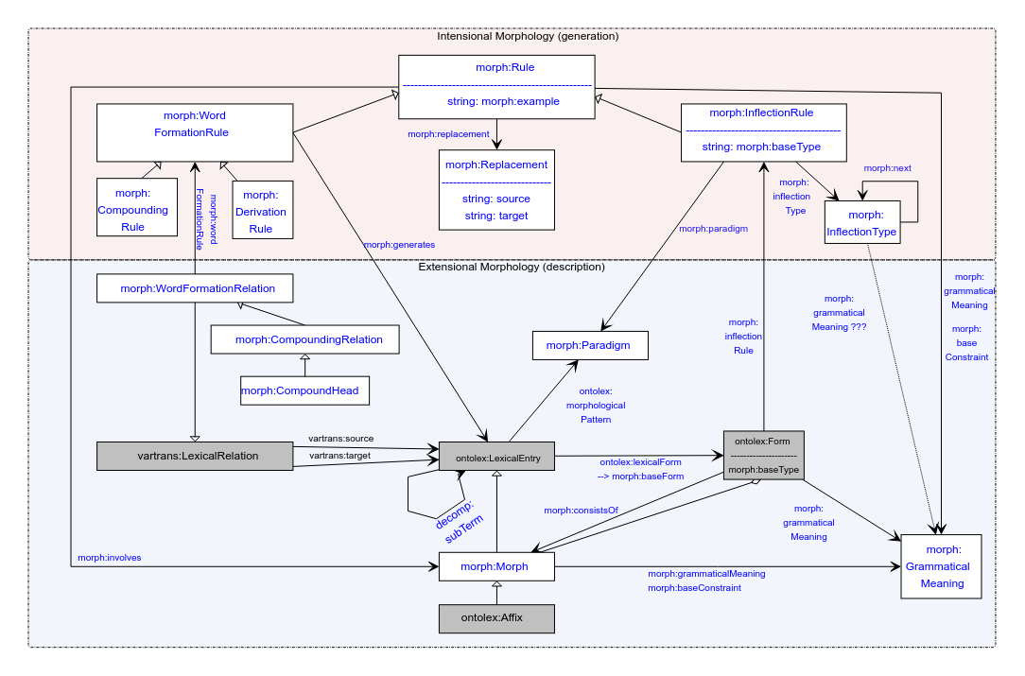

# 1. Replacement → RegexReplacement

FK: morph:source and morph:target being string literals can be too strictly defined given that the model will not be able to change after publication. What if we relax this restriction, move specifics about regular expressions into addenda.

… some discussion …

MI: **Suggestion** — having morph:Replacement underdefined, a new subclass morph:RegexReplacement which has the properties morph:Replacement has now.

# 2. Plans

Next time (04.10):

* Everyone whose issues are on GH are either present or we know the status
* Going through unmet requirements
* Going through problematic datasets

Time after next (18.10):

* MP presents the new standard for morphology, its compatibility with Morph.