Morph telco 2022-05-17, 13:15 CEST

**Link:** [**https://meet.google.com/nsj-tbcy-yop**](https://meet.google.com/nsj-tbcy-yop) **[CHECK HERE FOR UPDATED LINK(S)]**

**Latest Definitions:** [**https://github.com/ontolex/morph/blob/master/draft.md**](https://github.com/ontolex/morph/blob/master/draft.md)

**Nexus:** [**https://nexuslinguarum.eu/the-action/join-us**](https://nexuslinguarum.eu/the-action/join-us)

**Participants [please add yourself]:**

Christian Chiarcos (CC) (excused for being 10 min late)

Max Ionov (MI)

Katerina Gkirtzou (KG)

Besim Kabashi (BK)

Fahad Khan (FK)

Khadija Ait ElFqih (KAE)

Matteo Pellegrini (MP)

Ciprian-Octavian Truică (CT)

Penny Labropoulou (PL)

Elena Simona Apostol (ESA)

Sina Ahmadi (SA)

Elena Benzoni (EB)

Petra Steiner (PS)

Theodorus Fransen (TF)

Ranka Stanković (RS)

Gilles Sérasset (GS)

Mike Rosner (MR)

Table of Contents

0. Module draft (4.17)

1. Paradigm class

2. Finite State terminology

3. Open questions from the LDL paper

4. W3C day presentation

Next time

# 0. Module draft (4.17)

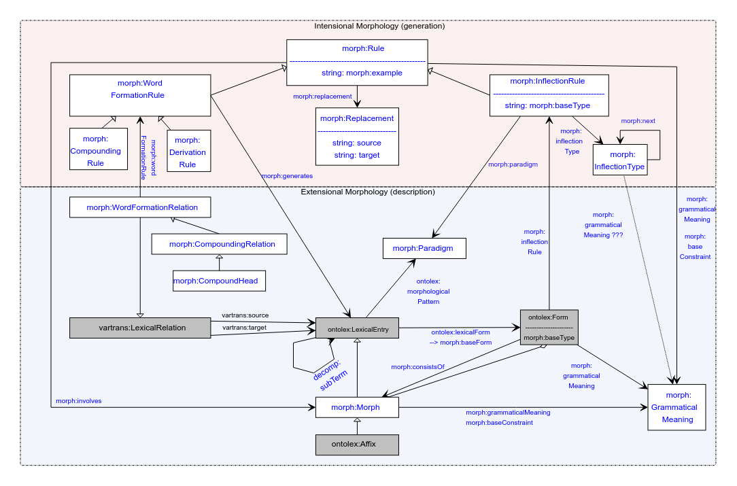

# 0. MWE paper

**TODO@MI, CC**: Finish the changes, submit the chapter until the 31.07

# 1. Paradigm class

MP: Naming “paradigm” may evoke incorrect associations, definition of paradigm in linguistics as a set of word forms

Note: we also need to rephrase the “paradigm” property, then

* + morphological pattern
  + Inflection type?
  + Inflection class?
    - MP: +1
    - GS: sounds like owl class
  + Inflection?

=> hard to get to a consensus, vote?

MP: paradigm → rules instead of the other way around

option 1:

morph:Paradigm > morph:InflectionClass, morph:paradigm > morph:inflectionClass

option 2:

morph:Paradigm > morph:MorphologicalPattern, morph:paradigm > morph:isInflectionRuleOf (or morph:InflectionRule, changing the direction of the arrow (i.e., going from morph:MorphologicalPattern to morph:InflectionRule rather than the opposite)

MI: This was exactly the idea behind the current class. Maybe just rephrase the [definition](https://github.com/ontolex/morph/blob/master/draft.md#morphparadigm)? (also, see MP remarks)

Cf. [requirement](https://docs.google.com/document/d/1s6uY-74Z9dPMau96AmPEHH_ivRvvWTK5-HZKIPTKyoA/edit#heading=h.b77jzkoaql9r) **N4**: Lexical data contains pointers to and/or tables of inflectional paradigms or classes including the respective stem affixes or the full word-forms. Both, the pointers to paradigms and the interconnection of word-forms that belong to a paradigm, should be representable.

MI: No problem with option 2, we need to find a way to see if everyone else is on board.

MP: Slight preference with option 1, but option 2 is also okay.

MI: Maybe rethink InflectionType name (InflectionSlot may be more intuitive) and then go for option 1

**TODO@MI**: discuss this CC, how to best come to a decision within the community

# 2. Finite State terminology

* Some of the aspects of the module allow it to model FST, albeit it might feel like a misuse (e.g. InflectionType as a state)
* Finite state terminology
  + Options: either within morph or within the scope of a new module?
    - If the latter:
      * Together with diachrony?
      * Together with sound classes?
* MI: Probably best keep it the way it is and FSTs can be implemented in a different module or another vocabulary outside of OntoLex, since it’s out of scope kinda
  + KG: +1
* CC: Treat it like the sound classes/character sounds — a (small) vocabulary out of morph, out of scope but motivated by morph

# 3. Open questions from the LDL paper

* - Variation in inflexion/Flexemes :: use to dialectal, diachronic or simply orthographic variation. Examples
  + In Latin, lavo `wash can be inflected according to either the 1st (lavare)

or the 3rd (lavere) conjugation.

* + Suppletion, eg in Old English, the verb wesan `to be' whose infinitive

represents one underlying root, whereas its indicative present singular forms

are based on two other roots (eom 1.sg. `(I) am'; bist 2.sg. `(you) are').

* + Modern Greek, `τραίνο' and `τρένο' have the same meaning and syntactic behaviour, so they can be modeled as the same ontolex:LexicalEntry, where the inflected forms of each are grouped together instead of all of them being represented as simply ontolex:otherForm. The current proposal is to introduce a new relation for orthographic variation (\onto{lexis:OrthVariant}) as a subclass of \onto{vartrans:LexicalRelation} and relate the orthographic variants through this relation.
  + MP: we can treat it as **resolved**. MP used Flexemes in his modeling but that was dataset-specific, and not necessary for the Morph module

See the slides here: https://zenodo.org/record/8036909

- Markers of morphological variation :: labels of style, dating, dialect, etc.

* + **Resolved by transfering the issue to LexInfo Vocabulary**
  + Note :: it would be desirable if the OntoLex-Morph vocabulary would eventually be accompanied by best practice recommendations for the assignment of markers and provenance.

- Challenges in word formation ::

* + not fully predictable phonological processes like assimilation or apophony, which prevent the simple juxtaposition of formative elements from generating the actual surface form of derivatives;
  + formal and semantic constraints that make a word formation rule not applicable to all the words in the lexicon with a specific part of speech.

(morph:GrammanticalMeaning??)

* CC: morph:baseConstraint should have **resolved** this

# 4. W3C day presentation

* <https://www.w3.org/community/ontolex/wiki/W3c_community_day_@_LDK2023>

CC: We can’t come up with a list of requirements right now because we still have open questions

* **TODO@MI**: go through all the requirements and give an overview of what is left
* **TODO@CC, MI**: discuss what is left
* Still TODO

# Next time

* Summer break
* Close open TODOs, especially, the ones from the last section: CC&MI to discuss what’s left and compile a list
* Restarting before LDK? 6.09? 20.09?
  + FK: We have Nexus plenary, so not 6.09