Analisi sullo smaltimento dei rifiuti

Elaborato Data Mining
Matteo Caruso
Elia Corti
Federico Jarach
Tommaso Zanni

Analisi target continuo
Il dataset scelto contiene le informazioni relative allo smaltimento dei rifiuti urbani per ogni comune, nello specifico si hanno 4341 osservazioni e 39 variabili. L’obiettivo è quello di costruire un modello robusto che vada a studiare la percentuale di rifiuti raccolti in modo differenziato.

Analisi descrittiva preliminare dei dati
## region province name tc
## Lombardia :1230 Bergamo: 218 Castro : 2 Min. : 25.69
## Campania : 405 Brescia: 172 Peglio : 2 1st Qu.:108.04
## Emilia_Romagna: 308 Milano : 131 Abano Terme : 1 Median :136.62
## Veneto : 265 Bolzano: 115 Abbadia Lariana: 1 Mean :154.24
## Toscana : 231 Salerno: 112 Abbateggio : 1 3rd Qu.:179.16
## Sicilia : 212 Como : 106 (Other) :4328 Max. :977.42
## (Other) :1690 (Other):3487 NA's : 6
## cres csor istat area
## Min. : 4.27 Min. : 3.39 Min. : 1272 Min. : 0.12
## 1st Qu.: 27.34 1st Qu.: 31.25 1st Qu.: 18135 1st Qu.: 10.85
## Median : 41.69 Median : 48.88 Median : 42015 Median : 22.73
## Mean : 54.18 Mean : 52.68 Mean : 47470 Mean : 40.99
## 3rd Qu.: 66.49 3rd Qu.: 66.44 3rd Qu.: 70049 3rd Qu.: 47.49
## Max. :670.32 Max. :582.16 Max. :111107 Max. :1287.39
## NA's :52 NA's :67 NA's :6
## pop alt isle sea
## Min. : 34 Min. : 1.0 Min. :0.000000 Min. :0.0000
## 1st Qu.: 1579 1st Qu.: 80.0 1st Qu.:0.000000 1st Qu.:0.0000
## Median : 3535 Median : 240.0 Median :0.000000 Median :0.0000
## Mean : 10204 Mean : 310.1 Mean :0.005075 Mean :0.1684
## 3rd Qu.: 8199 3rd Qu.: 459.0 3rd Qu.:0.000000 3rd Qu.:0.0000
## Max. :2617175 Max. :1816.0 Max. :1.000000 Max. :1.0000
## NA's :6 NA's :6 NA's :6
## pden wden urb fee
## Min. : 2.48 Min. : 892 Min. :1.00 PAYT : 557
## 1st Qu.: 62.59 1st Qu.: 23571 1st Qu.:2.00 STANDARD:3784
## Median : 151.32 Median : 68343 Median :3.00
## Mean : 405.05 Mean : 192058 Mean :2.49
## 3rd Qu.: 399.37 3rd Qu.: 194625 3rd Qu.:3.00
## Max. :12122.83 Max. :4978556 Max. :3.00
## NA's :6 NA's :6 NA's :6
## d_fee sample organic paper
## Min. :0.0000 Min. :0.0000 Min. : 0.0137 Min. : 0.00001
## 1st Qu.:0.0000 1st Qu.:0.0000 1st Qu.:11.1273 1st Qu.: 8.65575
## Median :0.0000 Median :1.0000 Median :24.9686 Median :10.87905
## Mean :0.1283 Mean :0.5469 Mean :22.2751 Mean :10.96127
## 3rd Qu.:0.0000 3rd Qu.:1.0000 3rd Qu.:31.8224 3rd Qu.:13.06169
## Max. :1.0000 Max. :1.0000 Max. :61.6391 Max. :45.28813
## NA's :512 NA's :25
## glass wood metal plastic
## Min. : 0.000 Min. : 0.000 Min. : 0.00001 Min. : 0.00001
## 1st Qu.: 7.147 1st Qu.: 2.086 1st Qu.: 0.87686 1st Qu.: 4.12610
## Median : 9.102 Median : 4.024 Median : 1.54092 Median : 5.79227
## Mean : 9.407 Mean : 4.114 Mean : 1.76442 Mean : 6.11216
## 3rd Qu.:11.278 3rd Qu.: 5.708 3rd Qu.: 2.35093 3rd Qu.: 7.54472
## Max. :39.836 Max. :25.117 Max. :20.67146 Max. :31.60474
## NA's :33 NA's :1095 NA's :246 NA's :39
## raee texile other msw_so
## Min. : 0.0000 Min. : 0.0000 Min. : 0.02946 Min. : 0
## 1st Qu.: 0.7769 1st Qu.: 0.3464 1st Qu.: 3.96485 1st Qu.: 373965
## Median : 1.1754 Median : 0.6292 Median : 7.13491 Median : 1040737
## Mean : 1.2331 Mean : 0.7570 Mean : 7.94159 Mean : 3248581
## 3rd Qu.: 1.5686 3rd Qu.: 0.9908 3rd Qu.:11.12996 3rd Qu.: 2725645
## Max. :17.9536 Max. :10.5845 Max. :37.15592 Max. :765130099
## NA's :314 NA's :1013 NA's :136
## msw_un msw sor geo
## Min. : 6185 Min. :1.997e+04 Min. : 0.25 Min. :1.000
## 1st Qu.: 175180 1st Qu.:6.117e+05 1st Qu.:57.83 1st Qu.:1.000
## Median : 409060 Median :1.524e+06 Median :70.84 Median :3.000
## Mean : 2042522 Mean :5.311e+06 Mean :66.24 Mean :2.291
## 3rd Qu.: 1056920 3rd Qu.:3.954e+06 3rd Qu.:79.09 3rd Qu.:3.000
## Max. :926757220 Max. :1.692e+09 Max. :97.48 Max. :3.000
## NA's :285
## roads s_wteregio s_landfill gdp
## Min. : 1.0 Min. : 0.000 Min. : 3.603 Min. : 6.035
## 1st Qu.: 25.0 1st Qu.: 8.905 1st Qu.: 4.551 1st Qu.: 6.811
## Median : 51.0 Median :24.468 Median :11.297 Median : 7.128
## Mean : 101.9 Mean :21.867 Mean :20.001 Mean : 7.231
## 3rd Qu.: 105.0 3rd Qu.:38.501 3rd Qu.:31.493 3rd Qu.: 7.571
## Max. :14970.0 Max. :65.122 Max. :92.532 Max. :10.539
## NA's :443 NA's :285 NA's :285 NA's :386
## proads wage finance
## Min. :-3.367 Min. : 7.866 Min. : 6.216
## 1st Qu.: 3.498 1st Qu.: 9.226 1st Qu.: 7.016
## Median : 4.356 Median : 9.523 Median : 7.342
## Mean : 4.254 Mean : 9.447 Mean : 7.448
## 3rd Qu.: 5.075 3rd Qu.: 9.665 3rd Qu.: 7.798
## Max. : 8.980 Max. :10.485 Max. :10.855
## NA's :443 NA's :285 NA's :386

Missing Data
Come prima operazione si è ritenuto necessario studiare la distribuzione e la frequenza dei valori mancanti, per facilitarne la comprensione si è deciso di utilizzare una rappresentazione grafica.
sapply(b, function(x)(sum(is.na(x)))) # NA counts
## region province name tc cres csor istat
## 0 0 6 0 52 67 0
## area pop alt isle sea pden wden
## 6 0 6 6 6 6 6
## urb fee d_fee sample organic paper glass
## 6 0 0 0 512 25 33
## wood metal plastic raee texile other msw_so
## 1095 246 39 314 1013 136 0
## msw_un msw sor geo roads s_wteregio s_landfill
## 0 0 0 285 443 285 285
## gdp proads wage finance
## 386 443 285 386
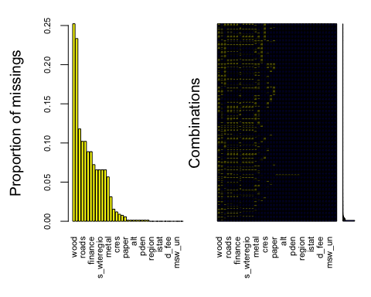
## region tc cres csor istat area pop
## 0 0 52 67 0 6 0
## alt isle sea pden wden urb d_fee
## 6 6 6 6 6 6 0
## organic paper glass metal plastic raee other
## 512 25 33 246 39 314 136
## msw_so msw_un msw geo roads s_wteregio s_landfill
## 0 0 0 285 443 285 285
## gdp proads wage
## 386 443 285

Mice Imputation
Dopo aver verificato che i valori mancanti siano MAR (missing at random) procediamo con l’imputazione solo dove vi è almeno 80% di valori presenti.

Collinearità
Ottenuto un dataset pieno e con le giuste variabili si può quindi creare uno starting model che, ci restituirà un elevato valore $R^{2}$ ma con molte variabili non significative nonché forti problemi di collinearità e eteroschedasticità.
##
## Call:
## lm(formula = sor ~ region + tc + cres + csor + istat + pop +
## area + alt + isle + sea + pden + wden + urb + d_fee + organic +
## paper + glass + metal + plastic + raee + other + msw_so +
## msw_un + geo + roads + s_landfill + gdp + proads + wage,
## data = b)
##
## Residuals:
## Min 1Q Median 3Q Max
## -48.987 -4.583 -0.328 4.390 38.584
##
## Coefficients:
## Estimate Std. Error t value Pr(>|t|)
## (Intercept) 3.018e+03 2.828e+03 1.067 0.28591
## regionBasilicata -3.645e+02 3.338e+02 -1.092 0.27502
## regionCalabria 1.575e+03 1.482e+03 1.063 0.28783
## regionCampania -2.725e+03 2.554e+03 -1.067 0.28608
## regionEmilia_Romagna -1.787e+03 1.671e+03 -1.069 0.28505
## regionFriuli_Venezia_Giulia -2.627e+03 2.456e+03 -1.069 0.28496
## regionLazio -2.111e+03 1.971e+03 -1.071 0.28417
## regionLiguria -1.658e+03 1.547e+03 -1.071 0.28408
## regionLombardia -2.656e+03 2.482e+03 -1.070 0.28464
## regionMarche 4.193e+02 3.974e+02 1.055 0.29148
## regionMolise 4.477e+03 4.199e+03 1.066 0.28636
## regionpiemonte -1.152e+03 1.072e+03 -1.074 0.28300
## regionPuglia 6.568e+02 6.204e+02 1.059 0.28981
## regionSardegna 1.849e+02 1.733e+02 1.067 0.28624
## regionSicilia 3.193e+03 2.995e+03 1.066 0.28652
## regionToscana -4.717e+02 4.365e+02 -1.080 0.28002
## regionTrentino_Alto_Adige -2.106e+03 1.969e+03 -1.070 0.28470
## regionUmbria 8.863e+02 8.370e+02 1.059 0.28972
## regionValle_d'Aosta 1.719e+03 1.611e+03 1.066 0.28626
## regionVeneto -2.108e+03 1.970e+03 -1.070 0.28469
## tc 8.129e-03 2.828e-03 2.874 0.00407 **
## cres -3.625e-02 4.235e-03 -8.559 < 2e-16 ***
## csor 4.125e-02 4.586e-03 8.994 < 2e-16 ***
## istat 4.375e-06 6.144e-06 0.712 0.47648
## pop 5.370e-05 2.111e-05 2.544 0.01099 *
## area 2.556e-02 2.850e-03 8.967 < 2e-16 ***
## alt -7.174e-03 6.382e-04 -11.241 < 2e-16 ***
## isle1 -5.406e+00 1.734e+00 -3.118 0.00183 **
## sea1 -8.054e-01 4.169e-01 -1.932 0.05343 .
## pden -4.710e-03 7.892e-04 -5.969 2.59e-09 ***
## wden 1.072e-05 1.748e-06 6.133 9.41e-10 ***
## urb -3.552e+00 3.072e-01 -11.564 < 2e-16 ***
## d_fee1 3.186e+00 4.203e-01 7.580 4.21e-14 ***
## organic 5.699e-01 1.098e-02 51.892 < 2e-16 ***
## paper 1.252e+00 3.650e-02 34.312 < 2e-16 ***
## glass 8.383e-01 3.854e-02 21.755 < 2e-16 ***
## metal 1.214e+00 1.029e-01 11.797 < 2e-16 ***
## plastic 1.093e+00 4.415e-02 24.766 < 2e-16 ***
## raee 1.001e+00 1.461e-01 6.852 8.31e-12 ***
## other 1.005e+00 3.016e-02 33.312 < 2e-16 ***
## msw_so 1.711e-07 3.929e-08 4.355 1.36e-05 ***
## msw_un -3.693e-07 3.833e-08 -9.635 < 2e-16 ***
## geo2 2.905e+00 1.736e+00 1.673 0.09432 .
## geo3 2.165e+00 2.600e+00 0.833 0.40507
## roads 2.040e-03 4.926e-04 4.140 3.54e-05 ***
## s_landfill -8.100e+01 7.594e+01 -1.067 0.28620
## gdp -2.242e+00 3.357e-01 -6.679 2.72e-11 ***
## proads 1.464e+00 1.684e-01 8.694 < 2e-16 ***
## wage 3.690e+00 7.795e-01 4.734 2.27e-06 ***
## ---
## Signif. codes: 0 '***' 0.001 '**' 0.01 '*' 0.05 '.' 0.1 ' ' 1
##
## Residual standard error: 7.735 on 4292 degrees of freedom
## Multiple R-squared: 0.8118, Adjusted R-squared: 0.8097
## F-statistic: 385.7 on 48 and 4292 DF, p-value: < 2.2e-16
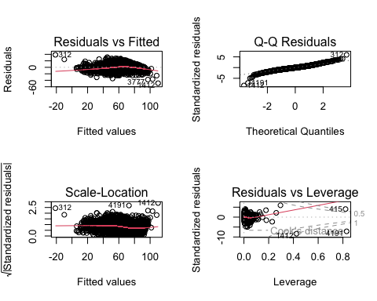
Per analizzare la collinearità delle variabili quantitative si sono utilizzati gli indicatori $VIF$ e $TOL$ per una visualizzazione grafica è stata rappresentata la matrice di correlazione:
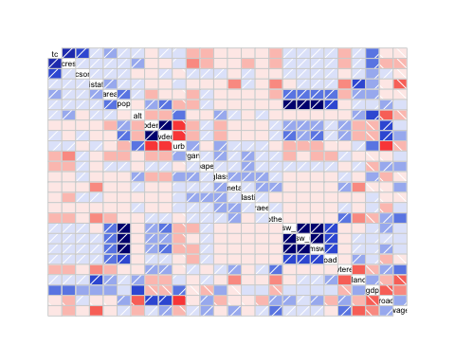

Variabili quantitative
Sotto sono state riportate le diagnostiche $VIF$ e $TOL$ prima e dopo le lavorazioni.
##
##
## All Individual Multicollinearity Diagnostics Result
##
## VIF TOL Wi Fi Leamer CVIF Klein
## Xtc 2.8986 0.3450 327.6959 341.4290 0.5874 -0.7147 0
## Xcres 2.3100 0.4329 226.1141 235.5901 0.6579 -0.5695 0
## Xcsor 1.5871 0.6301 101.3293 105.5758 0.7938 -0.3913 0
## Xistat 1.6633 0.6012 114.4794 119.2770 0.7754 -0.4101 0
## Xarea 1.7108 0.5845 122.6825 127.8239 0.7645 -0.4218 0
## Xpop 92.8204 0.0108 15848.2002 16512.3677 0.1038 -22.8851 1
## Xalt 1.7214 0.5809 124.5115 129.7295 0.7622 -0.4244 0
## Xpden 26.7162 0.0374 4438.6085 4624.6220 0.1935 -6.5869 1
## Xwden 28.4104 0.0352 4731.0322 4929.3006 0.1876 -7.0047 1
## Xurb 2.2949 0.4358 223.4974 232.8637 0.6601 -0.5658 0
## Xorganic 1.4163 0.7061 71.8545 74.8658 0.8403 -0.3492 0
## Xpaper 1.3404 0.7460 58.7548 61.2171 0.8637 -0.3305 0
## Xglass 1.2755 0.7840 47.5536 49.5465 0.8854 -0.3145 0
## Xmetal 1.3037 0.7671 52.4167 54.6134 0.8758 -0.3214 0
## Xplastic 1.2556 0.7965 44.1116 45.9603 0.8924 -0.3096 0
## Xraee 1.1251 0.8888 21.5979 22.5030 0.9428 -0.2774 0
## Xother 1.4712 0.6797 81.3312 84.7397 0.8244 -0.3627 0
## Xmsw_so 8951.8345 0.0001 1544914.0311 1609658.4005 0.0106 -2207.1011 1
## Xmsw_un 11907.1615 0.0001 2055003.4774 2141124.7124 0.0092 -2935.7456 1
## Xmsw 40200.8684 0.0000 6938497.2941 7229276.3425 0.0050 -9911.6421 1
## Xroads 1.5401 0.6493 93.2261 97.1330 0.8058 -0.3797 0
## Xs_wteregio 1.5851 0.6309 100.9903 105.2226 0.7943 -0.3908 0
## Xs_landfill 2.0268 0.4934 177.2312 184.6587 0.7024 -0.4997 0
## Xgdp 1.9892 0.5027 170.7341 177.8893 0.7090 -0.4904 0
## Xproads 2.4238 0.4126 245.7559 256.0550 0.6423 -0.5976 0
## Xwage 1.9336 0.5172 161.1441 167.8973 0.7191 -0.4767
##
## Call:
## imcdiag(mod = m)
##
##
## All Individual Multicollinearity Diagnostics Result
##
## VIF TOL Wi Fi Leamer CVIF Klein IND1 IND2
## Xtc 2.8541 0.3504 381.3277 400.4868 0.5919 -0.7527 0 0.0017 1.6858
## Xcres 2.2950 0.4357 266.3456 279.7276 0.6601 -0.6053 0 0.0021 1.4644
## Xcsor 1.5711 0.6365 117.4573 123.3587 0.7978 -0.4144 0 0.0031 0.9433
## Xistat 1.6616 0.6018 136.0774 142.9144 0.7758 -0.4382 0 0.0029 1.0333
## Xarea 1.6409 0.6094 131.8181 138.4411 0.7806 -0.4328 0 0.0030 1.0136
## Xalt 1.6965 0.5894 143.2541 150.4517 0.7677 -0.4474 0 0.0029 1.0655
## Xpden 1.8650 0.5362 177.9104 186.8492 0.7322 -0.4919 0 0.0026 1.2037
## Xurb 2.2571 0.4430 258.5508 271.5412 0.6656 -0.5953 0 0.0022 1.4454
## Xorganic 1.3788 0.7253 77.9007 81.8147 0.8516 -0.3636 0 0.0035 0.7129
## Xpaper 1.3184 0.7585 65.4785 68.7683 0.8709 -0.3477 0 0.0037 0.6267
## Xglass 1.2608 0.7932 53.6309 56.3255 0.8906 -0.3325 0 0.0039 0.5367
## Xmetal 1.3018 0.7681 62.0767 65.1956 0.8764 -0.3433 0 0.0037 0.6017
## Xplastic 1.2489 0.8007 51.1892 53.7611 0.8948 -0.3294 0 0.0039 0.5172
## Xraee 1.1232 0.8903 25.3392 26.6123 0.9436 -0.2962 0 0.0043 0.2847
## Xother 1.4550 0.6873 93.5708 98.2721 0.8290 -0.3837 0 0.0033 0.8115
## Xmsw_un 1.5565 0.6425 114.4575 120.2082 0.8015 -0.4105 0 0.0031 0.9279
## Xroads 1.5227 0.6567 107.5028 112.9041 0.8104 -0.4016 0 0.0032 0.8908
## Xs_wteregio 1.5609 0.6407 115.3523 121.1480 0.8004 -0.4117 0 0.0031 0.9325
## Xs_landfill 2.0206 0.4949 209.8938 220.4395 0.7035 -0.5329 0 0.0024 1.3107
## Xgdp 1.9568 0.5111 196.7723 206.6588 0.7149 -0.5161 0 0.0025 1.2689
## Xproads 2.4167 0.4138 291.3633 306.0023 0.6433 -0.6374 0 0.0020 1.5213
## Xwage 1.8623 0.5370 177.3533 186.2641 0.7328 -0.4912 0 0.0026 1.2016
##
## 1 --> COLLINEARITY is detected by the test
## 0 --> COLLINEARITY is not detected by the test
##
## Xistat , Xs_wteregio , Xs_landfill , coefficient(s) are non-significant may be due to multicollinearity
##
## R-square of y on all x: 0.7871
##
## * use method argument to check which regressors may be the reason of collinearity
## ===================================
Tutte le variabili collineari sono state eliminate una per volta in modo iterativo, fino ad ottenere per ogni variabile con $TOL>0.3$ e $VIF<5$.

Variabili qualitative
Per le variabili qualitative si è utilizzato il coefficiente di connessione $χ_{norm}^{2}$.
## X1 Row Column Chi.Square df p.value n u1 u2 nMinu1u2 Chi.Square.norm
## 1 1 region isle 74.144 19 0.000 4341 19 1 4341 0.0170798725
## 2 2 region sea 1150.484 19 0.000 4341 19 1 4341 0.2650274187
## 3 3 region d_fee 1143.261 19 0.000 4341 19 1 4341 0.2633635702
## 4 4 region geo 8324.733 38 0.000 4341 19 2 8682 0.9588497068
## 5 5 isle sea 92.183 1 0.000 4341 1 1 4341 0.0212354833
## 6 6 isle d_fee 2.204 1 0.138 4341 1 1 4341 0.0005077038
## 7 7 isle geo 23.567 2 0.000 4341 1 2 4341 0.0054288777
## 8 8 sea d_fee 53.301 1 0.000 4341 1 1 4341 0.0122784849
## 9 9 sea geo 444.808 2 0.000 4341 1 2 4341 0.1024667662
## 10 10 d_fee geo 372.685 2 0.000 4341 1 2 4341 0.0858523465
Le variabili più collineari risultano essere geo e region con $χ_{norm}^{2}=0.9588$. Visto che region confronto a geo ha correlazioni maggiori con le altre variabili si è ritenuto più giusto eliminare region.

Model Selection
Dopo aver verificato l’assenza di multicollinearità (tutti i valori di $χ_{norm}^{2}$ inferiori a 0.8 e $TOL$ superiori a 0.3), è stata effettuata una procedura di selezione del modello stepwise (step, direzione “both”).
Tale procedura, basata sul $AIC$, consente di individuare il modello più parsimonioso, eliminando le variabili statisticamente irrilevanti.
L’obiettivo è ottenere un modello più semplice ma informativamente equivalente, riducendo il rischio di overfitting e migliorando l’interpretabilità dei risultati.
summary(fitSTEPPED)
##
## Call:
## lm(formula = sor ~ tc + cres + csor + area + alt + isle + sea +
## urb + d_fee + organic + paper + glass + metal + plastic +
## raee + other + msw_un + msw + geo + roads + gdp + proads +
## wage, data = b)
##
## Residuals:
## Min 1Q Median 3Q Max
## -46.631 -4.791 -0.290 4.485 46.757
##
## Coefficients:
## Estimate Std. Error t value Pr(>|t|)
## (Intercept) -1.883e+01 6.714e+00 -2.804 0.005063 **
## tc 1.042e-02 2.766e-03 3.769 0.000166 ***
## cres -3.829e-02 4.269e-03 -8.969 < 2e-16 ***
## csor 4.897e-02 4.569e-03 10.717 < 2e-16 ***
## area 2.629e-02 2.612e-03 10.066 < 2e-16 ***
## alt -8.112e-03 5.834e-04 -13.905 < 2e-16 ***
## isle1 -3.645e+00 1.758e+00 -2.073 0.038236 *
## sea1 -9.029e-01 3.949e-01 -2.286 0.022277 *
## urb -3.511e+00 2.888e-01 -12.157 < 2e-16 ***
## d_fee1 3.604e+00 3.918e-01 9.198 < 2e-16 ***
## organic 5.594e-01 1.080e-02 51.798 < 2e-16 ***
## paper 1.233e+00 3.437e-02 35.887 < 2e-16 ***
## glass 7.956e-01 3.629e-02 21.927 < 2e-16 ***
## metal 1.130e+00 1.002e-01 11.269 < 2e-16 ***
## plastic 1.194e+00 4.127e-02 28.929 < 2e-16 ***
## raee 9.826e-01 1.471e-01 6.678 2.72e-11 ***
## other 9.499e-01 2.765e-02 34.352 < 2e-16 ***
## msw_un -5.837e-07 3.653e-08 -15.981 < 2e-16 ***
## msw 2.874e-07 2.036e-08 14.114 < 2e-16 ***
## geo2 -2.246e+00 4.993e-01 -4.498 7.04e-06 ***
## geo3 -3.110e+00 5.197e-01 -5.984 2.35e-09 ***
## roads 1.913e-03 5.006e-04 3.822 0.000134 ***
## gdp -1.522e+00 3.126e-01 -4.869 1.16e-06 ***
## proads 1.432e+00 1.590e-01 9.003 < 2e-16 ***
## wage 5.200e+00 7.108e-01 7.316 3.03e-13 ***
## ---
## Signif. codes: 0 '***' 0.001 '**' 0.01 '*' 0.05 '.' 0.1 ' ' 1
##
## Residual standard error: 7.925 on 4316 degrees of freedom
## Multiple R-squared: 0.8013, Adjusted R-squared: 0.8002
## F-statistic: 725.3 on 24 and 4316 DF, p-value: < 2.2e-16

Linearità per Y
Per valutare e migliorare la linearità della variabile dipendente $y$ (ovvero sor), è stata applicata la trasformazione di Box-Cox, al fine di rendere la relazione con le variabili esplicative più aderente ai presupposti della regressione lineare.
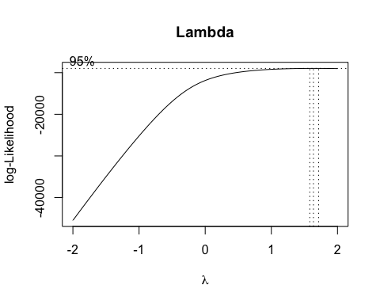
lambda
## [1] 1.636364
Il valore $λ=1.6363$ci suggerisce di effettuare la seguente trasformazione su $y$:
$$\hat{y}'={\hat{y}}^{2}/2$$
È importante sottolineare che nel momento in cui si fa inferenza non si sta più studiando $y$ ma $y'$ quindi per ricavare $y$ si dovrà usare la formula inversa.

##
## Call:
## lm(formula = I((sor^2)/2) ~ tc + cres + csor + area + alt + isle +
## sea + urb + d_fee + organic + paper + glass + metal + plastic +
## raee + other + msw_un + msw + geo + roads + gdp + proads +
## wage, data = b)
##
## Residuals:
## Min 1Q Median 3Q Max
## -2481.56 -295.58 -33.72 270.58 2852.50
##
## Coefficients:
## Estimate Std. Error t value Pr(>|t|)
## (Intercept) -2.246e+03 4.026e+02 -5.578 2.57e-08 ***
## tc 6.349e-01 1.659e-01 3.828 0.000131 ***
## cres -2.316e+00 2.560e-01 -9.047 < 2e-16 ***
## csor 2.335e+00 2.740e-01 8.523 < 2e-16 ***
## area 1.315e+00 1.566e-01 8.393 < 2e-16 ***
## alt -5.314e-01 3.498e-02 -15.188 < 2e-16 ***
## isle1 -1.726e+02 1.054e+02 -1.637 0.101688
## sea1 -7.527e+01 2.368e+01 -3.178 0.001491 **
## urb -1.982e+02 1.732e+01 -11.446 < 2e-16 ***
## d_fee1 3.207e+02 2.349e+01 13.651 < 2e-16 ***
## organic 3.153e+01 6.477e-01 48.683 < 2e-16 ***
## paper 6.379e+01 2.061e+00 30.951 < 2e-16 ***
## glass 3.589e+01 2.176e+00 16.494 < 2e-16 ***
## metal 6.986e+01 6.011e+00 11.622 < 2e-16 ***
## plastic 6.947e+01 2.475e+00 28.073 < 2e-16 ***
## raee 5.671e+01 8.823e+00 6.427 1.44e-10 ***
## other 5.699e+01 1.658e+00 34.369 < 2e-16 ***
## msw_un -2.991e-05 2.190e-06 -13.655 < 2e-16 ***
## msw 1.483e-05 1.221e-06 12.148 < 2e-16 ***
## geo2 -1.493e+02 2.994e+01 -4.988 6.35e-07 ***
## geo3 -1.989e+02 3.117e+01 -6.382 1.94e-10 ***
## roads 7.775e-02 3.002e-02 2.590 0.009638 **
## gdp -1.119e+02 1.874e+01 -5.970 2.57e-09 ***
## proads 5.713e+01 9.536e+00 5.991 2.26e-09 ***
## wage 3.194e+02 4.262e+01 7.494 8.06e-14 ***
## ---
## Signif. codes: 0 '***' 0.001 '**' 0.01 '*' 0.05 '.' 0.1 ' ' 1
##
## Residual standard error: 475.3 on 4316 degrees of freedom
## Multiple R-squared: 0.7843, Adjusted R-squared: 0.7831
## F-statistic: 653.8 on 24 and 4316 DF, p-value: < 2.2e-16
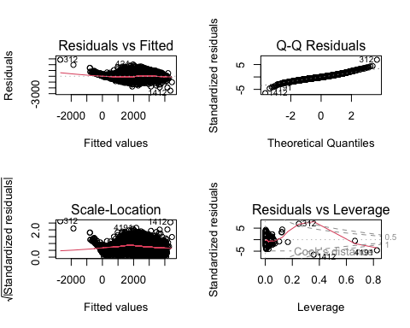

Linearità per X
Per migliorare la linearità e la stabilità del modello, alcune variabili indipendenti (covariate) sono state sottoposte a trasformazioni lineari, in modo da linearizzare il rapporto con la variabile target.
## Call: gam(formula = I((sor^2)/2) ~ s(tc) + s(cres) + s(csor) + s(area) +
## s(alt) + (isle) + (sea) + (urb) + (d_fee) + s(organic) +
## s(paper) + s(glass) + s(metal) + s(plastic) + s(raee) + s(other) +
## s(msw_un) + s(msw) + (geo) + s(roads) + s(gdp) + s(proads) +
## s(wage), data = b)
## Deviance Residuals:
## Min 1Q Median 3Q Max
## -2285.02 -228.85 -15.97 210.25 1864.45
##
## (Dispersion Parameter for gaussian family taken to be 150871.8)
##
## Null Deviance: 4519064912 on 4340 degrees of freedom
## Residual Deviance: 642108841 on 4255.99 degrees of freedom
## AIC: 64168.28
##
## Number of Local Scoring Iterations: NA
##
## Anova for Parametric Effects
## Df Sum Sq Mean Sq F value Pr(>F)
## s(tc) 1 285818373 285818373 1894.4454 < 2.2e-16 ***
## s(cres) 1 554686918 554686918 3676.5449 < 2.2e-16 ***
## s(csor) 1 66364929 66364929 439.8763 < 2.2e-16 ***
## s(area) 1 87794272 87794272 581.9131 < 2.2e-16 ***
## s(alt) 1 65458155 65458155 433.8661 < 2.2e-16 ***
## isle 1 789114 789114 5.2304 0.0222448 *
## sea 1 55024606 55024606 364.7110 < 2.2e-16 ***
## urb 1 1911484 1911484 12.6696 0.0003757 ***
## d_fee 1 109024904 109024904 722.6328 < 2.2e-16 ***
## s(organic) 1 731886148 731886148 4851.0469 < 2.2e-16 ***
## s(paper) 1 353206558 353206558 2341.1040 < 2.2e-16 ***
## s(glass) 1 105824386 105824386 701.4193 < 2.2e-16 ***
## s(metal) 1 141491436 141491436 937.8256 < 2.2e-16 ***
## s(plastic) 1 124037707 124037707 822.1398 < 2.2e-16 ***
## s(raee) 1 12700967 12700967 84.1838 < 2.2e-16 ***
## s(other) 1 335153126 335153126 2221.4432 < 2.2e-16 ***
## s(msw_un) 1 274584 274584 1.8200 0.1773869
## s(msw) 1 15953745 15953745 105.7437 < 2.2e-16 ***
## geo 2 755238 377619 2.5029 0.0819667 .
## s(roads) 1 458625 458625 3.0398 0.0813164 .
## s(gdp) 1 4989331 4989331 33.0700 9.513e-09 ***
## s(proads) 1 22580430 22580430 149.6663 < 2.2e-16 ***
## s(wage) 1 11744867 11744867 77.8467 < 2.2e-16 ***
## Residuals 4256 642108841 150872
## ---
## Signif. codes: 0 '***' 0.001 '**' 0.01 '*' 0.05 '.' 0.1 ' ' 1
##
## Anova for Nonparametric Effects
## Npar Df Npar F Pr(F)
## (Intercept)
## s(tc) 3.0 12.86 2.328e-08 ***
## s(cres) 3.0 35.42 < 2.2e-16 ***
## s(csor) 3.0 9.20 4.617e-06 ***
## s(area) 3.0 10.85 4.257e-07 ***
## s(alt) 3.0 19.54 1.407e-12 ***
## isle
## sea
## urb
## d_fee
## s(organic) 3.0 152.40 < 2.2e-16 ***
## s(paper) 3.0 8.18 2.001e-05 ***
## s(glass) 3.0 5.94 0.0004845 ***
## s(metal) 5.4 9.11 3.968e-09 ***
## s(plastic) 3.0 20.66 2.769e-13 ***
## s(raee) 6.6 3.65 0.0008193 ***
## s(other) 3.0 9.80 1.944e-06 ***
## s(msw_un) 3.0 1249.22 < 2.2e-16 ***
## s(msw) 3.0 1082.14 < 2.2e-16 ***
## geo
## s(roads) 3.0 26.42 < 2.2e-16 ***
## s(gdp) 3.0 14.98 1.074e-09 ***
## s(proads) 3.0 5.37 0.0010896 **
## s(wage) 3.0 11.29 2.254e-07 ***
## ---
## Signif. codes: 0 '***' 0.001 '**' 0.01 '*' 0.05 '.' 0.1 ' ' 1
## Analysis of Variance Table
##
## Model 1: I((sor^2)/2) ~ tc + cres + csor + area + alt + isle + sea + urb +
## d_fee + organic + paper + glass + metal + plastic + raee +
## other + msw_un + msw + geo + roads + gdp + proads + wage
## Model 2: I((sor^2)/2) ~ s(tc) + s(cres) + s(csor) + s(area) + s(alt) +
## (isle) + (sea) + (urb) + (d_fee) + s(organic) + s(paper) +
## s(glass) + s(metal) + s(plastic) + s(raee) + s(other) + s(msw_un) +
## s(msw) + (geo) + s(roads) + s(gdp) + s(proads) + s(wage)
## Res.Df RSS Df Sum of Sq Pr(>Chi)
## 1 4316 974908599
## 2 4256 642108841 60.01 332799758 < 2.2e-16 ***
## ---
## Signif. codes: 0 '***' 0.001 '**' 0.01 '*' 0.05 '.' 0.1 ' ' 1

Per modellare le relazioni non lineari tra la variabile dipendente sor e le covariate, è stato utilizzato un modello GAM (Generalized Additive Model).
Il confronto tramite il test ANOVA ha evidenziato che il modello GAM risulta più efficiente rispetto alla regressione lineare classica, consentendo una migliore rappresentazione delle eventuali non linearità presenti nei dati.
Successivamente, il modello GAM è stato rappresentato graficamente per visualizzare le relazioni tra la variabile dipendente sor e le covariate.
Parallelamente, sono state applicate trasformazioni lineari sulle covariate, al fine di stabilizzare le relazioni e rendere il modello più interpretabile.
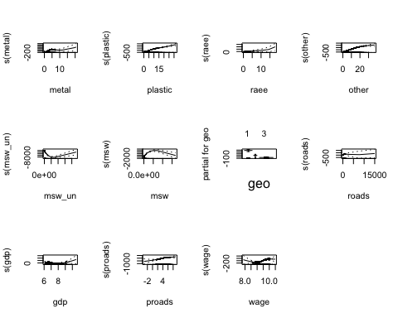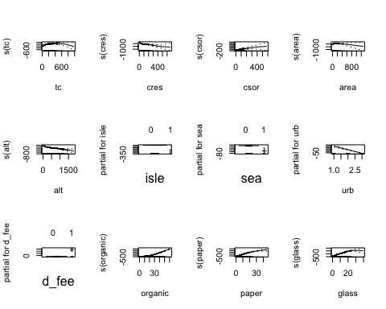

Dall’osservazione dei grafici prodotti dal modello GAM, sono emerse relazioni non lineari tra alcune covariate e la variabile dipendente sor.
Di conseguenza, sono state applicate trasformazioni logaritmiche alle covariate nel modello lineare.
Il successivo RESET test ha restituito un p-value pari a 0.4681, indicando assenza di specificazione errata del modello e confermando la bontà della forma funzionale scelta.
## Loading required package: zoo
##
## Attaching package: 'zoo'
## The following objects are masked from 'package:base':
##
## as.Date, as.Date.numeric
resettest(fit4, power = 2, type = "fitted", data = b)
##
## RESET test
##
## data: fit4
## RESET = 0.52667, df1 = 1, df2 = 4315, p-value = 0.4681
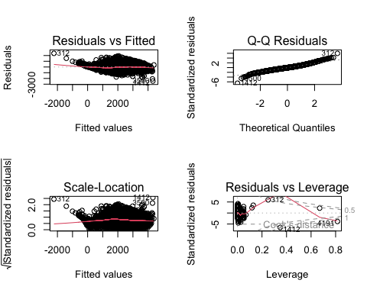

## Model:
## I((sor^2)/2) ~ I(log(tc + 1)) + I(log(cres + 1)) + I(log(csor +
## 1)) + I(log(area + 1)) + I(log(alt + 1)) + isle + sea + urb +
## d_fee + organic + paper + glass + metal + plastic + I(log(raee +
## 1)) + other + msw_un + msw + geo + roads + gdp + proads +
## wage
## Df Sum of Sq RSS AIC F value Pr(>F)
## <none> 916992935 53274
## I(log(tc + 1)) 1 16067359 933060294 53347 75.6241 < 2.2e-16 ***
## I(log(cres + 1)) 1 47466351 964459285 53491 223.4093 < 2.2e-16 ***
## I(log(csor + 1)) 1 875066 917868001 53276 4.1187 0.04247 *
## I(log(area + 1)) 1 26077298 943070233 53394 122.7377 < 2.2e-16 ***
## I(log(alt + 1)) 1 62409714 979402649 53558 293.7431 < 2.2e-16 ***
## isle 1 1797289 918790224 53280 8.4593 0.00365 **
## sea 1 4352860 921345795 53292 20.4876 6.164e-06 ***
## urb 1 35922149 952915084 53439 169.0744 < 2.2e-16 ***
## d_fee 1 17181247 934174182 53352 80.8668 < 2.2e-16 ***
## organic 1 515295245 1432288180 55208 2425.3341 < 2.2e-16 ***
## paper 1 197466071 1114459005 54119 929.4113 < 2.2e-16 ***
## glass 1 68582119 985575054 53585 322.7947 < 2.2e-16 ***
## metal 1 23385611 940378546 53381 110.0688 < 2.2e-16 ***
## plastic 1 182873866 1099866800 54061 860.7303 < 2.2e-16 ***
## I(log(raee + 1)) 1 10880458 927873392 53323 51.2109 9.702e-13 ***
## other 1 265866851 1182859786 54377 1251.3524 < 2.2e-16 ***
## msw_un 1 35551205 952544140 53437 167.3284 < 2.2e-16 ***
## msw 1 29506807 946499742 53409 138.8793 < 2.2e-16 ***
## geo 2 9442066 926435001 53314 22.2204 2.507e-10 ***
## roads 1 830569 917823503 53276 3.9092 0.04809 *
## gdp 1 10996899 927989833 53324 51.7590 7.363e-13 ***
## proads 1 10253013 927245948 53320 48.2577 4.296e-12 ***
## wage 1 10377439 927370374 53321 48.8434 3.198e-12 ***
## ---
## Signif. codes: 0 '***' 0.001 '**' 0.01 '*' 0.05 '.' 0.1 ' ' 1

Outlier
Durante la fase di diagnosi del modello, è stata condotta un’analisi dei outlier e dei punti influenti al fine di individuare eventuali osservazioni anomale che potessero compromettere la stima dei parametri.
I punti di leva rappresentano osservazioni con valori anomali nelle covariate, mentre i punti influenti sono quelli che esercitano un impatto significativo sui coefficienti della regressione.
L’identificazione e l’eventuale rimozione di tali osservazioni consentono di migliorare la robustezza e l’affidabilità del modello, garantendo stime più stabili e rappresentative del fenomeno analizzato.
Le osservazioni con valori di DFFITS superiori alla soglia convenzionale sono state considerate influenti e, se necessario, rimosse per migliorare la stabilità e l’affidabilità del modello.
## Osservazioni outlier (indici): 6 16 18 21 24 25 26 34 35 48 61 62 79 82 88 90 99 111 115 136 141 155 164 177 182 193 241 285 299 310 312 358 367 369 381 404 411 415 424 429 435 441 445 483 485 496 ... 4321 4325 4339
## Residuals:
## Min 1Q Median 3Q Max
## -39.690 -4.030 -0.224 3.751 31.250
##
## Coefficients:
## Estimate Std. Error t value Pr(>|t|)
## (Intercept) -1.671e+01 5.868e+00 -2.848 0.00442 **
## I(log(tc + 1)) 4.559e+00 3.701e-01 12.318 < 2e-16 ***
## I(log(cres + 1)) -3.996e+00 2.317e-01 -17.247 < 2e-16 ***
## I(log(area + 1)) 1.649e+00 1.336e-01 12.337 < 2e-16 ***
## I(log(alt + 1)) -1.798e+00 9.846e-02 -18.265 < 2e-16 ***
## sea1 -1.471e+00 3.359e-01 -4.379 1.22e-05 ***
## urb -3.387e+00 2.557e-01 -13.248 < 2e-16 ***
## d_fee1 6.249e-01 3.302e-01 1.892 0.05854 .
## organic 6.130e-01 9.343e-03 65.611 < 2e-16 ***
## paper 1.142e+00 2.978e-02 38.358 < 2e-16 ***
## glass 8.940e-01 3.110e-02 28.746 < 2e-16 ***
## metal 1.181e+00 8.980e-02 13.157 < 2e-16 ***
## plastic 1.196e+00 3.520e-02 33.981 < 2e-16 ***
## I(log(raee + 1)) 3.078e+00 3.328e-01 9.247 < 2e-16 ***
## other 1.034e+00 2.362e-02 43.778 < 2e-16 ***
## msw_un -1.378e-06 5.948e-08 -23.170 < 2e-16 ***
## msw 7.053e-07 3.222e-08 21.889 < 2e-16 ***
## geo2 -3.226e+00 4.231e-01 -7.626 3.00e-14 ***
## geo3 -3.292e+00 4.511e-01 -7.299 3.47e-13 ***
## roads 4.609e-03 1.039e-03 4.436 9.42e-06 ***
## gdp -1.349e+00 2.572e-01 -5.245 1.64e-07 ***
## proads 1.616e+00 1.435e-01 11.262 < 2e-16 ***
## wage 4.095e+00 6.196e-01 6.609 4.36e-11 ***
## ---
## Signif. codes: 0 '***' 0.001 '**' 0.01 '*' 0.05 '.' 0.1 ' ' 1
##
## Residual standard error: 6.308 on 4069 degrees of freedom
## Multiple R-squared: 0.8712, Adjusted R-squared: 0.8705
## F-statistic: 1251 on 22 and 4069 DF, p-value: < 2.2e-16
## RESET test
##
## data: mod_clean
## RESET = 638.02, df1 = 1, df2 = 4068, p-value < 2.2e-16
Si osserva che il RESET test del modello stimato a partire dal dataset privo di outlier risulta sensibilmente peggiore rispetto a quello ottenuto in precedenza.
Tale peggioramento può essere attribuito al fatto che le trasformazioni lineari applicate sia alla variabile target sia alle covariate non risultano più adeguate al nuovo campione di dati, modificando la struttura delle relazioni originariamente modellate.

Linearità di Y sul modello senza outlier
A partire dal modello senza outlier si procede nuovamente a creare uno starting model e trasformare la variabile target tramite Box-Cox
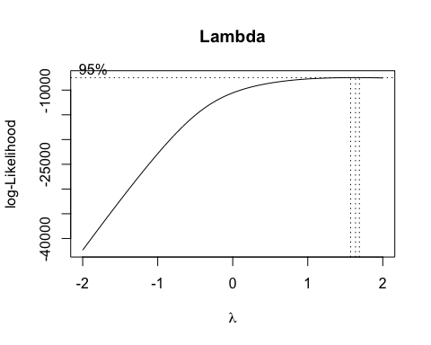
lambda
## [1] 1.636364
L’uotput restituito da Box-Cox ci ritorna lo stesso output del modello con gli outlier, quindi si procede a fare la stessa trasformazione.

Linearità di X sul modello senza outlier
vengono ripetuti gli stessi passaggi di prima.
## Call: gam(formula = I((sor^2)/2) ~ s(tc) + s(cres) + s(csor) + s(area) +
## s(alt) + (isle) + (sea) + (urb) + (d_fee) + s(organic) +
## s(paper) + s(glass) + s(metal) + s(plastic) + s(raee) + s(other) +
## s(msw_un) + s(msw) + (geo) + s(roads) + s(gdp) + s(proads) +
## s(wage), data = df_clean)
## Deviance Residuals:
## Min 1Q Median 3Q Max
## -1013.869 -195.190 -9.791 186.136 1285.604
##
## (Dispersion Parameter for gaussian family taken to be 95045.85)
##
## Null Deviance: 4157201383 on 4091 degrees of freedom
## Residual Deviance: 380942140 on 4007.983 degrees of freedom
## AIC: 58600.71
##
## Number of Local Scoring Iterations: NA
##
## Anova for Parametric Effects
## Df Sum Sq Mean Sq F value Pr(>F)
## s(tc) 1 296852232 296852232 3123.2530 < 2.2e-16 ***
## s(cres) 1 691464833 691464833 7275.0661 < 2.2e-16 ***
## s(csor) 1 33809800 33809800 355.7210 < 2.2e-16 ***
## s(area) 1 57460584 57460584 604.5565 < 2.2e-16 ***
## s(alt) 1 63924024 63924024 672.5599 < 2.2e-16 ***
## isle 1 276643 276643 2.9106 0.0880750 .
## sea 1 50034712 50034712 526.4271 < 2.2e-16 ***
## urb 1 4154171 4154171 43.7070 4.316e-11 ***
## d_fee 1 100859973 100859973 1061.1718 < 2.2e-16 ***
## s(organic) 1 714616010 714616010 7518.6452 < 2.2e-16 ***
## s(paper) 1 348163141 348163141 3663.1073 < 2.2e-16 ***
## s(glass) 1 110041151 110041151 1157.7691 < 2.2e-16 ***
## s(metal) 1 150720593 150720593 1585.7672 < 2.2e-16 ***
## s(plastic) 1 107864845 107864845 1134.8717 < 2.2e-16 ***
## s(raee) 1 12842698 12842698 135.1211 < 2.2e-16 ***
## s(other) 1 286933325 286933325 3018.8938 < 2.2e-16 ***
## s(msw_un) 1 7033372 7033372 73.9998 < 2.2e-16 ***
## s(msw) 1 135864444 135864444 1429.4622 < 2.2e-16 ***
## geo 2 1657728 828864 8.7207 0.0001663 ***
## s(roads) 1 52827 52827 0.5558 0.4559992
## s(gdp) 1 5162881 5162881 54.3199 2.058e-13 ***
## s(proads) 1 7480411 7480411 78.7032 < 2.2e-16 ***
## s(wage) 1 4911116 4911116 51.6710 7.790e-13 ***
## Residuals 4008 380942140 95046
## ---
## Signif. codes: 0 '***' 0.001 '**' 0.01 '*' 0.05 '.' 0.1 ' ' 1
##
## Anova for Nonparametric Effects
## Npar Df Npar F Pr(F)
## (Intercept)
## s(tc) 3.0 7.51 5.172e-05 ***
## s(cres) 3.0 44.12 < 2.2e-16 ***
## s(csor) 3.0 10.53 6.779e-07 ***
## s(area) 3.0 3.81 0.009680 **
## s(alt) 3.0 28.58 < 2.2e-16 ***
## isle
## sea
## urb
## d_fee
## s(organic) 3.0 142.83 < 2.2e-16 ***
## s(paper) 3.0 4.59 0.003281 **
## s(glass) 3.0 2.43 0.063204 .
## s(metal) 4.8 8.45 1.059e-07 ***
## s(plastic) 3.0 11.31 2.182e-07 ***
## s(raee) 6.2 2.60 0.014819 *
## s(other) 3.0 2.91 0.033357 *
## s(msw_un) 3.0 646.66 < 2.2e-16 ***
## s(msw) 3.0 688.59 < 2.2e-16 ***
## geo
## s(roads) 3.0 5.43 0.001001 **
## s(gdp) 3.0 10.54 6.722e-07 ***
## s(proads) 3.0 3.90 0.008558 **
## s(wage) 3.0 3.45 0.015806 *
## ---
## Signif. codes: 0 '***' 0.001 '**' 0.01 '*' 0.05 '.' 0.1 ' ' 1
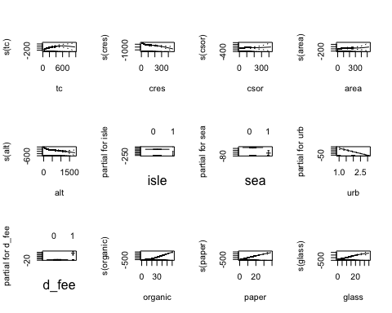
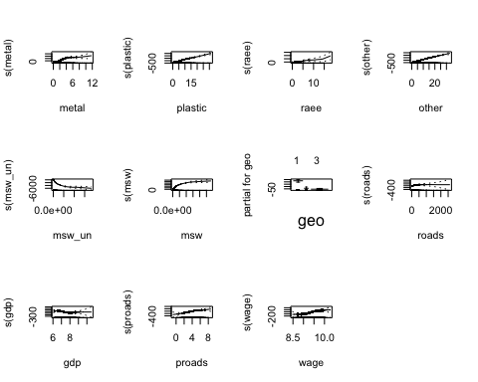
Si procede ora a stimare il nuovo modello con le adeguate trasformazioni e usando il dataset senza outlier.
## Call:
## lm(formula = I((sor^2)/2) ~ I(log(tc + 1)) + I(log(cres + 1)) +
## I(log(area + 1)) + I(log(alt + 1)) + sea + urb + d_fee +
## organic + paper + glass + metal + plastic + I(log(raee +
## 1)) + other + msw_un + msw + geo + roads + gdp + proads +
## wage, data = df_clean)
##
## Residuals:
## Min 1Q Median 3Q Max
## -2008.92 -246.14 -22.15 233.27 1826.89
##
## Coefficients:
## Estimate Std. Error t value Pr(>|t|)
## (Intercept) -1.866e+03 3.467e+02 -5.381 7.80e-08 ***
## I(log(tc + 1)) 2.860e+02 2.186e+01 13.081 < 2e-16 ***
## I(log(cres + 1)) -2.827e+02 1.369e+01 -20.657 < 2e-16 ***
## I(log(area + 1)) 8.271e+01 7.896e+00 10.476 < 2e-16 ***
## I(log(alt + 1)) -1.116e+02 5.817e+00 -19.185 < 2e-16 ***
## sea1 -1.008e+02 1.985e+01 -5.079 3.96e-07 ***
## urb -1.894e+02 1.511e+01 -12.537 < 2e-16 ***
## d_fee1 1.362e+02 1.951e+01 6.981 3.41e-12 ***
## organic 3.406e+01 5.520e-01 61.692 < 2e-16 ***
## paper 5.725e+01 1.759e+00 32.539 < 2e-16 ***
## glass 3.984e+01 1.837e+00 21.682 < 2e-16 ***
## metal 7.653e+01 5.306e+00 14.425 < 2e-16 ***
## plastic 6.989e+01 2.080e+00 33.603 < 2e-16 ***
## I(log(raee + 1)) 1.477e+02 1.967e+01 7.511 7.17e-14 ***
## other 6.148e+01 1.396e+00 44.048 < 2e-16 ***
## msw_un -7.569e-05 3.514e-06 -21.535 < 2e-16 ***
## msw 3.903e-05 1.904e-06 20.498 < 2e-16 ***
## geo2 -2.103e+02 2.500e+01 -8.415 < 2e-16 ***
## geo3 -2.110e+02 2.665e+01 -7.917 3.12e-15 ***
## roads 1.522e-01 6.140e-02 2.479 0.0132 *
## gdp -1.133e+02 1.520e+01 -7.457 1.08e-13 ***
## proads 5.906e+01 8.478e+00 6.966 3.79e-12 ***
## wage 2.590e+02 3.661e+01 7.076 1.74e-12 ***
## ---
## Signif. codes: 0 '***' 0.001 '**' 0.01 '*' 0.05 '.' 0.1 ' ' 1
##
## Residual standard error: 372.7 on 4069 degrees of freedom
## Multiple R-squared: 0.864, Adjusted R-squared: 0.8633
## F-statistic: 1175 on 22 and 4069 DF, p-value: < 2.2e-16
## RESET test
##
## data: mod_clean_T
## RESET = 4.6132, df1 = 1, df2 = 4068, p-value = 0.03179

Conclusioni
Togliendo i punti influenti si nota che il reset test peggiora; quindi si stima il modello utilizzando anche gli outlier.

Eteroschedasticità
Dopo aver stimato il modello si può dunque procedere a controllare la varianza degli errori.
##
## t test of coefficients:
##
## Estimate Std. Error t value Pr(>|t|)
## (Intercept) -1.9728e+03 4.5720e+02 -4.3149 1.633e-05 ***
## I(log(tc + 1)) 2.5892e+02 2.9634e+01 8.7372 < 2.2e-16 ***
## I(log(cres + 1)) -2.6072e+02 1.9195e+01 -13.5831 < 2.2e-16 ***
## I(log(csor + 1)) 2.6971e+01 1.3729e+01 1.9645 0.04953 *
## I(log(area + 1)) 9.6234e+01 1.5299e+01 6.2900 3.489e-10 ***
## I(log(alt + 1)) -1.1830e+02 7.8325e+00 -15.1037 < 2.2e-16 ***
## isle1 -2.9592e+02 1.1882e+02 -2.4905 0.01279 *
## sea1 -1.0655e+02 2.5250e+01 -4.2197 2.497e-05 ***
## urb -2.2116e+02 2.6369e+01 -8.3869 < 2.2e-16 ***
## d_fee1 2.0914e+02 2.5244e+01 8.2845 < 2.2e-16 ***
## organic 3.1917e+01 7.9348e-01 40.2237 < 2.2e-16 ***
## paper 6.1259e+01 2.4503e+00 25.0005 < 2.2e-16 ***
## glass 3.8138e+01 2.5026e+00 15.2392 < 2.2e-16 ***
## metal 6.1253e+01 6.6910e+00 9.1546 < 2.2e-16 ***
## plastic 6.9971e+01 2.6562e+00 26.3422 < 2.2e-16 ***
## I(log(raee + 1)) 1.6399e+02 2.3869e+01 6.8707 7.304e-12 ***
## other 5.8001e+01 1.7893e+00 32.4158 < 2.2e-16 ***
## msw_un -2.7568e-05 1.1277e-05 -2.4447 0.01454 *
## msw 1.3949e-05 6.5373e-06 2.1338 0.03291 *
## geo2 -1.5897e+02 3.3208e+01 -4.7873 1.747e-06 ***
## geo3 -1.9523e+02 3.5436e+01 -5.5095 3.809e-08 ***
## roads 5.7248e-02 2.3144e-01 0.2474 0.80464
## gdp -1.2638e+02 2.0359e+01 -6.2074 5.893e-10 ***
## proads 6.4880e+01 1.5620e+01 4.1535 3.337e-05 ***
## wage 2.8916e+02 4.7930e+01 6.0329 1.745e-09 ***
## ---
## Signif. codes: 0 '***' 0.001 '**' 0.01 '*' 0.05 '.' 0.1 ' ' 1
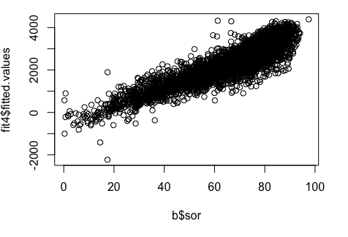

##
## Call:
## lm(formula = sor ~ tc + cres + csor + area + alt + isle + sea +
## urb + d_fee + organic + paper + glass + metal + plastic +
## raee + other + msw_un + msw + geo + roads + gdp + proads +
## wage, data = b)
##
## Residuals:
## Min 1Q Median 3Q Max
## -46.631 -4.791 -0.290 4.485 46.757
##
## Coefficients:
## Estimate Std. Error t value Pr(>|t|)
## (Intercept) -1.883e+01 6.714e+00 -2.804 0.005063 **
## tc 1.042e-02 2.766e-03 3.769 0.000166 ***
## cres -3.829e-02 4.269e-03 -8.969 < 2e-16 ***
## csor 4.897e-02 4.569e-03 10.717 < 2e-16 ***
## area 2.629e-02 2.612e-03 10.066 < 2e-16 ***
## alt -8.112e-03 5.834e-04 -13.905 < 2e-16 ***
## isle1 -3.645e+00 1.758e+00 -2.073 0.038236 *
## sea1 -9.029e-01 3.949e-01 -2.286 0.022277 *
## urb -3.511e+00 2.888e-01 -12.157 < 2e-16 ***
## d_fee1 3.604e+00 3.918e-01 9.198 < 2e-16 ***
## organic 5.594e-01 1.080e-02 51.798 < 2e-16 ***
## paper 1.233e+00 3.437e-02 35.887 < 2e-16 ***
## glass 7.956e-01 3.629e-02 21.927 < 2e-16 ***
## metal 1.130e+00 1.002e-01 11.269 < 2e-16 ***
## plastic 1.194e+00 4.127e-02 28.929 < 2e-16 ***
## raee 9.826e-01 1.471e-01 6.678 2.72e-11 ***
## other 9.499e-01 2.765e-02 34.352 < 2e-16 ***
## msw_un -5.837e-07 3.653e-08 -15.981 < 2e-16 ***
## msw 2.874e-07 2.036e-08 14.114 < 2e-16 ***
## geo2 -2.246e+00 4.993e-01 -4.498 7.04e-06 ***
## geo3 -3.110e+00 5.197e-01 -5.984 2.35e-09 ***
## roads 1.913e-03 5.006e-04 3.822 0.000134 ***
## gdp -1.522e+00 3.126e-01 -4.869 1.16e-06 ***
## proads 1.432e+00 1.590e-01 9.003 < 2e-16 ***
## wage 5.200e+00 7.108e-01 7.316 3.03e-13 ***
## ---
## Signif. codes: 0 '***' 0.001 '**' 0.01 '*' 0.05 '.' 0.1 ' ' 1
##
## Residual standard error: 7.925 on 4316 degrees of freedom
## Multiple R-squared: 0.8013, Adjusted R-squared: 0.8002
## F-statistic: 725.3 on 24 and 4316 DF, p-value: < 2.2e-16
##
## Number of bootstrap replications R = 1999
## original bootBias bootSE bootMed bootSkew
## (Intercept) -1.8828e+01 1.6595e-01 7.8194e+00 -1.8524e+01 -0.114436
## tc 1.0423e-02 1.0134e-05 3.5466e-03 1.0441e-02 -0.020831
## cres -3.8290e-02 3.2223e-04 5.9729e-03 -3.8008e-02 -0.082064
## csor 4.8969e-02 -4.2865e-04 5.7487e-03 4.8161e-02 0.324528
## area 2.6292e-02 -2.6688e-03 5.1142e-03 2.3679e-02 -0.015005
## alt -8.1121e-03 2.2264e-04 6.3590e-04 -7.8826e-03 -0.013307
## isle1 -3.6446e+00 1.2455e-03 2.0915e+00 -3.6868e+00 0.177059
## sea1 -9.0288e-01 8.7215e-03 4.2320e-01 -8.8586e-01 -0.036589
## urb -3.5107e+00 2.0341e-01 3.7520e-01 -3.3095e+00 0.052679
## d_fee1 3.6036e+00 -5.3406e-02 4.1097e-01 3.5598e+00 -0.056313
## organic 5.5945e-01 3.4353e-03 1.3983e-02 5.6300e-01 0.044373
## paper 1.2334e+00 -1.0967e-02 4.3745e-02 1.2223e+00 0.032041
## glass 7.9563e-01 3.2623e-03 4.3840e-02 7.9916e-01 -0.036831
## metal 1.1295e+00 8.3366e-03 1.0526e-01 1.1355e+00 0.140395
## plastic 1.1938e+00 -3.1868e-03 4.5035e-02 1.1903e+00 0.076463
## raee 9.8260e-01 8.9872e-03 1.9568e-01 9.9068e-01 0.046684
## other 9.4994e-01 1.6578e-03 2.8898e-02 9.5103e-01 -0.029531
## msw_un -5.8371e-07 -8.7973e-08 2.1951e-07 -6.2198e-07 -1.752473
## msw 2.8738e-07 4.2665e-08 1.2014e-07 3.0340e-07 1.283666
## geo2 -2.2459e+00 3.4064e-02 5.7684e-01 -2.2207e+00 0.035833
## geo3 -3.1102e+00 8.9924e-02 6.0175e-01 -3.0221e+00 -0.059081
## roads 1.9134e-03 2.0431e-03 3.4270e-03 1.9556e-03 0.938808
## gdp -1.5218e+00 4.2871e-03 3.4562e-01 -1.5176e+00 -0.117096
## proads 1.4317e+00 1.0451e-01 2.5397e-01 1.5026e+00 0.446233
## wage 5.1999e+00 -1.4769e-01 8.1365e-01 5.0380e+00 0.120975
## bootKurtosis
## (Intercept) -0.1130461
## tc -0.1033390
## cres -0.0630522
## csor 0.0011248
## area -0.3964177
## alt -0.0164168
## isle1 0.2399596
## sea1 0.0430777
## urb -0.0149459
## d_fee1 -0.2345870
## organic 0.1743563
## paper -0.0317868
## glass -0.0940843
## metal 0.0120704
## plastic -0.0719747
## raee 0.1498354
## other -0.1177664
## msw_un 5.7521797
## msw 2.4166142
## geo2 0.0133786
## geo3 0.0797591
## roads -0.5621308
## gdp 0.1614977
## proads -0.2285531
## wage 0.0401396

## Bootstrap percent confidence intervals
##
## Estimate 2.5 % 97.5 %
## (Intercept) -1.882823e+01 -3.414784e+01 -4.098937e+00
## tc 1.042328e-02 3.482003e-03 1.704413e-02
## cres -3.829036e-02 -4.941397e-02 -2.673183e-02
## csor 4.896897e-02 3.840761e-02 6.077048e-02
## area 2.629165e-02 1.384882e-02 3.366263e-02
## alt -8.112075e-03 -9.135885e-03 -6.621376e-03
## isle1 -3.644562e+00 -7.593464e+00 7.377068e-01
## sea1 -9.028808e-01 -1.749055e+00 -8.154378e-02
## urb -3.510680e+00 -4.060339e+00 -2.577080e+00
## d_fee1 3.603559e+00 2.757764e+00 4.323688e+00
## organic 5.594492e-01 5.355042e-01 5.900083e-01
## paper 1.233374e+00 1.139225e+00 1.307695e+00
## glass 7.956290e-01 7.120469e-01 8.846403e-01
## metal 1.129531e+00 9.361543e-01 1.354753e+00
## plastic 1.193757e+00 1.103286e+00 1.280244e+00
## raee 9.826042e-01 5.911719e-01 1.376447e+00
## other 9.499404e-01 8.944729e-01 1.009334e+00
## msw_un -5.837073e-07 -1.215384e-06 -3.962705e-07
## msw 2.873785e-07 1.746518e-07 6.263998e-07
## geo2 -2.245853e+00 -3.376675e+00 -1.037629e+00
## geo3 -3.110201e+00 -4.224387e+00 -1.826589e+00
## roads 1.913402e-03 8.247877e-04 1.134805e-02
## gdp -1.521839e+00 -2.216273e+00 -8.498200e-01
## proads 1.431664e+00 1.122336e+00 2.085069e+00
## wage 5.199886e+00 3.520577e+00 6.664758e+00
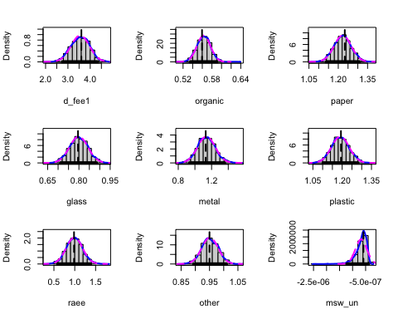
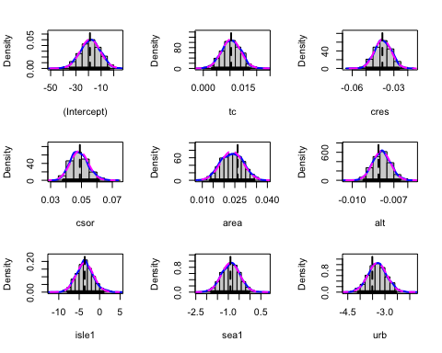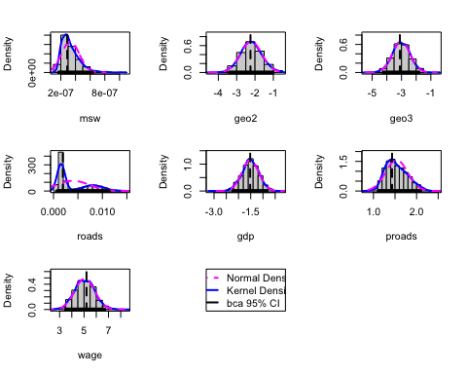
## Bootstrap normal confidence intervals
##
## Estimate 2.5 % 97.5 %
## (Intercept) -1.882823e+01 -3.431999e+01 -3.668375e+00
## tc 1.042328e-02 3.462001e-03 1.736430e-02
## cres -3.829036e-02 -5.031929e-02 -2.690588e-02
## csor 4.896897e-02 3.813044e-02 6.066481e-02
## area 2.629165e-02 1.893671e-02 3.898416e-02
## alt -8.112075e-03 -9.581056e-03 -7.088382e-03
## isle1 -3.644562e+00 -7.745106e+00 4.534922e-01
## sea1 -9.028808e-01 -1.741051e+00 -8.215348e-02
## urb -3.510680e+00 -4.449471e+00 -2.978707e+00
## d_fee1 3.603559e+00 2.851470e+00 4.462459e+00
## organic 5.594492e-01 5.286075e-01 5.834202e-01
## paper 1.233374e+00 1.158602e+00 1.330080e+00
## glass 7.956290e-01 7.064411e-01 8.782925e-01
## metal 1.129531e+00 9.148830e-01 1.327506e+00
## plastic 1.193757e+00 1.108678e+00 1.285211e+00
## raee 9.826042e-01 5.900878e-01 1.357146e+00
## other 9.499404e-01 8.916436e-01 1.004922e+00
## msw_un -5.837073e-07 -9.259736e-07 -6.549583e-08
## msw 2.873785e-07 9.238683e-09 4.801879e-07
## geo2 -2.245853e+00 -3.410507e+00 -1.149328e+00
## geo3 -3.110201e+00 -4.379527e+00 -2.020722e+00
## roads 1.913402e-03 -6.846509e-03 6.587023e-03
## gdp -1.521839e+00 -2.203523e+00 -8.487293e-01
## proads 1.431664e+00 8.293819e-01 1.824927e+00
## wage 5.199886e+00 3.752856e+00 6.942297e+00
Tramite ncvTest ai è verificato che la varianza non è costante, ossia non è indipendente dalle covariate.
Per risolvere il problema si è scelto di calcolare gli errori standard robusti di White; infine viene eseguita una procedura di bootstrap che consente di stimare la distribuzione empirica dei coefficienti e ottenere gli intervalli di confidenza al 95%.

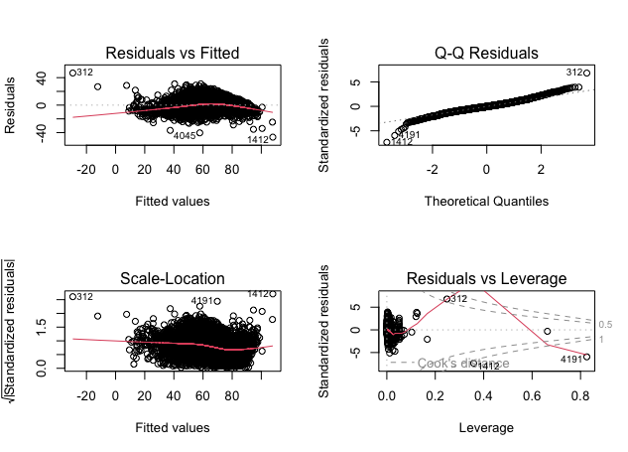

Analisi target dicotomico
L’obbiettivo è quello di costruire un modello logistico robusto utile ad analizzare per ogni comune il tipo di pagamento, si sceglie quindi di analizzare la variabile d_fee, che indica se i comuni hanno un pagamento di tipo PAYT (1) oppure una tipologia standard (0).

Zero Variance
## region province name tc
## Lombardia :1230 Bergamo: 218 Castro : 2 Min. : 25.69
## Campania : 405 Brescia: 172 Peglio : 2 1st Qu.:108.04
## Emilia_Romagna: 308 Milano : 131 Abano Terme : 1 Median :136.62
## Veneto : 265 Bolzano: 115 Abbadia Lariana: 1 Mean :154.24
## Toscana : 231 Salerno: 112 Abbateggio : 1 3rd Qu.:179.16
## Sicilia : 212 Como : 106 (Other) :4328 Max. :977.42
## (Other) :1690 (Other):3487 NA's : 6
## cres csor istat area
## Min. : 4.27 Min. : 3.39 Min. : 1272 Min. : 0.12
## 1st Qu.: 27.34 1st Qu.: 31.25 1st Qu.: 18135 1st Qu.: 10.85
## Median : 41.69 Median : 48.88 Median : 42015 Median : 22.73
## Mean : 54.18 Mean : 52.68 Mean : 47470 Mean : 40.99
## 3rd Qu.: 66.49 3rd Qu.: 66.44 3rd Qu.: 70049 3rd Qu.: 47.49
## Max. :670.32 Max. :582.16 Max. :111107 Max. :1287.39
## NA's :52 NA's :67 NA's :6
## pop alt isle sea
## Min. : 34 Min. : 1.0 Min. :0.000000 Min. :0.0000
## 1st Qu.: 1579 1st Qu.: 80.0 1st Qu.:0.000000 1st Qu.:0.0000
## Median : 3535 Median : 240.0 Median :0.000000 Median :0.0000
## Mean : 10204 Mean : 310.1 Mean :0.005075 Mean :0.1684
## 3rd Qu.: 8199 3rd Qu.: 459.0 3rd Qu.:0.000000 3rd Qu.:0.0000
## Max. :2617175 Max. :1816.0 Max. :1.000000 Max. :1.0000
## NA's :6 NA's :6 NA's :6
## pden wden urb fee
## Min. : 2.48 Min. : 892 Min. :1.00 PAYT : 557
## 1st Qu.: 62.59 1st Qu.: 23571 1st Qu.:2.00 STANDARD:3784
## Median : 151.32 Median : 68343 Median :3.00
## Mean : 405.05 Mean : 192058 Mean :2.49
## 3rd Qu.: 399.37 3rd Qu.: 194625 3rd Qu.:3.00
## Max. :12122.83 Max. :4978556 Max. :3.00
## NA's :6 NA's :6 NA's :6
## d_fee sample organic paper
## Min. :0.0000 Min. :0.0000 Min. : 0.0137 Min. : 0.00001
## 1st Qu.:0.0000 1st Qu.:0.0000 1st Qu.:11.1273 1st Qu.: 8.65575
## Median :0.0000 Median :1.0000 Median :24.9686 Median :10.87905
## Mean :0.1283 Mean :0.5469 Mean :22.2751 Mean :10.96127
## 3rd Qu.:0.0000 3rd Qu.:1.0000 3rd Qu.:31.8224 3rd Qu.:13.06169
## Max. :1.0000 Max. :1.0000 Max. :61.6391 Max. :45.28813
## NA's :512 NA's :25
## glass wood metal plastic
## Min. : 0.000 Min. : 0.000 Min. : 0.00001 Min. : 0.00001
## 1st Qu.: 7.147 1st Qu.: 2.086 1st Qu.: 0.87686 1st Qu.: 4.12610
## Median : 9.102 Median : 4.024 Median : 1.54092 Median : 5.79227
## Mean : 9.407 Mean : 4.114 Mean : 1.76442 Mean : 6.11216
## 3rd Qu.:11.278 3rd Qu.: 5.708 3rd Qu.: 2.35093 3rd Qu.: 7.54472
## Max. :39.836 Max. :25.117 Max. :20.67146 Max. :31.60474
## NA's :33 NA's :1095 NA's :246 NA's :39
## raee texile other msw_so
## Min. : 0.0000 Min. : 0.0000 Min. : 0.02946 Min. : 0
## 1st Qu.: 0.7769 1st Qu.: 0.3464 1st Qu.: 3.96485 1st Qu.: 373965
## Median : 1.1754 Median : 0.6292 Median : 7.13491 Median : 1040737
## Mean : 1.2331 Mean : 0.7570 Mean : 7.94159 Mean : 3248581
## 3rd Qu.: 1.5686 3rd Qu.: 0.9908 3rd Qu.:11.12996 3rd Qu.: 2725645
## Max. :17.9536 Max. :10.5845 Max. :37.15592 Max. :765130099
## NA's :314 NA's :1013 NA's :136
## msw_un msw sor geo
## Min. : 6185 Min. :1.997e+04 Min. : 0.25 Min. :1.000
## 1st Qu.: 175180 1st Qu.:6.117e+05 1st Qu.:57.83 1st Qu.:1.000
## Median : 409060 Median :1.524e+06 Median :70.84 Median :3.000
## Mean : 2042522 Mean :5.311e+06 Mean :66.24 Mean :2.291
## 3rd Qu.: 1056920 3rd Qu.:3.954e+06 3rd Qu.:79.09 3rd Qu.:3.000
## Max. :926757220 Max. :1.692e+09 Max. :97.48 Max. :3.000
## NA's :285
## roads s_wteregio s_landfill gdp
## Min. : 1.0 Min. : 0.000 Min. : 3.603 Min. : 6.035
## 1st Qu.: 25.0 1st Qu.: 8.905 1st Qu.: 4.551 1st Qu.: 6.811
## Median : 51.0 Median :24.468 Median :11.297 Median : 7.128
## Mean : 101.9 Mean :21.867 Mean :20.001 Mean : 7.231
## 3rd Qu.: 105.0 3rd Qu.:38.501 3rd Qu.:31.493 3rd Qu.: 7.571
## Max. :14970.0 Max. :65.122 Max. :92.532 Max. :10.539
## NA's :443 NA's :285 NA's :285 NA's :386
## proads wage finance
## Min. :-3.367 Min. : 7.866 Min. : 6.216
## 1st Qu.: 3.498 1st Qu.: 9.226 1st Qu.: 7.016
## Median : 4.356 Median : 9.523 Median : 7.342
## Mean : 4.254 Mean : 9.447 Mean : 7.448
## 3rd Qu.: 5.075 3rd Qu.: 9.665 3rd Qu.: 7.798
## Max. : 8.980 Max. :10.485 Max. :10.855
## NA's :443 NA's :285 NA's :386

## 'data.frame': 4341 obs. of 32 variables:
## $ region : Factor w/ 20 levels "Abruzzo","Basilicata",..: 5 5 5 5 13 5 5 7 20 8 ...
## $ tc : num 502 228 268 199 234 ...
## $ cres : num 129.3 49.5 50.6 41.1 58.3 ...
## $ csor : num 66.4 44.1 44.6 40.4 26 ...
## $ istat : int 38006 38011 38025 38014 110005 38010 38030 58120 27005 8050 ...
## $ area : num 283.8 34.4 26.6 84.3 35.7 ...
## $ pop : int 22648 4952 3895 7140 12193 3003 7364 67626 11793 2861 ...
## $ alt : int 1 1 1 1 1 1 1 1 1 2 ...
## $ isle : int 0 0 0 0 0 0 0 0 0 0 ...
## $ sea : int 1 1 1 1 1 0 0 1 1 1 ...
## $ pden : num 79.8 143.8 146.3 84.7 341.5 ...
## $ wden : num 119671 70031 81117 43320 201565 ...
## $ urb : int 2 3 3 3 2 3 3 2 2 2 ...
## $ d_fee : int 1 1 1 1 0 1 1 0 0 0 ...
## $ organic : num 3.137 35.041 37.377 45.31 0.428 ...
## $ paper : num 4.36 9.89 11.99 9.76 6.6 ...
## $ glass : num 3.59 9.52 6.65 7.55 4.33 ...
## $ metal : num 0.462 1.861 0.745 0.747 0.103 ...
## $ plastic : num 1.13 4.64 5.22 5.2 5.12 ...
## $ raee : num 0.346 1.609 1.728 0.692 0.275 ...
## $ other : num 3.2 9.02 16.04 9.77 4.05 ...
## $ msw_so : num 20396261 1831407 1694922 2881055 3026700 ...
## $ msw_un : int 13560520 580460 464400 770860 4169180 349620 556540 7895520 5659520 296480 ...
## $ msw : int 33956781 2411867 2159322 3651915 7195880 1682628 3336429 33435410 15175582 1553789 ...
## $ geo : int 3 3 3 3 1 3 3 2 3 3 ...
## $ roads : num 285 11 49 165 60 65 80 329 77 17 ...
## $ s_wteregio: num 33.11 33.11 33.11 33.11 4.05 ...
## $ s_landfill: num 15.2 15.2 15.2 15.2 45.4 ...
## $ gdp : num 7.27 7.11 7.27 7.09 7.25 ...
## $ proads : num 4.35 6.08 4.34 3.71 5.27 ...
## $ wage : num 9.44 9.51 8.89 9.43 9.13 ...
## $ dframe$sor: num 60.1 75.9 78.5 78.9 42.1 ...
##
## 0 1
## 1 209 16
## 2 1518 246
## 3 2057 295
Guardando la tabella delle frequenze congiunte si potrebbe concludere che più un comune è urbanizzato e maggiore è la tendenza ad avere un pagamento di tipo PAYT.

Collinearità variabili quantitative
come nel modello lineare bisogna controllare e gestire il fenomeno di collinearità, quindi si analizzano $TOL$ e $VIF$ e in modo iterativo si tolgono le variabili che risultano collineari.
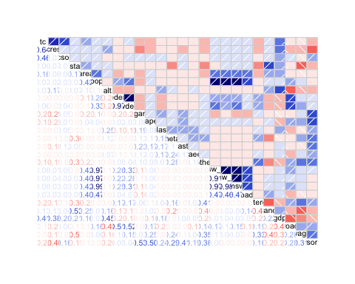

##
## Call:
## imcdiag(mod = m)
##
##
## All Individual Multicollinearity Diagnostics Result
##
## VIF TOL Wi Fi Leamer CVIF Klein
## Xtc 2.9004 0.3448 328.0043 341.7503 0.5872 4.0216 1
## Xcres 2.3582 0.4241 234.4219 244.2460 0.6512 3.2698 1
## Xcsor 1.6255 0.6152 107.9679 112.4926 0.7843 2.2539 1
## Xistat 1.6640 0.6010 114.6100 119.4131 0.7752 2.3073 1
## Xarea 1.7539 0.5702 130.1239 135.5772 0.7551 2.4319 1
## Xpop 92.6035 0.0108 15810.7579 16473.3563 0.1039 128.4018 1
## Xalt 1.7795 0.5620 134.5373 140.1756 0.7496 2.4674 1
## Xpden 26.8160 0.0373 4455.8336 4642.5690 0.1931 37.1824 1
## Xwden 28.4781 0.0351 4742.7140 4941.4720 0.1874 39.4870 1
## Xorganic 2.2320 0.4480 212.6367 221.5479 0.6694 3.0948 1
## Xpaper 1.7264 0.5792 125.3724 130.6266 0.7611 2.3938 1
## Xglass 1.4060 0.7113 70.0671 73.0035 0.8434 1.9495 1
## Xmetal 1.3352 0.7490 57.8490 60.2733 0.8654 1.8513 1
## Xplastic 1.4979 0.6676 85.9432 89.5449 0.8171 2.0770 1
## Xraee 1.1339 0.8819 23.1154 24.0841 0.9391 1.5723 0
## Xother 1.8420 0.5429 145.3262 151.4166 0.7368 2.5540 1
## Xmsw_so 9009.2439 0.0001 1554822.8982 1619982.5291 0.0105 12492.0060 1
## Xmsw_un 12007.6473 0.0001 2072347.3185 2159195.4004 0.0091 16649.5217 1
## Xmsw 40493.7894 0.0000 6989055.4476 7281953.2908 0.0050 56147.7373 1
## Xroads 1.5234 0.6564 90.3367 94.1225 0.8102 2.1123 1
## Xs_wteregio 1.5837 0.6314 100.7433 104.9653 0.7946 2.1959 1
## Xs_landfill 2.0266 0.4934 177.1984 184.6244 0.7024 2.8101 1
## Xgdp 1.9856 0.5036 170.1133 177.2424 0.7097 2.7532 1
## Xproads 2.1965 0.4553 206.5114 215.1659 0.6747 3.0456 1
## Xwage 1.9446 0.5142 163.0377 169.8703 0.7171 2.6963 1
## Xsor 4.8628 0.2056 666.7117 694.6523 0.4535 6.7426 1
Rimozione variabili . . .

##
## Call:
## imcdiag(mod = m)
##
##
## All Individual Multicollinearity Diagnostics Result
##
## VIF TOL Wi Fi Leamer CVIF Klein IND1
## Xtc 2.8571 0.3500 381.9337 401.1232 0.5916 3.9449 1 0.0017
## Xcres 2.3476 0.4260 277.1611 291.0865 0.6527 3.2415 1 0.0021
## Xcsor 1.6114 0.6206 125.7451 132.0630 0.7878 2.2249 1 0.0030
## Xistat 1.6525 0.6051 134.2071 140.9500 0.7779 2.2817 1 0.0029
## Xpop 86.7328 0.0115 17632.3713 18518.2765 0.1074 119.7559 1 0.0001
## Xalt 1.6897 0.5918 141.8511 148.9782 0.7693 2.3331 1 0.0029
## Xwden 1.7145 0.5833 146.9499 154.3331 0.7637 2.3673 1 0.0028
## Xorganic 1.9063 0.5246 186.3944 195.7594 0.7243 2.6321 1 0.0026
## Xpaper 1.6630 0.6013 136.3566 143.2076 0.7755 2.2962 1 0.0029
## Xglass 1.3294 0.7522 67.7501 71.1540 0.8673 1.8356 1 0.0037
## Xmetal 1.3295 0.7522 67.7570 71.1613 0.8673 1.8356 1 0.0037
## Xplastic 1.3941 0.7173 81.0450 85.1170 0.8470 1.9248 1 0.0035
## Xraee 1.1332 0.8825 27.3864 28.7624 0.9394 1.5646 0 0.0043
## Xmsw_so 22.2333 0.0450 4366.9781 4586.3886 0.2121 30.6985 1 0.0002
## Xmsw 106.6447 0.0094 21727.5848 22819.2463 0.0968 147.2492 1 0.0000
## Xroads 1.4677 0.6814 96.1812 101.0136 0.8254 2.0265 1 0.0033
## Xs_wteregio 1.5033 0.6652 103.5129 108.7137 0.8156 2.0757 1 0.0032
## Xs_landfill 1.9734 0.5067 200.1993 210.2580 0.7119 2.7248 1 0.0025
## Xgdp 1.9426 0.5148 193.8706 203.6112 0.7175 2.6823 1 0.0025
## Xproads 2.1767 0.4594 242.0102 254.1696 0.6778 3.0055 1 0.0022
## Xwage 1.8971 0.5271 184.4971 193.7669 0.7260 2.6194 1 0.0026
## Xsor 3.7866 0.2641 573.1017 601.8962 0.5139 5.2283 1 0.0013
## IND2
## Xtc 1.3109
## Xcres 1.1577
## Xcsor 0.7652
## Xistat 0.7964
## Xpop 1.9935
## Xalt 0.8232
## Xwden 0.8405
## Xorganic 0.9588
## Xpaper 0.8040
## Xglass 0.4997
## Xmetal 0.4998
## Xplastic 0.5701
## Xraee 0.2370
## Xmsw_so 1.9261
## Xmsw 1.9979
## Xroads 0.6426
## Xs_wteregio 0.6752
## Xs_landfill 0.9948
## Xgdp 0.9786
## Xproads 1.0902
## Xwage 0.9537
## Xsor 1.4842
##
## 1 --> COLLINEARITY is detected by the test
## 0 --> COLLINEARITY is not detected by the test
##
## Xtc , Xpop , Xorganic , Xmsw_so , Xmsw , Xroads , Xproads , coefficient(s) are non-significant may be due to multicollinearity
##
## R-square of y on all x: 0.1568
##
## * use method argument to check which regressors may be the reason of collinearity
## ===================================

Collinearità variabili qualitative
Per gestire la collinearità delle variabili qualitative è stato studiato il coefficiente di connessione $χ_{norm}^{2}$.
## X1 Row Column Chi.Square df p.value n u1 u2 nMinu1u2 Chi.Square.norm
## 1 1 region isle 74.144 19 0.000 4341 19 1 4341 0.0170798725
## 2 2 region sea 1150.484 19 0.000 4341 19 1 4341 0.2650274187
## 3 3 region urb 623.837 38 0.000 4341 19 2 8682 0.0718540306
## 4 4 region d_fee 1143.261 19 0.000 4341 19 1 4341 0.2633635702
## 5 5 region geo 8324.733 38 0.000 4341 19 2 8682 0.9588497068
## 6 6 isle sea 92.183 1 0.000 4341 1 1 4341 0.0212354833
## 7 7 isle urb 3.718 2 0.156 4341 1 2 4341 0.0008565554
## 8 8 isle d_fee 2.204 1 0.138 4341 1 1 4341 0.0005077038
## 9 9 isle geo 23.567 2 0.000 4341 1 2 4341 0.0054288777
## 10 10 sea urb 96.236 2 0.000 4341 1 2 4341 0.0221691709
## 11 11 sea d_fee 53.301 1 0.000 4341 1 1 4341 0.0122784849
## 12 12 sea geo 444.808 2 0.000 4341 1 2 4341 0.1024667662
## 13 13 urb d_fee 8.716 2 0.013 4341 2 1 4341 0.0020078003
## 14 14 urb geo 79.226 4 0.000 4341 2 2 8682 0.0091252690
## 15 15 d_fee geo 372.685 2 0.000 4341 1 2 4341 0.0858523465
Si può notare che le variabili geo e region hanno un $χ_{norm}^{2}$ pari a 0.9588 quindi risultano altamente connesse; si è ritenuto quindi corretto rimuovere ‘geo’.
##
## Call:
## glm(formula = d_fee ~ alt + pden + urb + organic + plastic +
## paper + glass + metal + raee + other + msw_un + sor + gdp +
## proads + wage, family = binomial, data = l_nuovo)
##
## Coefficients:
## Estimate Std. Error z value Pr(>|z|)
## (Intercept) -4.222e+01 2.943e+00 -14.347 < 2e-16 ***
## alt 8.713e-04 2.458e-04 3.546 0.000392 ***
## pden -6.908e-04 1.730e-04 -3.994 6.50e-05 ***
## urb2 -2.475e-01 3.818e-01 -0.648 0.516947
## urb3 2.435e-01 4.273e-01 0.570 0.568809
## organic -5.453e-03 5.244e-03 -1.040 0.298333
## plastic -9.422e-02 2.345e-02 -4.019 5.85e-05 ***
## paper 6.394e-02 1.626e-02 3.933 8.40e-05 ***
## glass -5.582e-02 1.877e-02 -2.974 0.002940 **
## metal 1.216e-01 3.944e-02 3.083 0.002051 **
## raee -2.593e-01 9.279e-02 -2.795 0.005196 **
## other -7.724e-02 1.319e-02 -5.856 4.73e-09 ***
## msw_un -5.756e-08 3.189e-08 -1.805 0.071050 .
## sor 9.079e-02 7.686e-03 11.812 < 2e-16 ***
## gdp -2.442e-02 1.317e-01 -0.185 0.852888
## proads 1.422e-01 7.609e-02 1.869 0.061604 .
## wage 3.611e+00 2.859e-01 12.629 < 2e-16 ***
## ---
## Signif. codes: 0 '***' 0.001 '**' 0.01 '*' 0.05 '.' 0.1 ' ' 1
##
## (Dispersion parameter for binomial family taken to be 1)
##
## Null deviance: 3326.6 on 4340 degrees of freedom
## Residual deviance: 2483.3 on 4324 degrees of freedom
## AIC: 2517.3
##
## Number of Fisher Scoring iterations: 8

Iterazioni tra variabili categoriali
## Single term deletions
##
## Model:
## d_fee ~ alt + pden + urb + organic + plastic + paper + glass +
## metal + raee + other + msw_un + sor + gdp + proads + wage
## Df Deviance AIC F value Pr(>F)
## <none> 2483.3 2517.3
## alt 1 2495.9 2527.9 21.9587 2.871e-06 ***
## pden 1 2501.9 2533.9 32.4546 1.301e-08 ***
## urb 2 2497.5 2527.5 12.3801 4.353e-06 ***
## organic 1 2484.3 2516.3 1.8806 0.1703410
## plastic 1 2500.3 2532.3 29.6855 5.364e-08 ***
## paper 1 2498.9 2530.9 27.1680 1.952e-07 ***
## glass 1 2492.4 2524.4 15.8674 6.905e-05 ***
## metal 1 2492.3 2524.3 15.7922 7.185e-05 ***
## raee 1 2491.8 2523.8 14.9320 0.0001131 ***
## other 1 2519.7 2551.7 63.5004 2.034e-15 ***
## msw_un 1 2487.7 2519.7 7.6449 0.0057174 **
## sor 1 2643.1 2675.1 278.2237 < 2.2e-16 ***
## gdp 1 2483.3 2515.3 0.0600 0.8065541
## proads 1 2486.8 2518.8 6.0831 0.0136868 *
## wage 1 2690.2 2722.2 360.3428 < 2.2e-16 ***
## ---
## Signif. codes: 0 '***' 0.001 '**' 0.01 '*' 0.05 '.' 0.1 ' ' 1

##
## Call:
## glm(formula = d_fee ~ alt + pden + urb + organic + plastic +
## paper + glass + metal + raee + other + msw_un + sor + gdp +
## proads + wage + sor * alt, family = binomial, data = l_nuovo)
##
## Coefficients:
## Estimate Std. Error z value Pr(>|z|)
## (Intercept) -4.609e+01 3.064e+00 -15.043 < 2e-16 ***
## alt 8.551e-03 9.753e-04 8.767 < 2e-16 ***
## pden -6.473e-04 1.749e-04 -3.702 0.000214 ***
## urb2 -1.440e-01 3.911e-01 -0.368 0.712790
## urb3 3.205e-01 4.371e-01 0.733 0.463440
## organic -1.125e-03 5.294e-03 -0.213 0.831695
## plastic -9.366e-02 2.407e-02 -3.891 0.000100 ***
## paper 7.000e-02 1.648e-02 4.246 2.18e-05 ***
## glass -4.642e-02 1.899e-02 -2.445 0.014482 *
## metal 1.056e-01 3.946e-02 2.676 0.007458 **
## raee -2.530e-01 9.355e-02 -2.705 0.006833 **
## other -7.890e-02 1.327e-02 -5.945 2.76e-09 ***
## msw_un -3.387e-08 3.060e-08 -1.107 0.268348
## sor 1.321e-01 9.904e-03 13.335 < 2e-16 ***
## gdp -6.553e-03 1.330e-01 -0.049 0.960707
## proads 1.492e-01 7.690e-02 1.940 0.052407 .
## wage 3.629e+00 2.938e-01 12.354 < 2e-16 ***
## alt:sor -1.060e-04 1.304e-05 -8.128 4.36e-16 ***
## ---
## Signif. codes: 0 '***' 0.001 '**' 0.01 '*' 0.05 '.' 0.1 ' ' 1
##
## (Dispersion parameter for binomial family taken to be 1)
##
## Null deviance: 3326.6 on 4340 degrees of freedom
## Residual deviance: 2426.6 on 4323 degrees of freedom
## AIC: 2462.6
##
## Number of Fisher Scoring iterations: 8
L’iterazione tra le variabili ‘sor’ e ‘alt’ risulta altamente significativa quindi si procede ad effettuare Model Selection partendo dal modello con l’iterazione.

Model selection
## Start: AIC=2462.55
## d_fee ~ alt + pden + urb + organic + plastic + paper + glass +
## metal + raee + other + msw_un + sor + gdp + proads + wage +
## sor * alt
## Df Deviance AIC
## - gdp 1 2426.6 2460.6
## - organic 1 2426.6 2460.6
## - msw_un 1 2428.1 2462.1
## <none> 2426.6 2462.6
## - proads 1 2430.3 2464.3
## - glass 1 2432.7 2466.7
## - metal 1 2433.6 2467.6
## - raee 1 2434.5 2468.5
## - urb 2 2438.3 2470.3
## - pden 1 2442.4 2476.4
## - plastic 1 2442.5 2476.5
## - paper 1 2444.8 2478.8
## - other 1 2464.3 2498.3
## - alt:sor 1 2483.3 2517.3
## - wage 1 2624.5 2658.5
##
## Step: AIC=2460.56
## d_fee ~ alt + pden + urb + organic + plastic + paper + glass +
## metal + raee + other + msw_un + sor + proads + wage + alt:sor
## Df Deviance AIC
## - organic 1 2426.6 2458.6
## - msw_un 1 2428.1 2460.1
## <none> 2426.6 2460.6
## - proads 1 2430.4 2462.4
## + gdp 1 2426.6 2462.6
## - glass 1 2432.7 2464.7
## - metal 1 2433.6 2465.6
## - raee 1 2434.5 2466.5
## - urb 2 2438.4 2468.4
## - pden 1 2442.5 2474.5
## - plastic 1 2442.6 2474.6
## - paper 1 2444.8 2476.8
## - other 1 2464.8 2496.8
## - alt:sor 1 2483.3 2515.3
## - wage 1 2624.9 2656.9
##
## Step: AIC=2458.6
## d_fee ~ alt + pden + urb + plastic + paper + glass + metal +
## raee + other + msw_un + sor + proads + wage + alt:sor
## Df Deviance AIC
## - msw_un 1 2428.1 2458.1
## <none> 2426.6 2458.6
## - proads 1 2430.5 2460.5
## + organic 1 2426.6 2460.6
## + gdp 1 2426.6 2460.6
## - glass 1 2432.7 2462.7
## - metal 1 2433.7 2463.7
## - raee 1 2434.5 2464.5
## - urb 2 2438.9 2466.9
## - pden 1 2442.6 2472.6
## - plastic 1 2442.6 2472.6
## - paper 1 2447.4 2477.4
## - other 1 2465.8 2495.8
## - alt:sor 1 2484.4 2514.4
## - wage 1 2625.8 2655.8
##
## Step: AIC=2458.12
## d_fee ~ alt + pden + urb + plastic + paper + glass + metal +
## raee + other + sor + proads + wage + alt:sor
## Df Deviance AIC
## <none> 2428.1 2458.1
## + msw_un 1 2426.6 2458.6
## - proads 1 2431.8 2459.8
## + gdp 1 2428.1 2460.1
## + organic 1 2428.1 2460.1
## - glass 1 2433.5 2461.5
## - metal 1 2435.4 2463.4
## - raee 1 2435.9 2463.9
## - urb 2 2441.2 2467.2
## - plastic 1 2443.4 2471.4
## - pden 1 2443.7 2471.7
## - paper 1 2448.1 2476.1
## - other 1 2465.9 2493.9
## - alt:sor 1 2488.1 2516.1
## - wage 1 2625.8 2653.8

##
## Call:
## glm(formula = d_fee ~ alt + pden + urb + plastic + paper + glass +
## metal + raee + other + sor + proads + wage + sor * alt, family = binomial,
## data = l_nuovo)
##
## Coefficients:
## Estimate Std. Error z value Pr(>|z|)
## (Intercept) -4.641e+01 2.902e+00 -15.991 < 2e-16 ***
## alt 8.707e-03 9.623e-04 9.048 < 2e-16 ***
## pden -6.262e-04 1.713e-04 -3.656 0.000256 ***
## urb2 7.261e-02 3.502e-01 0.207 0.835741
## urb3 5.545e-01 3.883e-01 1.428 0.153276
## plastic -9.096e-02 2.386e-02 -3.813 0.000137 ***
## paper 6.906e-02 1.556e-02 4.439 9.05e-06 ***
## glass -4.284e-02 1.867e-02 -2.294 0.021796 *
## metal 1.068e-01 3.933e-02 2.716 0.006613 **
## raee -2.493e-01 9.329e-02 -2.672 0.007529 **
## other -7.543e-02 1.267e-02 -5.952 2.64e-09 ***
## sor 1.335e-01 9.422e-03 14.168 < 2e-16 ***
## proads 1.447e-01 7.576e-02 1.911 0.056055 .
## wage 3.611e+00 2.929e-01 12.327 < 2e-16 ***
## alt:sor -1.080e-04 1.291e-05 -8.362 < 2e-16 ***
## ---
## Signif. codes: 0 '***' 0.001 '**' 0.01 '*' 0.05 '.' 0.1 ' ' 1
##
## (Dispersion parameter for binomial family taken to be 1)
##
## Null deviance: 3326.6 on 4340 degrees of freedom
## Residual deviance: 2428.1 on 4326 degrees of freedom
## AIC: 2458.1
##
## Number of Fisher Scoring iterations: 7
Come nel modello lineare si è effettuata una model selection com metodo ‘both’. Sono quindi state tolte le variabili:
- pop
- wden
- organic
- msw
- gdp

Odds Ratio
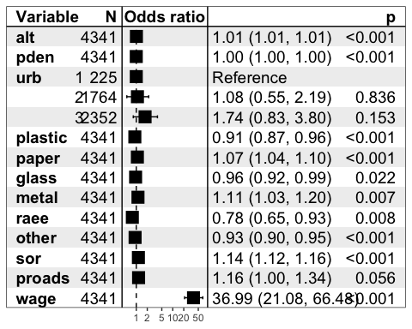
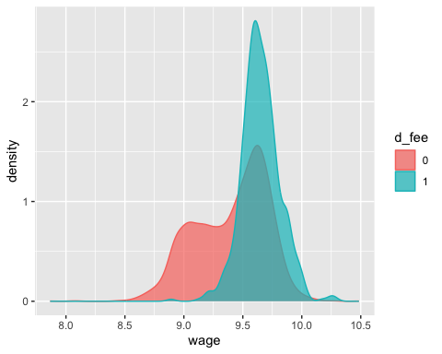
## OR 2.5 % 97.5 %
## (Intercept) 6.961655e-21 2.065694e-23 1.812724e-18
## alt 1.008745e+00 1.006824e+00 1.010653e+00
## pden 9.993740e-01 9.990280e-01 9.996983e-01
## urb2 1.075314e+00 5.511756e-01 2.186889e+00
## urb3 1.741044e+00 8.264543e-01 3.803055e+00
## plastic 9.130520e-01 8.708062e-01 9.561703e-01
## paper 1.071500e+00 1.039466e+00 1.104891e+00
## glass 9.580692e-01 9.233020e-01 9.934541e-01
## metal 1.112737e+00 1.029924e+00 1.202616e+00
## raee 7.793248e-01 6.472975e-01 9.314960e-01
## other 9.273476e-01 9.043395e-01 9.504113e-01
## sor 1.142822e+00 1.122254e+00 1.164498e+00
## proads 1.155750e+00 9.963154e-01 1.340937e+00
## wage 3.698554e+01 2.107779e+01 6.647584e+01
## alt:sor 9.998920e-01 9.998667e-01 9.999177e-01
In questo plot osserviamo gli Odds Ratio associati a ciascuna variabile indipendente L’Odds Ratio indica quanto cambia la propensione al verificarsi dell’evento al variare della covariata di riferimento Oltre al valore dell’Odds Ratio va valutato il p-value associato e il corrispettivo intervallo di confidenza, che indica la significatività dell’associazione.

R^2
##
## Call:
## glm(formula = d_fee ~ 1, family = binomial, data = l_nuovo)
##
## Coefficients:
## Estimate Std. Error z value Pr(>|z|)
## (Intercept) -1.91597 0.04538 -42.22 <2e-16 ***
## ---
## Signif. codes: 0 '***' 0.001 '**' 0.01 '*' 0.05 '.' 0.1 ' ' 1
##
## (Dispersion parameter for binomial family taken to be 1)
##
## Null deviance: 3326.6 on 4340 degrees of freedom
## Residual deviance: 3326.6 on 4340 degrees of freedom
## AIC: 3328.6
##
## Number of Fisher Scoring iterations: 4
R2
## [1] 0.2700978
$R^{2}$ è l’indice che misura l’adattamento del modello ai dati. Nel modello preso in considerazione l’$R^{2}$ è moderatamente basso, pari all’incirca a 0.27.

Probabilità ridotte

## predicted
## observed 0 1
## 0 3705 79
## 1 427 130
79/(3705+79)
## [1] 0.02087738
427/(427+130)
## [1] 0.7666068
Si osserva che per quanto riguarda l’individuazione di comuni con un tipo di pagamento STANDARD il modello ha una buona bontà di predizione in quanto solamente 2.09% dei comuni con un sistema STANDARD vengono misclassificati come PAYT, quindi per quanto riguarda l’individuazione di comuni con STANDARD ha una buona bontà predittiva.

Accuratezza
###ACCURATEZZA###
acc=t2[1,1]+t2[2,2]; acc
## [1] 0.883437
###TASSO D'ERRORE###
1-acc
## [1] 0.116563
Per quanto riguarda l’individuazione di comuni con pagamento PAYT, il modello non riesce a classificare correttamente il 76.4% dei dati, di conseguenza si può dire che per quanto riguarda il PAYT il modello non ha una buona capacità predittiva. Nonostante l’alta missclassificazione per il metodo di pagamento PAYT, il modello ha comunque una buona accuratezza pari all’88,3%, e di conseguenza un tasso di errore del 11.7% circa

