Malware Analysis and Incident Forensics (Ms Cybersecurity)
Systems and Enterprise Security (Ms Eng. in CS)
Practical test - 08/07/2021

First name: ________________ Last name:_______________ Enrollment num.:__________
Email: ______________________________________ (it will be used to send you the outcome of this test)

Rules: You can use the textbook, written notes or anything “physical” you brought from home. You have full internet access that you can use to access online documentation. Communicating with other students or other people in ANY form, or receiving unduly help to complete the test, is considered cheating. Any student caught cheating will have their test cancelled. To complete the test, copy the following questions in a new Google docs and fill it in with you answers. Please write your answer immediately after each question. Paste screenshots and code snippets to show whenever you think they can help comprehension. BEFORE the end of the test, produce a PDF and send it via e-mail at querzoni@diag.uniroma1.it and delia@diag.uniroma1.it with subject “MAIF-test-<your surname>-<your enrollment number>” (use the same text for the PDF file name).

Consider the sample named sample-20210708.exe and answer the following questions :

1 - What does a basic inspection of the PE file (e.g. header, sections, strings, resources) reveal about this sample?
First of all let’s open the sample in PEStudio and select the indicator tab. We can observe this two
Rows
That are commonly related to packed sample, let’s analyze it more deeply by selecting the sections tab.
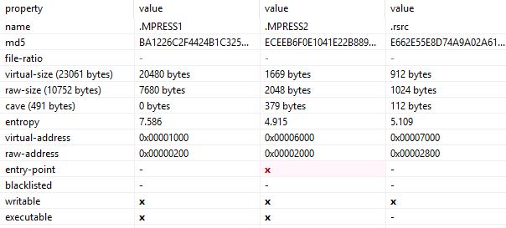
As we can see the name of the sections are related to a packer name, also we can observe that there is a
huge difference between raw and virtual size, an high value of entropy and the sections are writable and
executable, so my assumption that the malware is packed is getting more strong.
An important aspect of packed sample is the fact that there is one import for each library, to check it go in
libraries tab of PEStudio and analyze it.
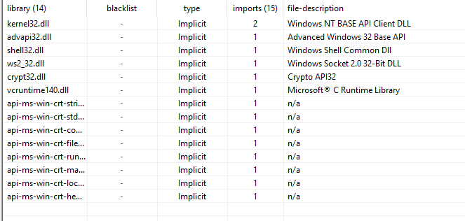
As I said before there is only one import for each library. Moreover the list of import is very shorts (10) all
this hints let me think that the sample is packed.
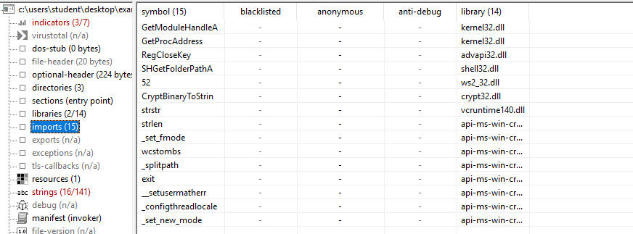
There are some interesting imports like GetModuleHandle and GetProcAddress mostly used in packed sample.
There is also SHGetFolderPathA that retrieves the path of a folder that will be useful in debugging
also is probable that somewhere network communication is happening due the
presence of ws2_32.dll and so on, and maybe there will be a movement in the registry due the presence of RegCloseKey
In the string sections I’ve found the following interesting strings:
- MPRESS1,2: related to the packer;
- V2.19: maybe the packer version;
- Port: %h: related to a port in the network communication;
- 4\notepa
- D.exe: maybe there is the creation of a process called notepad.exe
- CurrentV
- Ersion\R
- unOnc: it’s a registry key to run something at each login, so it can be an hint of persistence;
- Time%: involve something with the system time;

2 - Which packer was used to pack this sample? Provide the original entry point (OEP) address and details how you located the tail jump address.
The packer used is Mpress as we can see from the PEStudio strings, but in order to be sure
let’s open the sample with detect it easy tool.
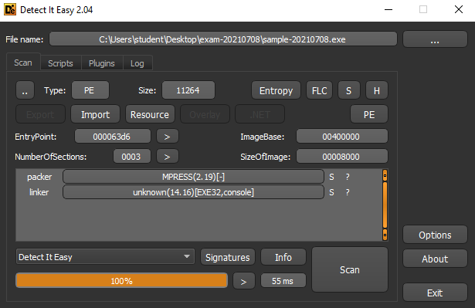

That confirm my suggestion.
In order to find the tail jump and the OEP let’s open the sample in IDA and put a breakpoint
in the “pusha” instruction, then run the code, press one time step-over, in the stack view
select the first address and click “Follow in hex dump” and put a breakpoint in the selected
region
Then press the play button.
The tail jump can be found at 00404817
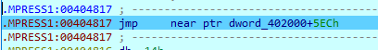
instead the OEP is located at 004025EC.
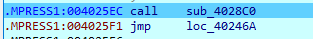

3 - Provide details about the IAT reconstruction process that you carried out to unpack the code. HINT: you can check the result of your unpacking work comparing the resulting code with the one contained in the sample sample-20210708-unpacked.exe (e.g. check API uses)
Once retrieved the OEP let’s open Scylla attach it to the sample process and insert the real
OEP, the press IAT Autosearch and then GetImports, that’s the result.
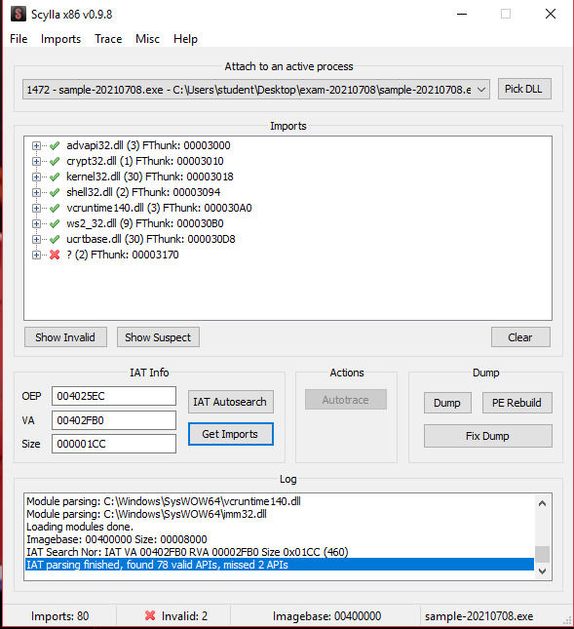
We need to remove the 2 invalid API, right click them and press delete tree node
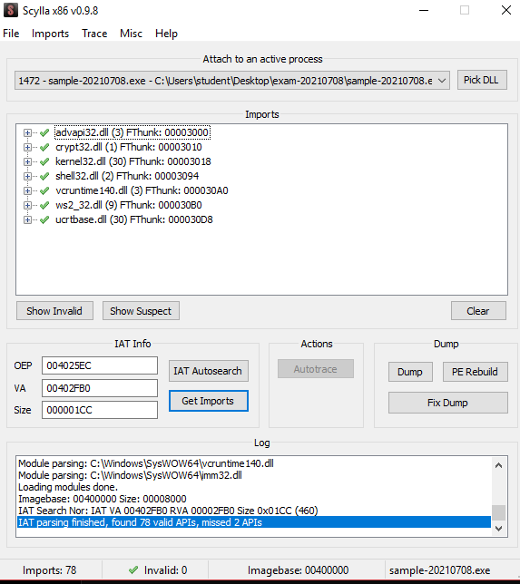
Then press Dump and once did that press Fix Dump by selecting the dump version of the
sample. To check if the unpacking process is correct we expect from the original unpacked
sample 78 imports, so let’s open it with PeStudio
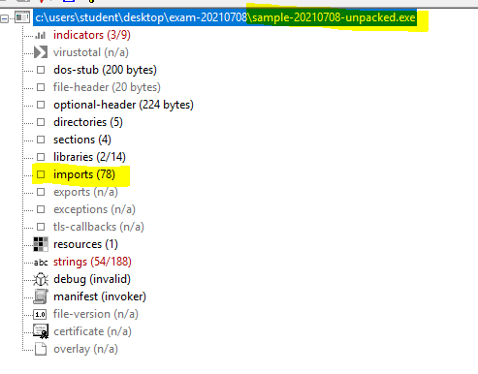
And that’s it.

Consider the sample named sample-20210708-unpacked.exe and answer the following questions:

4 - Provide a brief, high-level description of the functionalities implemented by the sample (what it does, when, how). Try to keep it short (like 10 lines). Reference answers to other questions wherever you see fit.
It checks the list of processes to see if multiple instances of the sample are running, if it is it will close the sample. Then it retrieves Windows system information and based on that it choose in which folder save the 4m4-trd.exe file. Then it creates a registry key associated to the previously exe file to run the malware at each restart of the machine. Then it retrieves the functions to perform shellcode injection in the process notepad.exe or calc.exe based of the system version. Then it retrieves the time and computer name encrypt them create a socket send this informations and waits for commands from the server to perform some actions in the client.
5 - List the processes, registry keys, files and network connections created/manipulated by the sample (and its byproducts, e.g. injected payloads, if any) during its functioning. Detail the methodology you used to acquire this list. (Come back to this question to complete it as you acquire further details during the test)
I extracted this informations by using processmonitor + wireShark.
Registry keys:
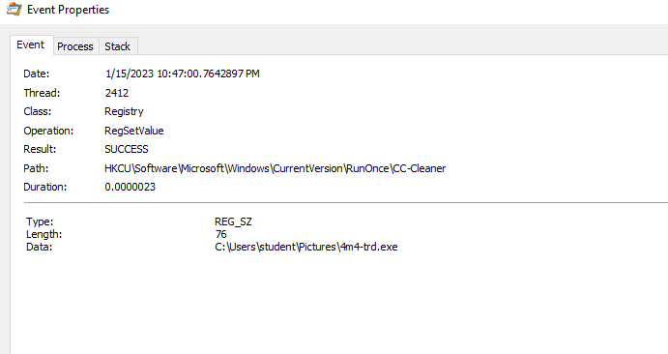
Processes:
Files:

Network:
Tcp connection that fails
6 - List the subroutines used by the sample (and its byproducts, if any) to implement its main functionalities and provide a sketch of the execution transfers among them (e.g sketch a tree/graph). NOTE: If the sample uses some shellcode, listing its parts is optional. HINTS: The main subroutine starts at 0x401d00. You can safely ignore all subroutines starting at address 0x402300 or higher as they are standard compiler-generated code, and functions at 0x{401550, 401560, 4015c0, 4015e0, 401b10, 401b30, 401fa0, 401fe0}: think of 0x{4015e0, 401fa0} as some C sprintf(), while 0x{401b10, 401b30} check the Windows version in use.

7 - Does the sample make queries about the surrounding environment before unveiling its activities? If yes, describe them and pinpoint specific instructions/functions in the code.
Yes it checks if an instance of the malware is already present in the running process list, if it is then quit the program by using ExitProcess gathered GetProcessAddres

8 - Does the sample include any persistence mechanisms? If yes, describe its details and reference specific instructions/functions in the code.
Yes, it creates an exe with the malware content and create a registry key RunOnce linked to the created exe to execute it at each restart of the system.

9 - Does the sample perform any code injection activities? Which kind of injection pattern do you recognize? Describe the characteristics and behavior of the injected payload. Optionally, describe also the interactions taking place after the injection between the main process and the injected one.
It performs a shellcode injection in the notepad.exe process or calc.exe process (depending on the windows version)
This is the shellcode:
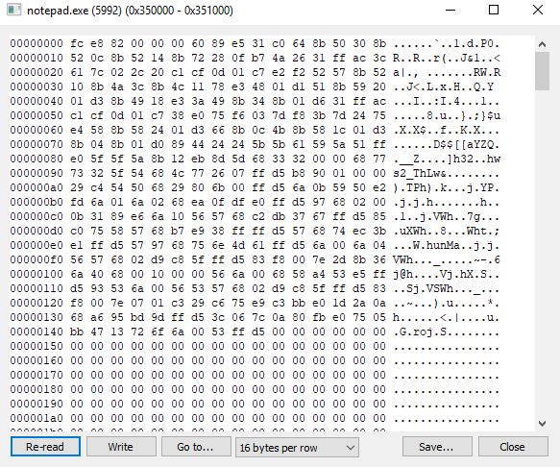
The shellcode creates a listening socket
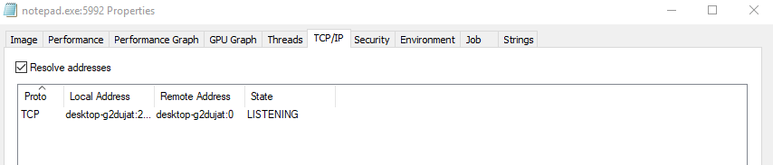

10 - Does the sample beacon an external C2? Which kind of beaconing does the malware use? Which information is sent with the beacon? Does the sample implement any communication protocol with the C2? If so, describe the functionalities implemented by the protocol.
It gets the system informations like the hostname and the time and send them to the server. The clients wait for some commands:
- Q: quit;
- S: sleep at the end it send a Bye string to the server.

11 - List the obfuscation actions (if any) performed by the sample to hide its activities from a plain static analysis. Pinpoint and describe specific code snippets.

