The two papers where I got a lot of the equations used and the initial estimates for the parameters.

**On-lattice agent-based simulation of populations of cells within the open-source Chaste framework:**

<https://royalsocietypublishing.org/doi/full/10.1098/rsfs.2012.0081>

**A computational multiscale agent-based model for simulating spatio-temporal tumor immune response to PD1 and PDL1 inhibition:**

<https://royalsocietypublishing.org/doi/full/10.1098/rsif.2017.0320#RSIF20170320F2>

The library I used is Agentpy. The space is a square grid where each cell can contain at maximum one agent at the time.

The end product of the simulation is an animation of cancer development starting with a single proliferating cell initialized in the center of the grid. The cell can replicate, move, or enter a quiescent state if there is not enough oxygen. After a certain predefined time, if not awakened by an adequate amount of oxygen, the quiescent cell will also die and be removed from the grid. The number of dead tumor cells at each iteration is saved because it determines the number of T cells that will be recruited, according to the equation:

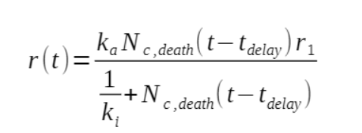

N is the number of dead tumor cells, k_a and k_i, mutational burden and neoantigen_strength of the patient, respectively, are genetically determined parameters that influence the speed of recognition of tumor cells by the immune system.

Also r is used to determine the rate of recruitment.

T_delay indicates the reaction time of the immune system, which must get the dendritic cells to the lymph nodes and prime the T cells, which enter the microenvironment through the blood vessels, randomly extracted on the grid. T cells arrive in the effector state, and switch to the active state when they detect a tumor cell in their Moore neighborhood. In the active state they can identify a cancer cell and attack it.

Cancer cells are of two types, depending on whether the PDL1 protein is present.

This protein in normal cells prevents the killing of self material, and therefore the onset of autoimmune diseases, by inhibiting the action of the immune system. This protein has a chance to appear whenever the cancer cell is triggered by a T cell attack. When it is activated, the chance of being killed by a T cell is lower. At each replication of the tumor cell the presence or absence of the protein is conserved.

Each cell is labeled with an attribute which is the phase, Φ∈[0,1], which is increased at each iteration according to this equation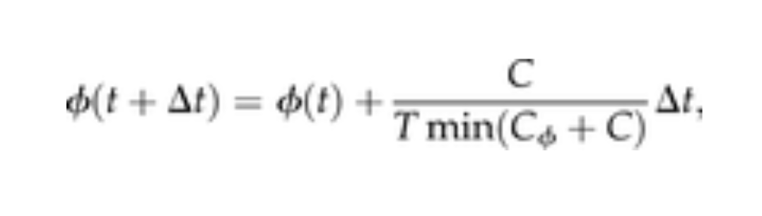

Where Tmin is the minimum period of the cell cycle, and $C_{ϕ}$ is the oxygen concentration at which the metabolic rate is half the maximum. C is precisely the oxygen concentration of the location in the grid of the cell; this equation basically indicates that the more a cell consumes oxygen, the more it "ages" rapidly. When the phase is greater than 1, replication occurs, zeroing the phase for the two daughter cells.

The cytokine IL-2 is produced by newly activated T cells for a predetermined period of time, and a sufficient concentration of this chemical species is a necessary condition for T cell replication of any type.

Both the diffusion of 02 and of IL-2 are obtained by solving the partial differential equation:

$$\frac{∂C}{∂t}=D∇^{2}C-dC+λ$$

Where C is the concentration, D is the diffusion coefficient, d is the degradation rate (in the case of oxygen it is consumable and is applied in the positions of the grid where a cell is present) and lambda is the production rate, for oxygen comes from blood vessels, and for IL-2 from newly activated T cells.

I solved this equation by discretizing it and solving for each time-step synchronized with the rest of the simulation.