**Part 1**

**Task 1**

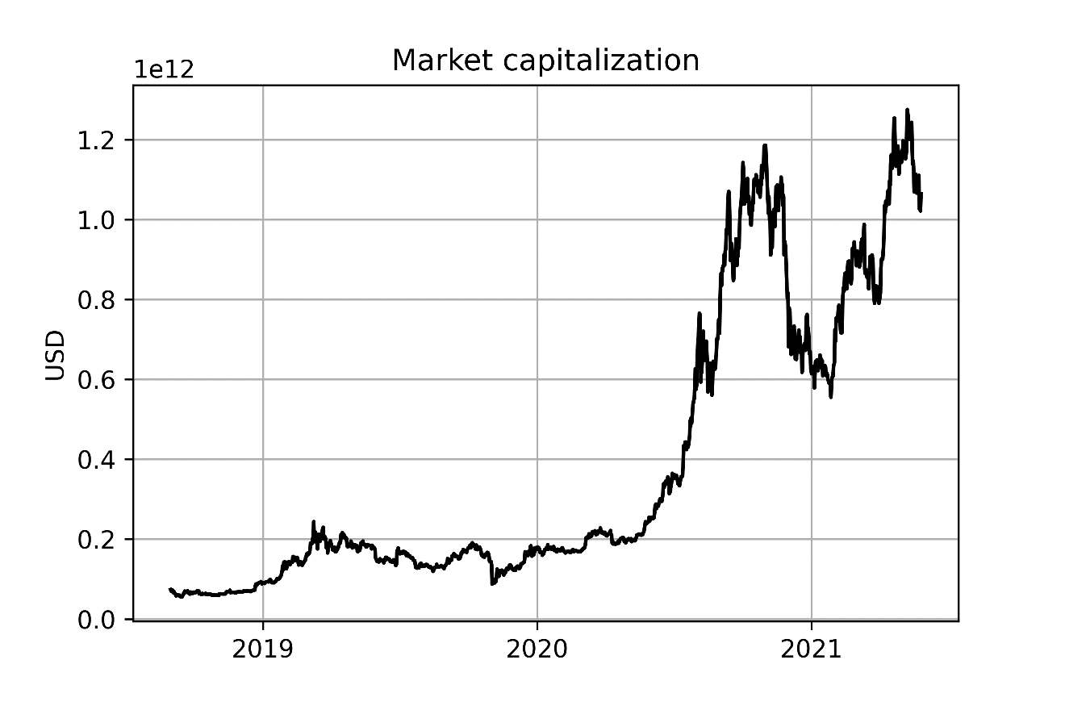

**Task 2**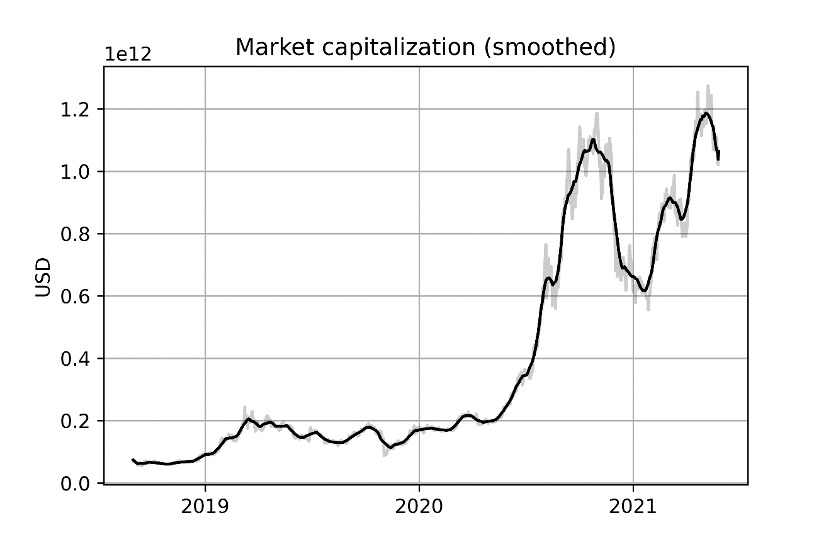

**Task 3**

The data shows a sixfold increase in market capitalization during the second half of 2020, with a subsequent 50% fall which already recovered in the first half of 2021. The data is consistent with the large increase in price that Bitcoin experienced since 2020. In just one year Bitcoin reached the 9th position (as of 03/12/2021) in the list of the largest assets by capitalization, preceded only by 6 stocks, gold, and silver. If this trend is going to continue, in a few years Bitcoin may become the largest asset in the market.