**CS 410000 Computer Architecture**

**Homework 1**

**(Due: 2020-09-28 23:59)**

[學號] [姓名]

Please evaluate your computer performance by executing the following benchmarks, and fill the blanks of table. In addition, basic hardware information of your computer has to be reported too. You can download the benchmark source code from iLms, and re-compile them for your Linux system.

|  |
| --- |
| **Compile Instructions**  1) Change directories to “src” of benchmarks. (eq. SPEC2000_SS/CINT2000/164.gzip/src)  2) Make sure your gcc location in *Makefile.defaults* (eq. cc=gcc), and type "make",  3) Execute the “./run” script, and report your program elapsed time. |

|  |  |
| --- | --- |
| Reference machine information | |
| Processor model | Intel(R) Core(TM) i5-1038NG7 CPU @ 2.00GHz |
| Memory size | 16 GB |
| Operating system (OS) | Mac OS X 10.15.4 |

|  |  |  |  |
| --- | --- | --- | --- |
| Benchmark | Execution time of your machine (second) | Execution time of reference machine (second) | Speedup of your machine w.r.t. reference machine |
| 175.vpr | 5% | 0.853 | 10% |
| 181.mcf | 5% | 0.362 | 10% |
| 256.bzip2 | 5% | 2.933 | 10% |
| Arithmetic mean |  |  | 10% |

|  |  |
| --- | --- |
| Your machine information | |
| Processor number | 5% |
| Memory | 5% |
| Operating system (OS) | 5% |

Snapshots of compilation results (including 175.vpr, 181.mcf,and 256.bzip2). 3*5%

E.g.

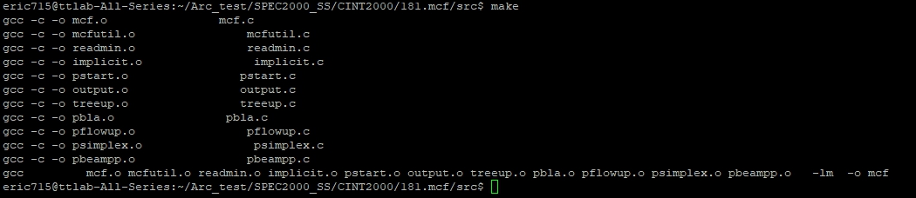

Snapshots of execution results (including 175.vpr,181.mcf,and 256.bzip2). 3*5%

E.g.

