**EECS 481 Software Engineering**

**Project Plan Document**

**Group Members: Anthony Chiang, Deng Ke Teo, Bryant Ku, Steven Louie, Mark**

**Mevorah, Jason Terranova, Steven Uy**

**System Description**

To improve the quality of life of people with cerebral palsy, we propose a communication tool using eye-tracking technology that will allow cerebral palsy patients to potentially be more expressive in communicating their thoughts. The tool leverages the eye-tracking capabilities of the Creative Intel Gesture Camera to enable people with cerebral palsy to be better at communicating.

In the context of Grace, a teenage girl with cerebral palsy, and her family, who we are working closely with in this project, daily communication between Grace and the people around her is usually binary-she would reply yes or no to questions by waving her hand or shaking her head. In school, she uses a table of pictures to communicate her thoughts, which usually takes some time because of her limited movements. Our communication application, that serves as a hybrid between an on-screen keyboard and communication grid, will allow Grace to communicate with family, friends and teachers in more expressively.

**Workload Partition**

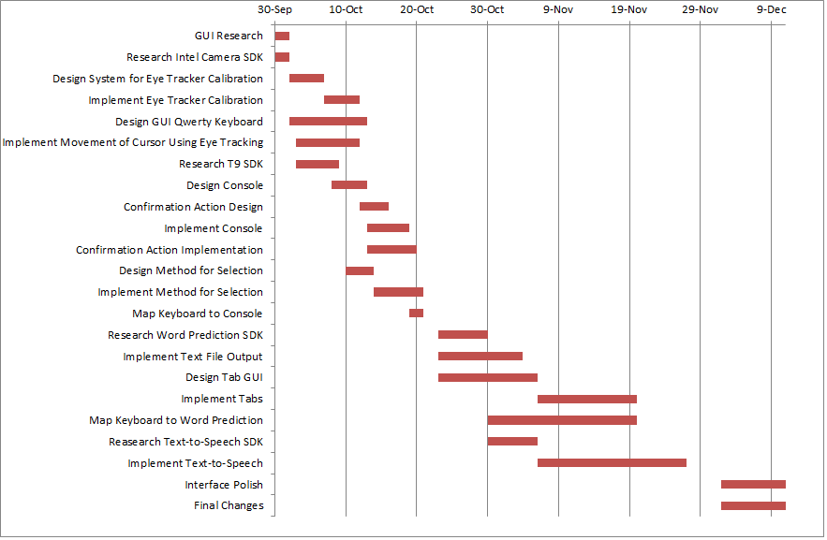

**Alpha Release**

*Keyboard*

Description: Implement a user interface that has the option to use either a qwerty or T9 keyboard with eye-tracking input.

*Eye Tracking*

Description: Backend logic for eye-tracking feature that will be integrated with the keyboard.

Resources: Intel Creative Camera, Intel Perceptual Computing SDK 2013, Windows Laptop

*Console*

Description: The console is responsible for displaying information like words, sentences, and selection to the user on screen. It is dynamic in that it will display information based on what the user is doing within the application i.e. entering words, or browsing stored sentences.

Start Date: 30 September 2013

End Date: 21 October 2013

Resources: Intel Creative Camera, Windows Laptop

**Beta Release**

*Word Completion*

Description: Implement word completion feature.

Resources: OpenAdapt Library

*Tabs*

Description: Implement tabs on GUI to switch between word/keyboard contexts and a tab controller to switch between the tabs. The user will have the ability to save words or sentences in the tabs and reload another time.

*Text File Output*

Description: This will allow the user to save a message to an external text file for later use.

*Text To Speech*

Description: Using a speech synthesizer library, we will convert user text input to speech.

Start Date: 23 October 2013

End Date: 27 November 2013

Resources: Microsoft Speech Platform SDK 11

**Final Release**

*User Interface Polish*

Description: Button sizes will be enlarged based on the cursor position and screen size. Graphics and overall appearance will be improved.

*Sentence Completion*

Description: This gives the user the ability to complete a possible sentence depending on the words already typed.

Start Date: 2 December 2013

End Date: 11 December 2013

**Workload Estimate**

For our project, we are using COCOMO as the form of workload estimation. COCOMO produces an estimate of workload based on a variety of contributing factors and their relative importance. Our application demands an average level of end user efficiency and data communication as well as reusability. We classify the development mode of our project as organic due to a small team size. We expect to add additional features if time permits to better match the needs of Grace.

The Technical Complexity Factor (TCF) is 15 and the Unadjusted Function Points (UFP) is 64. These two values were used to calculate the Lines of Code (LOC) that is 2560. The product of all the Cost Drivers (CDs) is 0.6973. The LOC and product of CDs were used to calculate the labor months required to complete the project that is 5.987 which is also 909.992 labor hours. This also corresponds to 129.9989 hours per person.

We will be using Pivotal Tracker to track project development. This tool facilitates agile development. Individual tasks will be scored and assigned to different members of the team. A relatively equal amount of points allotted will ensure a fair balance of work among the team.

**Risk Management**

|  |
| --- |
| **Risk Description:** Grace’s intermittent involuntary head movements may hinder the focus of her pupils on the screen. |
| **Risk Detection:** The group will observe and record how long it takes for her to return her head to the correct position. |
| **Risk Avoidance:** Tests involving voluntary head movement will reduce the risk. |
| **Risk Mitigation Plan:** To prevent accidental selection, as the camera detects any turn of the head outside a rotation range, the program will remain idle for a time period determined by the user until the head returns within the range and pupil’s are focused on the screen. |

|  |
| --- |
| **Risk Description:** Pupil tracking is impossible with the Creative Intel gesture camera. |
| **Risk Detection:** If the existing SDK for Creative Intel camera fails pupil tracking nearing a release date, a hardware change will be discussed. |
| **Risk Avoidance:** Early research with the SDK and the Intel camera will reduce the risk. |
| **Risk Mitigation Plan:** Many hardware alternatives exist, such as the Kinect with an external lens or a high definition webcam. |

|  |
| --- |
| **Risk Description:** Grace’s eye movements may not be stable enough for our implementation. |
| **Risk Detection:** The group will work with Grace, observing her pupil focus while reading text on a screen. |
| **Risk Avoidance:** This risk can be avoided through extensive testing to ensure that Grace’s eye movements match up with the cursor on the screen. Initial testing without Grace will need to focus on simulating movements similar to Grace’s. |
| **Risk Mitigation Plan:** If Grace’s movements do not match our expectations, we will have to adjust the eye tracking to accommodate them. |

|  |
| --- |
| **Risk Description:** Multiple objects or people in the background being detected may interfere with the eye tracking and selection. |
| **Risk Detection:** This risk can be detected through tests with the Intel camera such as multiple people or moving objects in the background. |
| **Risk Avoidance:** Recognizing the eye structures and having the person sit closer to the camera will reduce the risk. |
| **Risk Mitigation Plan:** If this risk does occur, the environment can be controlled without additional objects or eye tracking can be designed specifically for Grace. |

**Group Organization**

Our group will be following a flat structure where each member is directly involved in the decision making process. Our seven-person group is split into two smaller groups with one group working on the tool’s GUI and the other on the backend eye-tracking logic. Work will be divided equally among team members. Bi-weekly standup meetings will be held during or after class lectures for individual members to report on their work progress. Quitting and firing policies have been laid out in the group contract with the latter being decided based on unanimous decisions.

**References**

"Intel Perceptual Computing SDK 2013." *Intel Software*. N.p., n.d. Web. 28 Sept. 2013. <<http://software.intel.com/en-us/vcsource/tools/perceptual-computing-sdk>>.

"Microsoft Speech Programming Guide." *Microsoft Developer Network*. Microsoft, n.d. Web. 28 Sept. 2013. <http://msdn.microsoft.com/en-us/library/hh378466%28v=office.14%29.aspx>.

"Pivotal Tracker - Agile Project Management Software." *Pivotal Tracker*. N.p., n.d. Web. 28 Sept. 2013. <https://www.pivotaltracker.com/>.