Matt McDade

ESC HW Problem # 19

A)

Code is seen below-

x = linspace(-1, 1, 101)

y = exp(1./(x.^2 - 1));

y(1) = 0;

y(length(y)) = 0;

p = polyfit(x, y, 10)

x1 = linspace(-1, 1);

y1 = polyval(p, x1);

plot(x, y, 'o', x1, y1, 'b-')

Output coefficients and plot seen below-

p =

Columns 1 through 8

-1.1247 -0.0000 3.1281 0.0000 -2.4430 -0.0000 0.5089 0.0000

Columns 9 through 11

-0.4350 -0.0000 0.3689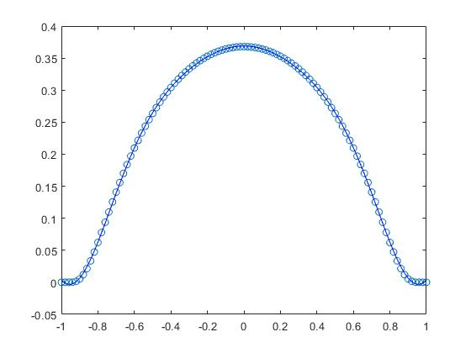

B) Code is seen below-

x = linspace(0, 1, 101);

y = besselj(1,x);

xx = linspace(0, 1, 1001);

yy = besselj(1, xx);

p = polyfit(x, y, 8);

x1 = linspace(0, 1);

y1 = polyval(p, x1);

pp = polyfit(xx, yy, 8);

yy1 = polyval(pp, x1);

plot(x, y, 'o', x1, y1, 'b-', x1, yy1, 'r-')

legend('Data', '101 Points', '1001 Points')

Plot seen below-

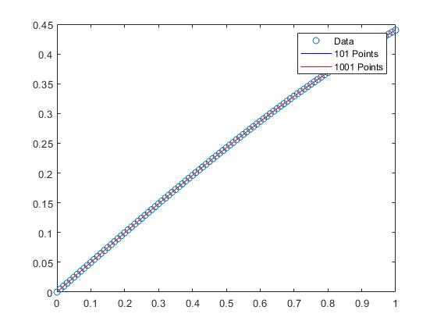

Since there is so little different between the two different approximations, I showed that the two lines are different by comparing by subtracting the two and printing out the difference:

diff1 = y(floor(length(y)/2)) - yy(floor(length(yy)/2))

diff2 = y(floor(length(y)/3)) - yy(floor(length(yy)/3))

diff3 = y(floor(length(y)/4)) - yy(floor(length(yy)/4))

Which outputs:

diff1 =

-0.0041

diff2 =

-0.0058

diff3 =

-0.0044