Matt McDade

Embedded Scientific Computing

HW Problem # 20

1. Again, not sure how to get coefficients or polynomials from the way that I found to do it, which I’m pretty sure doesn’t look right in the graphs. They both look very noisy

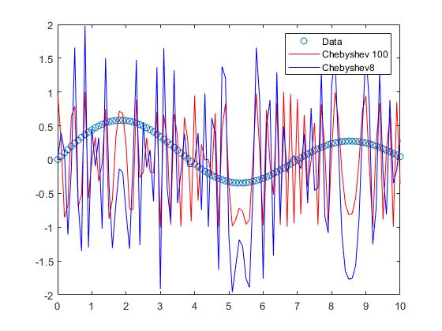

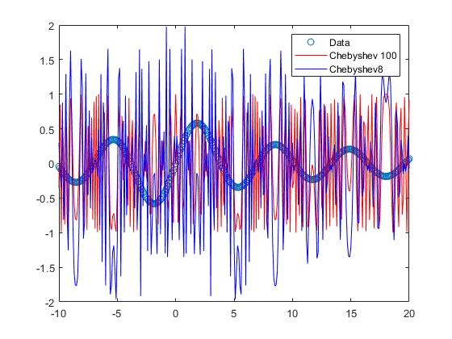

1. These seem large, I’m assuming something is wrong with the way I found how to do L1 norms in Matlab. See code for how I got this:

l1 =

92.1256

matL1 =

92.1256

Matlab code:

x = 0:0.1:10;

x_2 = -10:0.1:20;

y = besselj(1,x);

y_2 = besselj(1, x_2);

cheby100 = chebyshevT(100, y);

cheby92 = chebyshevT(92, y);

cheby8 = cheby100 - cheby92;

cheby100_2 = chebyshevT(100, y_2);

cheby92_2 = chebyshevT(92, y_2);

cheby8_2 = cheby100_2 - cheby92_2;

figure(1)

plot(x, y, 'o', x, cheby100, 'r-', x, cheby8, 'b-')

legend('Data', 'Chebyshev 100', 'Chebyshev8')

figure(2)

plot(x_2, y_2, 'o', x_2, cheby100_2, 'r-', x_2, cheby8_2, 'b-')

legend('Data', 'Chebyshev 100', 'Chebyshev8')

l1 = (sum(abs(y-cheby8)))

matL1 = norm(y-cheby8,1)