Senior Design Project Proposal

Design Project: Smart Parking Deck

Design Team: 06

Julie Aichinger

Matt McDade

Ryne Turner

Laveréna Wienclaw

Date Submitted:

22 March 2018

**1. Problem Statement**

Needs:

The need to be met is the difficulty of finding parking at the University and other places like it. It is extremely difficult to find parking on campus throughout the day. With next year going to a 4 day week, we predict that this parking issue will only escalate, making this project even more necessary. The current limitation is there is no current infrastructure in place, so we will be starting from scratch. (RT)

Objective:

This parking system design will include a thorough combination of both hardware and software. Applications will be designed to show drivers the presence of available parking spots on both a display physically at the parking lot and on mobile devices. Within the parking lots there will be hardware sensors to sense where the spots are available. Sensors will be at each parking spot location. (RT)

Research Survey/Background:

The purpose of a smart parking system is to inform drivers of available parking spaces and decrease the amount of time spent on travel. The system would be composed of a readable, durable user interface which can inform drivers of the approximate locations of vacant parking spaces. A screen would display this information before the entrance to each floor of the parking decks where the system is implemented. A mobile application for both iOS and Android will be used to inform students which parking lots are currently available and how many spaces are open so that they are able to pre-plan their arrival. This system not only provides greater convenience to the user, but it also provides a way to improve traffic efficiency on campus. This low-maintenance system would use infrared or ultrasonic sensors positioned above ground beside each space to detect the presence of a vehicle, and it would be connected to a network that would update the mobile applications and the displays in real time. This would require an Internet hub per floor to send the information to a web server. In these ways the smart parking system provides methods for The University of Akron to maximize usage of its available spaces and decrease commute time.

From the perspective of a student, the basic theory behind a more refined parking system is to apply the technology that exists in other areas on campus to ones that improve efficiency by ensuring a more fluid movement of traffic. Students need to have a productive time-management system to drive from work or home and arrive to class punctually, and the implementation of this proposed system will help students accomplish this objective. From the perspective of The University of Akron, it could be advantageous to enact an inexpensive smart parking system that would help its students arrive more safely and when expected. The planned design of this system also helps collect data on traffic patterns that do not yet exist, potentially exposing other room for improvement in terms of which spaces are most advantageous for permanent residents versus commuting students. It could also support the upcoming transitions to a four-day week and the expected traffic pattern changes that would result, maintaining the orderliness that is necessary when many more students may be present on campus for extended periods of time.

Smart parking is one technology that exists in part in the surrounding areas of Northeastern Ohio, but it has yet to be actualized at The University of Akron. Older plans have existed for a brand of this system, but these plans used image processing upon entrance of the vehicle into the parking deck, which is a far less effective way of measuring what parking spaces are filled or empty and would provide little to no discernible benefit to the student as it lacks the specificity needed in order to do so. One example of a successful demonstration of similar concepts would be the Smart Parking Garage, CLE of the Cleveland Airport. This garage manages many vehicles through a combination of intuitive signage and valet parking. There are also very advanced automated parking deck systems used primarily for storage of cars during longer periods of time, but these systems exist far outside the range and scope of this project due to sensible financial limitations. Some of these examples are discussed in the paragraphs below.

Some of the limitations of current designs include mobile applications with limited or unintuitive functionality, lack of a real-time update system for those entering the parking decks, and inaccurate recognition of smaller vehicles. These are all areas this design seeks to rectify. Many current designs could cost up to $70 per space, and these systems are ineffective in many cases due to the sensor’s position on the ground, bulk, and low battery life. The design of this proposal is a partially wired circuit connecting sensors near each space, which means much lower cost, much lower maintenance, and much greater effectiveness. Realistically speaking, this means that it could be more difficult to install initially, but after initial installation has been completed, little to no further maintenance should be required. There are two very different definitions of what a “smart” parking system means. The first definition is an advanced machine that automatically stores your vehicle in a mechanical compartment inaccessible from roadways. The second definition is an improved parking system based on the detection of empty spaces and the number of vehicles present in a parking deck. The second definition of a smart parking system is what this proposal means to substantially refine. Some of the small-scale goals of this project are designing a top-down, easy-to-read display for drivers entering the parking decks and a weather-resistant housing for the circuit.

While thinking of specific technologies to use for implementing this idea, there are two relatively inexpensive types of sensors to calculate distance: infrared and ultrasonic. Infrared sensors work by emitting an infrared light invisible to the human eye, which then reflects off any nearby surfaces and back to a sensor. If this is applied to calculate distance, the sensor is placed near the initial infrared emitter so a timing calculation may be performed and eventually translated into a voltage. Ultrasonic sensors work in a similar way, utilizing an emitter and receiver to time the difference between the sending and receiving signals but uses sound instead of light (Mohammad, 2009). (RT)

Ultrasonic sensors can offer higher quality at shorter ranges. Since the project idea is to mount these devices on either the wall in front of the parking space or the ceiling above it, a measuring distance of a few meters is required. Ultrasonic sensors also have the characteristic of not being as sensitive to the material that reflects the sound wave. For example, infrared light bounces much more effectively off of reflective surfaces, such as a smooth metal and have a harder time with non-reflective substances such as cloth or water (Mohammad, 2009). This means that infrared scores a point towards being used in the device. Lastly, ultrasonic sensors are less sensitive under lighting conditions but more sensitive to ambient noises (and vice versa for infrared sensors). This makes sense since each infrared and ultrasonic sensors use light and sound, respectively, to measure distance.

These differences highlight infrared sensors as being the better choice of the two sensors for the application of this parking space system. If initial testing proves too difficult because of the changes in lighting, the ultrasonic sensor path will most likely be taken. (MM)

Two relevant patents were found to assist in the design of this project. The first one is described as “Method for managing a parking lot” (US Grant number of US7688225B1). It describes a way to manage a parking lot system and the spots within that system. It includes gathering parking data and transforming the data into highly usable information by using a complex mathematical probability. This includes information about a moving object in a parking lot. It accomplishes this task using a video input and audio input device. It also includes an efficient method for transmitting a map of the parking lot to a mobile device. The second patent relevant to our project is titled “Computer-implemented system and method for managing motor vehicle parking reservations” (US Grant number of US8799037B2). It describes a method of managing parking locations through a server and uses sensors to detect the presence of a vehicle. This patent describes a need for the user to reserve the spot and to make a parking account. It then verifies the parking reservation against the identity of the motorist to allow use of the parking spot.

This technology anticipates the use of sensors, computer networks, and mobile applications. Both patents use similar technologies, but neither of them use all of the technologies that are anticipated to be used during the design of this project. Because of this, it can be concluded that the design of this project does not risk intellectual property infringement. (JA)

Some researchers have taken it upon themselves to get more involved with the use of RFID and, in the case found, plan on solving the issue of slow payment via tickets when entering and exiting a parking garage. Pala and Inanc propose check-in and check-outs for parking payment using RFID to expedite the process (Pala, 2007). The information of cars entering or exiting could easily be used to answer how many parking spots are left in a deck, but this number does not clue the user to the exact location in the parking lot where the open spot exists and still may lead to wasted time and frustration on the part of the user.

A group of researchers interested in a smart parking system proposed the use of an optical sensor in a wireless sensor network (WSN) in order to detect a car coming into a deck as well as the direction the car is going (for the purpose of measuring where an open parking space could be found) (Chinrungrueng, Sunantachaikul, & Triamlumlerd, 2007). The issues found in this design lies within the detection ability of the sensors as they cannot reliably distinguish between automobiles and humans. Another issue could be the reliability in knowing where an open parking spot is located based solely on the direction of a car as it is very possible for cars to change direction at the command of the driver.

The best method discovered in the efficiency of an intelligent parking system lies with the use of vehicular ad hoc networks (VANET). This type of wireless communication uses the networking capabilities between cars in order to tell a person trying to find a parking space the relevant locations to travel using real-time updates with the added benefits of anti-theft protection and friendly parking information dissemination (Lu, Lin, Zhu, & Shen, 2009). While this method in test cases proved helpful, it is in the best interest for this senior design proposal to provide a relatively lower-priced solution per parking spot in order to keep accurate data of the highest possible caliber.(LW)

In conclusion, this proposal emphasizes the need for an effective communication device that allows the students to save time and the University of Akron to maximize its current parking inventory. This smart parking deck design will be valuable in both of these areas it aims to mend. The project requires an advanced knowledge of circuit design and sensor technology, which is applicable to the logic and signal processing classes taken by the participating computer and electrical engineers. The project also requires the design of mobile applications as well as the displays for each parking deck level. This means that the proposed concept has both a hardware and a software component. (The current plan of this design project is to test using twelve strategically-positioned spaces of the Schrank Parking Deck.) (RT)

Marketing Requirements:

(JA, RT)

* This system should be cost efficient for users of the parking system.
* This system should be able to sense the presence of a vehicle.
* This system should be applicable to universities in cities.
* This system should be useful for students, faculty, and visitors.
* This system should decrease travel time.
* This system should be accurate in vehicle detection.
* This system should have an intuitive user interface via a phone application.
* This system should have displays that are easily interpretable and not distracting.
* This system should have displays that are energy efficient.
* This system should be able to present live data on the displays and the phone application.
* This system should able to operate under all weather conditions.
* This system should have a long-lasting power supply.
* This system should be easy to manage and perform updates.

Objective Tree:

(LW)

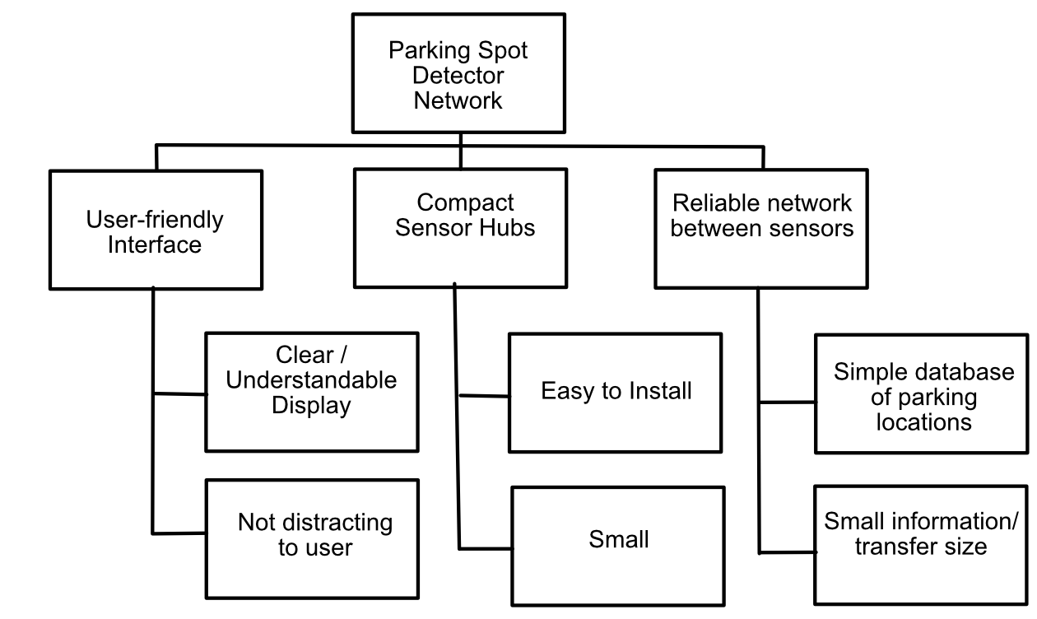

Level 0 Block Diagram:

(LW)

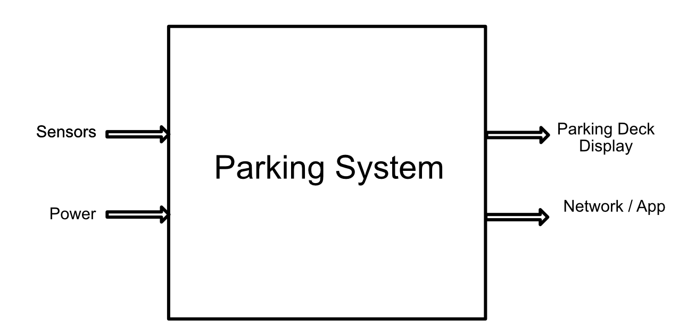

**Mechanical Sketch of System**

(MM)

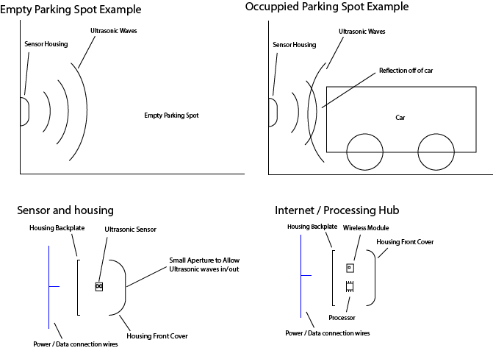

**2. Design Team Information**

Julie Aichinger, Computer Engineering, ESI: yes.

Matthew McDade, Computer Engineering, ESI: yes.

Ryne Turner, Dual Computer & Electrical Engineering, ESI: yes.

Laveréna Wienclaw, Computer Engineering, ESI: yes.

**3. References**

Chinrungrueng, J., Sunantachaikul, U., Triamlumlerd, S. (2007). Smart Parking: an Application of optical Wireless Sensor Network. *Applications and the Internet Workshops 2007.SAINT Workshops 2007. International Symposium on.*

Lu, R., Lin, X., Zhu, H., Shen, X. (2009). SPARK: A New VANET-based Smart Parking Scheme for Large Parking Lots. *IEEE INFOCOM 2009.*

Mohammad, T. (2009). Using Ultrasonic and Infrared Sensors for Distance Measurement. *World Academy of Science, Engineering and Technology International Journal of Mechanical and Mechatronics Engineering,* *3*(3), 267-272. Retrieved February

28, 2018, from http://waset.org/publications/6833

Pala, Z., Inanc, N. (2007). Smart Parking Applications Using RFID Technology. *RFID Eurasia, 2007 1st Annual.* US7688225B1 - Method for managing a parking lot. (2000, January 14). Retrieved March 01,2018, from https://patents.google.com/patent/US7688225B1

S., A. (2016). Performance comparison of Infrared and Ultrasonic sensors for obstacles of different materials in vehicle/ robot navigation applications. *Materials Science*

*and Engineering,* *149*. Retrieved February 28, 2018, from http://iopscience.iop.org/article/10.1088/1757-899X/149/1/012141/pdf

US7688225B1 - Method for managing a parking lot. (2000, January 14). Retrieved

March 01,2018, from https://patents.google.com/patent/US7688225B1

US8799037B2 - Computer-implemented system and method for managing motor vehicle parking reservations. (2010, October 14). Retrieved March 01, 2018, from https://patents.google.com/patent/US8799037B2