SDA 2018-2019 Matthew Fader

Assignment 1 – Oct 15, 2018

# Executive summary

# List of Abbreviations

|  |  |
| --- | --- |
| Acronym |  |
| ASAP | As soon as possible |
| c |  |
| d |  |

# Table of Contents

Introduction 2

List of Abbreviations 3

Table of Contents 4

Table of Figures 5

Table of Tables 6

Introduction 7

Title of the business idea 8

Sub heading 1 8

Sub heading 2 8

Your own name 9

Description of the idea 9

Likely market (not a marketing plan -just an outline) 9

Competitors – if any 9

Conclusion / Summary 10

References 11

Bibliography 12

Appendix A: Appendix A Title 13

Appendix B: Appendix B Title 14

Appendix C: Appendix C Title 14

# Table of Figures

# Table of Tables

# Introduction

The BLANK APP is the

# write up for forum

You are expected to post by 15th October in the Assignment 1 Study Period discussion forum a post reflecting on your work so far in this course. This post will be no more than 130 words and will outline what worked/ did not work for you regarding this assignment tasks. What you liked, what you found difficult etc.

I find android over complicated and shit already, hope that changes, device didn’t recognize right off, and demos need to be updated then the tools needed to be downgraded to have the app upgraded just to run on a modern device ick! Take screen shots of updates. Title database_demo.skd

https://stackoverflow.com/questions/44546849/unsupported-method-baseconfig-getapplicationidsuffix#

avd hates amd so I had to install hypervisor windows, easy! Nope not at all as its still not working. And linda told me she tests all apps on a phone so make sure they work for phone and tablet users. Which means for me make damn sure emulator works

<https://stackoverflow.com/questions/26355645/error-in-launching-avd-with-amd-processor>

help for hardware acceleration above

## Task 1

Insert screen shots of app working. Note the no hardcoding in the app. Just emulate the damn thing and bobs your uncle

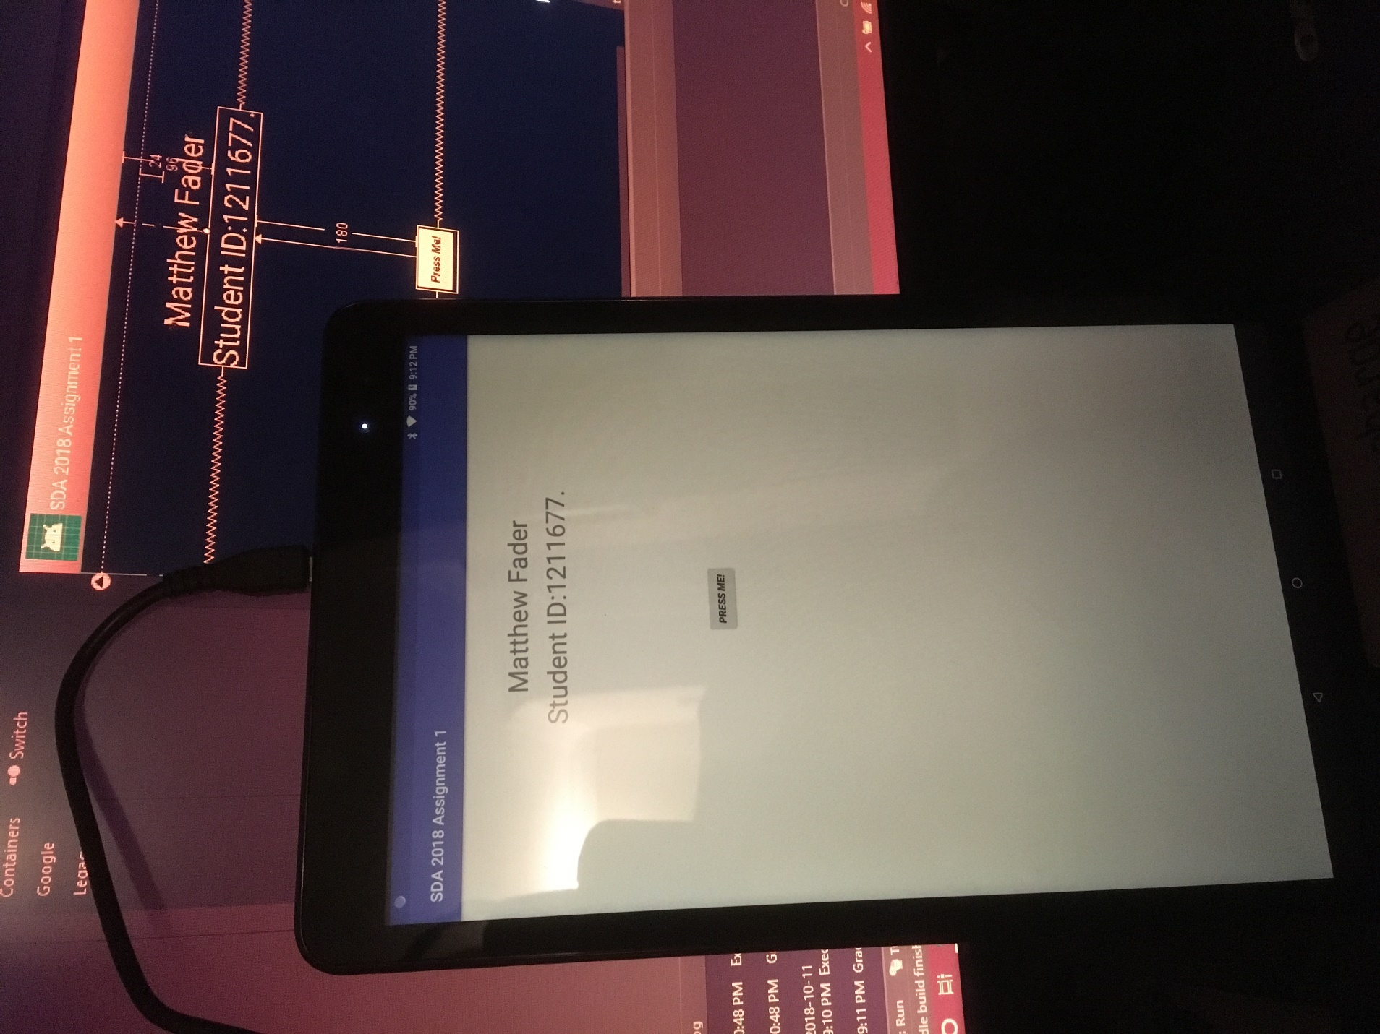A screen shot of a computer

Description generated with very high confidence

Initally durring the workshop I had an issue with what I thought to be a hardware reconginzition problem. But I found out soon after that android studio wont show that your device is available for debugging mode unless the app itself can be built by gradel first. Therefore that app I was trying to run on my device wouldn’t even compile making me belive that my tablelt wouldn’t work.

## Task 2

## Task 3

## Task 4

## Task 5

## Task 6

## Task 7

## Likely market (not a marketing plan -just an outline)

## Competitors – if any

# Conclusion / Summary

Main conclusion stuff here

# References

Use the in builts don’t use bibliography in ms00b at all!

# Bibliography

# Appendix A: Appendix A Title

# Appendix B: Appendix B Title

# Appendix C: Appendix C Title

Any other detail that you feel is important

Note: Size of Document should be 1000 words maximum.

The submission deadline for Stage 2 is 11th December 2017