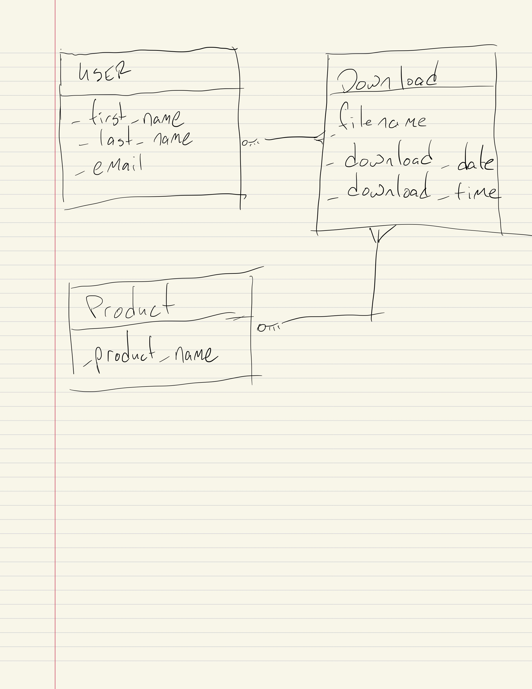

In this diagram, the user has a one to many relationship with the download table and the product table has a one to many relationship with the download table as well. This would mean that there is a many to many relationship with the user and the product tables. The download table’s download date and download time could form a piece of composite data, potentially.