**Heuristic Evaluation Report**

Date: 7/25/21

Prepared By (team member names):

Matt James

***Evaluation***

Name of website being evaluated:

Https://goodproduct.com

Describe the scenario you used to focus your evaluation:

Navigate to a specific product and purchase it.

**Problem #1**

Insert print screen, location of problem:

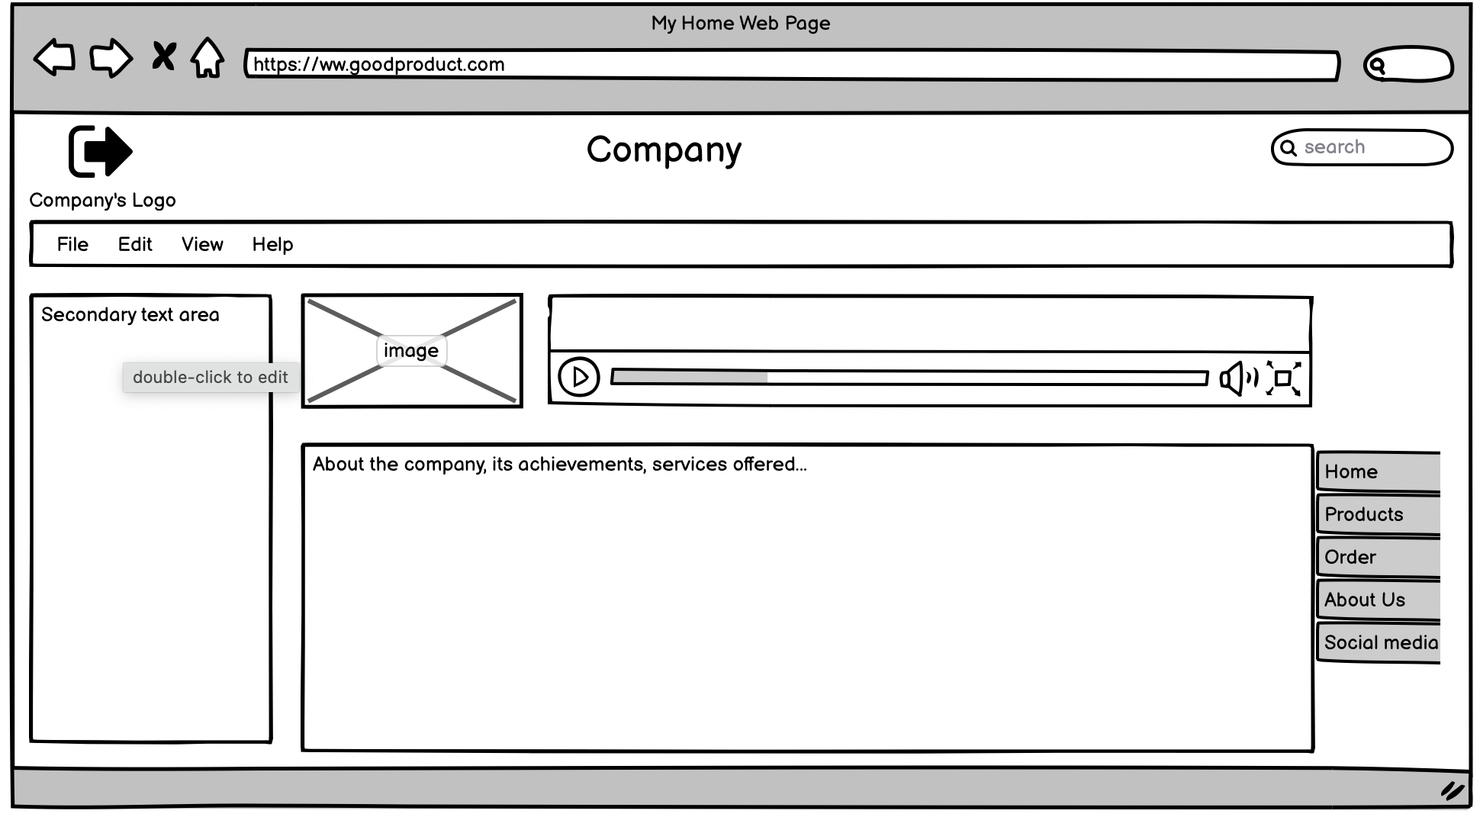

Name of heuristic: Consistency and standards

Reason for reporting negative or positive: Products link is in a sidebar nav and the top nav is more akin to a word processing application.

Scope of problem: Home page

Severity of problem (high/medium/low): High

Justification for severity rating: Primary navigation is located in an area typically reserved for extraneous information and could be very easy to miss. It is also inconsistent with placement in downstream pages, causing a potential usability disconnect as a user navigates the site.

Suggestions to fix: Move primary navigation to the header to maintain consistency with other pages on the site.

Possible trade-offs (why fix might not work): If the file/edit/view/help nav is needed for the homepage, it will become harder to find.

**Problem #2**

Insert print screen, location of problem: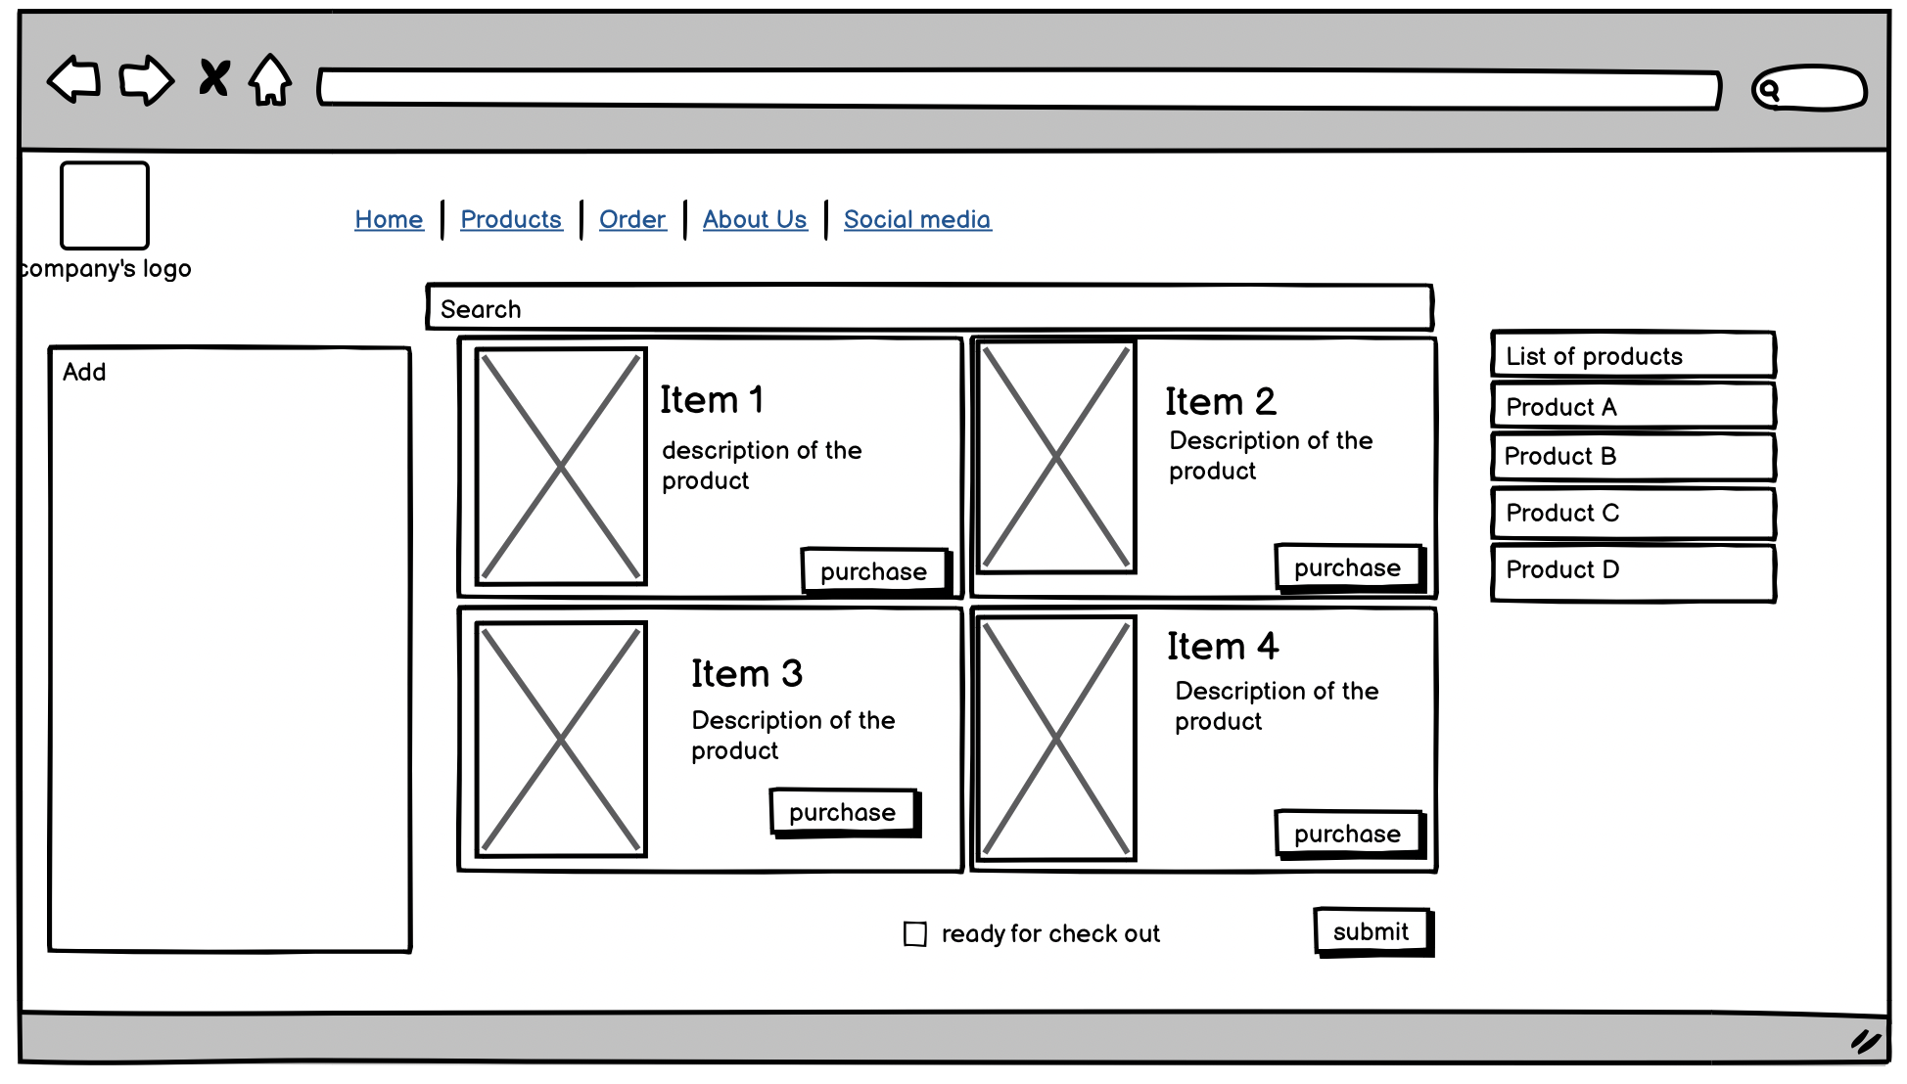

Name of heuristic: Consistency and standards

Reason for reporting negative or positive: Search bar is inconsistent with the rest of the site.

Scope of problem: Products page

Severity of problem (high/medium/low): Medium

Justification for severity rating: Users still have the ability to search for a product so the ability to complete a task is maintained. However, the inconsistency with the rest of the site could lead to a momentary disconnect for users.

Suggestions to fix: Maintain the existing search UI from the rest of the site and change the search input on this page to a ‘filter’ UI.

Possible trade-offs (why fix might not work): There is potential for users to not immediately intuit what a ‘filter’ is. User testing with this interface is recommended.