**Heuristic Evaluation Report**

Date: 7/24/21

Prepared By (team member names):

Matt James

***Evaluation***

Name of website being evaluated: Web Design Agency

Describe the scenario you used to focus your evaluation:

Jessica has a question about [COMPANY]’s services and wants to contact

a representative.

**Problem #1**

Insert print screen, location of problem:

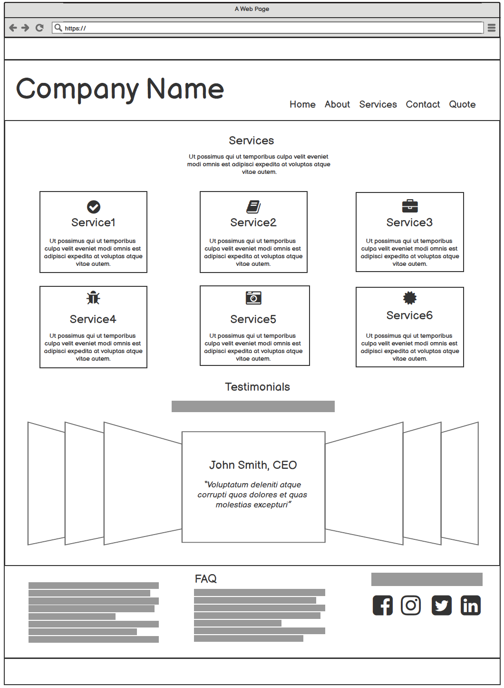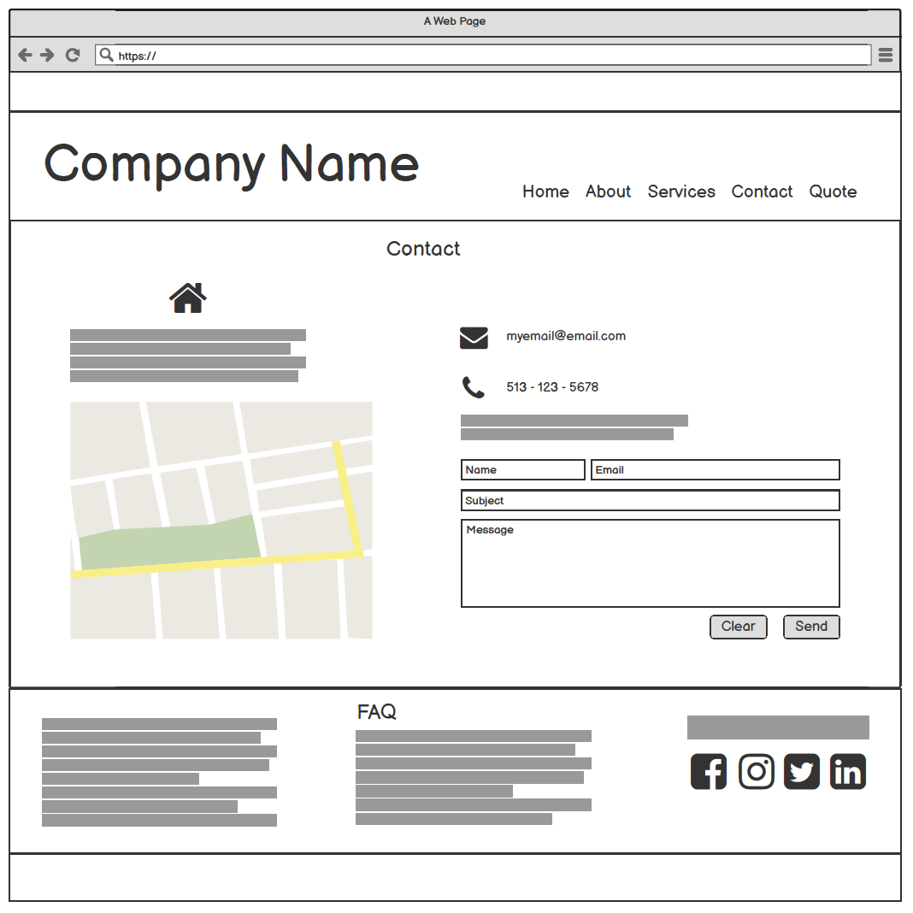

Name of heuristic:  Recognition rather than recall

Reason for reporting negative or positive: Disconnect between services and contact

Scope of problem: Ability to contact company is a separate page from services page, forcing a user to navigate away from the services page to contact company.

Severity of problem (high/medium/low): Medium

Justification for severity rating: User is still able to review services and is able to contact company, so the intended use case is still supported, but in a less efficient manner.

Suggestions to fix: Add a contact form in the services page in place of the testimonials. This will allow a user retain the context of the services offered while completing the contact form. Consider moving testimonials to the home page.

Possible trade-offs (why fix might not work): Adding a contact form below the services would put it below the fold, especially on mobile and a user may not see it. A possible fix for this would be an anchor link on each service that links a user to the form.

**Problem #2**

Insert print screen, location of problem: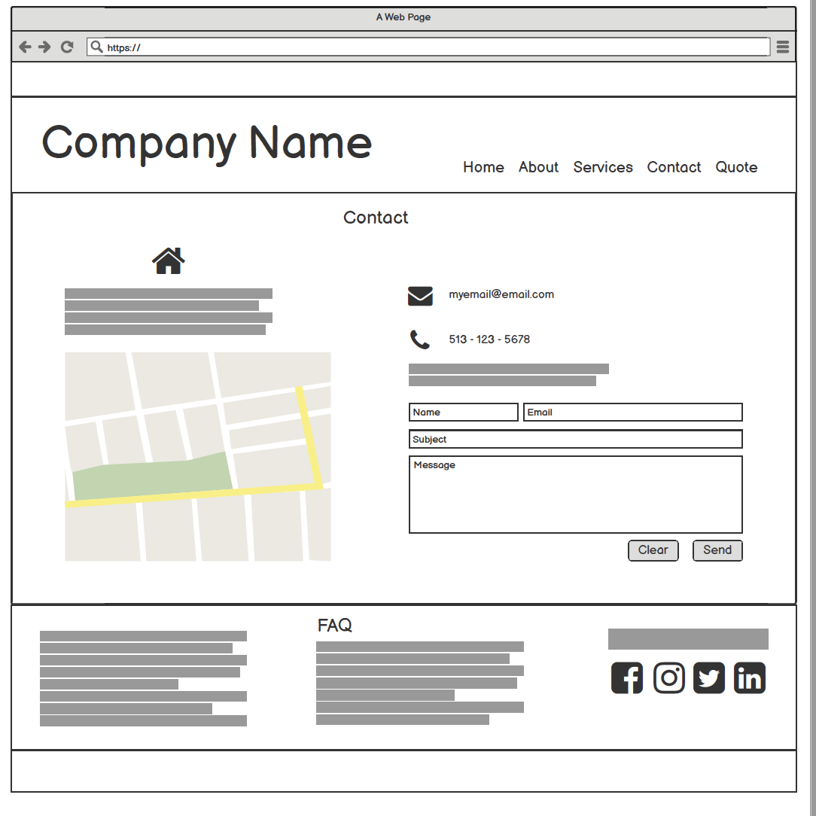

Name of heuristic: Error prevention

Reason for reporting negative or positive: Form fields do no indicate which fields are required and name field is not clear that it requires a full name or not.

Scope of problem: Contact form

Severity of problem (high/medium/low): High

Justification for severity rating: It is not clear which fields are required and is not clear what the error messages would be. Error messages would be communicative but frustrating. A lack of error messages would be both frustrating and prevent form submission.

Suggestions to fix: Add an asterisk next to required form fields with text that says ‘Required’.

Possible trade-offs (why fix might not work): Slightly clutters the UI.