**Matt Gambill**

**ECE 3561**

**MT1**

**MUX21**

library ieee;

use ieee.std_logic_1164.all;

use ieee.std_logic_arith.all;

ENTITY two_one_MUX IS

PORT(a : IN std_logic;

b : IN std_logic;

sel : IN std_logic;

z : OUT std_logic);

END two_one_MUX;

ARCHITECTURE BEHAVIORAL OF two_one_MUX IS

BEGIN

z <= ((not(sel) and a) or (sel and b));

END BEHAVIORAL;

**Test Bench**

library ieee;

use ieee.std_logic_1164.all;

use ieee.std_logic_arith.all;

ENTITY tb2_1_MUX IS

END tb2_1_MUX;

ARCHITECTURE one OF tb2_1_MUX IS

COMPONENT two_one_MUX

PORT(a,b,sel: IN std_logic; z: OUT std_logic);

END COMPONENT;

SIGNAL a,b,sel,z : std_logic := '0';

SIGNAL s1 : std_logic_vector(3 downto 0);

signal i : integer := 0;

SIGNAL clk : BIT :='1';

BEGIN

mux1 : two_one_MUX PORT MAP(a,b,sel,z);

clk <= NOT clk AFTER 10 ns;

PROCESS(clk)

BEGIN

IF (i<4) THEN

s1 <= conv_std_logic_vector(i, s1'length);

a <= s1(0);

b <= s1(1);

i <= i + 1;

ELSE

i<=0;

sel <= NOT sel;

END IF;

END PROCESS;

END one;

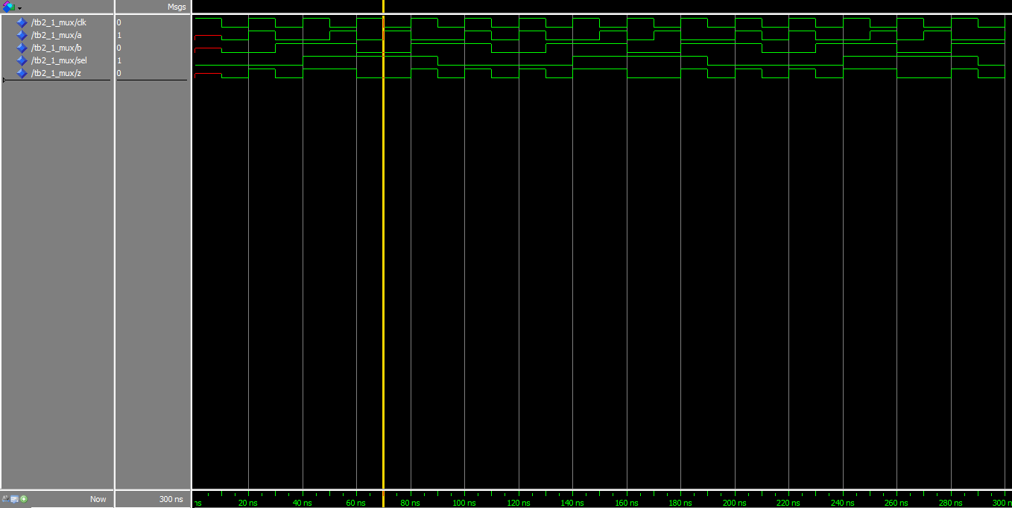

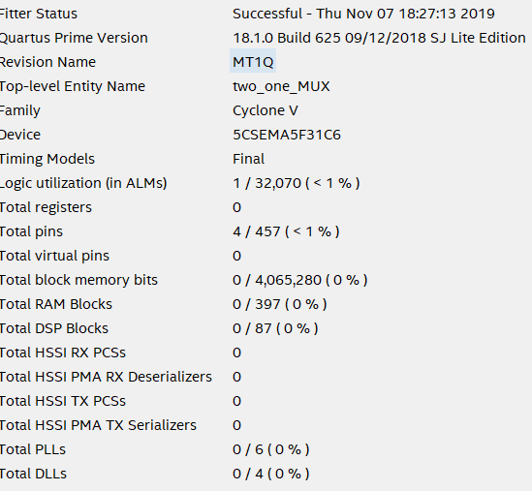

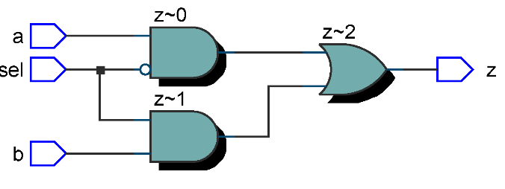

**MUX21_4_Bit**

library ieee;

use ieee.std_logic_1164.all;

use ieee.std_logic_arith.all;

-- input is 4 bits, input(0) = a,input(1) = b, input(2) = sel

ENTITY MUX21_4BIT_BUS IS

PORT(input : IN std_logic_vector(3 downto 0); output : OUT std_logic_vector(3 downto 0) );

END MUX21_4BIT_BUS;

ARCHITECTURE BEHAVIORAL OF MUX21_4BIT_BUS IS

BEGIN

output(0) <= ((not(input(2)) and input(0)) or (input(2) and input(1)));

END BEHAVIORAL;

**TestBench**

library ieee;

use ieee.std_logic_1164.all;

use ieee.std_logic_arith.all;

ENTITY tbMUX21_4_BIT_BUS IS

END tbMUX21_4_BIT_BUS;

ARCHITECTURE one OF tbMUX21_4_BIT_BUS IS

COMPONENT MUX21_4BIT_BUS

PORT(input : IN std_logic_vector(3 downto 0); output : OUT std_logic_vector(3 downto 0) );

END COMPONENT;

SIGNAL z : std_logic_vector(3 downto 0);

SIGNAL s1,s2 : std_logic_vector(3 downto 0) := "0000";

signal i : integer := 0;

SIGNAL clk : BIT :='1';

BEGIN

mux1 : MUX21_4BIT_BUS PORT MAP(s2,z);

clk <= NOT clk AFTER 10 ns;

PROCESS(clk)

BEGIN

IF (i<4) THEN

s1 <= conv_std_logic_vector(i, s1'length);

s2(0) <= s1(0);

s2(1) <= s1(1);

i <= i + 1;

ELSE

i<=0;

s2(2) <= NOT s2(2);

END IF;

END PROCESS;

END one;

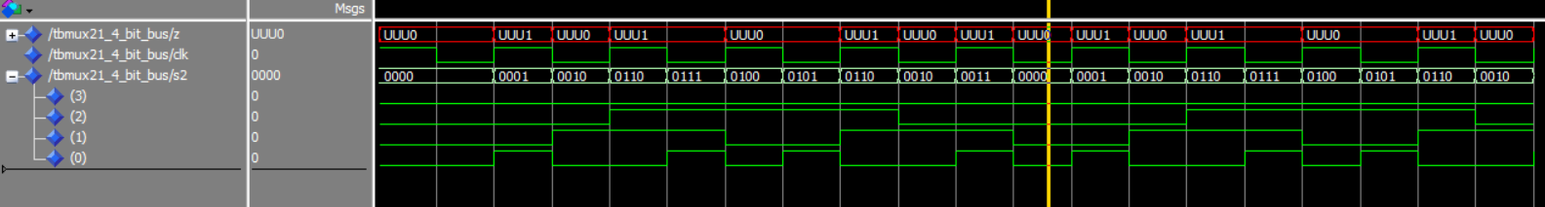

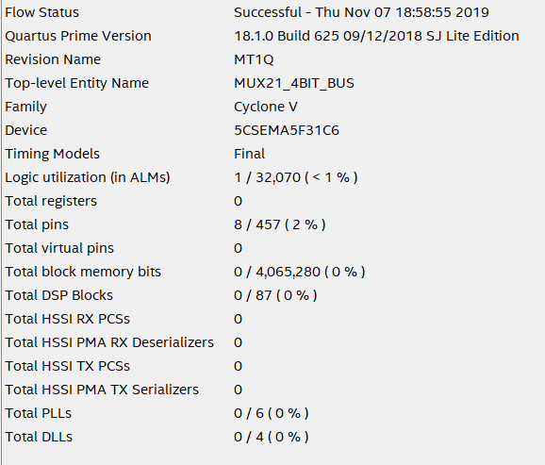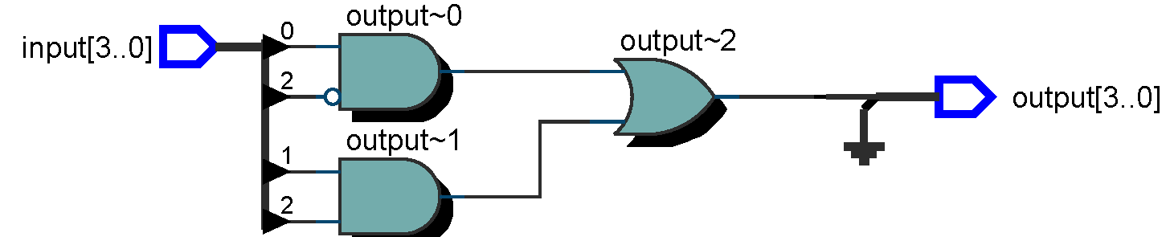

**MUX21_16_bit**

library ieee;

use ieee.std_logic_1164.all;

use ieee.std_logic_arith.all;

-- input is 4 bits, input(0) = a,input(1) = b, input(2) = sel

ENTITY two_one_MUX_16_wide IS

PORT(input : IN std_logic_vector(15 downto 0); output : OUT std_logic_vector(15 downto 0) );

END two_one_MUX_16_wide;

ARCHITECTURE BEHAVIORAL OF two_one_MUX_16_wide IS

BEGIN

output(0) <= ((not(input(2)) and input(0)) or (input(2) and input(1)));

END BEHAVIORAL;

**Test Bench**

library ieee;

use ieee.std_logic_1164.all;

use ieee.std_logic_arith.all;

ENTITY tbMUX21_16_wide IS

END tbMUX21_16_wide;

ARCHITECTURE one OF tbMUX21_16_wide IS

COMPONENT MUX21_16_wide

PORT(input : IN std_logic_vector(15 downto 0); output : OUT std_logic_vector(15 downto 0) );

END COMPONENT;

SIGNAL z : std_logic_vector(15 downto 0);

SIGNAL s1,s2 : std_logic_vector(15 downto 0) := "0000000000000000";

signal i : integer := 0;

SIGNAL clk : BIT :='1';

BEGIN

mux1 : MUX21_16_wide PORT MAP(s2,z);

clk <= NOT clk AFTER 10 ns;

PROCESS(clk)

BEGIN

IF (i<4) THEN

s1 <= conv_std_logic_vector(i, s1'length);

s2(0) <= s1(0);

s2(1) <= s1(1);

i <= i + 1;

ELSE

i<=0;

s2(2) <= NOT s2(2);

END IF;

END PROCESS;

END one;

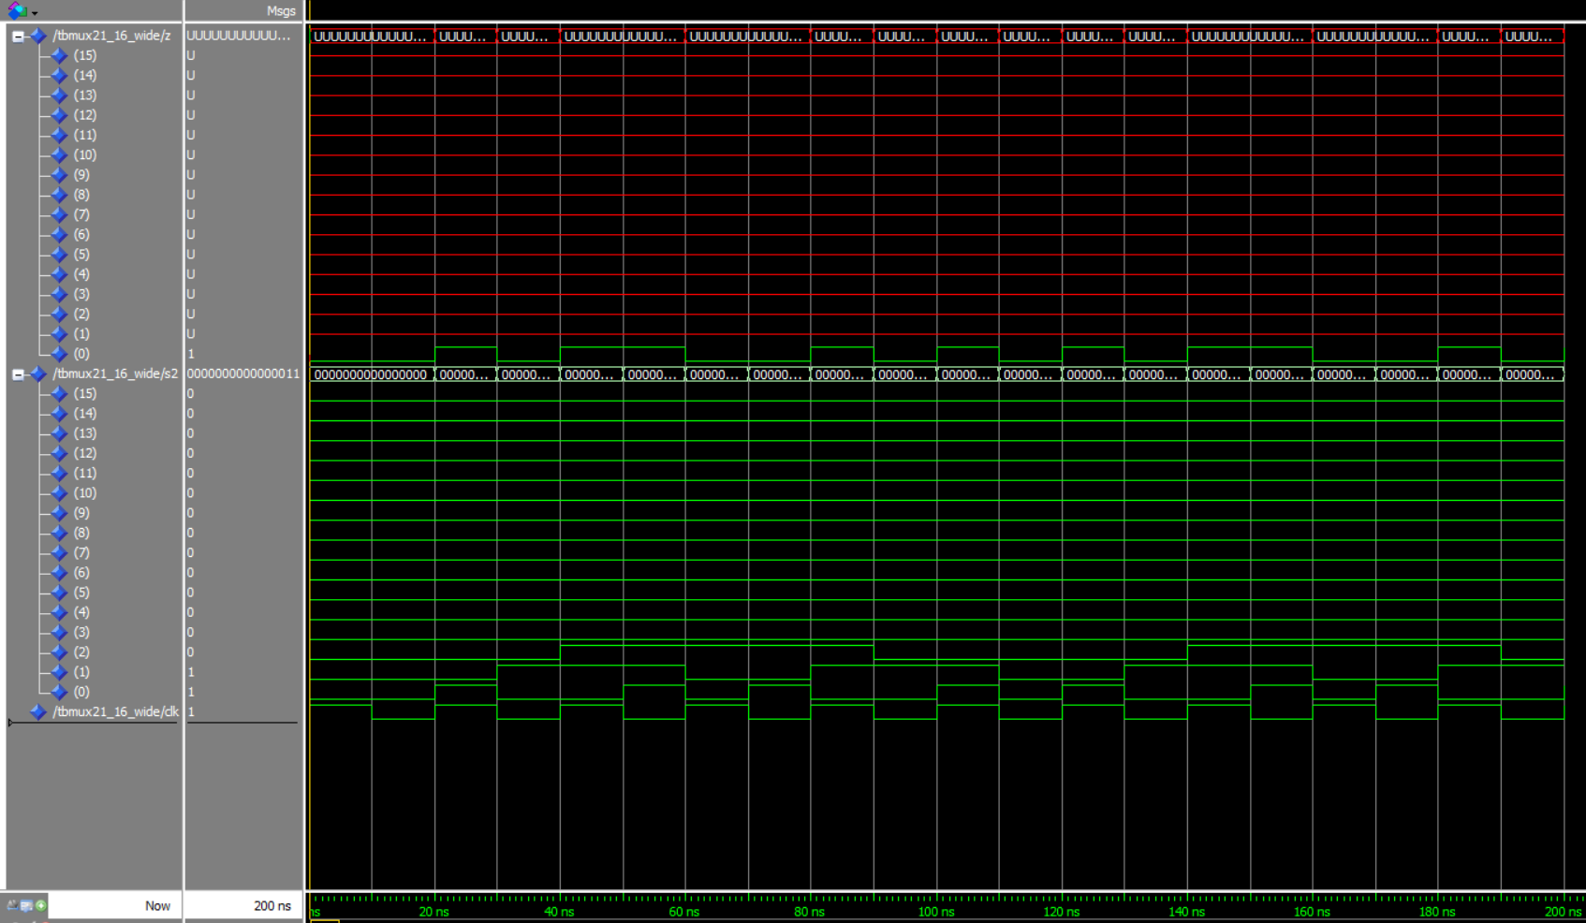

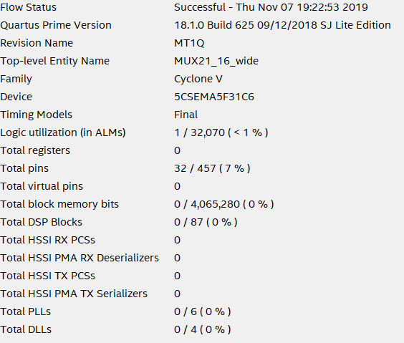

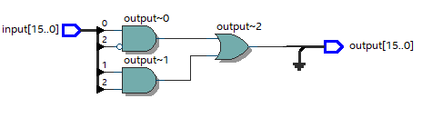

**MUX41_1_Wide**

library ieee;

use ieee.std_logic_1164.all;

use ieee.std_logic_arith.all;

ENTITY MUX_41_1_wide IS

port(a,b,c,d,sel_0,sel_1 : IN std_logic; z : OUT std_logic);

END MUX_41_1_wide;

ARCHITECTURE BEHAVIORAL OF MUX_41_1_wide IS

COMPONENT two_one_MUX

PORT(a,b,sel: IN std_logic; z: OUT std_logic);

END COMPONENT;

SIGNAL z0,z1 : std_logic :='0';

Begin

mux0 : two_one_MUX PORT MAP(a,b,sel_0,z0);

mux1 : two_one_MUX PORT MAP(c,d,sel_0,z1);

mux2 : two_one_MUX PORT MAP(z0,z1,sel_1,z);

END BEHAVIORAL;

**Test Bench**

LIBRARY ieee;

USE ieee.std_logic_1164.ALL;

USE ieee.std_logic_arith.ALL;

ENTITY tb4_1_MUX IS

END tb4_1_MUX;

ARCHITECTURE one OF tb4_1_MUX IS

COMPONENT MUX_41_1_wide

PORT (

a, b, c, d, sel_0, sel_1 : IN std_logic;

z : OUT std_logic

);

END COMPONENT;

SIGNAL a, b, c, d, sel_0, sel_1, z : std_logic := '0';

SIGNAL s1 : std_logic_vector(3 DOWNTO 0);

SIGNAL i,j : INTEGER := 0;

SIGNAL clk : BIT := '1';

BEGIN

mux1 : MUX_41_1_wide PORT MAP(a, b, c, d, sel_0, sel_1, z);

clk <= NOT clk AFTER 10 ns;

PROCESS (clk)

BEGIN

IF (i < 16) THEN

s1 <= conv_std_logic_vector(i, s1'length);

a <= s1(0);

b <= s1(1);

c <= s1(2);

d <= s1(3);

i <= i + 1;

ELSE

i <= 0;

j <= j + 1;

sel_0 <= NOT sel_0;

END IF;

IF(j > 1 AND j < 4) THEN

sel_1 <= '1';

ELSE

sel_1 <='0';

END IF;

END PROCESS;

END one;



