**MT4**

**Matt Gambill**

**ECE3561**

**dff_en**

library ieee;

use ieee.std_logic_1164.all;

use ieee.std_logic_arith.all;

Entity dff_en IS

port(d,clk,en : IN std_logic; q : OUT std_logic);

End dff_en;

ARCHITECTURE BEHAVIORAL OF dff_en IS

BEGIN

Process

BEGIN

Wait UNTIL clk='1' AND clk'event;

IF en='1' THEN

q<=d;

END IF;

END PROCESS;

END BEHAVIORAL;

**Test Bench**

library ieee;

use ieee.std_logic_1164.all;

use ieee.std_logic_arith.all;

ENTITY tbdff_en IS

END tbdff_en;

ARCHITECTURE one OF tbdff_en IS

COMPONENT dff_en

port(d,clk,en : IN std_logic; q : OUT std_logic);

END COMPONENT;

SIGNAL d,q,en : std_logic := '0';

SIGNAL s1 : std_logic_vector(3 downto 0);

signal i : integer := 0;

SIGNAL clk : std_logic :='1';

BEGIN

dff0 : dff_en PORT MAP(d,clk,en,q);

clk <= NOT clk AFTER 10 ns;

PROCESS(clk)

BEGIN

IF (i<4) THEN

s1 <= conv_std_logic_vector(i, s1'length);

d <= s1(1);

i <= i + 1;

ELSE

i<=0;

en <= NOT en;

END IF;

END PROCESS;

END one;

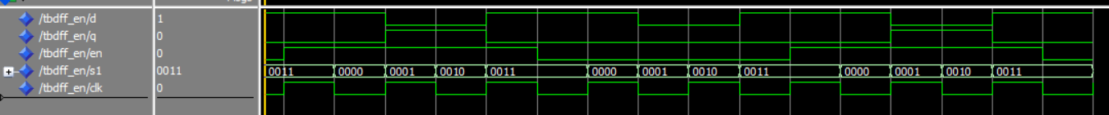

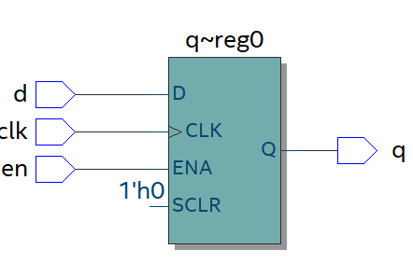

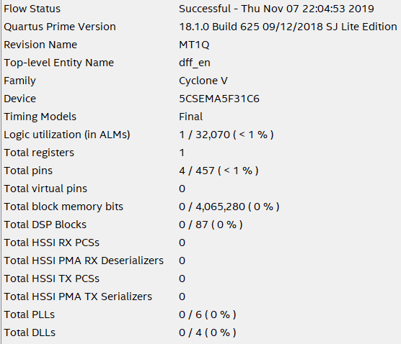

**dff_en_16_wide**

library ieee;

use ieee.std_logic_1164.all;

use ieee.std_logic_arith.all;

Entity dff_en_16_wide IS

port(clk : IN std_logic; d,en : IN std_logic_vector(15 downto 0); q : OUT std_logic_vector(15 downto 0));

End dff_en_16_wide;

ARCHITECTURE BEHAVIORAL OF dff_en_16_wide IS

BEGIN

Process

BEGIN

Wait UNTIL clk='1' AND clk'event;

for i in 15 downto 0 loop

IF en(i)='1' THEN

q(i)<=d(i);

END IF;

end loop;

END PROCESS;

END BEHAVIORAL;

**Test Bench**

library ieee;

use ieee.std_logic_1164.all;

use ieee.std_logic_arith.all;

ENTITY tbdff_en_16_wide IS

END tbdff_en_16_wide;

ARCHITECTURE one OF tbdff_en_16_wide IS

COMPONENT dff_en_16_wide

port(clk : IN std_logic; d,en : IN std_logic_vector(15 downto 0); q : OUT std_logic_vector(15 downto 0));

END COMPONENT;

SIGNAL d,q,en : std_logic_vector(15 downto 0) := "0000000000000000";

SIGNAL s1 : std_logic_vector(3 downto 0);

signal i : integer := 0;

SIGNAL clk : std_logic :='1';

BEGIN

dff0 : dff_en_16_wide PORT MAP(clk, d,en,q);

clk <= NOT clk AFTER 10 ns;

PROCESS(clk)

BEGIN

IF (i<4) THEN

s1 <= conv_std_logic_vector(i, s1'length);

i <= i + 1;

ELSE

i<=0;

en <= NOT en;

END IF;

for i in 15 downto 0 loop

d(i) <= s1(1);

end loop;

END PROCESS;

END one;

