**MT5**

**Matt Gambill**

**ECE3561**

**BUSDR_1_WIDE**

LIBRARY IEEE;

USE IEEE.STD_LOGIC_1164.ALL;

ENTITY BUSDR_1_WIDE IS

PORT (

drive : IN STD_LOGIC;

data : IN STD_LOGIC;

intbus : OUT STD_LOGIC

);

END BUSDR_1_WIDE;

ARCHITECTURE Behavioral OF BUSDR_1_WIDE IS

BEGIN

intbus <= data WHEN (drive = '1') ELSE 'Z';

END Behavioral;

**Test Bench**

library ieee;

use ieee.std_logic_1164.all;

use ieee.std_logic_arith.all;

ENTITY tbBUSDR_1_WIDE IS

END tbBUSDR_1_WIDE;

ARCHITECTURE one OF tbBUSDR_1_WIDE IS

COMPONENT BUSDR_1_WIDE

PORT (

drive : IN STD_LOGIC;

data : IN STD_LOGIC;

intbus : OUT STD_LOGIC

);

END COMPONENT;

SIGNAL en,data_i,data_o : std_logic := '0';

SIGNAL s1 : std_logic_vector(3 downto 0);

signal i : integer := 0;

SIGNAL clk : std_logic :='1';

BEGIN

busdr0 : BUSDR_1_WIDE PORT MAP(en,data_i,data_o);

clk <= NOT clk AFTER 10 ns;

PROCESS(clk)

BEGIN

IF (i<4) THEN

s1 <= conv_std_logic_vector(i, s1'length);

data_i <= s1(1);

i <= i + 1;

ELSE

i<=0;

en <= NOT en;

END IF;

END PROCESS;

END one;



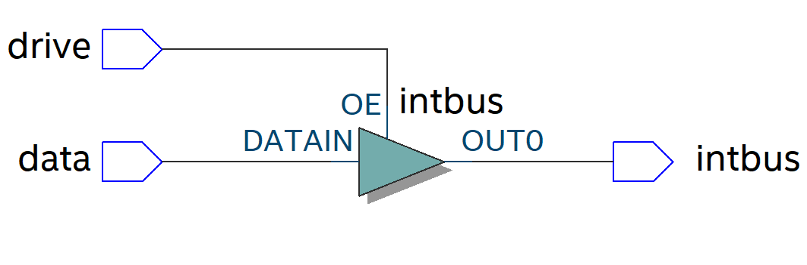

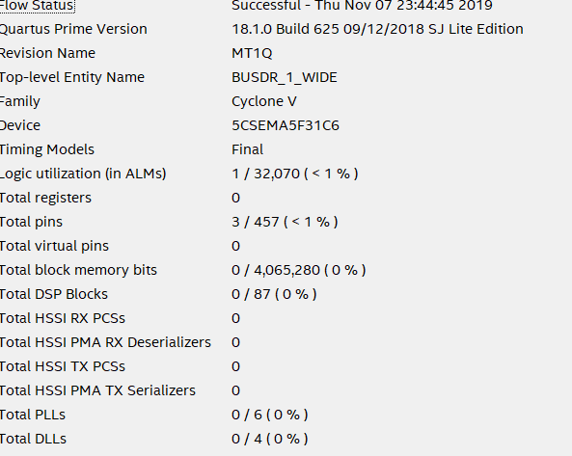

**BUSDR_16_WIDE**

LIBRARY IEEE;

USE IEEE.STD_LOGIC_1164.ALL;

ENTITY busdr_16_wide IS

PORT (

drive : IN STD_LOGIC;

data : IN STD_LOGIC_VECTOR(15 DOWNTO 0);

intbus : OUT STD_LOGIC_VECTOR(15 DOWNTO 0)

);

END busdr_16_wide;

ARCHITECTURE Behavioral OF busdr_16_wide IS

BEGIN

intbus <= data WHEN (drive = '1') ELSE "ZZZZZZZZZZZZZZZZ";

END Behavioral;

**Test Bench**

library ieee;

use ieee.std_logic_1164.all;

use ieee.std_logic_arith.all;

ENTITY tbBUSDR_16_WIDE IS

END tbBUSDR_16_WIDE;

ARCHITECTURE one OF tbBUSDR_16_WIDE IS

COMPONENT BUSDR_16_WIDE

PORT (

drive : IN STD_LOGIC;

data : IN STD_LOGIC_VECTOR(15 DOWNTO 0);

intbus : OUT STD_LOGIC_VECTOR(15 DOWNTO 0)

);

END COMPONENT;

SIGNAL data_i,data_o : std_logic_vector(15 downto 0) := "0000000000000000";

SIGNAL s1 : std_logic_vector(3 downto 0);

signal i : integer := 0;

SIGNAL en : std_logic :='0';

SIGNAL clk : std_logic :='1';

BEGIN

busdr0 : BUSDR_16_WIDE PORT MAP(en,data_i,data_o);

clk <= NOT clk AFTER 10 ns;

PROCESS(clk)

BEGIN

IF (i<4) THEN

s1 <= conv_std_logic_vector(i, s1'length);

i <= i + 1;

ELSE

i<=0;

en <= NOT en;

END IF;

for i in 15 downto 0 loop

data_i(i) <= s1(1);

end loop;

END PROCESS;

END one;

