
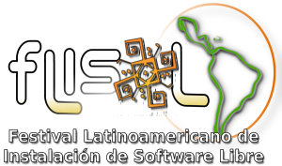
Popayán, April 10th 2008
Mis:
PILAR CAMPOS
Press Office
Universidad del Cauca
Cauca City

Greetings,

On the 26th of April of the present year, the Free Software Instalation Latinamerican Festival – FLISoL will take place, the event of the biggest Free Technologies diffusion in Latinamerica. It's main goal is to promote the use of free software, content and technologies, speaking of it's filosofy, success, advace and development in the artistic, academic and business area. It is orginized in Popayán by the city's Free Software Community.
Having in count the role of the communitation media, as a means for society to find different development alternatives, we consider your participation of vital importance in the spreading and covering of this event.
We are open to provide any required information.

Sincerelly,

Alejandra Narvaez Camayo Ulises Hernande Pino
FLISoL 2008 Popayán Coordinator Educative Investigation Network - ieRed
Universidad del Cauca GNU/Linux Group Universidad del Cauca

Of. Doctorado en Educación, Carrera 2A # 3N-111
Teléfono: 8209800 Ext. 2316, Celular: 312 891 3455
Correo: drakexle@gmail.com

